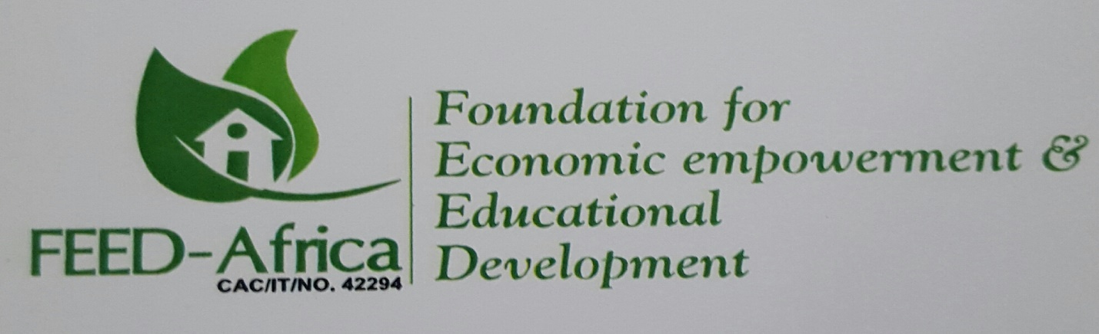

WHO WE ARE
The Foundation for Economic empowerment & Educational Development (FEED-Africa Foundation) is a non-governmental, non-profit, non-religious, Civil Society organization founded on the ideals of Good Governance, Community Service, Public enlightenment and Education, Philanthropy and the overall goal of societal development. It is registered with the Corporate Affairs Commission as an Incorporated Trustee, (CAC/IT/No. 42294), in December 2010.
Most commonly known by its acronym FEED-Africa foundation, it was established in recognition of the tremendous challenges faced by Nigeria and Africa in general, and the ever-increasing threats to societal stability arising from injustice, social iniquities and inequalities.
Over the years, the scourge of economic degradation, social deprivation, illiteracy, hunger and disease in Nigeria and Africa, has pushed restraint to the brinks and given vent to pent-up frustrations leading to break down of law and order resulting in violence, wanton destruction of life and property and untimely and avoidable deaths. The physical and psychological effects of all these on the nation are best imagined.
In Nigeria particularly, social malfeasance is at an all-time high; morality has taken the back bench; acts that had hitherto been inconceivable are now the norm rather than the exception. Materialism and the quest for wealth has led to abdication of parental responsibility, leaving children and wards without guidance, direction and focus; the result of which reflects in heightened crime rate, increased juvenile delinquency, increased sexual promiscuity and prostitution, illicit drug use and abuse and various other forms of social and societal vices. It is in a bid to help address these lacunae in the hope of attaining an egalitarian society with better living conditions that FEED-Africa foundation was founded.

MISSION
Our mission is to enhance the quality of life of Nigerians and Africans by initiating, executing and promoting programs that support and encourage improved access to social, economic and educational opportunities for all.
VISION
FEED-Africa foundation envisages a society where all citizens have equal and unhindered access to existing and emerging opportunities in educational, economic, environmental, social and other spheres of life, in order to realize their innate and inherent potentials.

OUR FOCUS

Legislative & Policy Advocacy
Principally, much of the ills plaguing our society stem from ignorance and lack of, or limited awareness. These restrictions hinder access to requisite information on issues that affect the daily lives of citizens. To help address this, FEED-Africa Foundation, working in partnership with departments of government and other civil society organizations, helps to shape government policies through legal and legislative instruments such as bills, motions and appropriation sessions, while also monitoring their implementation. In this regard, focus is on democratic institutions, service delivery, Rule of Law and Anti – Corruption.

Good Governance & Human Rights Monitoring
Good governance and human rights are mutually reinforcing. Human rights principles provide a set of values to guide the work of governments and other political and social actors. They also provide a set of performance standards against which these actors can be held accountable. Moreover, human rights principles inform the content of good governance efforts and often, inform the development of legislative frameworks, policies, programmes, budgetary allocations and other measures.

Alternately, without good governance, human rights cannot be respected and protected in a sustainable manner as the implementation of human rights relies on a conducive and enabling environment. These include appropriate legal frameworks and institutions as well as political, managerial and administrative processes responsible for responding to the rights and needs of the population.

Environment
Realizing the role of the citizen in governance and the need to ensure inclusivity, FEED-Africa Foundation promotes awareness campaigns on environmental issues including habitat and climate change and its effects, citizenship obligations and participation in governance. Through these, we advocate for government policies that impact positively on the lives of the citizens and ensure good governance and better living standards.

Educational Development
(Improving Access to, and Quality of, Education)
Realizing the importance and role of education in individual and national development, one of our core priorities is to improve access to education. This is done through subsidizing the cost of tuition in some cases and where the situation demands, the Foundation assumes complete responsibility, if possible. We also collaborate in the training of teachers as a way of improving quality, and provision of infrastructure like classrooms, furniture and instructional materials which aims at achieving better and more conducive learning environments.

Economic empowerment
(Alleviating Extreme Poverty, improving living standards)
Much of a people’s lifestyle is determined by their economic circumstances. In recognition of this, FEED-Africa Foundation, working with and within communities, aim to impart entrepreneurial skills through training and instruction. Beneficiaries of skills acquisition programs are given soft loans to start small businesses of their own. This area targets mostly women and youth.

HOW WE OPERATE
FEED-Africa Foundation works through, and in partnership with, community based cooperative societies and other groups, Public Organizations, Government Ministries, Agencies and Philanthropies. Our strategy of working through collaborations is to build institutional capacity to sustain our programs and ensure that such programs meet the targeted beneficiaries. In so doing, the Foundation forges partnerships with Local, State and Federal Government agencies, donor organizations and other international bodies working in similar focal areas. These collaborations become even more pertinent and imperative realizing that there already exist a number of very important and critical actors in the areas the Foundation also operates.

An important component of the Foundation’s work is the dedication to methodical analysis and documentation of the projects undertaken in order to strengthen and improve our future activities and assist in influencing policies, especially those that have direct bearing on our operations and the people and communities we serve.

