Proposal title: Wellness Center to serve Poor People in Hard to reach Kabale District in South Western Uganda. Budget needed USD 85,000.
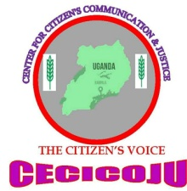
Name Of Applying Institution | CENTER FOR CITIZENS COMUNICATION AND JUSTICE (CECICOJU)N LTD
Address | Plot 123 Nyaika Avenue, Fortportal/  Bunagana Village, Kamuganguzi Sub County, Kabale District
Contact Details Tel: | +256782961421  Email: Cecicoju95@Gmail.Com
Contact Person | Everns Turyahikayo Bagamuhunda
Tittle: | Executive Director
Submission Date | 15th November 2019
Amount Needed | 85,000 Usd
Start Date | Depending On Availability Of Funds
End Date | 2 Years
Project Goal | The Aim Is To Provide A Comprehensive Health Programmed (Preventive, Curative, And Rehabilitation), Aimed At Reaching Target Groups, By Improving The Access To Basic Health Services.
Objectives | - Provide Emergency Services, Treatment Of Common Diseases And Injuries, Maternal And Peri-Natal Healthcare, A 24 Hour/Day Delivery Service, Emergency Obstetric Care, PNC Services, Family Planning Service, Immunization, Tuberculosis Control, Child Health Services (Including Oral Health Services, Accident Prevention And Rehabilitation, Post Trauma Problems, Operation Services, Chronic Disease – Diagnosis, Control And Referral, Counseling And School Health Programme And Preventive Services) And Outreach Support Such As Seasonal RH Camps At A Community Level;  - Have An Operating Theatre And The Capacity For Surgery, Specifically For Emergency Obstetrics And Gynecology; As Well As A Full Range Of Simple Procedures;  - Ultimately Provide Support And Outreach Services To The Surrounding Area
Proposed Activities | - Land Excavation And Clearing Of Bushes  - Procurement Of Building Materials  - General Construction  - Launching
Expected Outcomes | Communities Are Free From Diseases And Poverty
- USD 15 Can Help In Purchase Of One Bag Of Cement
- USD 25 Could Help To Buy One Versatile Iron Sheet.
- USD 45 Could Assist In Leveling And Excavation Of Land

- Executive summary
It is proposed to set up a 25-bed community Wellness Center with community multipurpose Hall, administrative offices, to offer Medical services for the vulnerable poor in Kabale District western Uganda. The Facility will give maximum support to hard to reach areas covering over three Districts, Kabale, Rubanda, and Rukiga. The Purpose is to offer and to provide access to medical services to vulnerable communities that cannot access services due to mobility and other related problems in the area. The constructed WELLNESS Center will also ofer services to other parts like Rwanda being near the border of Uganda AND Rwanda. Kabale District is Hilly area and over 85% of the population has no road network. Patients are curried on locally made stretchers known as engozi to walk over 50 kilometers to access medical care.
The aim is to provide a comprehensive health programmed (preventive, curative, and rehabilitation), aimed at reaching target groups, by improving the access to basic health services.
The focus of this programme is to improve access to and affordability for medical and health care services for the vulnerable people who form a large group in the surrounding area), disabled people, women, children, elderly, and other marginalized people, affected by all types of discrimination.

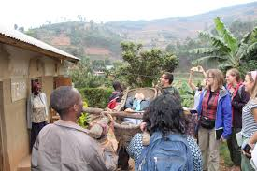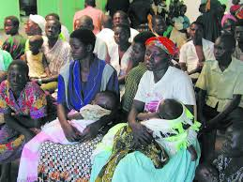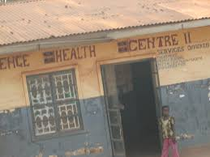
Problem
    - There is a general absence of healthcare facilities in the area. Most hospitals and doctors are located in the more populated areas. The nearest (referral ) hospitals Kabale Hos[ital is over 50 miles are from the area.
    - The Only Government Sub District health facility in the area has no facilities for surgery.
    - Access to affordable health care services far exceeds the income of the majority of the population Over 80 percent of the population lives in rural areas, often many hours' walk from the nearest primary health post.
    - Maternal health and infant mortality are major problems in Kabale District despite recent efforts for improvement.
    - Most areas have no access to clean water which has resulted into epidemics.
    - Access to emergency caesarian operations is limited and often financially beyond the reach of the majority of residents
    - Access to main grid electricity is still a dream to most of the areas.
    - there is evidenced poverty among the locals that can easily be observed.
    - Pregnant Mothers are dying on the way to far distant health facilities due to delay in accesiing medical care.
Solution
A community wellness center in KABALE district will provide and ensure affordable access to healthcare services for the poor communities in the surrounding hill districts of Kabale, Rubanda, Rukiga, and the neoghuring republic of Rwanda.
Based on the vision of Center for Citizens Communication and justice, the 25-bed community elness Centre should:
    - provide emergency services, treatment of common diseases and injuries, maternal and peri-natal healthcare, a 24 hour/day delivery service, emergency obstetric care, PNC services, family planning service, immunization, tuberculosis control, child health services (including oral health services, accident prevention and rehabilitation, post trauma problems, operation services, chronic disease – diagnosis, control and referral, counseling and school health programme and preventive services) and outreach support such as seasonal RH camps at a community level;
    - be initially run by a doctors, and 6-7 nurses (Phase 1)
    - have an operating theatre and the capacity for surgery, specifically for emergency obstetrics and gynecology; as well as a full range of simple procedures;
    - ultimately provide support and outreach services to the surrounding area

Funding is required for:
      - Building the 25-bed structure, including an operating theatre, maternity department, OPD and laboratory, administartive offices and a community Hall for gathering . This is estimated to cost about 75,000 USD
      - Phase 1 – building a complete Out Patients’ Department (OPD), one ward and hospital administration offices would cost around 35,000 USD
      - Phase 2 – adding the maternity services and a second ward is estimated to cost 25,000
      - Phase 3 – emergency, operating theatres and two more wards will cost around 10,000 USD

As well as contributing the land, the surrounding VDCs (Village Development Committees) have committed o providing timber and the local community will provide local materials like sand and stone, and labour. The value of this contribution has not been factored into the estimates but could make up 25- 30% of the building costs, based on experience of building projects elsewhere.
Statement of need
WHY BUILD A COMMUNITY WELNESS CENTRE
The districts of Kabale, Rubanda and Rukiga (formerly KABALE dISTRICT) are all in the Hills where mobility is still a challenge. Over 1,326,355 people live in these hill districts. Farming is at subsistance level, where people plant for only eating. Crops are affected by soil eroisions, and many people are dyig because of starvation. Access to healthcare facilities in these districts is limited. Other than the district hospital there is just one Health Sub District Health Center 4 at RUBAYA sub county , twenty five kilometers away from the proposed wellness center construction.
In Uganda Generally there is no Health insurance scheme to help vulnerable community access halth facilities easily. Because of this , medical care is only accessed by rich families. this project will develop a comprehensive Medical Insurance based on community empowerment. Locating a community Welness center will provide maximum access to people living in a large area. The project will also work as a nutrition center for the vulnerable communities some who are victims of HIV/AIDS as well as children.
Kabale District is located in the South western Uganda bordering Republic of Rwanda, about 450km west of Kampala city the capital of Uganda in the Western Region. The Community Welness Center is to be established at Bunagana Village, Kyasano Parish, Kamuganguzi Sub County, Ndorwa County, Kabale District.
In the absence of comprehensive primary healthcare and hospitals, patients often travel long distances, causing undue delay in obtaining proper medical treatment.
Among the children, 95 out of 1,000 do not survive to their fifth birthday. Girls still have a higher mortality rate than boys. Access to health care, along with the nutritional status of children, tends to worsen among the excluded groups, resulting into their low human development.
For the majority of people, healthcare services, even if available, are often out of the reach of many of the poorer people. A community Wellness Center would be able to help address this, by providing affordable healthcare services to the poorer sections of society.
- Project description
Objectives
The primary objective for creating a community Welness Center in Kabale District focussing on serving the underserved poor, and , to work with the local community to provide affordable and accessible quality modern healthcare facilities to the deprived people of communities in this Western region of Uganda
    - The community Welness center will be an independent, non-profit organization run for, and by the local community to provide quality health services.
    - It aims to provide affordable and quality healthcare for all, in particular focusing on deprived groups, marginalized people, women, and children.
    - The hospital will improve access to HEALTH care services.
    - The center will provide outpatient and inpatient services, (general surgery, obstetrics and gynecology, orthopedics, family planning and will include general ward and neonatal care.
    - Initially, a full OPD service will be provided, with one in-patients’ ward. Maternity services, a further ward would follow, with emergency services, operating theatres and two more wards being built to complete the hospital.
    - A center will act as a nutrition Center for the poor.
    - Will offer Community Health Insurance scheme for the poor
    - A village Savings and credit scheme will be established for project sustainability.
    - Mobile clinics and community outreaches shall be conducted weekly, reaching out to the poor.
Methods
The community Wellnes Center will be managed by the local community, with the objective of offering affordable access to medical care. The User Management Health Committee will help to determine the running of the hospital in conjunction with donors, NGOs and other national and international organisations.
A Five Acre Land has been provided and construction will commence as soon as possible subject to funding. At this stage, a provisional floor plan of the hospital has been drawn up and engineers have estimated a tentative building cost.

3.2.1 Staffing/Administration
Center for Citizens Communication and Justice (CECICOJU) is providing management/administrative support for the set-up of the center . A technical overseer will be required for the construction work.
Center for Citizens Communication and Justice (CECICOJU) is responsible for fund-raising and administration of the project.

3.2.2. Sustainability
To provide low cost services, it cannot be expected to cover costs in a profitable manner, even if the hospital is run efficiently and cost-effectively. It is aimed to cover costs as far as possible, to rely on additional funds only for subsidizing services to the poor.
With this in mind, it is envisaged that those people able to afford to pay a modest and affordable charge for services, should pay. Patients who are assessed to be unable to pay, should receive treatment free or at a subsidized rate.
The center would aim to be as self-sufficient as possible, but it would also be proactive in seeking funding to help the needy, and for outreach work that would start from Phase 3, providing medical services in the more remote areas of the surrounding districts.
The new CENTER will need to establish its reputation, but it is envisaged that within a short period of time, patient volumes will necessitate recruitment of further staff.
To start with however, funding will need to be set aside to cover the start-up costs (staffing, running costs etc.). There are indications from a number of NGOs that they would be willing to cover some of the staff costs and to provide equipment, so it is envisaged that the running costs of the hospital that need to be met from revenues will be considerably lower than detailed here.
A senior doctor and other staff will be available to commence after construction, Locally available staff resources have already been identified and there will be need to call for both local and international volunteers and consultants to work with the center. Staff incentives and staff retention polices will be high priority. Staff recruitment and retention are seen as key to the success of this center.
The community center will report to the District Department of Health and is in the process of being registered with the Ministry of Health.
- Organizational Information
Center for Citizens Communication and Justice (CECICOJU) was set up in June 2013 to help advance communication and education and to assist in the provision of healthcare in the rural areas of Uganda. Center for Citizens Communication and Justice (CECICOJU) is a Ugandan Indegenous NGO being set up and to be registered by the Uganda Registrattive services bureau and the National Non Governmental board.
CECICOJU has since established projects aiming at saving lives especially mothers and cHILDREN. wITH SUPPORT FROM development partners save Vitamin Agels (USA), pOPULATION SERVICES INTERNATIONAL greed GREEDSCHAMP Netherlands etc, the organization has registered undoubted succes both locally and Nationally. Donors both local and around the world support the work of CECICOJU.
Community wellness CENTER Management Committee
Following an initial meeting in Kabale with over 20 members of the local community including representatives from the community village health teams, Local Council management committee, drinking water manager committee and youth organization, a welness center user management committee is being formed to represent the local community, including a minimum of 30 percent representation by women, and representatives from the traditionally marginalized communities. This committee will be responsible for the provision of labour and local supply of raw materials for the center construction, as well as day-to-day management issues once the center is established.
- Conclusion
Subject to available funding, work can commence at any time but in phases. This should commence with the construction of the OPD rooms, one ward, and the hospital administration offices.
Construction should then continue with Phase 2, to build the maternity department (including delivery room, pre- and post- natal wards, wash areas, sterilisation etc.) and a further ward. This would lead into Phase 3 when the operating theatre (minor and major), pre- and post op wards, emergency and further two wards would be completed.
Every opportunity for income generation within the center will also be explored, such as growing vegetables in the surrounding grounds, ambulance transport services, private patient services, training and others means to enable the center to provide medical services to those who are genuinely in need.
It is anticipated that the center will work very closely with the local communities that it serves, in seeking ways to provide better quality and level of healthcare, awareness and to seek ways to provide insurance/saving schemes making medical services more accessible to everyone, including the poorest.
A community Wellness center , will introduce more accessible medical services to the poor people of the western region of Uganda that are critically important for improving current health conditions. This will include a large number of people from the poorly served hill districts as well as a very large surrounding area in Rwanda.
Costs and revenues
A breakdown of costs and income is given. The Center is divided into the main departments of OPD, emergency, maternity, OT, in-patient wards, lab/radiology/tests, with accommodation for dental services, a pharmacy and canteen.
- USD 15 can help in purchase of one bag of Cement
- USD 25 could help to buy one Versatile Iron sheet.
- USD 45 Could assist in leveling and excavation of land
- USD 75 could assist in procuring Iron bars, General construction,

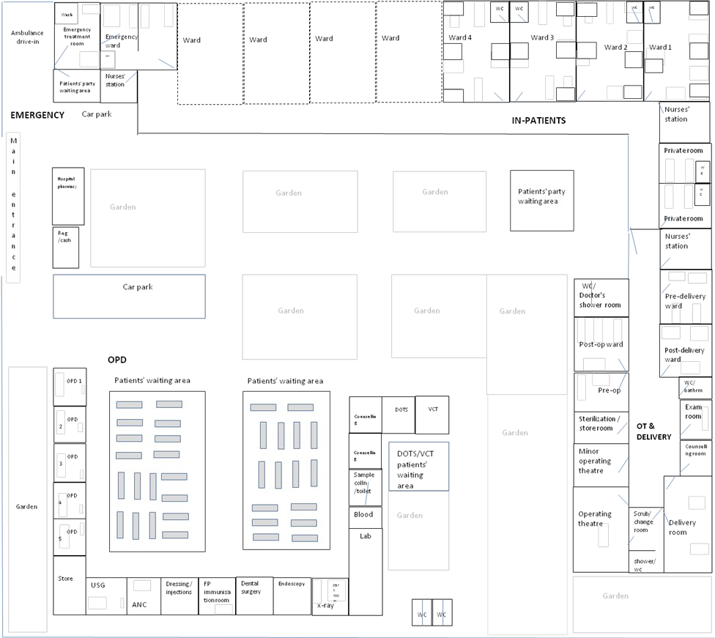
Example A

