GLOBALGIVING SEPTEMBER ACCELERATOR, 2019

Project Implementing Organization: Bugema Community Child Based Organization.

ORGANIZATION BACKGROUND
Bugema Community Child Based Organization is a non-profit making was incepted in 2012 by a group of professionals comprising of Social Workers, Community Development Workers, Counsellors, Clinical Officers, Lawyers and Psychiatrists to reach out to vulnerable, marginalized and disadvantaged children in communities by providing free health care services, legal assistance, nutrition, housing, clean and safe drinking water, quality education, skills development and entrepreneurship.
Bugema Community Child Based Organization (BCCBO) UGANDA is fully registered with the government of the Republic of Uganda under Certificate Number CD-017.
LOCATION OF BCCBO
BCCBO Headquarter is located 32kms north Kampala, along Gayaza-Zirobwe road in Kamira in Bugema-Lukyamu Local Council 1, Kamira Parish, Bamunanika County, Luwero District, Central Region, Uganda. BCCBO also has sub-branches in Nakisunga-Mukono District, Apache – Gulu District, Ibanda-Mbarara District, Kaluguza-Kibale District and Nakavule -Bugiri District.
BCCBO CORE VALUES
Professionalism
Transparency
Teamwork
Non-Judgmental
Caring
BCCBO ORGANIZATION STRUCTURE

BOARD OF TRUSTEES

PROGRAMMES MANAGER

ASSISTANT PROGRAMMES MANAGER

CHIEF ACCOUNTANT

SENIOR ACCOUNTANT

FIELD OPPERATIONS MANAGER

HUMAN RESOURCE MANAGER

INTERNAL EDITOR

WELFARE MANAGER

SOCIAL WORKER

CHIEF COUNSELOR

VOLUNTEER MANAGER

BCCBO PREVIOUS PROJECT SUCCESSES
In 2012, Bugema Community Child Based Organization (BCCBO) UGANDA constructed 9 boreholes to provide clean and safe drinking water to Maziba, Kiwangula, Katente, Bunsule, Apache, Nakavule, Nakisunga, Nyabushozi and Kalungu communities in rural Uganda.
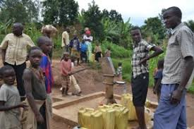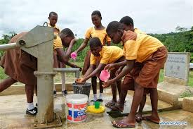
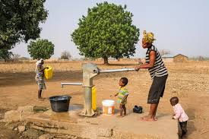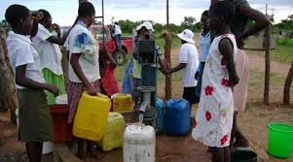
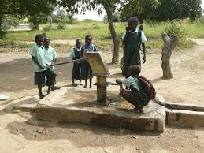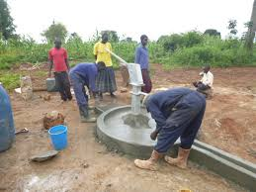

In 2013, Bugema Community Child Based Organization (BCCBO) built a school for children with special needs such as the lame, the blind and the deaf in Guluddene. Currently, this school is providing special education to 314 children with special needs.
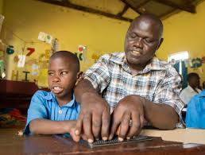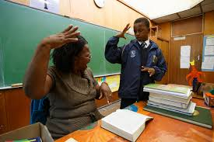
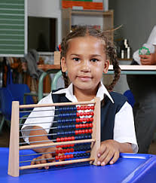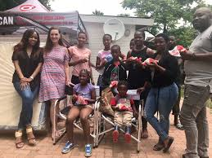
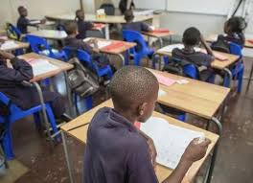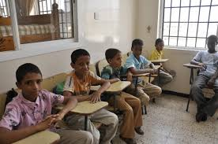

In 2014, Bugema Community Child Based Organization (BCCBO) constructed a Health Centre in Kalangala District. Currently, this Health Centre is serving more than 4,000 people in Ssese Islands-Kalagala-District.
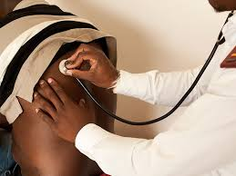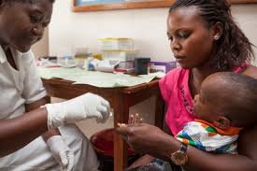
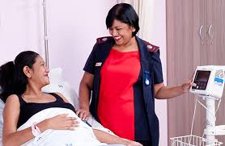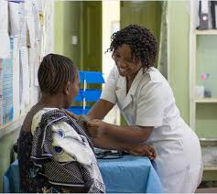
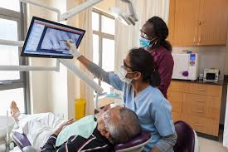
In 2015, Bugema Community Child Based Organization conducted fundraising and purchased 6 ambulances to help mother in labour as well as other emergency situations. Currently these ambulances are serving more than 5000 maternal mothers.
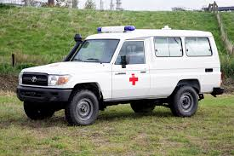
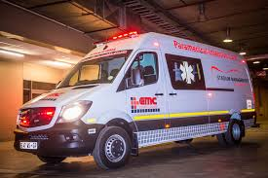
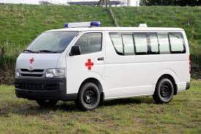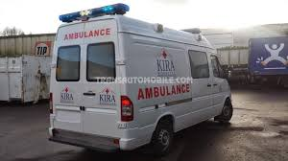
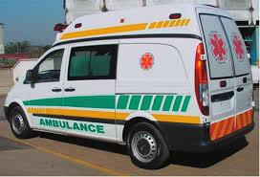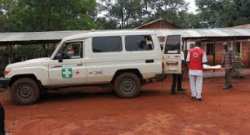
In 2016, Bugema Community Child Based Organization established Legal National Team comprising of professional lawyers, advocates and social workers. Currently, this Legal Team is providing Legal Assistance to more than 45,000 children and women whose rights and freedom are violated.
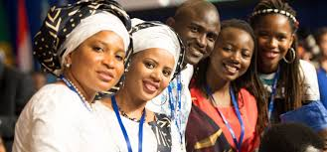
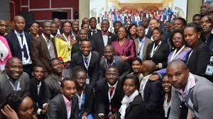
In 2017, Bugema Community Child Based Organization (BCCBO) trained 88,765 people in Home Care and Support for people living with HIV/AIDS and those with disabilities. Currently, the trained 88765 people have also trained more than 450,000 caregivers at household level.
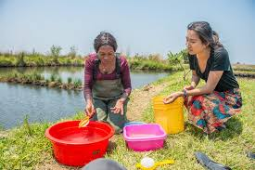
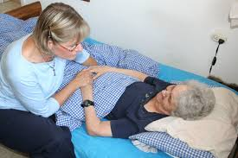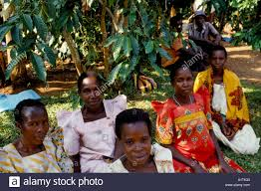
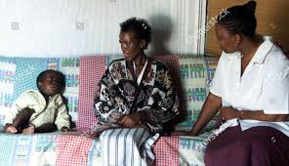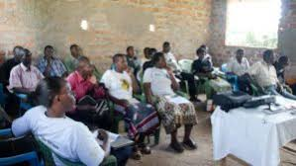
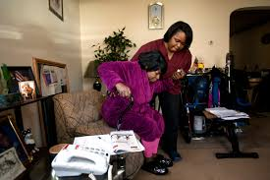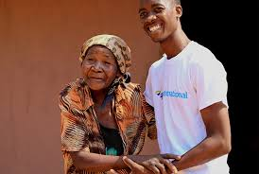
In 2018, Bugema Community Child Based Organization (BCCBO) sponsored 19 children with heart problems to seek medical attention in India. Currently these children are living the quality of life that everybody would desire!
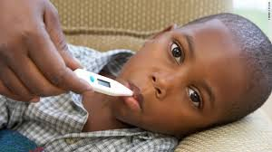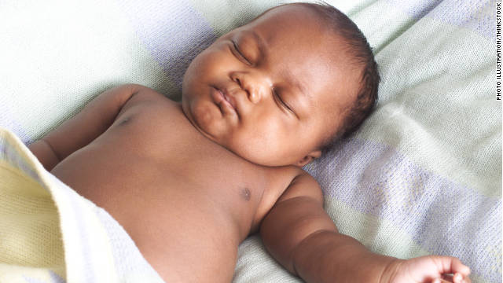
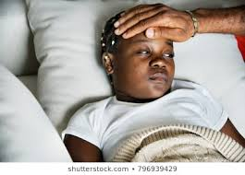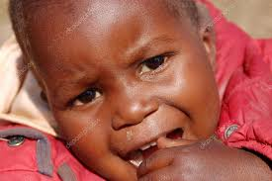
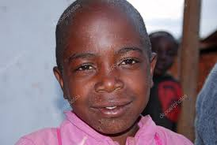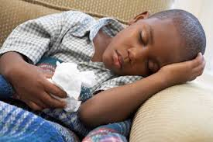
In 2019, Bugema Community Child Based Organization (BCCBO) Designed and implemented “Skills Development and Entrepreneurship for Girl-Child Empowerment” project. Through “Skills Development and Entrepreneurship” girl children are equipped with basic healthcare skills, small scale business management skills, agricultural skills, vocational skills such as Tailoring, Bakery, Bridal Care, Art, Craft and Design, Catering, Resource Mobilization, Utilization and Conservation, Juice Making, Liquid Soap Making.
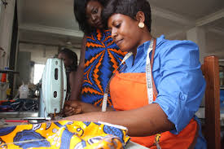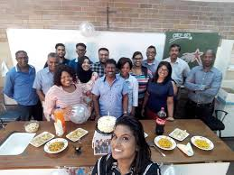
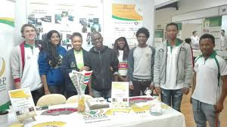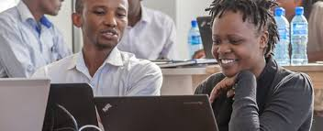
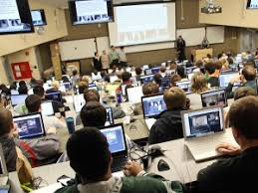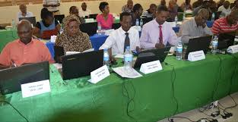

Project Vision: To empower a Girl Child so that she significantly contributes to the well-being of the society in the future.
Project Mission: To produce productive Girl Children who are healthy, literate, responsible and devoted for better performance in social, economic, cultural, political and religious activities for making the society a better place to live in.
Project Summary
Hundreds of thousands of girl children in Uganda are living a life characterized by vulnerability, marginalization and disadvantageness. This manifests itself in terms of poverty, gender-based violence, illiteracy, ignorance, child abuse, child labour, socio-cultural oppression and discrimination. Most of girl-children experiencing all this hail from single-parented homes and child-headed families especially in rural Uganda.
What is the Challenge?
According to statistics from UNICEF, World Bank, World Health Organization and World Vision, 63% of girl children in Uganda live a life driven by poverty, hunger, ignorance, illiteracy, violence, abuse, child labour and oppression putting their future in jeopardy. The majority of these children live in rural communities in Uganda. They lack access to skills development and entrepreneurial opportunities that would otherwise have improved their quality of life!
How is the Challenge being address?
After carrying Girl Child Life Ground Survey in March 2019, Bugema Community Child Based Organization (BCCBO) UGANDA designed and implemented a program “Skills Development and Entrepreneurship” to empower 1000 vulnerable, marginalized and disadvantaged Girl-Children in especially in rural Uganda. Through “Skills Development and Entrepreneurship” girl children are equipped with basic healthcare skills, small scale business management skills, agricultural skills, vocational skills such as Tailoring, Bakery, Bridal Care, Art, Craft and Design, Catering, Resource Mobilization, Utilization and Conservation, Juice Making, Liquid Soap Making.

Project Long –Term Impact
"Skills Development for Girl Child Empowerment" will help 600 girl children especially in rural Uganda to acquire skills such as healthcare skills, small scale business management skills, agricultural skills, vocational skills such as Tailoring, Bakery, Bridal Care, Art, Craft & Design, Catering, Resource Mobilization, Utilization and Conservation, Juice Making and Liquid Soap Making. This will help them to create more jobs for others as well as raise money for their basic necessities of life.
Therefore, your support / donation to this project will make a difference in a girl-child’s life.
For more information about Bugema Community Child Based Organization (BCCBO) UGANDA
Contact Mutyaba Paul,
Programmes Manager,
BCCBO
Tel: +256787088857
Email: bccboUganda@yahoo.com

