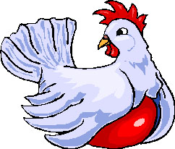

**community local chickens enterprise**

Investment Costs

**Target**  500 hens

**Floor space** 28m² (*4.0 m X 7.0m*)

**No. of Nests** 30 (*6 cm above the ground*)

**Size of Nests** *30cm X 30cm*

**Drinkers** 4 × 15 Litres (*60 Litres per day*)

**Feeders** 1m linear feeder for 25 layers

**Feeding** one hen *eats 120 of feed per day or 3.5 kg per month)*

**Perches** 25 chickens need 5m (Length) i.e. 6cm above the floor

**Litter**  2cm deep saw dust

**Lighting** 16 hrs of light/day

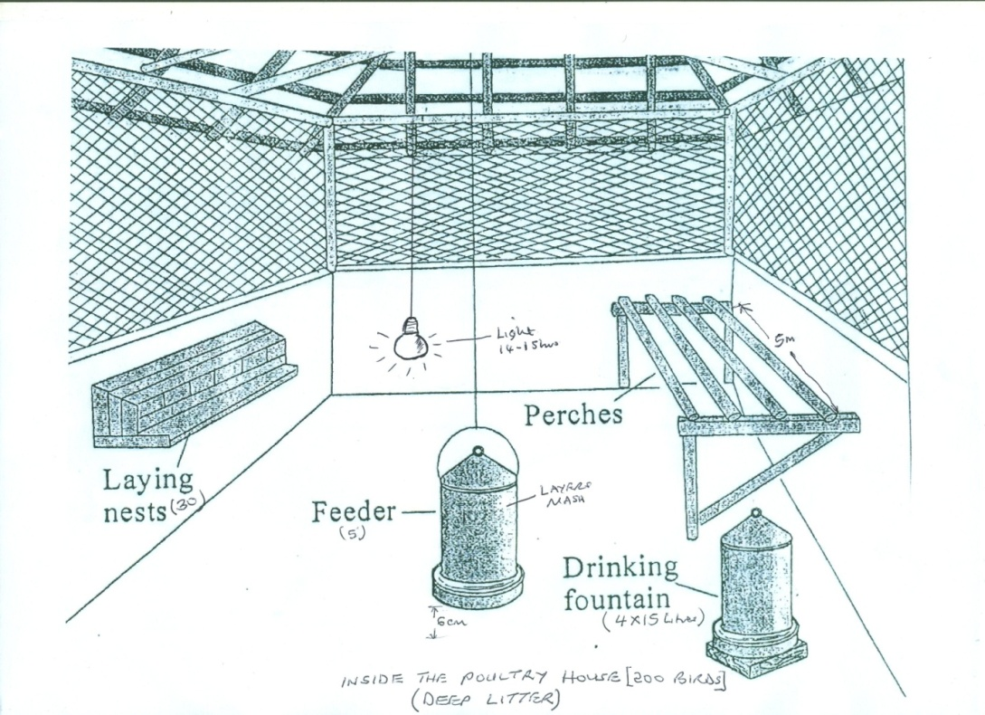

1. **Cost-benefit Analysis**

**Projected Direct Costs**

|  |  |
| --- | --- |
| **Cost Components** | **Year 1** |
| 1. **Fixed Costs** | , |
| Cost of 500 laying hens | 2,200, |
| Poultry Equipment *(Feeder, Drinkers,and incubator* | 5,300 |
| Building materials (Wire mesh, perches) | 200 |
| Labour costs | 0 |
| Veterinary Supplies (disinfectants/stress pak/vaccines) | 200 |
| Basic Poultry enterprise Training | 100 |
| **Total Fixed Costs** | **8,000** |
| 1. **Variable Costs** |  |
| Feed ($450/month or 20 × 50kg bags @ $50 each) for 3 months | 500 |
| Veterinary services | 1,500 |
| **Sub Total Variable Costs (A)** | **2,000** |
| **Admin. Overhead Costs @10% (B)** | **1,000** |
| **Total Variable Costs (A+B)** | **3,000** |
| **Total Direct Costs (a +b)** | **14,000** |
|  |  |
|  |  |

**Returns/Income**

**Year 1**

Assuming laying percent at 90%

* 200 hens × 90% ×8 months ×30 days × $0.10/Egg = **4,320**

**Income Projections**

|  |  |
| --- | --- |
| **Returns** | **Year 1(US$)** |
| Eggs Sold/Year | 4,320 |
| Sale of Culled Hens | 0 |
| **Total Projected Income** | **4,320** |

**Projected Return on Investment**

|  |  |
| --- | --- |
| **Item** | **Year 1 (US$)** |
| Total Investment (Total Direct Costs) | **14000** |
| Income | **4,320** |
| **Enterprise returns/Profit** | **+3,075** |

**Project sustainanbility**

This statement list the inflows (income generated by the local chicken/ layers business). The difference between the inflows (i**ncome**) and **investment cost** give the net cash flow (**+1,075**). This net cash flow can be positive or negative. **It should be noted that this net cash flow is positive from time of Investment in Year 1.** This local chicken **Business is therefore viable**!

In the initial stage, the project will be sustained by donor funds. However, in the long run the poultry project will finance itself. Part of the funds will be re-invested in the poultry business to expand the project, hence increasing sales and profits.

NB. **The community will construct a Poultry House as contribution to Education support for orphans**

**Some proposed poultry houses**

