**DELIVERANCE MINISTRIES INTERNATIONAL**

**MINISTERE DE GUERISON ET DE DELIVRANCE LUMIERE DU MONDE**

**(MGDLM)**

**FIGHT NEAR STARVATION IN RURAL HAITI**

**PROJECT DOCUMENTATION**

Dear Friends and Partners, Your Donations have supported this vital work of DMI/MGDLM to advance families’ need in remote areas of Haiti and other parts of the world. As we continue to grow, we will reach beyond our limits, make available more programs, create real and lasting changes in the lives of those needy children and desperate communities.

We want to tell you that your gifts are going directly toward the most pressing needs in these communities, they are going directly to the programs that need it the most, in an attempt to break the cycle of Hunger and Poverty and create sustainable change.

Each day Children and families across the globe are suffering from fierce reality of inescable situations.

These lives are changing thanks to loving hearts like yours saying yes to help!

A life beyond Amazing is a life of generosity. Everyone has something to give!

Ministere de Guerison et de Deliverance Lumiere du Monde ( MGDLM) says thank you for giving to those in need with all your hearts. Because of your donations, our programs are now serving more people in Haiti.

Please take a moment and view the lives you are changing:

**DETAIL BUDGET BREAKDOWN OF FIGHTING NEAR STARVATION**

|  |  |  |  |  |  |  |  |  |  |
| --- | --- | --- | --- | --- | --- | --- | --- | --- | --- |
| For Financial Year Ending: | |  |  |  |  |  |  |  |  |
|  |  |  |  |  | **xch rate (HTG to USD)** | **90.00** |  |
| 12/01/2019 to 12/01/2020 | |  |  |  |  |  |  |  |  |
|  |  |  |  |  | **HTG** | | **USD** | |  |
| **Item** | **Monthly Quantity** | **Unit** | **Unit Costs** |  | **Monthly Cost** | **Annual Cost** | **Monthly Cost** | **Annual Cost** |
| **1. Staff Costs** | | | |  | 30,000.00  30,000.00 | 360,000.0  360,000.0 | $333,33  $333,33 | $4,000.00  $4,000.00 |  |
| Administrator  Supervisor | 1  1 | Salary  Salary | 30,000.00  30,000.00 |
| Nurses | 6 | Salary | 30,000.00 |  | 180,000.00 | 2,160,000.00 | $2,000 | $24,000.00 |  |
| Nurses Aid | 5 | Salary | 22,500.00 |  | 112,500.00 | 1,350,000.00 | $1,250.00 | $15,000.00 |  |
| Truck Drivers | 3 | Salary | 27,000.00 |  | 81,000.00 | 972,000.00 | $900.00 | $10,800.00 |  |
| **Staff Costs Total** | | | |  | **433,500.00** | **5,202,000.00** | **$4,816.66** | **$57,792.00** |  |
| **2.** | |  |  |
| **2.1 Rent** | **1/12** | **Annual** | **$10,500.00** |  | **59,500.00** | **1,710,000.00** | **$875.00** | **$10,500.00** |  |
| **2.1 Utilities Costs** | | | |  |  |  |  |  |  |
| Electricity |  |  |  |  |  |  |  |  |  |
| Drinking Water | 1500 | Gallon bottles | 30.00 |  | 45,000.00 | 540,000.00 | $500.00 | $6,000.00 |  |
| Bulk Water | 4 | Trucks | 2,500.00 |  | 10,000.00 | 120,000.00 | $112.00 | $1,344.00 |  |
| Gas Propane |  |  |  |  | **30,750.00** | **369,000.00** | $341.66  **$590.44** | $4100.00  $7,080.00  **$18,524.00** |  |
| **Utilities Costs Total**  **2.2 Washing, Cleaning & Hygiene Costs** | | | |
| Washing Powder | 6 | Bags | 1875.00 |  | 11,250.00 | 135,000.00 | $125.00 | $1500.00 |  |
| Soap | 10 | Boxes | 900.00 |  | 9,000.00 | 108,000.00 | 100$ | $1,200.00 |  |
| Diapers | 6 | Boxes | 5,000.00 |  | 30,000.00 | 360,000.00 | $333,33 | $4,000.00 |  |
| **Washing, Cleaning & Hygiene Costs Total** | | | |  | **50,250.00** | **603,000.00** | **$558.33** | **$6,700.00** |  |
|  | | | |  |  |  |  |
| **3. Food Costs** | |  |  |  |  |  |  |  |  |
|  |  |  |  |  |  |  |  |  |  |
| Cereal | 30 | Boxes | 900.00 | 27,000.00 | 324,000.00 | $300.00 | $3.600 |
|  |  |  |  |  |  |  |  |
|  |  |  |  |  |  |  |  |
|  |  |  |  |  |  |  |  |  |  |
| Spaghetti | 60 | Boxes | 425.00 |  | 25,500.00 | 306,000.00 | $283.00 | $3,396.00 |  |
|  |  |  |  |  |  |  |  |  |  |
|  |  |  |  |  |  |  |  |  |  |
| Bread | 40 | Bags | 350.00 | 14,000.00 | 168,000.00 | $156.00 | $1,872.00 |
|  |  |  |  |  |  |  |  |
| Corn Meal | 15 | Bags | 950.00 | 14,550.00 | 171,600.00 | $162.00 | $1,944.00 |
| Vegetables | 20 | Boxes | 600.00 |  | 12,000.00 | 144,000.00 | $133.00 | $1,596.00 |  |
| Butter | 20 | Containers | 500.00 |  | 10,000.00 | 120,000.00 | $111.00 | $1.332.00 |  |
| Specialty Formula for all babies | 23 | Containers | 342,000.00 |  | 342,000.00 | 4,104,000.00 | $3800.00 | $45,000.00 |  |
| Medicines |  |  |  | 13,500.00 | 1,620,000.00 | $1,500.00 | $18,000.00 |
| Oatmeal | 12 | Bags | 1,500.00 | 18,000.00 | 216,000.00 | $200.00 | $2,400.00 |
|  |  |  |  |  |  |  |  |
|  |  |  |  |  |  |  |  |  |  |
|  |  |  |  |  |  |  |  |  |  |
|  |  |  |  |  |  |  |  |  |  |
| Rice | 1000 | Bags | 1,250.00 |  | 1,250,000.00 | 15,000,000.00 | $3,472.00 | $41,664.00 |  |
| Beans | 50 | Bags | 1,890.00 | 94,500.00 | 1,134,000.00 | $1,050.00 | $11,600.00 |
| **Food Cost Total** | | | | **$1,821,000.00** | **23,307,600.00** | **$21,581.00** | **$258,973.00** |
|  |  |  |  |  |  |  |  |  |  |
| **4. Total Final Costs** | |  |  |  | **2,450,000.00** | **31,851,600.00** | **$29,492.00** | **$353,907.00** |  |
|  |  |  |  |  |  |  |  |  |  |

821**million**people go to bed hungry every night.

You and I can change that.

**Let’s Stop Near starvation!**

**POVERTY** has been cited as one of the main reasons why millions of children, women and families do not get access to the rights they are entitled to, being home to every sixth child in the world (Ministry of Statistics and Program Implementation, 2012), has not been able to ensure the Right to Survival, Right to Development, Right to Protection and Right to Participation to its children.

Any issue that causes a [children rights](http://www.cry.org/issues-views/girl-child) violation like female or child labor, is a symptom of deep-rooted problems such as lack of livelihoods, caste or gender bias.

Poverty and the problems arising from it, like **HUNGER**, **POVERTY, ILLITERACY, MALNUTRITION**, often hit the children in the worst manner because they are the most vulnerable.

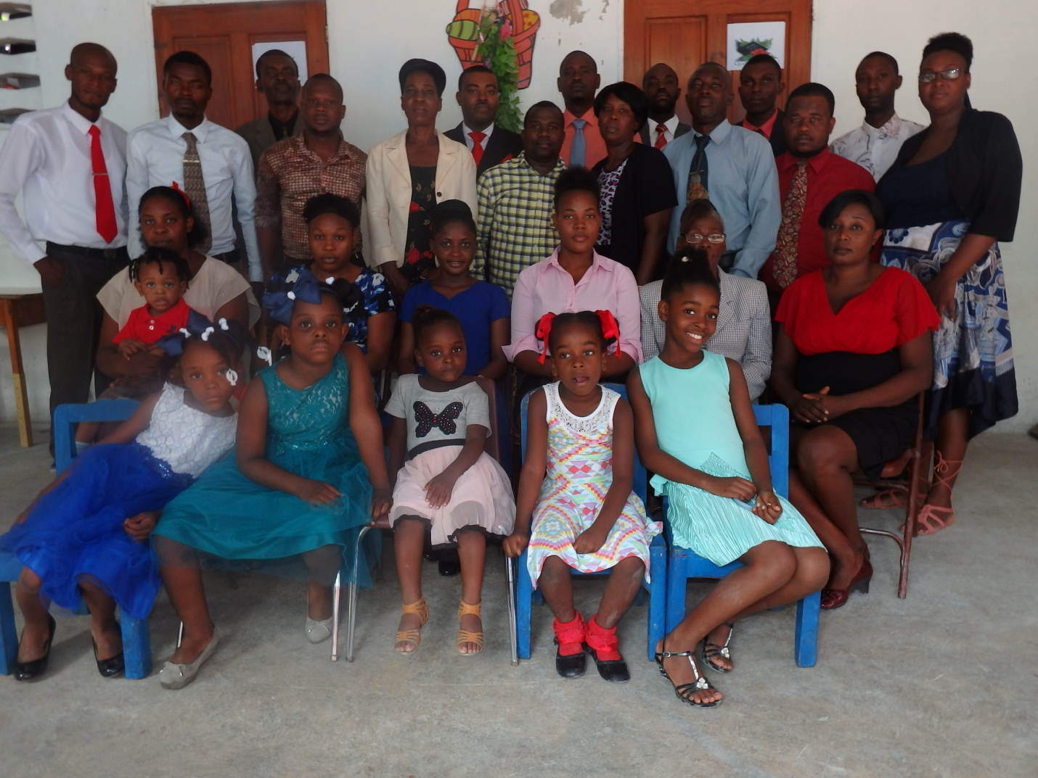

**CARREFOUR FAMILY CENTER**

**A meeting with the center organizers to prepare for FNS Project**

**CARREFOUR FAMILY CENTER WAITIING TO FOOD DISTRIBUTION**

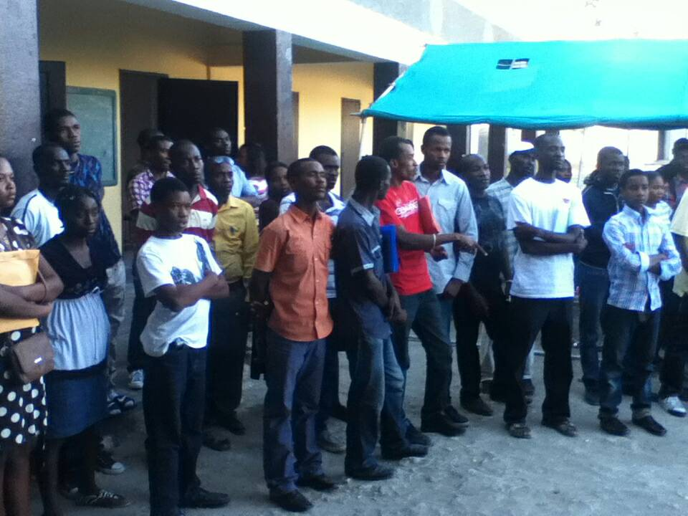

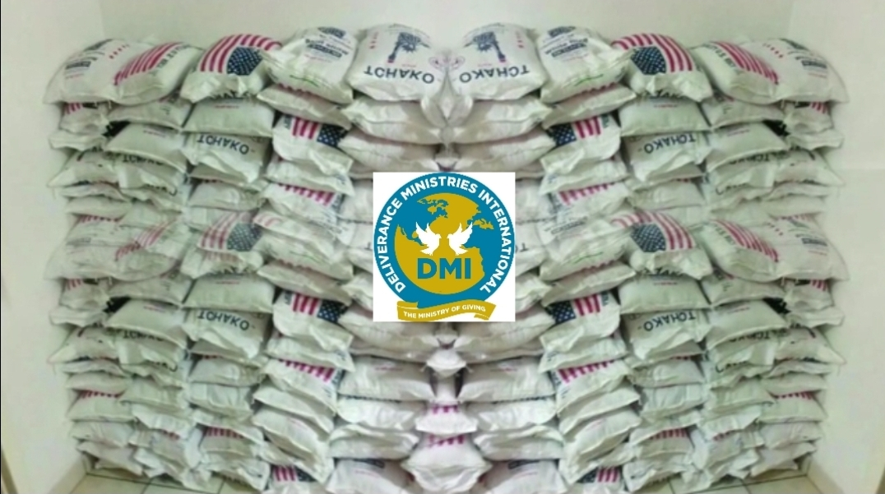

**DMI FOOD DISTRIBUTION FIGHTING HUNGER!**

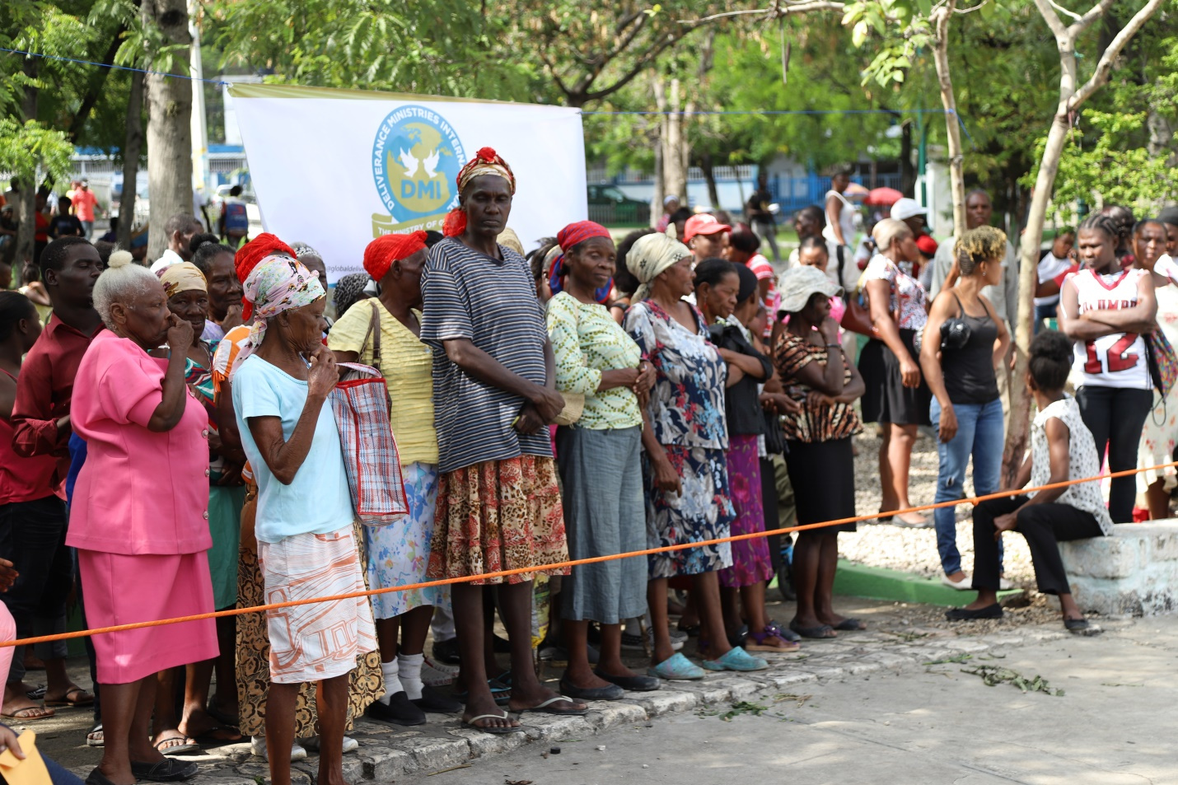

**GROUP OF WOMAN WAITING FOR FOOD DISTRIBUTION IN PETIONVILLE, HAITI**

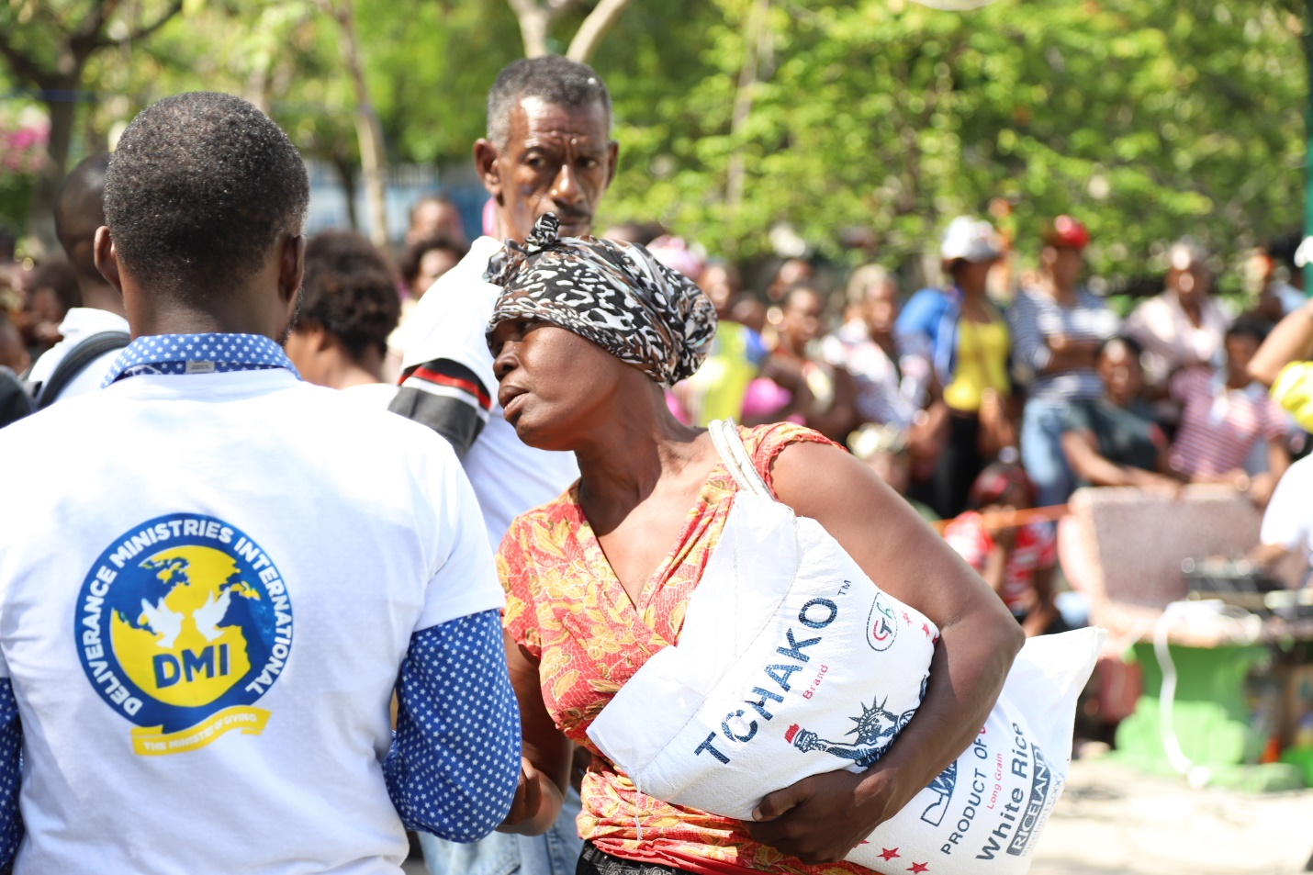

**DMI HUNGER RELIEF IS CHANGING LIVES THROUGH FOOD DISTRIBUTION:**

We have great Hope for Haiti, despite its challenges. The economy continues to collapse with bag of rice costing double what it did four years ago. The vast majority of the people are poor under poverty line cannot afford to buy rice.

Our Partners and friends have been providing these bags of rice for these desperate families preventing from going to bed hungry.

**DMI FEEDING PROGRAM**

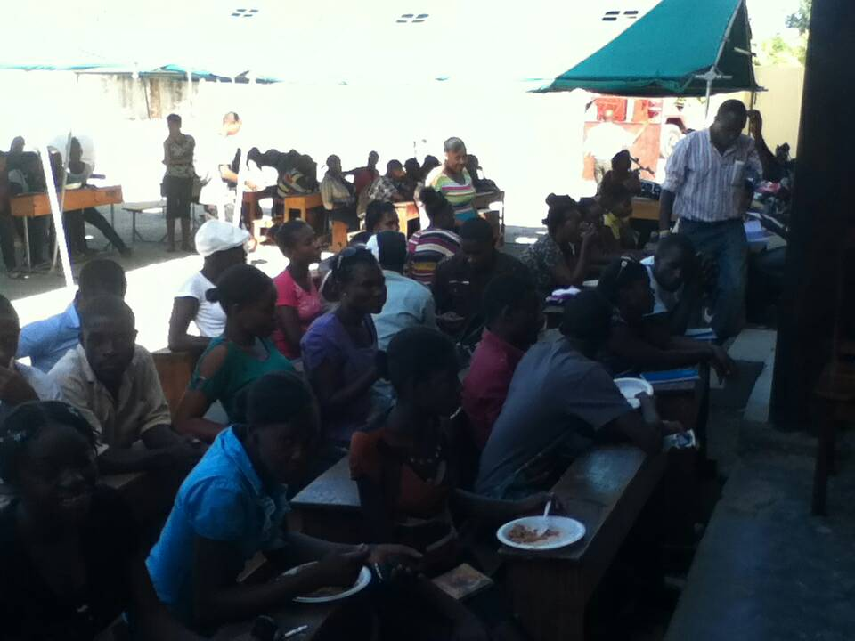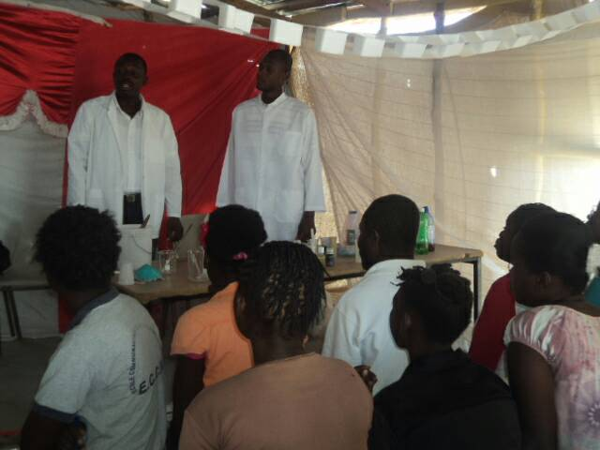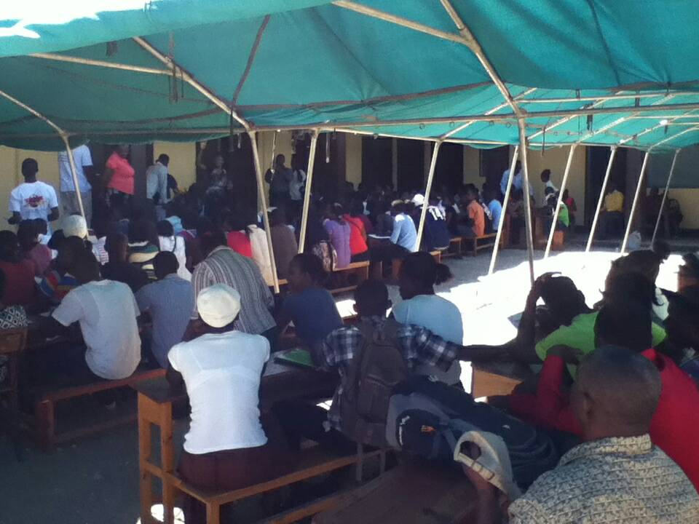

**DMI HEALTH EDUCATION PROGRAMS: PREVENTING DISEASE AND DEATHS!!!**

Take Action, Together we can Save millions of lives!