AMAZON THEATRIX ENSEMBLE
2019

AMAZON THEATRIX ENSEMBLE amazontheatrixensemble@gmail.com
P.O BOX 19450- 40100 facebook/ Amazon Theatrix Ensemble
KISUMU 0701 739 992/ 0702 625 678

Our ref: 030/2016

GROUP PROFILE
Amazon Theatrix Ensemble (A.T.E) is a youth group formed late November, 2011 with the main focus being Talent Development and Cultivation. Registered with the Ministry of Culture and National Heritage registration number being PAD/2508/05/2013, A.T.E prioritized arts as a social tool for advocacy embracing it as a professional platform where members could earn a living as they focus on communal sensitization and empowerment through performing and visual arts in the quest of building their self-Esteem and socio-economic gain.
A.T.E majors art genres like Contemporary dance, Traditional Dance,Modelling Fashion and Design, Stage theater, Community Theater(PET and MAGNET),Spoken Word,Narratives,Stand Up Comedy, Radio Dramas, Film Production and Advertising,, Visual Arts Production and Branding, Event Management and roadshows
VISION STATEMENT:
- The youths today are the future of tomorrow. The arts are unique means to educate, stimulate tolerance, and raise awareness and foster holistic growth and social integration. A well expressed creativity among youths empowers strong personalities coming back into the society.
MISSION STATEMENT:
- To support and develop programs that uses the arts and media as main tool for development among youths. To address and advance education, arts, creativity, social cohesion, crime and resilience health, employability, Women Empowerment, Democracy and Governance, children right in Kisumu and western Kenya. To create a platform of well-trained artist who will be able to provide authentic communication with vulnerable communities
In Kisumu County, A.T.E stands out as the most professional youth theatre group having won in many different capacities, which is, lifting Kisumu County’s name in the 2012 G-pange Gate Festival, Ministry of Culture and National Heritage 2012 art festival and the 2013 Kisumu Peer Educators festival.
A.T.E also has a separate department that handles school drama festival. This is dubbed the A.T.E faculty which has a capacity of five (5) A.T.E members mandated with the task of producing professional artistic pieces. The A.T.E faculty has so far taken two schools to the nationals namely Kisumu Boys’ High School and Sawagongo Secondary School with choral verses and plays.
A.T.E in line with its activities of sensitizing, advocating and empowering community with information and Education, we tend to dwell on various thematic areas in our productions which includes;
- Sexual Reproductive Health (SRH,HIV/AIDS) advocacy and awareness creation
- Human rights advocacy and democracy
- Peace , Crime, Drug and Substance abuse
- Women Empowernment,Leadership and Devolved Government System
- Climate change programs , Environmental conservation and sensitization
- Conducting trainings to interested individuals or Organization in Martial Arts,Aerobics,Zumba,Body flexibility and stretches, Yoga among others
PARTNERS
- Kisumu Urban Apostolate Program(KUAP)
- Care Kenya International
- Umande Trust
- WAYAN
- NAAC
- Pal Omega CBO
A.T.E HIERACHY
BOARD OF DIRECTORS
Finance and Admin
Artistic Directors (HODS)
OFFICE ASSISTANT/ SECRETARY
MEMBERS
MANAGING COMMITTEE
Director Programs

Membership
Amazon Theatrix Ensemble (A.T.E) believes in the art of democracy and an all-inclusive type of participation regardless of tribe, color, race, political affiliation or cultural identity. To this course, A.T.E derives membership from the general public but with specific consideration in artistic orientation within Kisumu County.
Currently, A.T.E has a membership of twenty four (24) with 40% female body and 60% masculine population.
A.T.E as a youth led theatre group has a special interest in fellow youths in capacity building and improving their self-esteem through arts.

Photo Gallery

Teen Bash Festival Fashion and Design Participants of young people pose for a photo on the red carpet, advocating for healthy and informed young people on sexual reproductive health, HIV/AIDS through arts
Amazon Artists during Unesco-Knatcom 2018 Festival performance
Amazon Dancers performing at a community outreach on Sexual Reproductive Health, HIV/AIDS
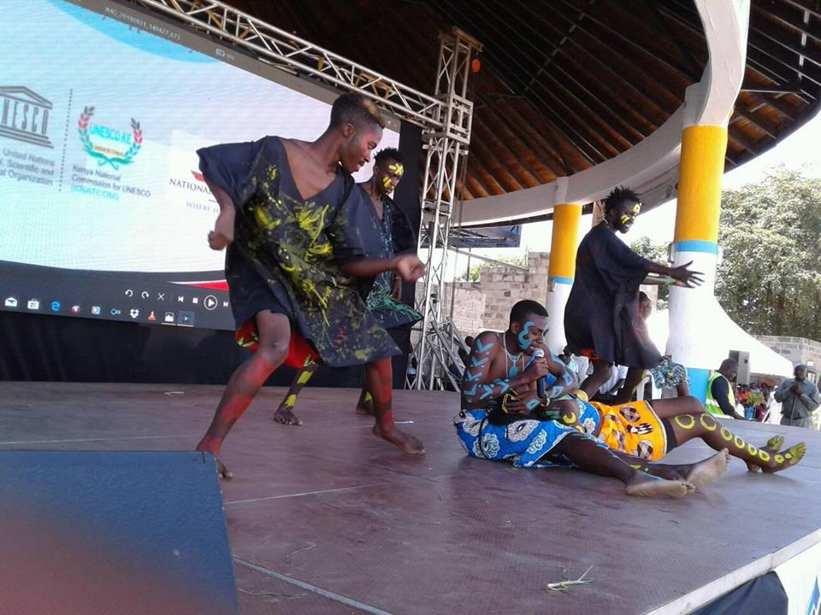
2018 UNESCO-KNATCOM PERFORMANCE AT JOMO KENYATTA SPORTS GROUND KISUMU COUNTY
AMAZON DANCERS PERFORMING AT SEME SUB-COUNTY ON CHILDREN RIGHTS AND VULNERABILITY

