Kulika Uganda

Promotion of Inclusive Green heat for climate smart agriculture

A STORY OF FUEL BRIQUETTES

Summary of the Kulika Uganda Fuel Briquettes Initiative
Building simple manufacturing presses and skilling women on making and sale of briquettes will drive both significant income and significant improvement in household health. The first phase of this project will meaningfully increase income for 200 families and impact 100 additional lives with better income security. On population health, we estimate the work will reduce smoke-related negative health in 5,000 people by (75%). In addition to these two primary improvements, we will deliver a secondary benefit of slowing deforestation driven by use of fuel wood and charcoal versus briquettes for cooking.

The Current Situation
Rural women in Uganda struggle to earn 1 dollar a day and have limited ways to earn daily income outside of the growing seasons. By relying on agricultural produce to earn income, a woman will have sellable produce after a full season (approximately 3 months).

Income generating opportunity
Over 90% of households both in rural and urban areas in Uganda use either firewood or charcoal or both as energy for cooking and in poultry production. A study on awareness of health effects of cooking smoke among women in Ethiopia highlighted that rural women reported 2-3 times more respiratory diseases in the children and in themselves. One of the income generating opportunities is making and selling briquettes.

What we believe
When women get engaged in producing, using and selling briquettes they will earn income and can do so more regularly and experience less smoke in the kitchen. There is a secondary benefit around natural resource sustainability health of the planet. Across these different benefits, briquette making, marketing and use elevates the women, their families and the communities they live in.

Introduction To Briquettes
Fuel briquettes are a low cost, locally made fuel for cooking or heating. The briquettes are made from combustible compressed carbonized materials mainly from a combination of agricultural waste products and residue (e.g. cassava, millet / rice / sorghum straws, maize cobs, groundnut husks, molasses etc.).

Carbonization is done using simple kilns made out of metal drums. The materials are filled in a drum, heated using grass in a tightly covered kiln. After 1-2 hours, the materials are carbonated, they are then let to cool for at least 2 hours and then crushed using fabricated machines or by pounding using simple tools. The semi powdered materials are then mixed with a binder of choice e.g. porridge made out of cassava or molasses, a waste product from sugarcane. The semi solid mixture is then put in machines, pressed and extruded to dry for 2 to 3 days ready to be used for cooking and selling.

The Goal for Phase 1
The goal is that by March 2020;
- At least 200 rural women will be making, using and selling briquettes
- Grow their annual income by 40% through sales of briquettes
- Reduce the rate of deforestation through less use of fire wood for cooking
- Establish a market for briquettes as a fuel wood/charcoal alternative
- Construct adequate number of presses to provide each women’s group for briquette making
- Reduce smoke related sicknesses of 5,000 people

What Is in It for The Women Through this Intervention?
a) The women will be trained to make briquettes
The model is unique in such a way that the women gain skills on waste material carbonization, briquetting making processes, quality assurance of the carbonated materials, briquette making using simple tools for small production, and business skills to aid them in selling the briquettes.

b) Earning from carbonized materials
The briquettes will be produced using carbonized maize cobs with cassava as the binding material. The women will supply ready carbonized materials to the unit at the Kulika training centre at Ugx 5,000 per 100 kg bag. It is planned that each participant will sell at least 5 bags of carbonated materials each week, thus earning 25,000 shs. This translates to a minimum of one dollar per day. Below is business case of involving women in carbonization process;
Carbonized materials
Amount per week | kgs | price UGX /kg
Maize cobs | 5 bags x 5,000 = 25,000 | 5,000

c) The women will earn a commission of UGX 200 per kg sold
The women will work as sales agents and they will earn a commission of Ugx 200 per Kg sold. Below is business case of involving women and youth as sales agents
Amount sold per day | kgs | price UGX /kg
Number of kilograms | 100 x 200 = 20,000 | 1,000

d) Reduced smoke in the kitchen houses hence promoting healthy lives
The briquettes are in a series of clean cooking materials especially in the developing countries. Quality briquettes burn without smoke and produce adequate energy for cooking. This reduces the incidences of smoke related sickness e.g. bronchitis, cough, flue, eye infections and lung cancer which is contracted after long exposure to smoke.

Kulika Uganda is a nonprofit making NGO registered in Uganda. The organization’s vison is enhanced livelihoods with a mission to promote relevant skills and technologies to empower rural communities. Kulika Uganda embodies the values of integrity, commitment, teamwork, respect and learning. To enhance her position as a market leader in Ecological organic Agriculture, Kulika Uganda focuses on farmer training with emphasis on processes, products and value chain development; establishing social innovation projects with farmer groups; ensuring financial sustainability and growth of the organization; building capacity of human resources and ensuring the effective and efficiency in all operations to rebrand the image of Kulika Uganda.

Pictures 1: Woman holding briquettes in a basin
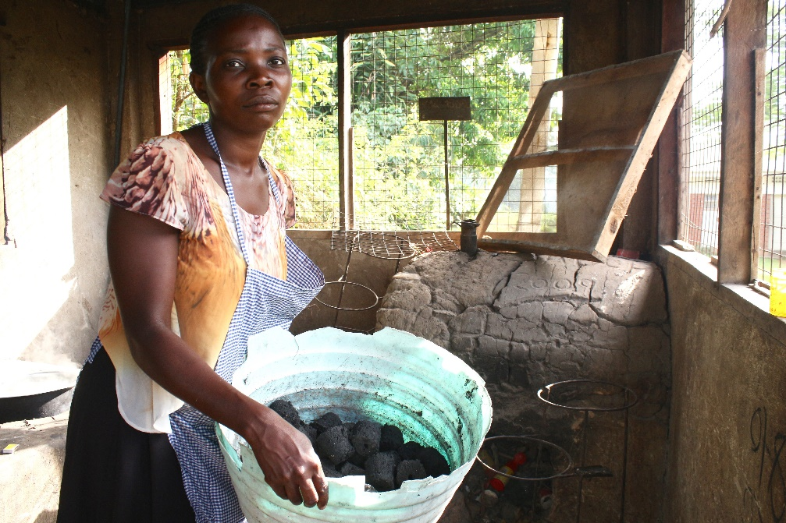

Picture 2: A woman holding briquettes in the hand
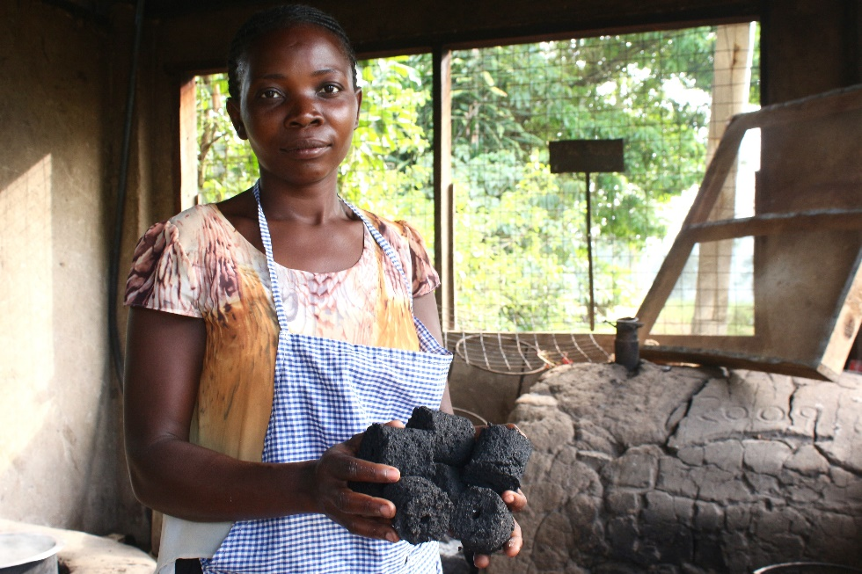

Picture 3: Briquettes being lit in a local stove
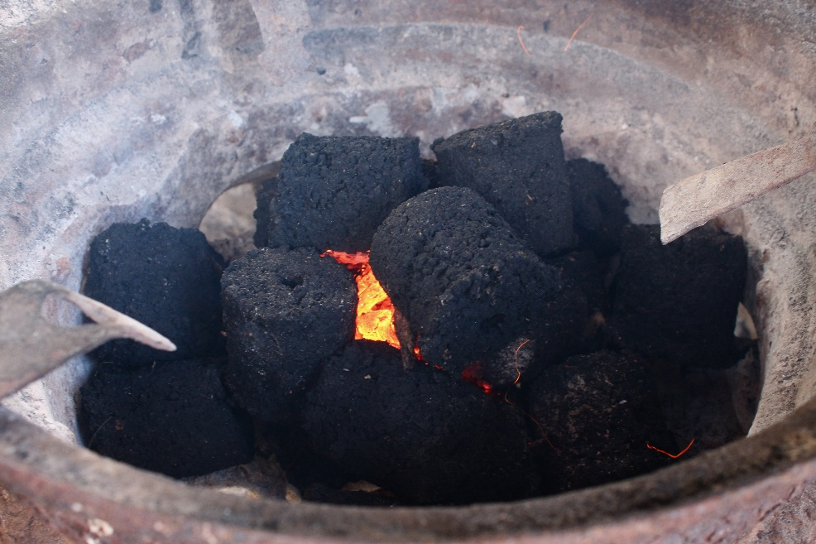

Project Facilitation
Below is the items/requirements for the project implementation
Budget to Train 100 women, provide Start up Equipment and Materials for
2 (two) cooperative Societies of 50 women each.
 | Items | Qnty | Price | Amount in UGX | Amount in US Dollars
1 | Construction of workshop unit and briquette store
 | Cement | 80 | 30,000 | 2,400,000 | 649
 | Sand | 6 | 180,000 | 1,080,000 | 292
 | Bricks | 10,000 | 230 | 2,300,000 | 622
 | Iron sheets (Pcs) | 100 | 25,000 | 2,500,000 | 676
 | Iron poles (Pcs) | 60 | 40,000 | 2,400,000 | 649
 | Wire mesh (Pcs) | 25 | 50,000 | 1,250,000 | 338
 | Timber (pieces) | 5 | 600,000 | 3,000,000 | 811
 | Sub - Total |  |  | 14,930,000 | 4035
2 | Equipment/Tools |  |  |  | 0
 | Motorised Briquette Extruder | 2 | 5,500,000 | 11,000,000 | 2973
 | Motorised Crusher | 2 | 2,000,000 | 4,000,000 | 1081
 | Motorised Mixer | 2 | 2,000,000 | 4,000,000 | 1081
 | Engine | 2 | 1,500,000 | 3,000,000 | 811
 | Kilns | 6 | 150,000 | 900,000 | 243
 | Drying Racks | 3 | 500,000 | 1,500,000 | 405
 | Tarpaulins | 6 | 70,000 | 420,000 | 114
 | Spades | 6 | 18,000 | 108,000 | 29
 | Wheel barrows | 6 | 120,000 | 720,000 | 195
 | Sub - Total |  |  | 25,648,000 | 6932
3 | Training of women |  |  |  | 0
 | Binders | 300 | 1,000 | 300,000 | 81
 | Agricultural wastes | 3 | 500,000 | 1,500,000 | 405
 | Meals during training | 200 | 10,000 | 2,000,000 | 541
 | Training fees for 2 Trainers | 25 | 100,000 | 2,500,000 | 676
 | Sub - Total |  |  | 4,500,000 | 1216
4 | Protective Gears |  |  |  | 0
 | Gumboots | 100 | 25,000 | 2,500,000 | 676
 | Gloves | 100 | 4,200 | 420,000 | 114
 | Over coats | 100 | 30,000 | 3,000,000 | 811
 | Musk | 100 | 5,000 | 500,000 | 135
 | Sub - Total |  |  | 6,420,000 | 1735
5 | Marketing |  |  |  | 0
 | Transport | 1 | 1,000,000 | 1,000,000 | 270
 | Adverts | 1 | 500,000 | 500,000 | 135
 | Branding & Packaging | 500 | 5,000 | 2,500,000 | 676
 | Sub - Total |  |  | 4,000,000 | 1081
 | Total |  |  | 55,498,000 | 14,999

