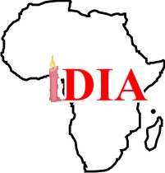

Collaborates With
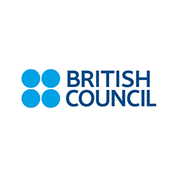
To Deliver

ACTIVE CITIZENS PROGRAMME
Brief On YMCA

Imole Development Initiative for Africa (IDIA Africa) is a non-governmental initiative envisioned to "Create the African dream through human and community development" with education, community and youth development as our key focus areas.
Our community impact story dates back to 2001 with the deployment of a volunteer teacher to offer pro-bono teaching service at a tuition-free coaching center for students from low income families in Bariga area of Lagos State, Nigeria.
Vision
Create the African dream through human and community development
Mission
Equip young Africans with skills to combat poverty and transform communities

Brief On British Council

The British Council is the United Kingdom’s international organisation for cultural relations.
In terms of reach and impact, British Council is the world’s leading cultural relations organisation. Cultural relations is a component of international relations which focuses on developing people-to-people links and complements government-to-people and government-to-government contact
The British Council was established in 1934 and has been in Nigeria since 1943. It currently operates from offices in Abuja, Kano, Lagos and Port-Harcourt and continue to engage in cultural relations work, building links between citizens of the United Kingdom and Nigeria. The Council’s activities are delivered through Arts, Education, English and Society business units as well as a thriving exams unit providing opportunities for thousands of Nigerians to acquire globally recognised qualifications.
About Active Citizens Programme

Active Citizens is a social leadership training programme that promotes intercultural dialogue and community-led social development. Through the programme, we bring together people with different beliefs and perspectives to learn from and share with each other. The Active Citizens programme believes that building trust and understanding is pivotal to creating a safer and more prosperous world.

The programme equips participants with skills and knowledge needed to affect social change in their communities.
Active Citizens connects thousands of like-minded people around the world who collectively want to make a fairer and more inclusive society.

Methodology

The first phase of the delivery of Active Citizens programme is class-based. This is delivered through an activity-based semi-official learning process. The programme adopts the metaphor of a river to typify the journey of an Active Citizen.

The second phase is community-based. Trained Active Citizens embark on community development projects in different local communities of their choice. They are encouraged to identify community problems, proffer solutions, draw an action plan, attract the required resources and solve the identified problem. This phase is designed to be continual.

Duration

The duration of the class-based phase of the programme is five days while the community-based second phase is continuous.

Benefits

Leadership Development
The programme structure, content and delivery are designed to ensure that participants imbibe community-based leadership skills required to engender continuous dialogue, trust and understanding.

Community Development
Trained Active Citizens embark on community development projects of their interest. These projects represent solutions to identified community problems. Working with the communities, the Active Citizens interact, cooperate and collaborate to implement the projects.

National Exchange Programme
Selected trained Active Citizens will have the opportunity to participate in the annual Active Citizen national exchange programme organized by British Council. This affords them the opportunity to meet and share knowledge and experiences on the programme. In the Nigerian context, this has served as a veritable platform for cultural understanding and integration. The selected Active Citizens acquire first hand experience of the life and culture of the host community. They also interact with Active Citizens from other communities across the country in a free and secured atmosphere.

International Exchange Programme
The Active Citizen programme has presence in 42 countries across the globe. Beyond the national exchange programme, the trained participants will also have the opportunity to participate in the Active Citizen international exchange programme. Due to limited spaces, only Active Citizens who have distinguished themselves through the impact of their activities in their local communities are selected to participate in the international exchange programme.

Global Network
Because the dream of the Active Citizens programme is to create a web of globally connected people who are locally engaged, The new Active Citizens become part of the over 350, 000 large Active Citizens family spread across the world. The British Council, partner organisations and facilitators in different parts of the world will continue to implement the programme in new communities and create more Active Citizens as the years roll by.

British Council Certification
Successful Active Citizens programme participants will be certified by the British Council as a way of formally establishing their new knowledge and skills. The certification requirements are the same across all parts of the world.

Our Active Citizens Experience

Our programme delivery experience is vast and robust across several programme areas. For the purpose of the Active Citizens programme we have trained Active Citizens from Lagos, Oyo, Ogun and Plateau States. We also provided facilitation and coordination support during the Active Citizens National Study Visit held at Usmanu Danfodiyyo University, Sokoto State in March 2016.

Below are a few of our experience in picture:
First phase (class-based) of the training held at Tarkwa Bay Island, Lagos

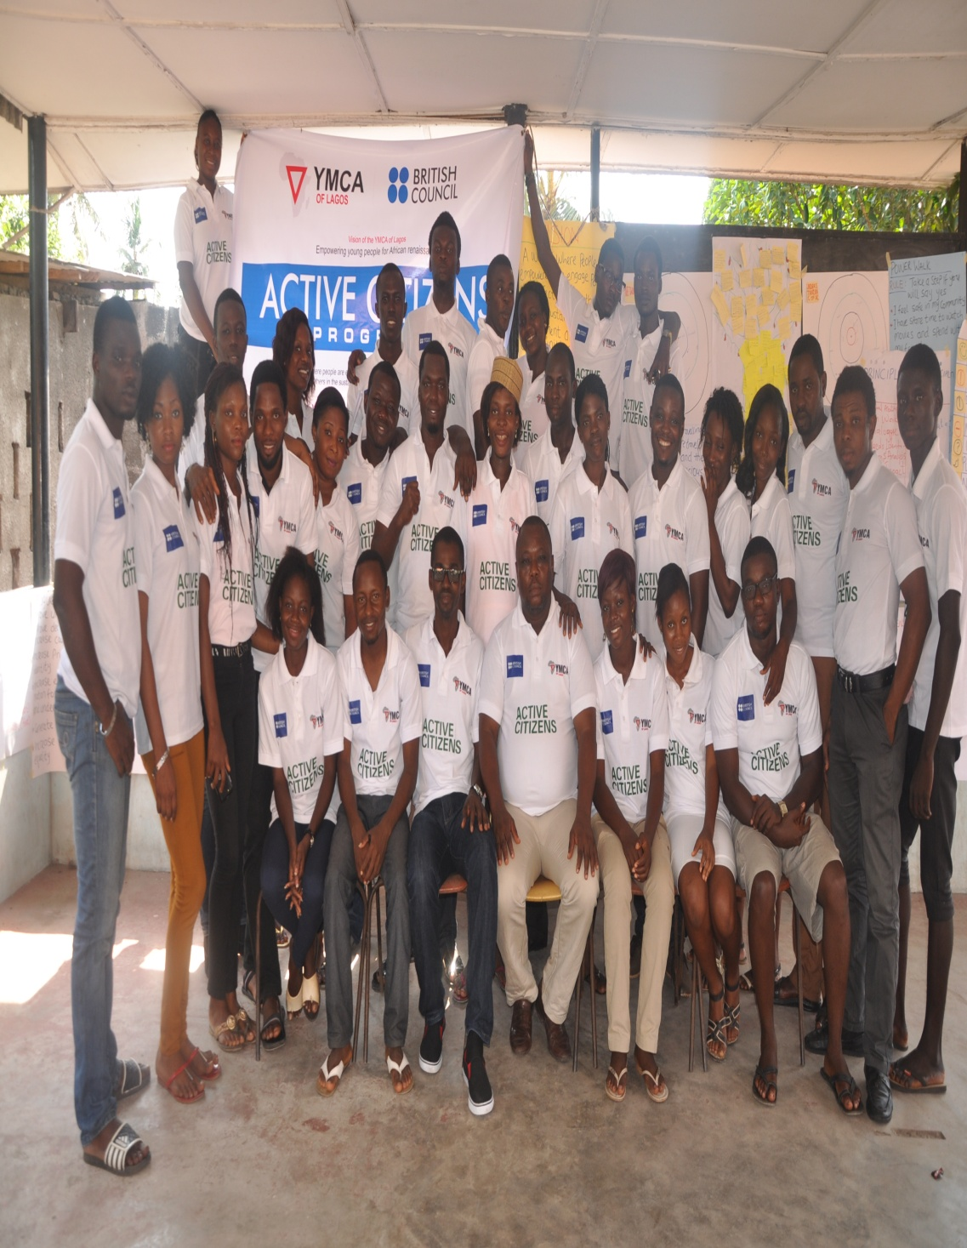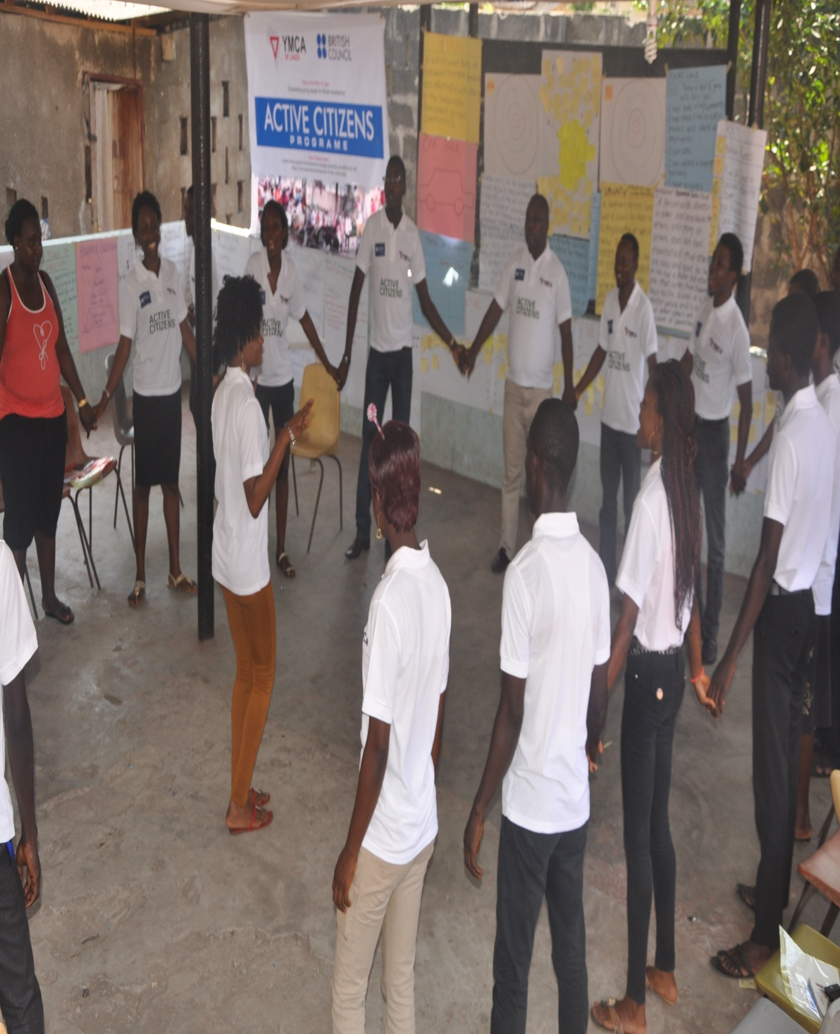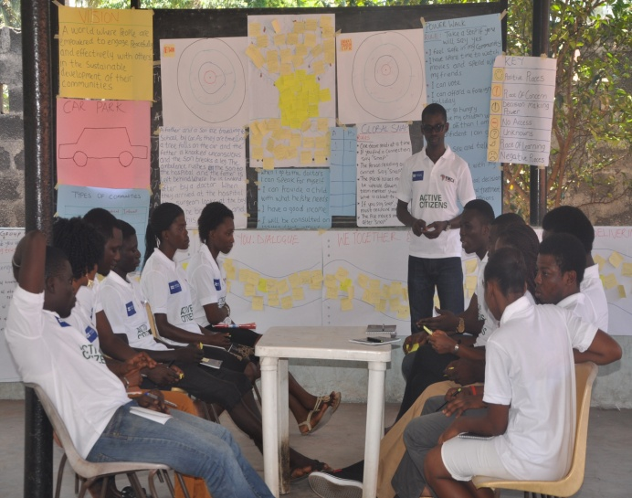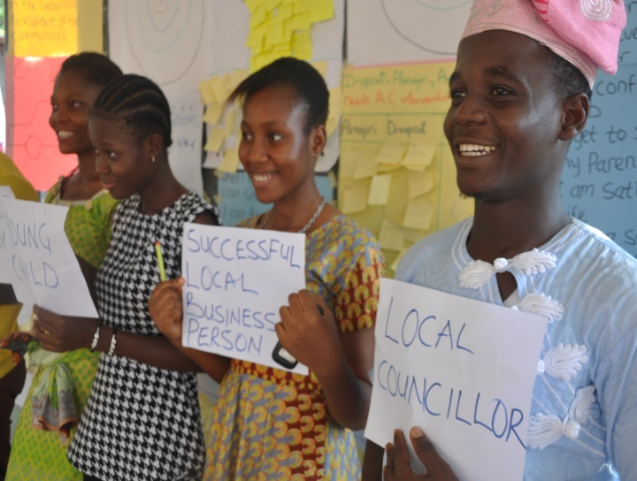

Social Action Project 1: Career Counseling for JSS3 Students of Mobolaji Bank Anthony Junior High School, Sabo-Yaba, Lagos
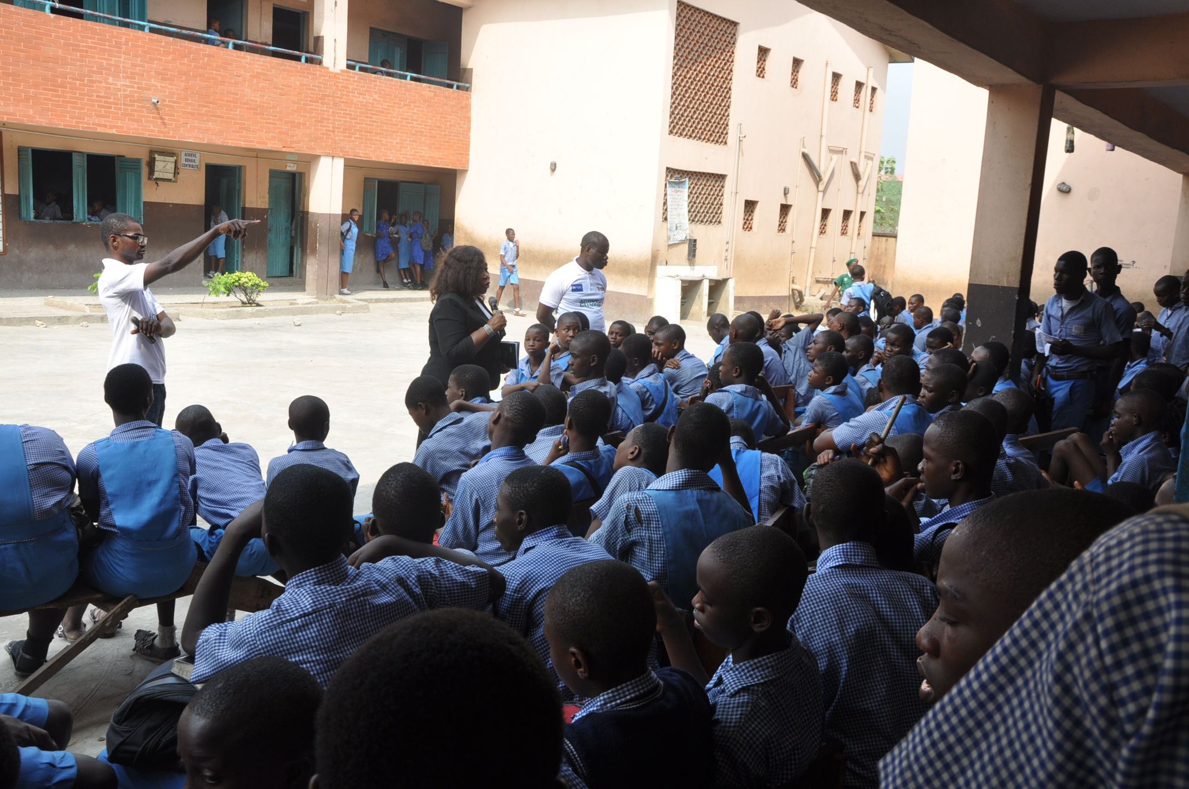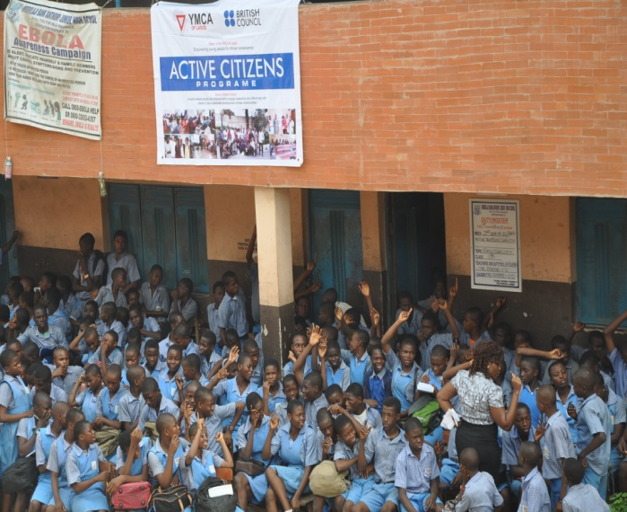

Social Action Project 2: Cleaning and leveling of the bad portion of Olorungbotemi Street, off Atan-Ajayi Street, Ayobo, Lagos.

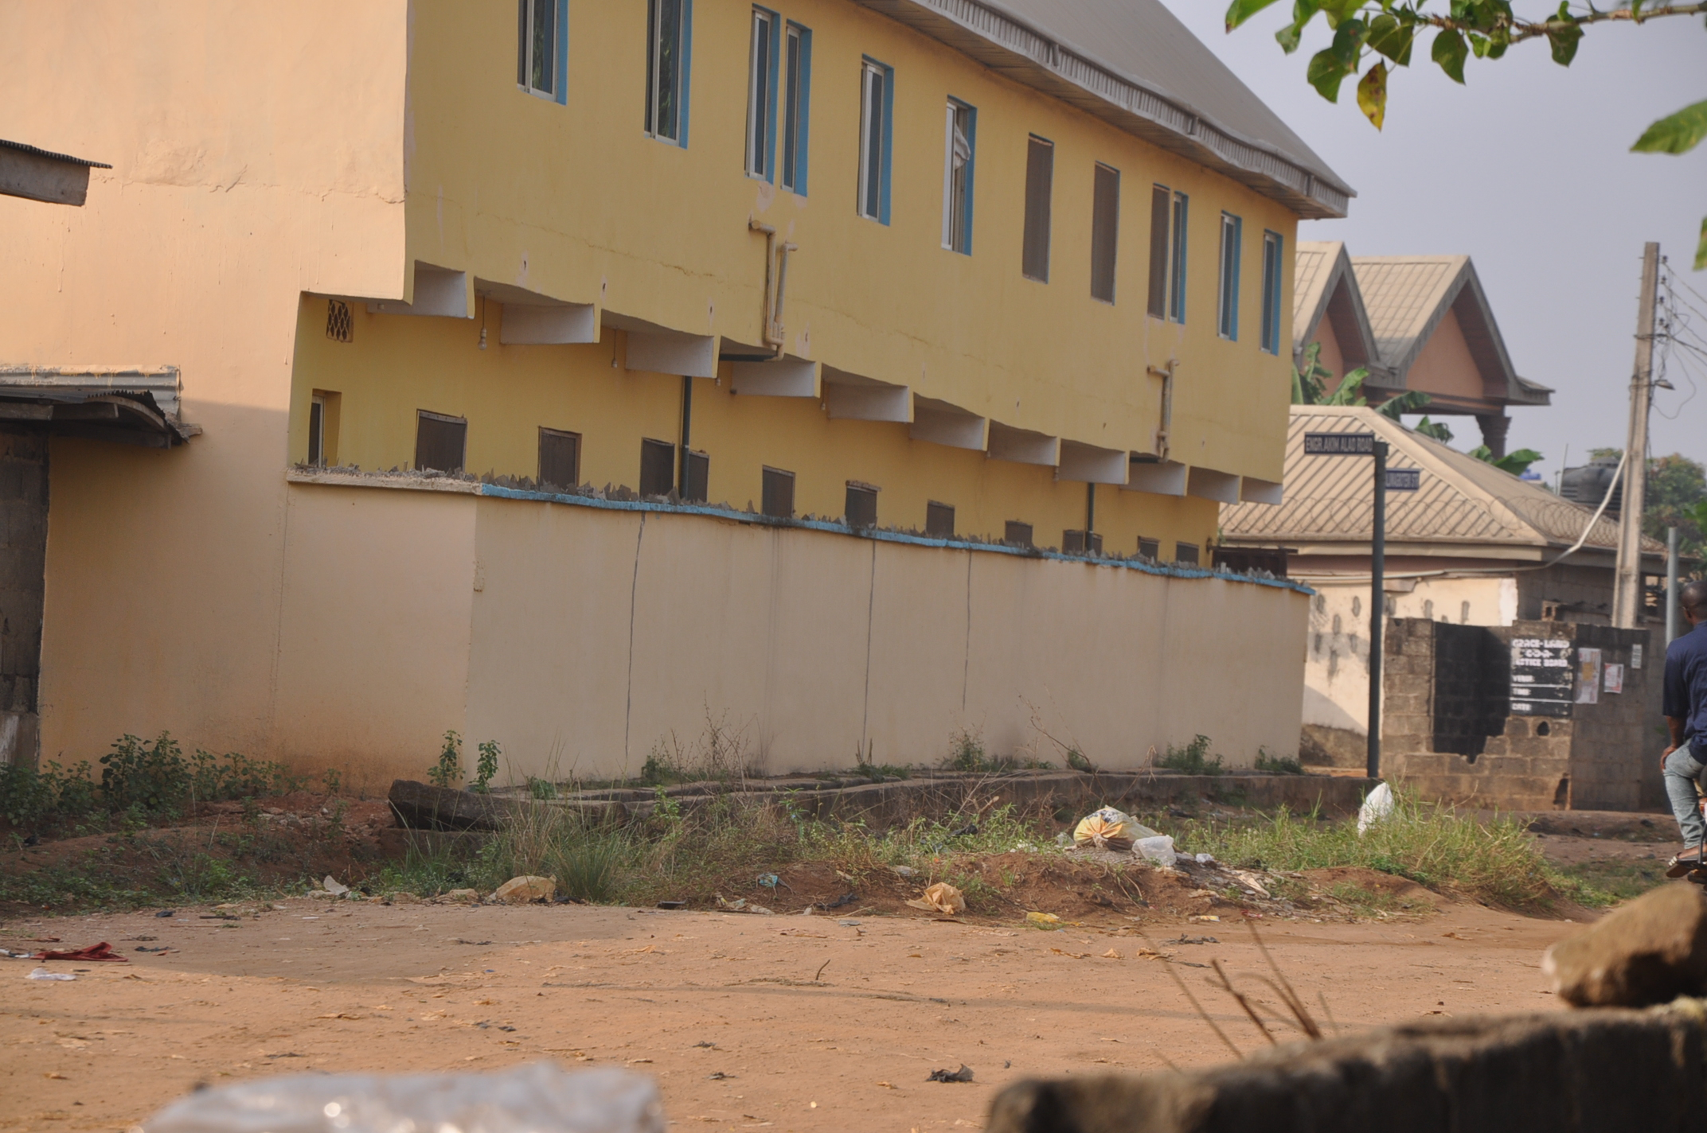
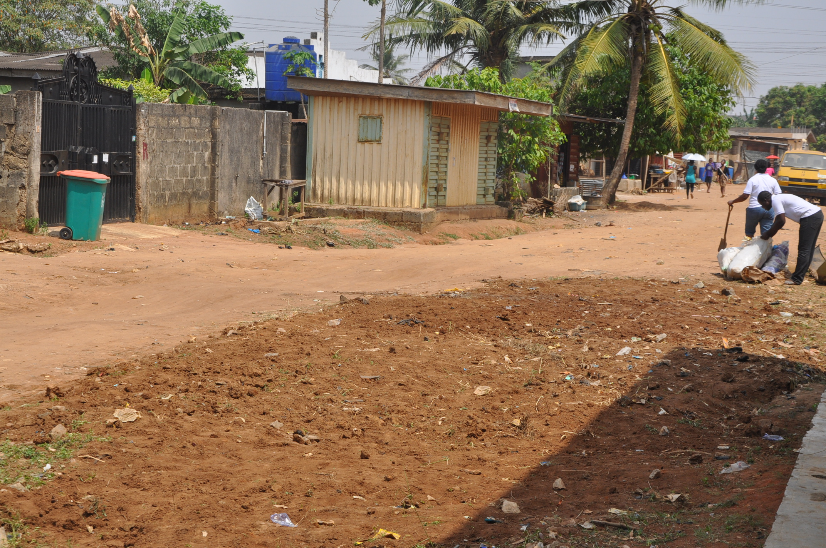
Before our intervention After our intervention

Social Action Project 3: Free Computer Appreciation Training and Free Medical Test held at YMCA Centre, Oke-Ado, Ibadan, Oyo State.

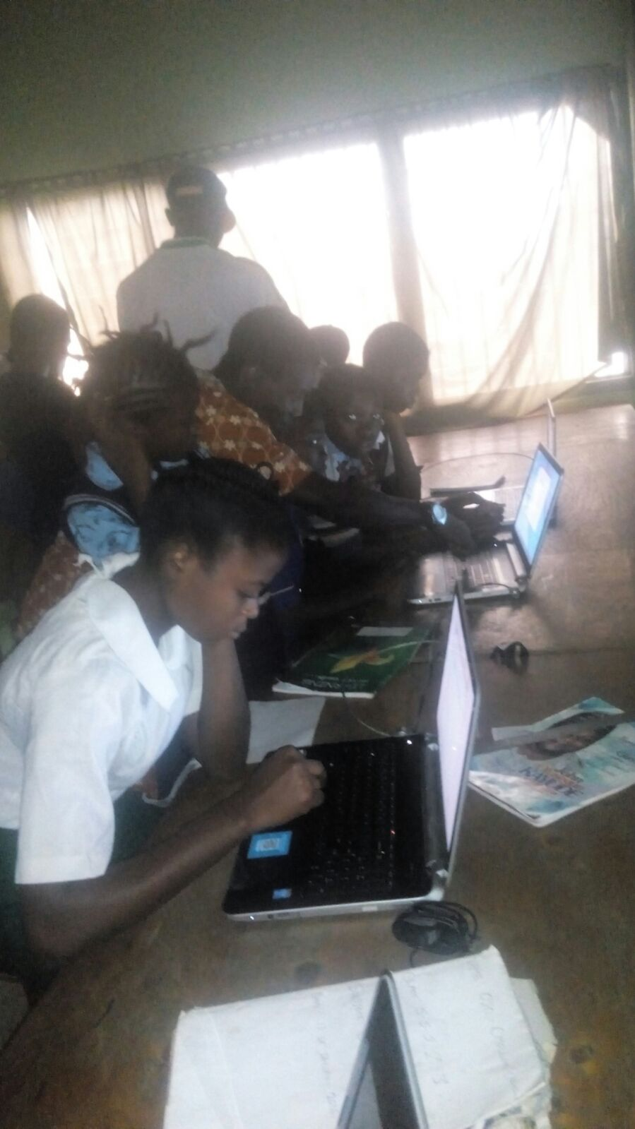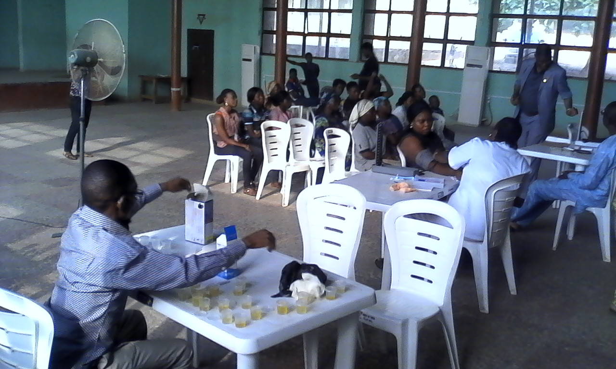

- Social Action Project 4: Advocacy project on use of pedestrian bridge in
Ojota-Ketu-Mile 12 axis of Ikorodu road, Lagos

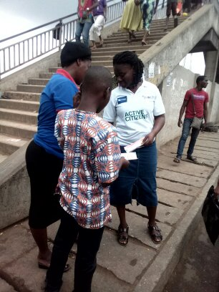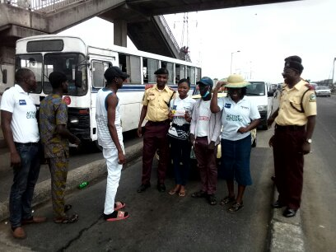
- Social Action Project 5 Cleaning and fumigation project aimed at reducing the Scorge of
Malaria held at estate for the physically challenged, Amuwo-Odofin, Lagos

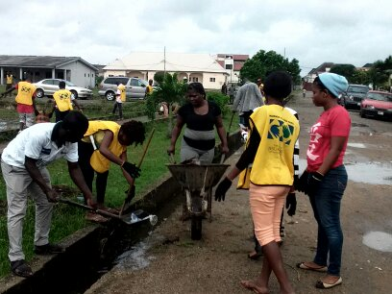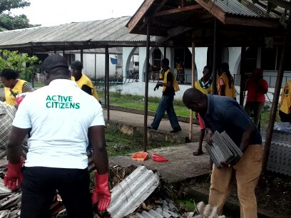

- Social Action Project 6 Seminar of proper hand washing techniques held to commemorate the Global Hand Washing Day at Cherubim & Seraphim Movement Church Ayo Ni O, Surulere, Lagos, Nigeria

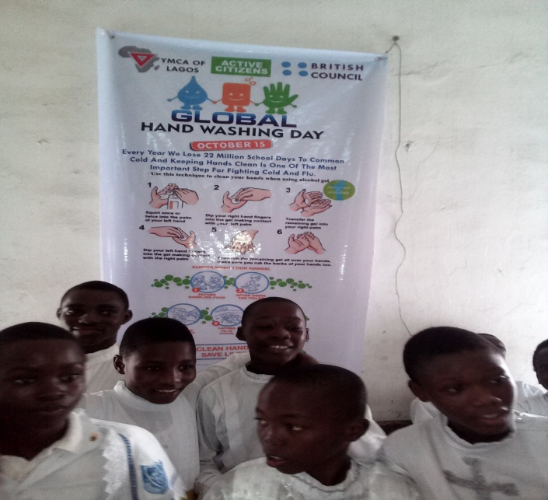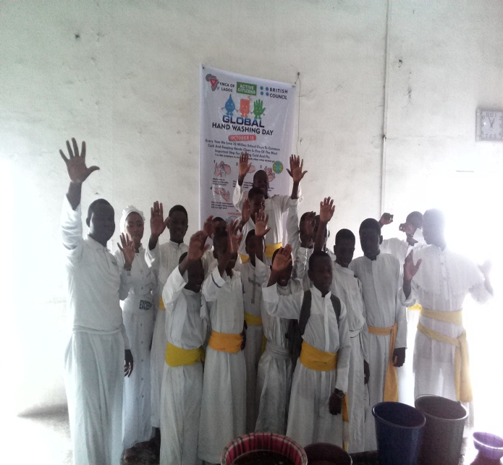

- Social Action Project 7 Cultural Day & End of Year Party for public school students and children from less privileged homes Held at YMCA of Lagos Hall, Ikoyi, Lagos, Nigeria

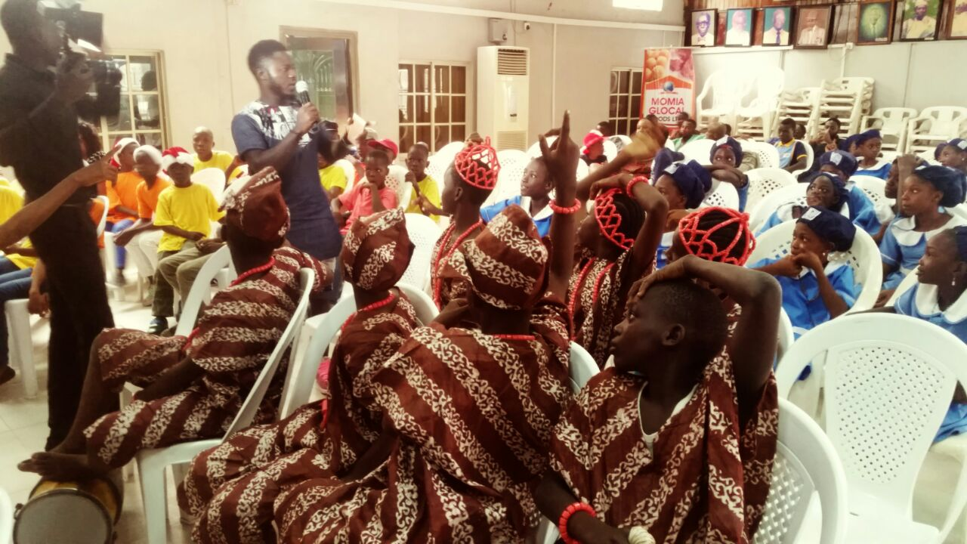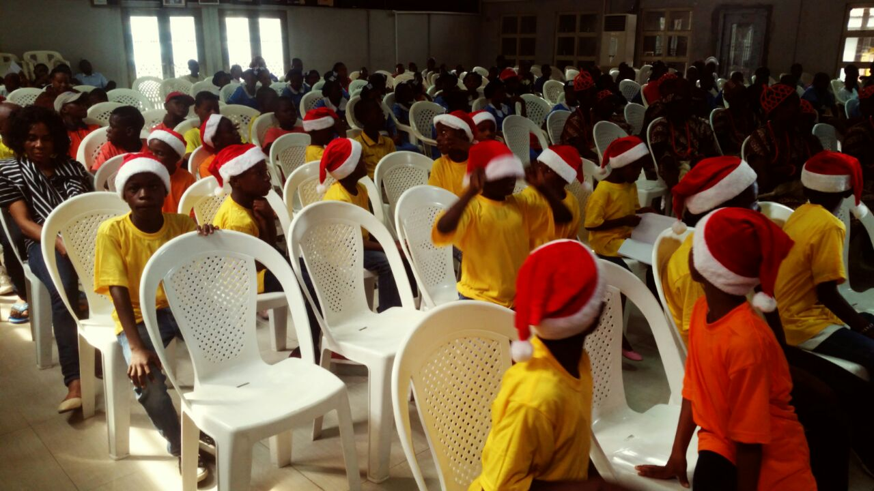

- Social Action Project 8 Cancer Awareness Seminar held to commemorate the World Cancer Day at Cherubim & Seraphim Movement Church Ayo Ni O, Surulere, Lagos, Nigeria

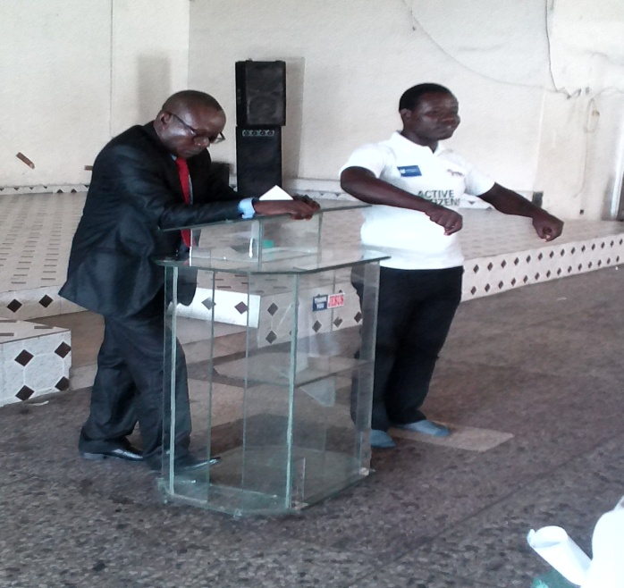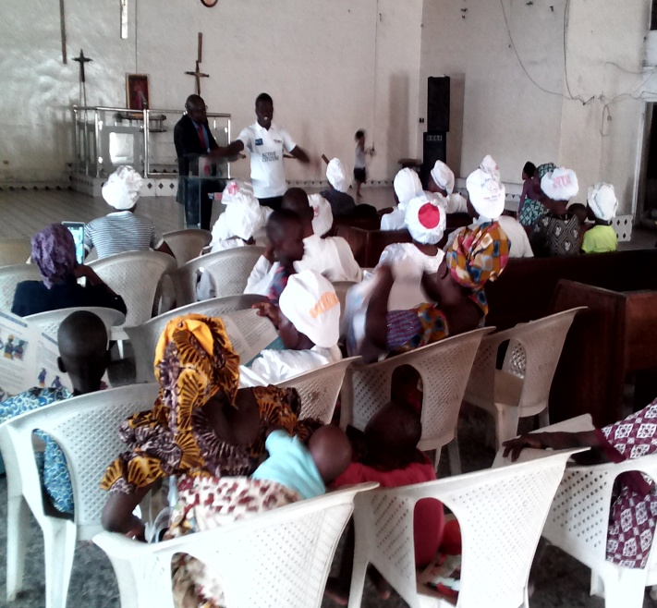

- Active Citizens National Study Visit hosted by Usmanu Danfodiyyo University, Sokoto State, Nigeria.

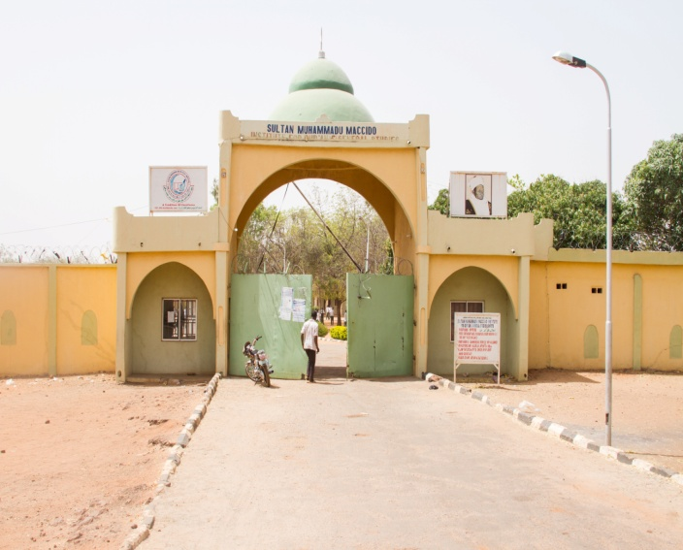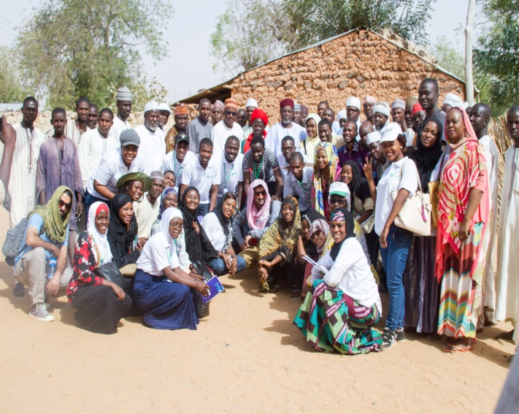

Other Social Action Projects at different planning stages include:

- Adult literacy project in Bariga, Lagos

- Refurbishment of Ireti Junior High School library

- Installation of road signs and markings the T-Junction beside Mobil petrol station on Awolowo road, Ikoyi Lagos

Cost Implications

This depends on location and number of participants. But generally, the programme is always not expensive to run.
Further Information

For further information on the Active Citizens programme, please call:
Adeniyi - 08069660653, olufemiakindayomi@gmail.com

Akindayomi Adeniyi Olufemi

