Support Climate action in rural communities through COVID

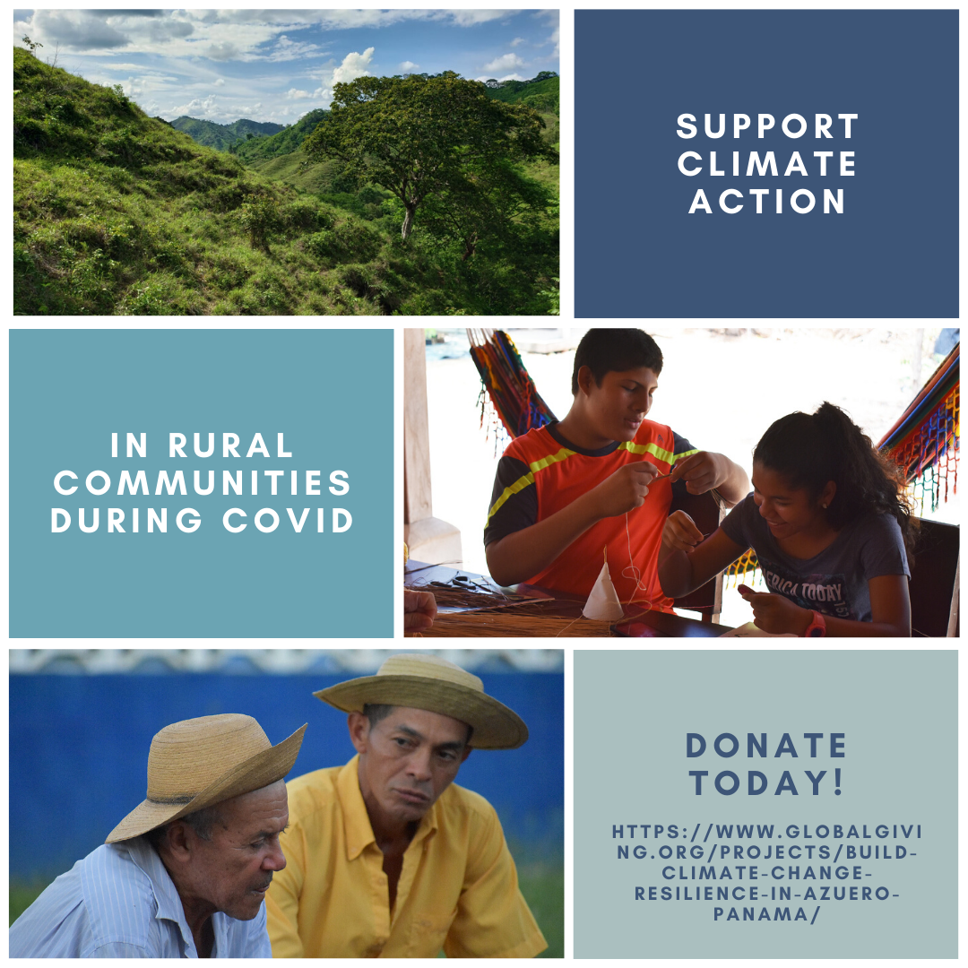

Project Summary
This week, as we celebrate the 50th anniversary of Earth Day, rural communities in Azuero are simultaneously vulnerable to climate change and the impacts of COVID. Pro Eco Azuero is supporting climate change action advocates at the peak of the Azuero dry season and Panama COVID epidemic by giving them income through microcontracts to produce seedlings and artisanal products from the comfort of their own homes. This project supports precisely the MOST vulnerable populations to COVID- elderly, low-income community members by making them into income-generating environmental heroes at this difficult time.
WHAT IS THE PROBLEM?
Once mostly tropical dry forest, Panama's Azuero peninsula is now a degraded agricultural landscape that is less than 7% forested. Climate change imperils local wildlife and hurts the wellbeing of local communities. Azuero's population is one of the most vulnerable populations to COVID- elderly, low-income community members, and economically they are being affected since small scale agricultural work is often done in groups here and the tourism industry has crashed.

HOW WILL THIS PROJECT SOLVE THE PROBLEM?
As the June-August 2020 reforestation season approaches, Pro Eco Azuero has partnered with some of the most knowledgeable community elders in touch with the land to produce seedlings and artisanal products from the comfort of their own homes through microcontracts. This program empowers people who may otherwise feel isolated or experience income loss to become the everyday superheroes Azuero needs to increase resilience to the looming climate crisis by reforesting local watersheds with native and fruit species. Azuero staff make limited visits to deliver supplies and retrieve tree seedlings or finished handicrafts at the end of the contract and provide virtual guidance with community members as they work safely from their own home.
POTENTIAL LONG-TERM IMPACT
In a country that's in total lockdown, the project empowers rural community members to produce and generate income through this difficult time. We hope that this becomes a way to support their families while accelerating efforts to combat another crisis humanity now faces - climate change. The project is directly tied to our vision of restoring an 80 km tropical dry forest ecological corridor that restores spider monkey habitat, protects watersheds, enhances food security, and builds climate change resilience. The seedlings produced in the coming months will be planted in the corridor in 2020 and monitored by the Pro Eco Azuero team (see our youtube channel for more details on this program).

