**C**

**T**

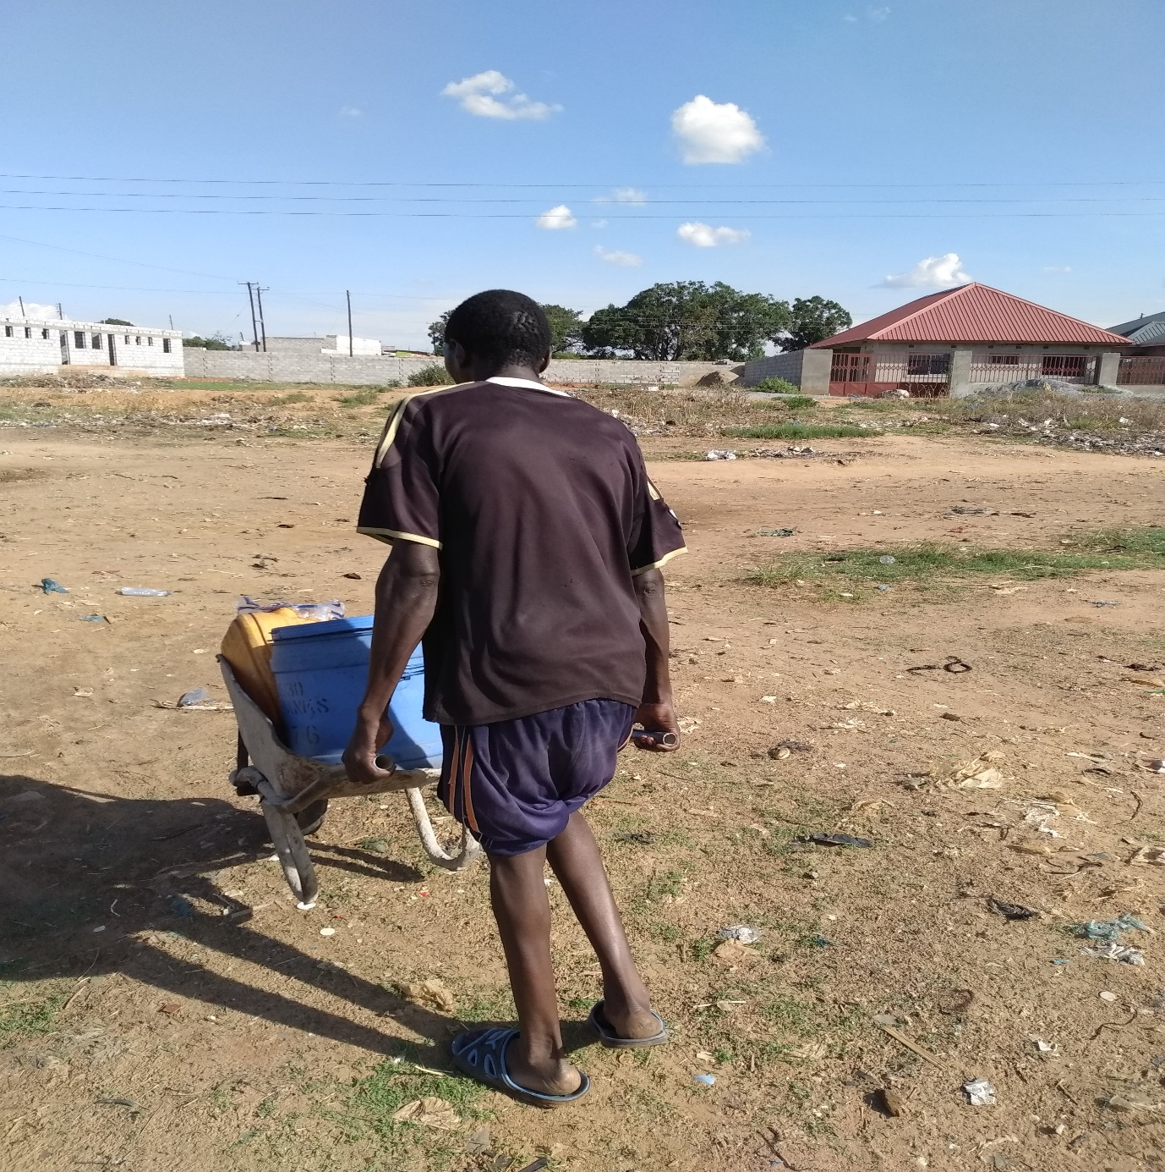



**Organizational Description**

Tandanzala Community Arts is a comprehensive arts organization committed to offering a broad range of programs in arts, culture, livelihood activities and education to meet the needs of the community. As comprehensive, Tandanzala Community Arts views awareness, sensitization and practical training as a shared task of discovering, integrating, applying and communicating knowledge at the intersections of informal and formal education, across the disciplines, and through combining theory with practice.

Based in Kabanana Compound of Lusaka, the organization was formally established in 2012, has a membership of 50 full time diverse artists, facilitators and trainers, and is registered with the Registrar of Arts Associations under the National Arts Council of Zambia.

Tandanzala Community Arts commits itself to a distinctive vision of well-informed communities and societies that fully participate in social-economic activities at all levels with its main tool being culture (song, dance and drama) used to stimulate community reflection and promote togetherness and concepts of sustainable community action throughout the communities it operates from.

The organization’s members, volunteers and employees are servant-leaders who connect community development and learning with leadership and service. In partnership with local authorities, government and quasi government institutions as well as numerous stakeholders and cooperating partners, the organization works with others to improve the human community.

**Mission of the organization**

The Tandanzala Community Arts mission is to promote community participation and well-

being of all people through community partnership. Furthermore, the organization

represents core values of access for all; respect; communication and transparency;

accountability; dedication to others.

**Vision of the organization**

Well-informed communities and societies that fully participate in social-economic activities at all levels.

**Background to the programme**

The Government of the republic of Zambia has been providing various services for disabled people through the Ministry of Education, Ministry of Health and Ministry of Community Development and Social Services. Social and vocational services for disabled people are also provided by NGOs. Most of the services have certain basic characteristics:-

* They are provided primarily by urban-based, specialist institutions, both governmental and non-governmental, covering a negligible percentage of the needs of the disabled people in Zambia;
* Services are unevenly distributed across the country and are mostly located in the urban areas, whereas the majority of disabled people live in the rural areas;
* Vocational training provided through the Government's rehabilitation centres is of poor quality and lacks viability as to employment prospects;
* Special education in special schools only benefits a very small number of disabled children and rarely leads to employment in adult life.

It is recognised that the majority of these disabled people, who represent one of the most vulnerable groups in the rural areas, benefit little from these services, if at all.

**Aims**

The aims of the Tandanzala Community Based Rehabilitation Programme are:

* To improve the well-being, lives and livelihoods of people with disabilities;
* To raise awareness and mobilise resources at village level, thereby enabling parents to be more effective in helping their disabled children to attend school, learn skills and participate productively in family and community life;
* To establish links between service providers in health, education, community development and social welfare at community level, thereby meeting the needs of disabled individuals more efficiently and effectively;
* To strengthen networking and coordination of people with disabilities to enable them to play a role in the mobilisation of the community, implementation of village level activities, and management of the programme;
* To promote the human rights of persons with disabilities.

These aims reflect the developmental objectives of the Tandanzala Community Arts Community Based Disability Programme. The programme is intended to benefit babies, children, young people and adults with physical disabilities, visual and hearing impairments and learning difficulties. Their families and the local communities are also expected to benefit from the programme as recipients of project inputs.

**Challenges in addressing disabilities**

**Early identification**

Lack of systematic child health services leads to many disabilities, particularly mild and moderate learning difficulties, which may not be detected at an early stage. Even when children have been identified, access to education is delayed, owing to lack of awareness from medical personnel who do not appreciate the value of early childhood education for these children. The absence of effective referral systems also delays matters.

This leads to pressure on the kindergartens to accept older children and those with more severe learning difficulties. Teachers and schools new to the work may find themselves faced with problems with which they are not equipped to deal. In the long term, the presence of appropriate educational facilities in the area, greater public awareness of disability, reductions in stigma and prejudice and improved child health facilities will change this situation. In the short term, the programme team will decide how much time and how many resources should be directed towards improving early identification systems. The programme team will support the kindergartens in the enrolment procedure so as to ensure that each kindergarten has the best possible chance of success.

**Families**

Fear of mental disability and strong prejudice puts great strain on the families involved. As the facilities and understanding in communities increase, this problem will ease, but in the meantime, work with the families must be slow and patient. Parents are unused to the type of daily cooperation which is needed in an integration programme and teachers are new to the type of relationship they need to build with the parents. Members of many of the families are poorly educated, so the design of any materials and the methods used to reach families must be very flexible.

**Response in addressing disabilities**

**Community-Based Rehabilitation**

Community-Based Rehabilitation (CBR) has been offered as one response to this emerging philosophy. The goal of CBR is to demystify the rehabilitation process and give responsibility back to the individual, family and community. Someone from the community, a health worker, teacher, social worker, or volunteer, is recruited and trained. This worker then works with families to develop an education and training programme. In this way, simple rehabilitation tasks are delegated to auxiliaries or volunteers, whose work

is supported by a rehabilitation therapist. An essential ingredient of CBR is the involvement of the community in the planning, implementation and evaluation of the programme.

**Parental and community involvement**

Many of the social and emotional needs of parents can best be met by participation in an informal voluntary association with other parents of children with special needs. The nature of this partnership must emerge from the parents and reflect their needs and interests. Parents who meet other parents with disabled children find such contacts very helpful as they find comfort in the knowledge that they were not alone. Tandanzala Community Arts is facilitating the development of a local network of families who can provide mutual support for one another. Such a network will provide a formidable force in working for change in poor rural communities of Zambia. Effective participation cannot be brought about by insistence from external providers. People will become involved only if they feel that they are genuinely being consulted about their needs. Effective consultation is key to change as the community learns to solve its own problems. The members of various communities need to improve their skills in consultation, develop their management ability and become more sensitive, as they listen to others.

**The role of Tandanzala Community Arts in addressing disabilities**

* Mobilisation of and support for the disabled within their respective communities.
* Form Community Disability Committees comprising a cross-section of members of the community, including people with disabilities and/or their family members.
* Train people with disabilities and local supervisors to support disabled individuals and families with disabled members.
* Facilitate the breaking down of rehabilitation strategies into simple tasks, carried out in small steps, accompanied and facilitated by the use of appropriate, simplified literature and aids and appliances.
* Facilitate home programmes carried out by family members of the handicapped persons and supervised by community volunteers with minimum levels of education.
* Facilitate the expansion of rehabilitation to include not only home training and therapy, but skills training and development of income-generating projects to employ disabled persons and their families.

**Target areas**

The programme has targeted communities where effecting change is a little easier and where success is more possible. It has been designed to give children entering special education the best possible chance by allowing them to attend early childhood education.

