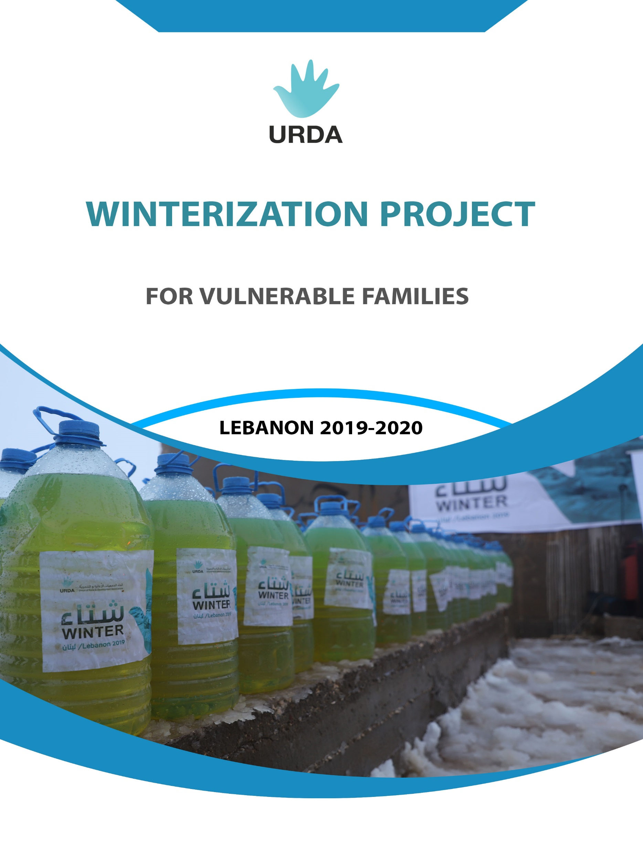

Project Concept Note
Project Name | Winterization project for Vulnerable Families in Lebanon
Background | Last winter inclement weather swept through Lebanon starting on February 2019, with the peak of heavy rain, thunderstorms, strong winds and flooding hitting different Lebanese areas. Refugees were impacted by back to back extreme weather conditions. During the first storm, refugees struggled to cope with heavy snow, torrential rain and gusting winds that flooded sites and damaged shelters. This situation was compounded by a second storm, bringing new precipitations, snow and low temperatures. This added to the already saturated lands, rivers and streams causing more floods and displacement of refugees and impacting vulnerable Lebanese. Also, tragically, four refugees, of which three are children, perished as a result of the storms.  As an act of storm preparedness and mitigation measures, URDA’s winterization strategy is focused on saving lives and ensuring minimum standards in elevated areas in Lebanon for refugees and the most vulnerable Lebanese. In the absence of existing permanent shelter options for refugees, URDA provides winterization projects in informal shelter sites to ensure that they are provided blankets, mattresses, weather proofing kits, household goods, clothes, hygiene kits, baby kits, food parcels, fuel, and other protection-related non-food items NFI distributed according to selection criteria of the most vulnerable persons of concern.  URDA Winterization plan of 2019-2020 aim is to secure two main social services: relief and health. Relief services include the provision of (CRIs) core relief items: (FIs) Food Items by distribution of food parcels, and (NFI) Non-Food Items by distribution of fuel, blankets, winter clothes, and heaters. Health services include the provision of medicines, the operation of the mobile clinic in informal shelter sites, and the coverage of medical consultations for those in dire need.  The plan targets, mostly, those who do not receive winterization assistance from other agencies. Amongst these, the project prioritizes highly vulnerable groups (such as female/ child headed household units, household units with individuals with special needs, household units headed by elderlies, household units with 6+ members, low income/ high debt household units, and household sharing one shelter with 2+ other households) notably those residing in marginalized areas in Lebanon.
Description | Based on the continuous assessment of needs conducted by URDA shelter field teams in different Lebanese governorates, this year’s winterization assistance includes seven main services to protect 500 vulnerable families in different Lebanese regions before winter arrives to mitigate the risk of diseases and illnesses:  Intervention Distribution Items Details  Provision of additional winter items in core relief items and non-food items (CRIs/NFIs) packages; Heating Fuel 20 liters/ family  Thermal blankets 2 blankets/ family  Winter clothes $80 voucher  Provision of winter food items (FIs) packages; Food parcels $25 food parcel including basic food components  Heaters $55 for the heater including an oven and accessories  Provision of health services Medicines $10 medicinal kit relevant to winter diseases  Mobile clinic $1,500 operational costs to mobile clinic visit to camps  Medical consultations $10/patient in medical centers
Main goal | SDG#1: No Poverty  Eliminating poverty, especially extreme poverty providing equal rights to economic resources and securing basic social services such as education and health.
Sub - Goal | - Helping 700 families of the poorest and the most vulnerable in the country to lift them out of poverty through winter assistance project.  - Improving the health and well-being of 500 families in different Lebanese governorates.  - Increasing the level of coordination and solidarity between NGOs active in emergency response.
Location | Rural and remote areas and refugee camps all over Lebanon
Beneficiaries | 700 families
Mechanism | Preparatory Phase:  - Identification of targeted locations for the 2019 – 2020 winter season.  - Needs assessment for the targeted population in these locations.  - Profiling of and development of selection criteria for the persons of concern.  - Launching a national call for tenders.  - Bid analysis and selection of suppliers.  Implementation Phase:  - Purchase, verification and storage of winterization kits.  - Setting up of distribution centers.  - Distribution of winterization kits.  - Provision of medicines.  - Operation of mobile clinic.  - Coverage of medical consultations.  - Media coverage.  Evaluation Phase:  - Monitoring and evaluation.  - Financial and Narrative reporting.  - Reporting and closure.
Duration | Three months – November 2019 through January 2020.
Supervising party | URDA - Union of Relief and Development Associations
Implementing party | URDA -Relief Department
Budget | $ 71,700  Seventy-one thousand, seven hundred US Dollars
Detailed budget:
1 | Activities, supplies, commodities, material, equipment
2.1 | fuel | heating fuel + gallon and delivery to site cost = 0.74*20 liters + 2.5$ gallon cost +delivery = 17.3 (price of fuel is subject to variation) | 17.3 | family | 200 | 3 | $ 3,460
2.2 | blankets | thermal blanket costs 14$ including delivery to site.  (2 blankets per family) | 14 | family | 200 | 3 | $ 5,600
2.3 | winter clothes | voucher | 80 | family | 200 | 3 | $ 16,000
2.4 | food parcels | basic food components | 25 | family | 200 | 3 | $ 5,000
2.5 | heaters | fuel operated heater with oven and all accessories | 55 | family | 200 | 3 | $ 11,000
2.6 | medicines | relevant to winter diseases / per patient | 10 | patient | 500 | 3 | $ 5,000
2.7 | mobile clinic operation | 10 visits are needed to cover for 500 patients, each visit costs $1500 to operate the clinic for 5 hours | 1500 | patient | 500 | 3 | $ 15,000
2.8 | medical consultations | per patient in medical centers | 10 | patient | 500 | 3 | $ 5,000
3 | sub total |  |  |  |  |  | $ 71,700

