IMPROVING MENSTRUAL HYGIENE NEEDS OF ADOLESCENT GIRLS THROUGH CAPACITY BUILDING PROGRAMS AND PROVISION OF FREE SANITARY PADS TO ENCOURAGE GIRLS SCHOOL PARTICIPATION IN ADAMAWA STATE, NORTH-EASTERN NIGERIA.
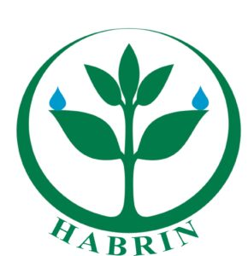

PROJECT TITTLE: WINBACK A GIRL TO SCHOOL

Project Key Driver: humanity africa and better life for rural communities initiative (HABRIN).

Project Location: COMMUNITIES OF ADAMAWA STATE, NORTH-EASTERN NIGERIA.

Project Objective: Menstrual Hygiene Awareness / Girls Child School Participation/ Capacity Building.

Project Country: Nigeria

Project Co-Ordinator / Contact: AbdulRaheem AbdulRahman

Contact Telephone: +234 (0) 8099446225 | +234 (0) 8188888799

Email: info.habrin@gmail.com

Project Starts: 2020

Project Ends: 2021

Our Organisation’s Aims & Objectives:
Introduction:
HUMANITY AFRICA AND BETTER LIFE FOR RURAL COMMUNITIES INITIATIVE (HABRIN) (CAC/IT/NO 83618) is a non-governmental organization that spearhead’s developmental undertakings with focus on environmental management and capacity building. The organization was registered in Nigeria with the Corporate Affairs Commission (CAC) to serve as a catalyst for community action and development by helping communities get involved in sustainable development. As part of fulfilling its mandate, HABRIN has been training Sustainable Environment Champions (SEC's) in communities through its mentorship and capacity building programs for young people in order to widen and strengthen its scope of environmental advocacy.
More so, as the activities of the organization are all geared towards making a difference locally, it acts as facilitator, advocate and agent of change by creating and promoting a stronger voice for the rural-urban poor, thus ensuring collective action, intervention and response at the community, state and national levels using a veritable feedback mechanism. Currently, HABRIN’s activities have been domiciled in Nigeria.
Our Organisation, HABRIN, is committed to protecting and ensuring quality environment that is adequate for good health and wellbeing for present and future generations. Our aim is to see greener environmental practices entrenched in the consciousness of all Nigerians and sustained as our way of life. For us, going green means to live our lives in a way that is friendly to the natural environment and sustainable for the earth as a whole.
We have been actively engaging in environmental sanitation/ sensitization exercise within and outside the FCT, Abuja.

PROJECT SUMMARY:
In Nigeria today, more than 52% of adolescent girls opt not to attend classes when they are on their menses merely because they have no material to remedy themselves. In a random interview conducted by our team, we gathered from 32 girls in fufore town, Adamawa state, where by lack of sanitary facilities has pushed menstruating girls out of school permanently to avoid shame and humiliation from their peers in a community where menstruation was considered a taboo. When girls drop out of school at an early age, they are less likely to return to education, leaving them vulnerable to early marriage, violence and forced sexual relations. Unless something is done now, their reproductive health and education is at great risk.

In the light of the foregoing, HABRIN will be engaged in furthering the menstrual hygiene management care through provision of sanitary items, mentorship and capacity building programs for young girls and women aims to address menstruation related myths prevalent in northern part of Nigeria that is preventing girls from participating and attending school, as they feel shame and fear humiliation from their peers. This we intend to achieve through collaborative partnership with individuals, policy makers, community gate keepers, parent teachers association and artisans in order to advance the cause of better menstrual hygiene management that will enable women and girls to reach their full potential in areas such as education. Over 70% of girls chid and women formed Nigeria population. At HABRIN, we believe that empowering the girl child would ultimately lead to building a better nation that is capable of attaining all its intended sustainable development goals.

PROJECT OBJECTIVES
- To raise awareness of the fundamental role that MHM plays in enabling women and girls to reach their full potential in areas such as education.
- To empower and ensure that women and girls can manage their periods in a way that is not only healthy, but that enables their full participation in school, work, and other activities.
- To remove certain barriers that can prevent girls’ child education.
- To activate MHM box in schools where menstrual care materials are stored/donated and we shall do this by working with communities head teachers and head prefect for project ownership and continuity.

Target Audience: 2000 Adolescent School Girls.
Secondary Audience: 120 School Teachers And Head Girls.

Stakeholders
- Communities’ Gate Keepers; School Teachers, Community leaders, adolescent school girls and women.
- State ministry of education, State environmental Protection agency, parent/teachers association, State universal basic education board.
- Non- governmental organizations, mass media and sponsorship partners.

Output Target:
- To enable adolescent school girls grow into women who are empowered to care for themselves, their families, and their communities.
- To reduce early girls child marriages by 60 percent.
- To boost girls school participation by 60 percent.

Action Plan:
Objective | Planned Activities | Responsibility | Time Schedule | Expected Outcome
- To boost hygiene care, reproductive health awareness and increase girls’ school participation by 60 percent.  - To re-orientate and educate adolescent girls and communities leaders on the myths associated with certain socio cultural believes on menstrual periods. | Advocacy and reorientation  Meetings with communities  Stakeholders.  Stakeholders mobilization and Sensitization programs. | Humanity Africa and better life for rural communities  (HABRIN).  Consultant. | Q1, 2020  January-March, 2020 | Communities mobilized and sensitized.  Adolescent school Girls are empowered.  Adolescent school Girls participation and reproductive health improved.
Donations of Menstrual hygiene management packs.

Print and electronic media

To ensure that women and girls can manage their periods in a way that is not only healthy, but that enables their full participation in school, work, and other activities. | Monitoring and  Supervision  Documentation and Reporting | Humanity Africa and better life for rural communities  (HABRIN).  Consultant. | Q2, 2020.  April – June,  2020. | Girls Child sexual molestations decreased significantly.
To remove certain barriers that can prevent girls’ education and reduce child marriage by 60 percent. | Monitoring and  Supervision  Documentation and Reporting | Humanity Africa and better life for rural communities  (HABRIN).  Consultant. | Q3, 2020.  July–September,  2020  Q3, 2020. | Interventions effectively and efficiently managed.
To Activate MHM box in communities schools for project ownership and continuity. | Documentation and Reporting  Drafting & submission of reports/outcome | Humanity Africa and better life for rural communities  (HABRIN).  Consultant. | Q4, 2020.  October-December  2020 | Girls Child early Marriages decreased significantly.

PROGRAM SCHEDULE / IMPLEMENTATION STRATEGY

- PARTICIPANTS / PROGRAM STRUCTURE

- The program will be delivered with the aim of a training of the trainer (TOT) Strategy with a maximum of twenty (20) teachers and 20 Adolescent school girls across three Local government areas of Adamawa state for a pilot project, two teachers and two girls per school making it a total of 120 teachers/students (participants)

- An appropriate venue will be sought at a strategic location to accommodate all participants

Duration:
The training, development and support program will be drawn and delivered as a one (1) week training program.
2Days Training | Time
Day 1 | 10am – 2pm
Day 2 | 10am – 2pm

- Certification:
All participants will be awarded with a certificate of completion.

- MONITORING AND EVALUATION

We would liaise with the State Universal Basic Education Board to request that some staff members be nominated from the special education needs department and staff of the ministry of women affairs state ministry of environment to work with our team to ensure compliance and measure impact of program.

- PROGRAM/TRAINING CONTENT
We will deliver capacity building program for teachers and adolescent school girls as part of their continuing personal development on menstrual hygiene management (MHM) in the areas of;
- General introduction to special needs of menstruating girls
- Emotional intelligence.
- Project materials (IPC materials, note pads, pens,)/Practical Tips / Demonstration on MHM.
- Menstrual care item (set of underwear, reusable pad, bathing soap, shaving stick, deodorant.

PROJECT DURATION

- The expected duration of the project is one full calendar year.

REPORTING SYSTEM

- Mid-term financial and narrative report will be submitted after three months following initiation of the project.

- Final narrative and financial report will be submitted within two months after completion of the project.

Outcome Indicators - Post Training Term of Reference
- Participants’ Attendance Records
- Completed participants’ feedback (evaluation) questionnaire to ascertain participants’ application of knowledge gained on work practice.
- Records of follow up / mentorship / observation visits for 2 weeks after the training workshop.
- Head of School / Teachers and school girls verbal feedback to be recorded (audio taped) as part of Indicators for evidence collection.
- Report by the Monitoring & Evaluation Team.
- Documentation of MHM items

SUSTAINABILITY OF PROJECT
HABRIN Team will;
(a). Ensure that the program is delivered with the aim of a training of the trainer (TOT) Strategy with a maximum of twenty (20) teachers and 20 Adolescent girls across three Local government areas of Adamawa state for a pilot project, two teachers and two girls per school making it a total of 120 teachers (participants) so they can in turn train others to broaden the reach and promote continuity geared at sustainability.
(b). Set up Menstrual hygiene management (MHM) box in each school with a school teacher and a prefect as the coordinators of MHM. They will attend to menstrual needs of the girls.
(c)). Set up a mentorship / follow up / observation visits at regular intervals to the schools to ensure sustainability of program.
(d). Organize and carry out bi-annual basic refresher workshops for the teachers and head girls to ensure sustainability of knowledge gained and continuity of practice.
Quality Audit/Programme Management:
Our Programme Co-ordinator will be responsible for coordinating the resource personnel, the training programs, learning plan monitoring & review, advice and feedback.

Monitoring & Evaluation:
Two (2) Representatives from your organisation and two (2) representatives from the Universal Basic Education Board (UBEB) will work together with our Programme Co-ordinator to facilitate proper monitoring and evaluation of the programme to ensure that the programme’s aims and objectives are met.

Projects Implemented by our Organisation:

S/N | Project Description | Estimated Cost($) | Year Implemented | Donors
a. | Menstrual Hygiene Management – Sensitization and distribution of sanitary pads to girls and women at the internally displaced persons camp, Furore, Adamawa state. | $ 4,438.00 | 2018 | - Members of Board of Trustees  - Good will donors
b. | Environmental Sensitization- Environmental awareness and distribution of waste materials at Kubwa, Mpape, Dutse and Its environs within the Bwari Area Council Abuja.  WASH intervention at the Bama IDP camp Abuja- Cleaning and donation of sanitary materials and including distribution of sweaters to the kids at the IDP camp. | $12,778.00 | 2017 | - Members of Board of Trustees  - Good will donors  - Adama Beverages Limited.
c. | Clean Up 9JA Environmental Awareness And Interventions - Environmental awareness and capacity programs for the informal waste collectors popularly called ‘’Babanbola’’ at kubwa, Abuja and distribution of waste collection equipments aims at proper waste disposal and protection of waste collectors from health hazards. | $ 3,422.00 | 2016 | - Members of the board of Trustees

Organisation’s Work Force

S/N | NAME | WORK ROLE
1. | AbdulRaheem AbdulRahman | Program Manager
2. | Ali Mohammed | Quality Assurance / MER coordinator
3. | Grace Bamaiyi | Project Officer
4. | Abubakar Ijoko | Operations & Administrative Associate
5. | Kaseina Nkom Dashe | Communication And Strategies.
6. | Ibrahim Nuhu | Logistic Officer
7. | Moses Attah | Project Officer-
8. | Ekeoma Ogbonnaya | Project Officer
9. | Muhammad Usman | WASH Officer
10 | Olabanji Ejibunu Ahmed. | Communication Officer
11 | Sherif Mohammed | Legal adviser
12 | Dr. Ummu Bajoga. | Project Advisor- Environmental health
13 | Ruth Achi | Volunteer
14 | Najaatu Nazeer | Program officer
15 | Recheal Isaac | Volunteer
16 | Ayuba Timothy | MER Officer
17 | Idris Ajia | Project Advisor – Renewable energy
18 | Aishat Suleiman | Secretary
19 | Onyejeakor Macdonald Chikwendu | Environmental Officer -- Consultant

Organisation’s List of Board of Trustees
S/N | Name | Position
1. | Mohammed Atiku Abubakar | Chairman
2. | AbdulRaheem AbdulRahman | Member
3. | Aishat Suleiman | Secretary
4. | Alir Alao Arisekola | Member
5. | Abubakar Ijoko Orlando | Member

CONCLUSION

Donation to this project is considered a great support to reproductive health, education and quality of life of adolescent poor school girls whose sources of livelihood have been affected as a result of incessant Bokoharam attacks in the North-East.

HABRIN will ensure technical expertise and accountability for implementation of the project.

At HABRIN, we believe that a sustainable menstrual hygiene management (MHM) is not a distant dream. We hope to contribute to ensuring a sustainable MHM in three (3) ways: partnership & advocacy; projects implementation & capacity building and research & strategy. We also believe that the efficacy of this strategy lies in the active participation of various stakeholders and so strive to engage them.
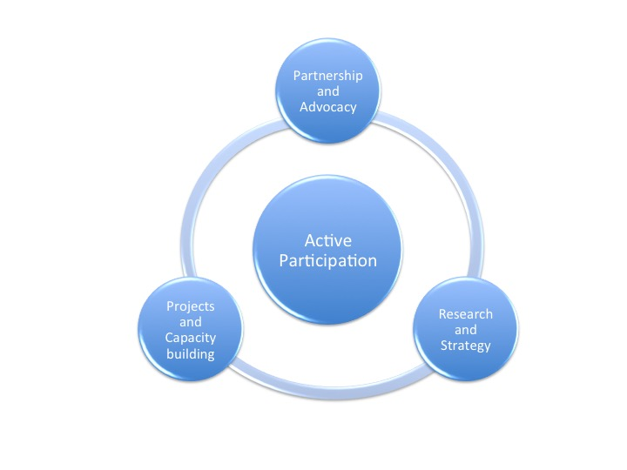

Prepared By;

AbdulRaheem AbdulRahman
CEO.
Humanity Africa And Better Life For Rural Communities Initiative -HABRIN

