NEWS  2021 LAST  QUARTER | LETTER
 | THE OTHER SIDE FOUNDATION SCHOOL FOR OVC
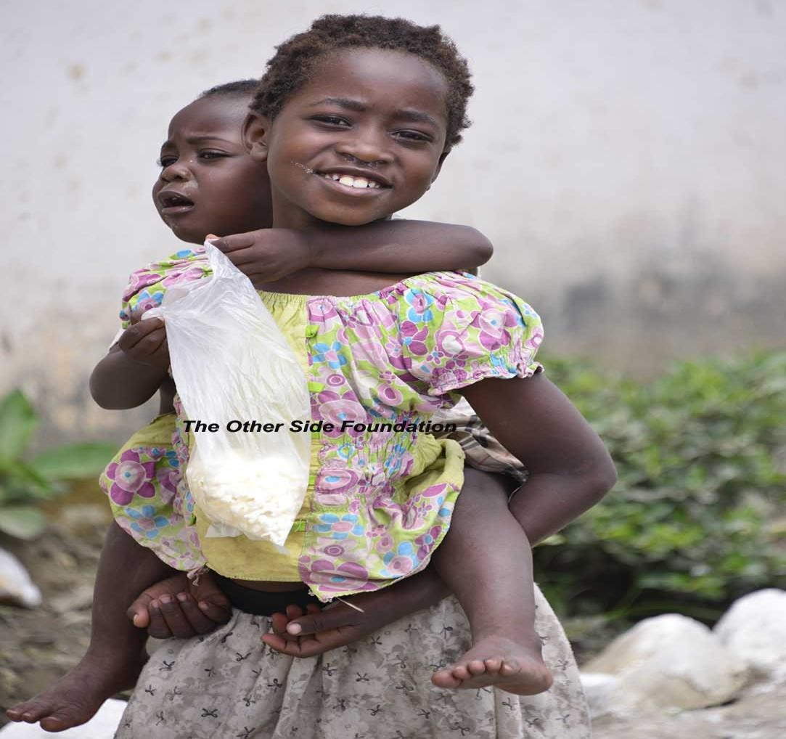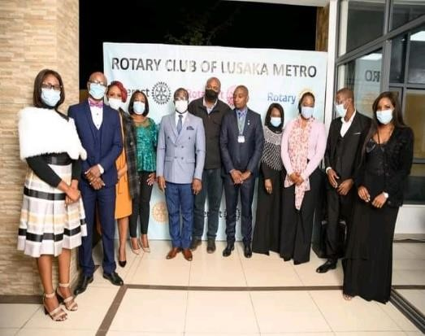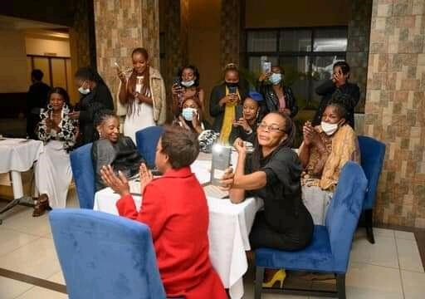

Inside

THE ISSUE

Dinner with Rotarians

Shelter extension

Christmas
party

Feeding programme

Donations

Global
G
iving
A
wards

TOSF
A
nnual
D
inner

Road to
UNZA

Grade seven examinations

Kids

Athletics

Reuse, recycle

Grade 1 enrolment

Dinner with Rotarians

T
here is nothing that excites employees
more
than motivation because it
inspires and promotes
efficiency in an organisation.
Knowing this
TOSF
directors render both intrinsic and extrinsic motivation to
their

staff.
As
a mark of appreciation

for

the

good work ethics and performance of 2
TOSF School teachers,

the
directors
paid
for
a

gala
dinner
organised by

the Lusaka Metro Club at Asmara H
otel in Lusaka.

       | www.theothersidefoundation.com
Friends of TOSF Zambia/The other Side Foundation school for

@OfTosf
FriendsoftosfZambia
SHELTER EXTENSION
TOSF School feeding programme and some outdoor activities occurred under a small shelter which could not accommodate the growing number of their students due to limited resources available then. As a result of limited space for close to 500 orphans and vulnerable children, they sometimes had to eat under the scorching sun and during the rainy season they were confined in their classes though cooked food was ready to be served. To address this challenge Ms Melanie Rohling based in Lusaka (sponsored 10%) and Smiling Children e. V Germany (sponsored 90%) of the new extension of the shelter. Feeding, assembly, outdoor learning and library hours take place daily in this new covered recreation area Thank you, Miss Rohling and Children.
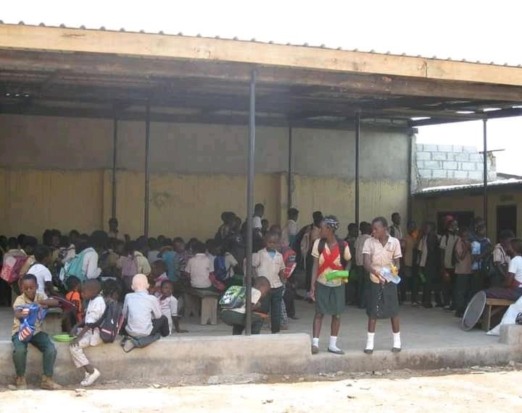
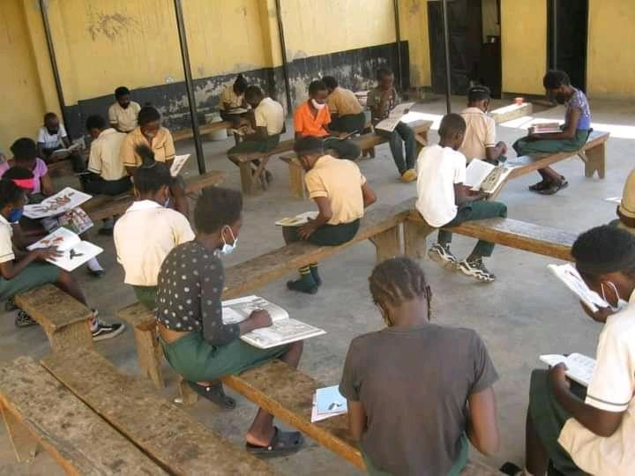

.

EXTENDED SHELTER



CHRISTMAS PARTY


The annual Christmas party since 2007 for the children at TOSF School for OVC, is something that cheers these vulnerable children. It makes them feel loved, valued and treasured. Mr. and Mrs. Champ know how to put smiles on the faces of these OVCs who are overjoyed and look forward every year for the only Christmas party they could ever wish for. You will be surprised to see how excited these children are on that occasion. We are grateful for their kind gesture.

FOOD SPONSORSHIP BY UPAKAAR INITIATIVE LTD

With donor fatigue and sponsors hard to come by due to high poverty
level in Zambia, we at TOSF School are privileged to have sponsors who believe in our cause and grassroots outreach programs in impoverished
areas. Mt Meru Petroleum Zambia Ltd, Ramakrishna Vedanta Center
Lusaka and Upakaarprogram. Children cannot study at school on an empty stomach which Initiative Ltd partnered with us in our feeding is the predicament many of our students face. They come from impoverished families who cannot even provide for one meal a day. Mr

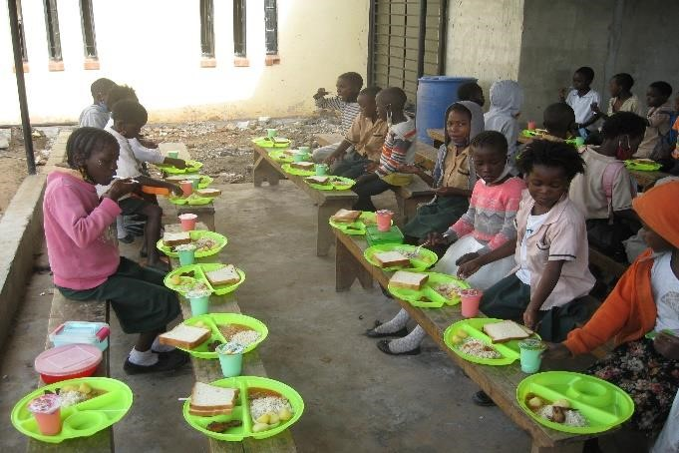
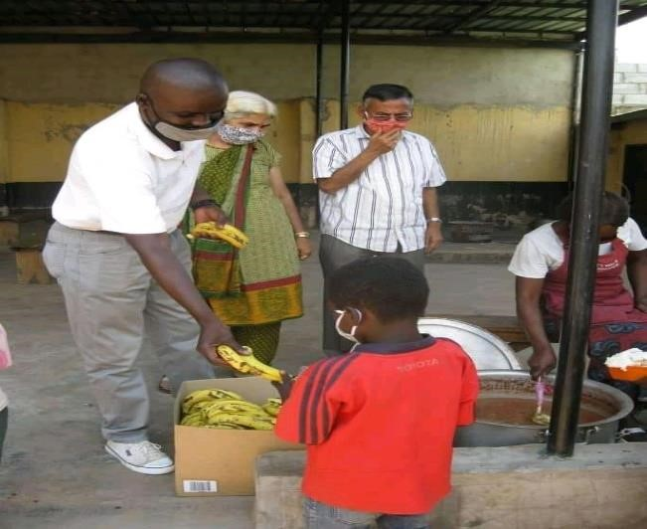

& Mrs Subramanian of Upakaar Initiative Ltd are actively involved and the major provider in TOSF school’s feeding program since 1st April, 2021. They have provided 450 new plates for the children and sponsor a nourishing meal 3 times a week.

