Bakitang’a Lukusi women Group is a self help group that was formed with the aim of assisting women in the rural areas within the environs of the large Kakamega County in the Western Region. The Founder who is a trained journalist came up with this noble idea to support women and children from the vulnerable families. The action was prompted by her experience and heart breaking incidences witnessed during her news anchoring field assignment. The most vulnerable members of the society are women and children
The Vision Statement of the group is to be a self reliant woman society. In order to achieve this dream, the group intends to create avenues that empower women economically for improved livelihoods. The means for realization of the outcome is to; provide a platform that builds partnership amongst women, sensitize women on management of self help businesses as source of income and ensure that there is union for the common good of members.
The activities of the group are geared towards events that will positive influence behavior change of women in rural areas, girl child and the marginalized street children.

PROJECTS [1]
STREET CHILDREN FEEDING PROGRAMME.

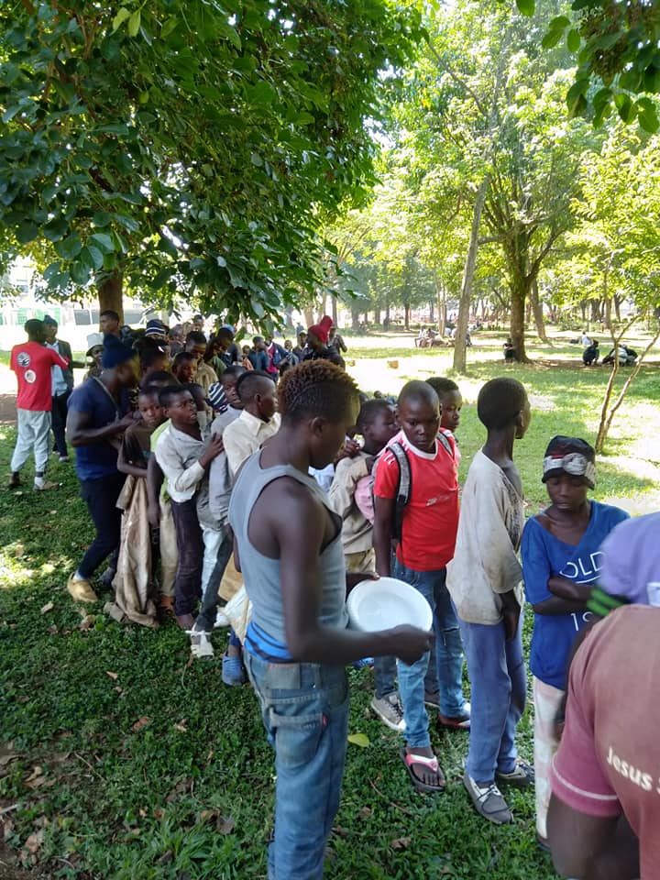

On Christmas Holiday, December 2018, the group members decided to feed disadvantage street children in Kakamega. The purpose of this programme was to make the children enjoy like the rest of the world and know that they still being cared regardless of their position in the society. Approximately 50 children were fed. The lesson learnt from the street children was that most of them ran away from their homes either after the death or separation of their parents.
As the December 2019, Christmas holiday is approaching, the group intends to upscale the programme by not only feeding them but also engaging local media houses for the street children talent show to tap their talent and share their stories. Further, we intend to work with local provisional administration for follow on their whereabouts and if possible organize for street children back to home tour.

PROJECTS [2] MENTORSHIP PROGRAMME
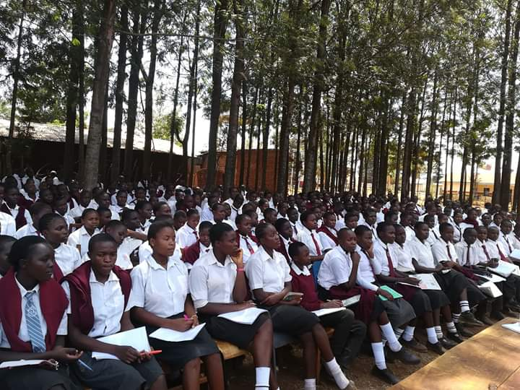
During the month of February, 2019, Bakitang’a women group together with other partners organized and held a mentorship programme in Kongoni Secondary school, Likuyani Sub County Kakamega. Thematic area that guided the programme was; sexual reproduction health and abortion, drug abuse and early pregnancies. School enrolment is over 400 students and different stakeholders were engaged. Ladies were provided with sanitary towels and boys were give shoe polish each.
During the year 2020, the group targets to conduct outreach program in two secondary schools and two primary schools in Likuyani Sub County Kakamega County. The major sensitization topics will be on Sexual Reproduction Health, Effects of abortion and disadvantages of early marriages. Students and pupils will be provided with sanitary towels for girls and underwear for boys.

PROJECTS [3] Value Addition & capacity Building
Kakamega County is located in Western region of Kenya. The major source of income is agriculture but due to high population growth land resource has become limited to the extent that residents cannot produce enough for daily subsistence.
This resultant impact is rise in poverty level because they have nothing to sell for income. As a group we want to support members on value addition to be able to produce beyond subsistence using the limited space within our homesteads.
The staple food in the region is ‘‘Ugali chicken” i.e. a meal prepared from maize flour served with chicken stew. The demand for chicken is therefore very high to making hotel owners to source from far. The group has seen this as a big business potential.
During the year 2020, we target to upgrade the normal way that our members are rearing chicken by develop at least ten (10) modern structures and replacing the indigenous breed that takes too long before they mature with the improved Indigenous breed that Kenya Agricultural and Livestock Research organization introduced in the market.
For purposes of sustainability, this will go hand in hand with capacity building sessions where members will be equipped with the necessarily skills on other income generating initiatives, entrepreneurship and management of self owned income generating enterprises.
Below is the photo describing the vision of this project for the group

PROJECTS [4]

Establishment of tree nurseries
Girl child and women are the ones overburdened by the family chores mainly search for food, firewood and water. They therefore spend most of their time in these tasks rather than schooling or engaging into other income generating activities for mothers. The resultant impact is early pregnancies & marriages for young girls and domestic violence for mothers.
As a group of women, we intend to grow on farm fruit and fodder trees that will enable us get firewood, fruits and animal fodder at the door step and therefore the reduced turnaround time in search of this basic items be used for by girl child and for other income generating activities for women.
During the year, we intend to embrace agro forestry by generating 50,000 tree seedlings that will be distributed to members for on farm planting and even to the nearby public institutions.

BUDGET FOR BAKITANG'A WOMEN GROUP FOR THE PERIOD JULY 2019-JUNE 2020
S/No | Item Description | Quantity | Frequency | unit cost | Total (Kshs) | Expected Source
1 | training members on enterprenuership and management of self owned income generating enterprises | 10 | 4 | 2000 | 80,000.00 | Group Members
2 | support members on value addition of poultry keeping through improved breed & costruction of modern structures. | 10 | 1 | 30,000 | 300,000.00 | Partners
3 | establish a tree nursery to embrace agroforestery by raising 50,000 tree seedlings & distibuting to members for on farm planting | 1 | 1 | 50,000 | 50,000.00 | County Government
4 | mentorship programme on sexual reproductivehealth in selected rural schools ( procure pads & underwears for need students) | 1 | 4 | 50000 | 200,000.00 | Partners
5 | promotion of water, hygene and sanitation at the rural level through training | 1 | 2 | 100000 | 200,000.00 | partners
6 | production of Education, Information and communication materials (posters, fliers & manuals) | 500 | 1 | 250 | 125,000.00 | Partners
7 | feed street children on three calender holidays' | 50 | 3 | 600 | 90,000.00 | partners
8 | Publicity through local FMs | 1 | 2 | 50000 | 100,000.00 | partners
 | Total Amount |  |  |  | 1,145,000.00

