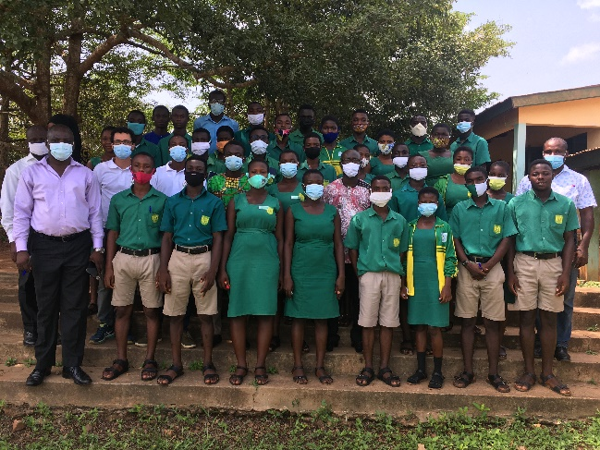 | 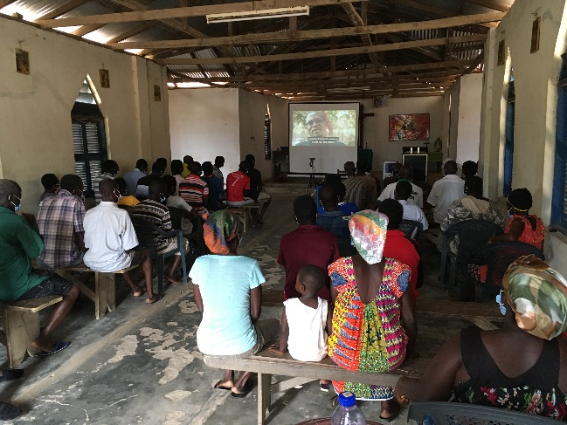
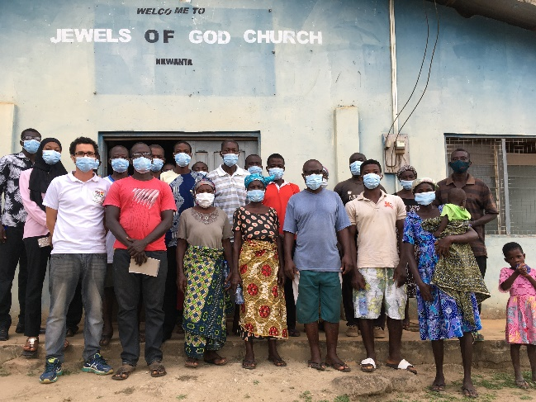 | 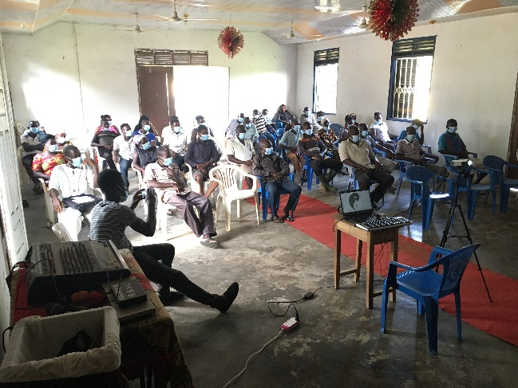
Figure 1: Participants in screening of short videos in November 2020 at Mankessim Senior High School (top left), as well as in the farming communities of Krofu (top right), Nkwanta (bottom left) and Abofrem (bottom right).
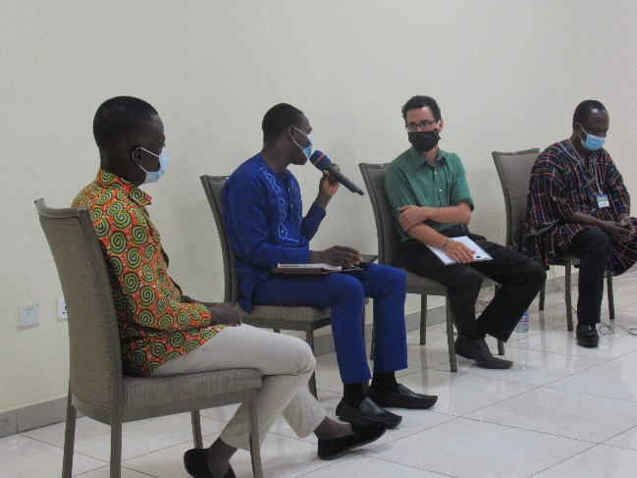 | 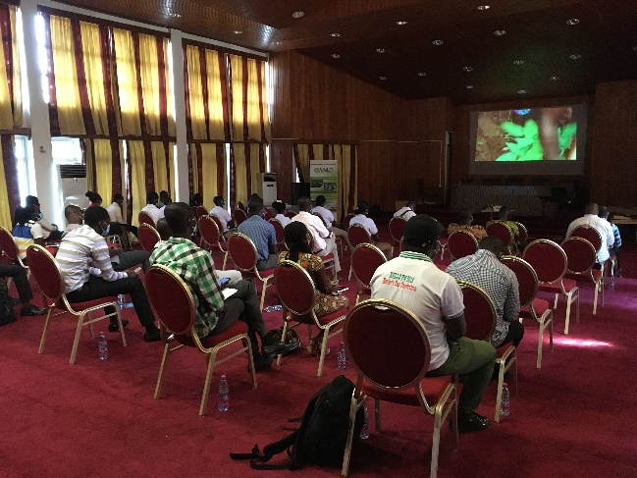
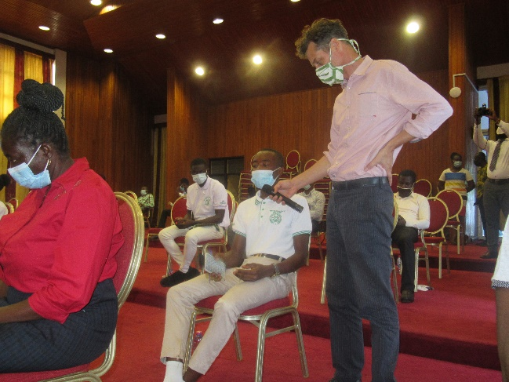 | 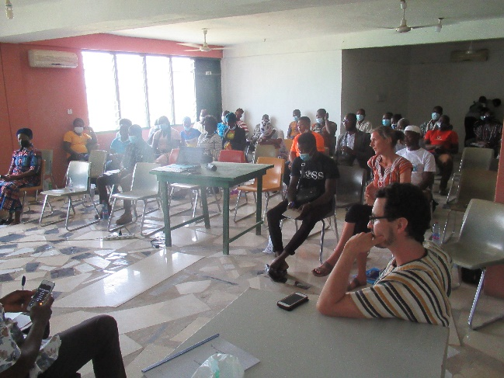
Figure 2: Impressions from the documentary screenings in June 2021 in Accra (top left), Kumasi (top right and bottom left) and Bolgatanga (bottom right).

