**BRING SMILE ON NEGLEGTED GYPSY CHILDREN-Pakistan**

Reported: June 19, 2019

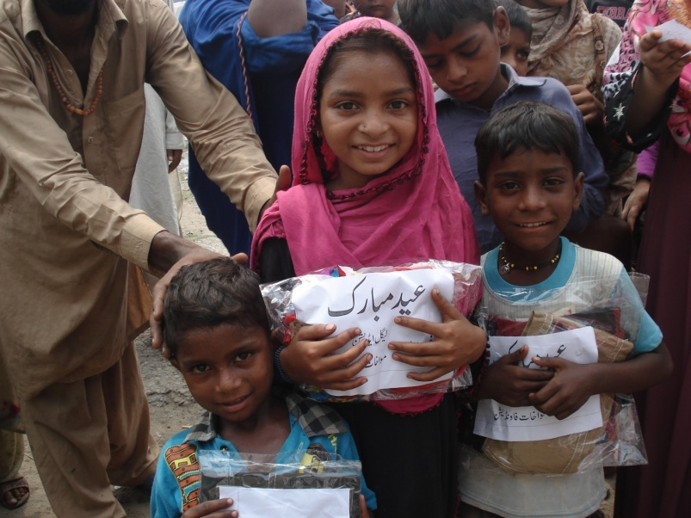

**Background**

In Pakistan July 2016 Muslims celebrated Eid ul fitr (religious festival) by wear new clothes; enjoy traditional foods especially deserts, visits to friends and relatives house and big attraction for children to get eidi (money) from elders. Islam gives message of brotherhood, mean share joys with neglected and poor people on festivals. During whole Ramadan Muslims give Zakat, Donation and funds to poor families for purchase of new clothes and food and celebrate Eid in same spirit like other Muslim families.

Gypsy Families are most neglected community and lives below poverty line in our society. They remain deprived of basic rights despite being Pakistani citizens. According to statistics, there are over seven million gypsies living in Pakistan. But despite their number, gypsies have no identity due to their lack of documentation.

Muwakhat Foundation is working since July 2013 for uplift living standard of poor by provides food, health, education and legal support especially to women and girls. First time, Muwakhat Foundation planned to give new clothes, Hina (girls design tattoos on hand) and Eidi (some money) to gypsy children age from 4 to 8 years. This idea was promoted in friends and relatives and mostly individual philanthropist did financial contribution in the holy month of Ramadan. Result individual small contributions become big chunk of funds for bring smile on innocent faces.

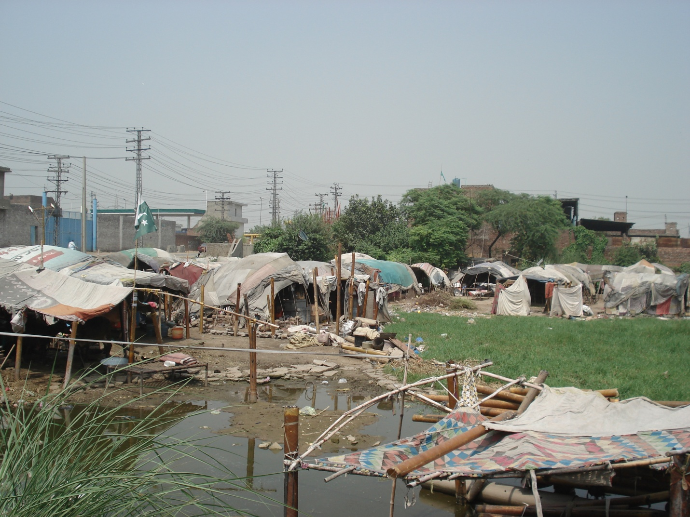

**EID GIFTS DISTRIBUTION EVENT**

Three days before Eid ul Fitr festivals Muwakhat Foundation purchased new clothes, Hina and made 300 Eid Gifts for selected gypsy children age between 4 and 8 years. These children were chosen by staff members through field survey in gypsy community of Lahore city. The small event arranged for distribution of gifts and invited some individual philanthropists who are working at grass root level for poor community. All 300 packages were distributed to gypsy children. The moment is caught by eye of camera, smile on children’s faces on received of new clothes and Eidi(money).

**Some pictures of distribution of gifts to children**

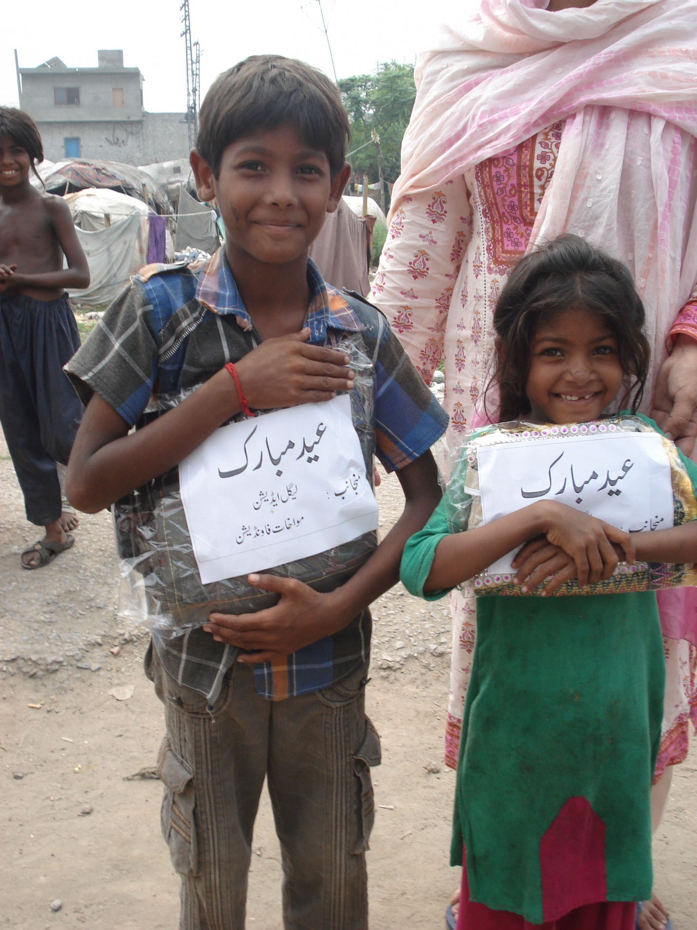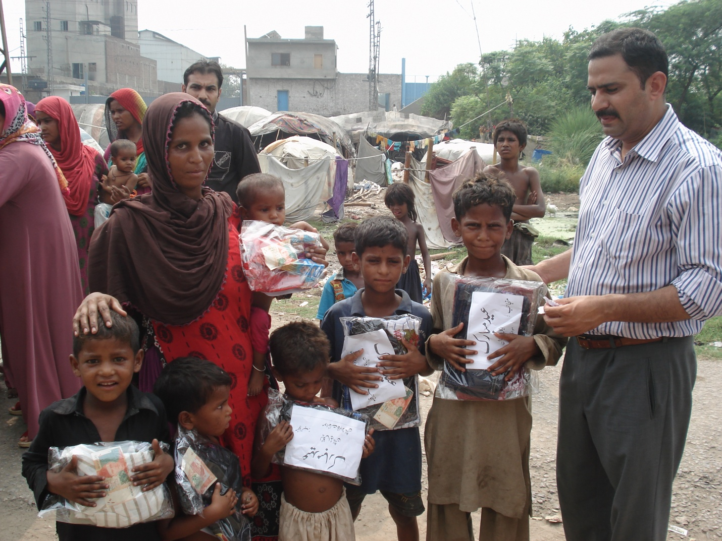

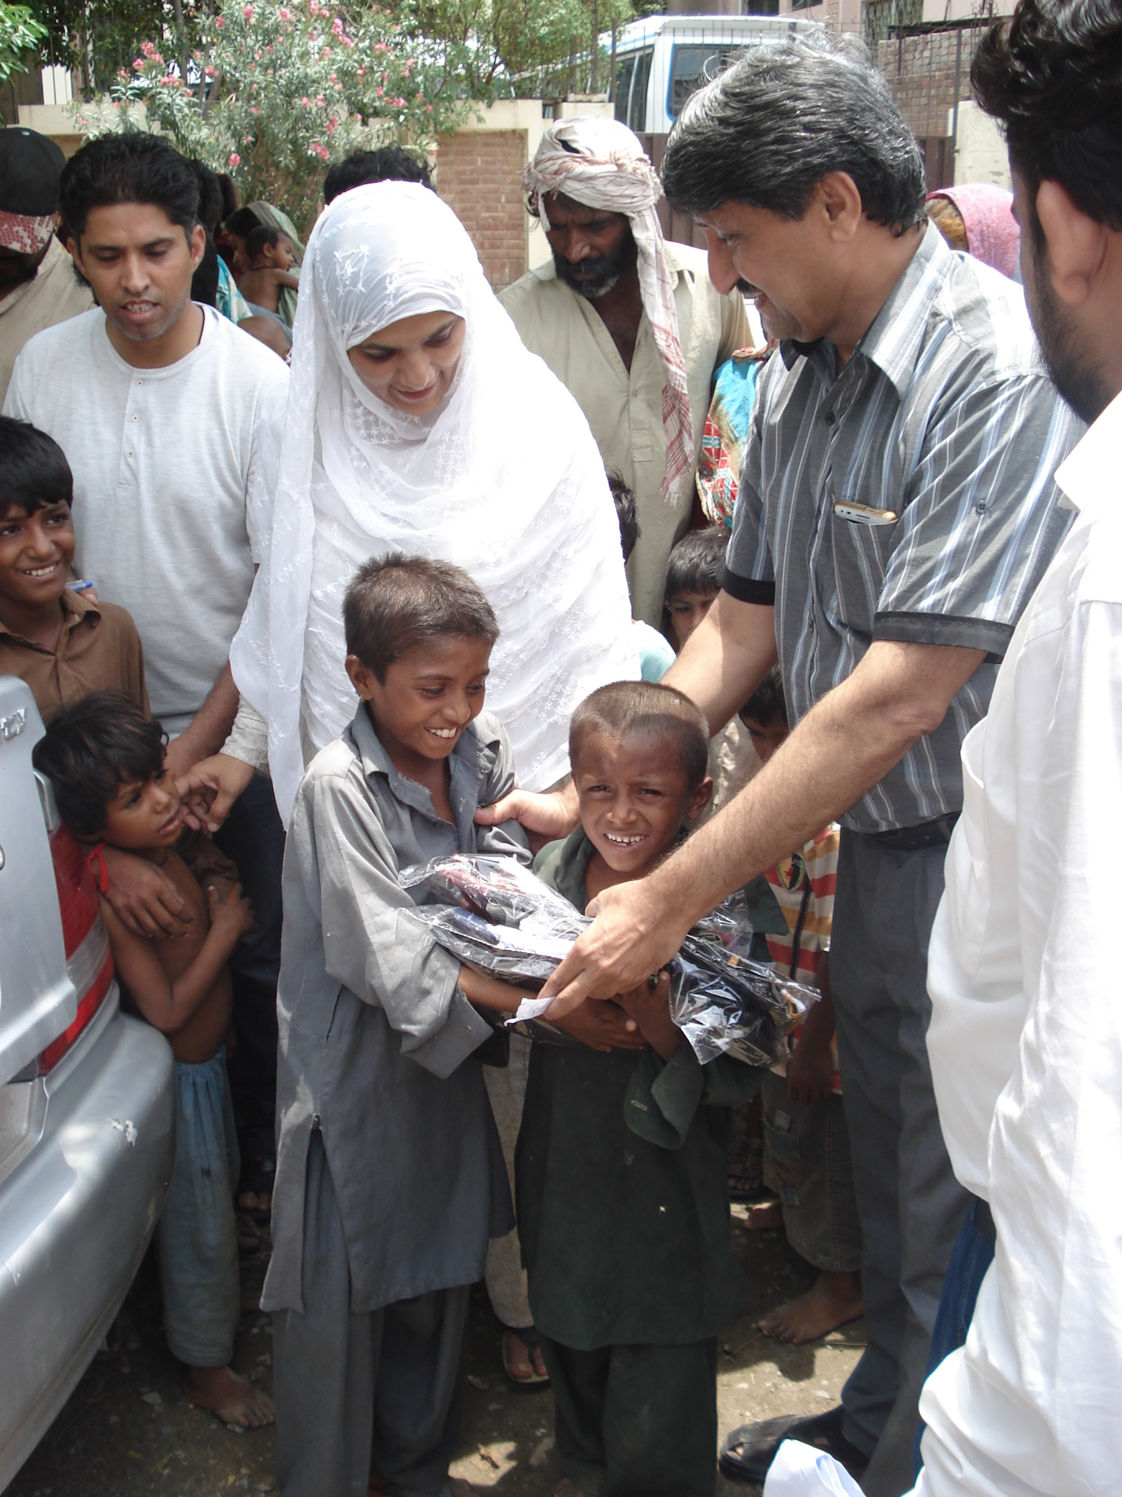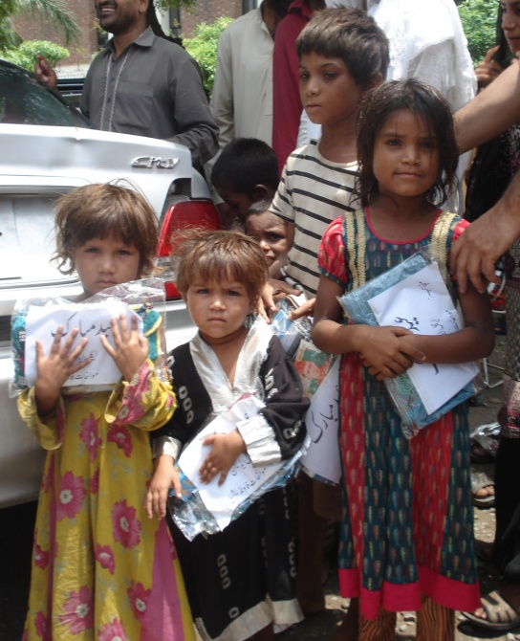

**LEARNING**

Muwakhat Foundation did small effort for gypsy children but they need long term support to come out from poverty trap and live respectable life. In future Muwakhat Foundation select 500 gypsy families , provide basic needs for three years to bring lasting happiness.