A Proposal Seeking Support for Education of Hearing Impaired Children

To provide Special Education for Hearing Impaired Children
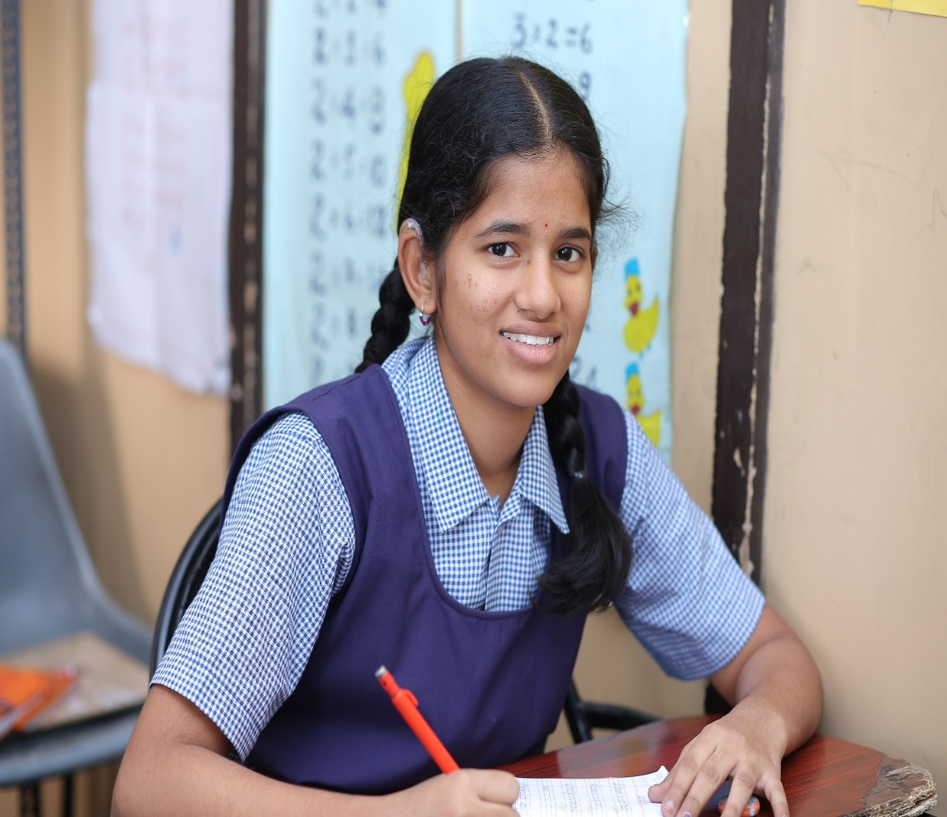

Table of Contents
Executive Summary 3
Project Area 4
Number of Beneficiaries 4
Goal of the Project 5
Project Objectives 5
The Need 5
Scope of the Project 6
Provide Hearing Aids 6
Auditory training 6
Speech therapy 7
Academics 7
Special Educators as instructors 7
Trained mothers to train the children 8
Low teacher student ratio 8
Use of Visual Aids in Teaching 8
Computer Lab 8
Computer Syllabus 8
Science Laboratory 8
Sports Activities 9
Art and Craft 9
Pre Vocational and Skill Development Program 9
Indian Sign Language 9
Monitoring and Evaluation Plan 10
Measurable Outcomes 11
Support Sought 12
Budget Breakup 12
Newspaper Clippings 13
Deliverables to the donors 13
About Ashray Akruti 14

Executive Summary
Hearing loss is the most common sensory deficit in humans today. Hearing impairment cannot be seen and hence its effects are not visible to others, so deaf people suffer in silence. Unlike blindness, deafness often provokes ridicules rather than sympathy. Very often a deaf person is isolated from family and friends and greeted by unsympathetic attitude. The consequences for a child born with hearing loss is quite severe. A child with hearing loss cannot develop speech and language abilities. This puts the child at a disadvantage in school, higher education, and limits future professional opportunities. The major problem of the child deaf is one that of communicating with the hearing and speaking world.
In 2012, WHO released new estimates on the magnitude of disabling hearing loss. The following estimates are based on 42 population-based studies.
- There are 360 million persons in the world with disabling hearing loss (5.3% of the world’s population)
- 328 million (91%) of these are adults (183 million males, 145 million females)
- 32 (9%) millions of these are children
- The prevalence of disabling hearing loss in children is greatest in South Asia, Asia Pacific and Sub-Saharan Africa
- Approximately one-third of persons over 65 years are affected by disabling hearing loss

Please click on this link and verifyhttp://www.who.int/pbd/deafness/WHO_GE_HL.pdf
The study conducted by Indian Institute of Public Health (IIPH), Hyderabad and London School of Hygiene and Tropical Medicine (LSHTM) reveals 12.2% (43.04 lakh) out of its 3.52 crore population, as per 2011 census in the new Telangana state, are disabled and they could be suffering from one or more forms of disabilities like epilepsy, vision, hearing, depression and physical impairments, says a new study.
2 in 1000 children born in India are deaf; 6 in 1000 children born in Andhra Pradesh and Telangana are born deaf which is three times the national average and6 times the global average. Globally children with disabilities count for one-third of all children out-of-school. In developing countries, the numbers are even more staggering, with 90% of all children with disabilities out-of-school.
Recognizing the need to provide special education facilities to children with hearing impairment, a school for the Hearing Impaired children was started in 1996 in Hyderabad, Telangana State, India. Which was started with five children and now caters the educational needs of 550 children.
The organization has been following several techniques in imparting special education to the hearing impaired children, the main feature being that the children are encouraged to speak. The focus is to enhance the residual hearing power of the children thus encouraging the children to express themselves through speech. The institution encourages participation of the mothers in effective development of their children. All the staff members are well equipped to train hearing impaired children. Children are given special training in auditory and verbal skills and also coached for SSC Board examinations of the State. The institution steadfastly maintains a low teacher-student ratio, which enables a special child to get the individual attention.
The school also encourages the students to participate in extracurricular activities like drawing, yoga, dance, Karate etc. so that it develops the children as well rounded personalities. The school also has well equipped Computer Lab, Science Laboratory and library which helps the students in learning.

The organization over the past twenty-two years has integrated children with hearing loss in the mainstream education system. The organization’s flagship project school has grown exponentially over the years and has been enrolling students not only from its locality, but now also from all over the state and the country! The organization is providing education to about 550 children with disability through its five centers in Hyderabad. Under the supervision and constant care of the faculty and staff, the children have performed admirable results in Secondary Board Examinations.
About the Project -Special Education of Hearing Impaired Children

Project Area
Hyderabad, Telangana State

Number of Beneficiaries
40 Hearing Impaired Children

Goal of the Project
- To provide comprehensive educational and rehabilitation program for children with hearing impairment and promote Inclusion.

Project Objectives
- To provide a comprehensive instructional program from Pre School through high school.
- To Provide Hearing evaluation and appropriate hearing aids
- To provide counseling services to students and parents
- To encourage parental involvement and understanding of special education programs.
- To provide support and services for the students to enable them to access higher education.

The Need

Hearing loss is the most common sensory deficit in humans today.
- WHO estimates, 360 million persons in the world are with disabling hearing loss. Approximately 8 % (32mn) of total affected population are children, majority of them are in South Asia.

- 2 in 1000 children born in India are deaf.

- 6 in 1000 children born in Andhra Pradesh /Telangana are born deaf which is three times the national average and six times the global average.

Globally, children with disabilities count for one-third of all children out-of-school. In developing countries, the numbers are even more staggering, with 90% of all children with disabilities out-of-school.

A breakthrough legislation that, provided for education and economic rehabilitation of With regard to India, The Equal Opportunities, and Rights of Persons with Disabilities Act 1995 was comprehensive people with disabilities. It states that free, education for children with disabilities up to the age of 18 years must be provided in an appropriate environment. The government has launched the Sarva Shiksha Abhiyan (SSA). This proposes to implement ‘universalization of elementary education’ (UEE) in a mission mode.

Further Right to Education (RTE) mandates free and compulsory education to all children from 6-14 years of age. The key objective of RTE- SSA is Universalization of Elementary Education (UEE). This goal of UEE, has further been facilitated by the Constitutional (86th Amendment) Act, making free and compulsory elementary education a Fundamental Right, for all the children in the age group of 6-14 years. This Amendment has given a new thrust to the education Children with Special Needs (CWSN), as without their Inclusion, the objective of UEE cannot be achieved.

Though the Government has worked extensively on this issue, the scale and magnitude of the challenge at hand is too large for them to succeed without civil society also playing a role.

Scope of the Project
The main objective of Ashray Akruti is to empower the hearing impaired students. Ashray Akruti is providing quality education for the children with Hearing Impairment since 1996. Medium of instruction is English. The syllabus and curriculum is according to the state of Telangana board. The syllabus is adapted to suit the requirements of the students. The teacher and student ratio is 1:8. The process of teaching involves individually planned systematically monitored teaching methods, adaptive methods, accessible settings and other interventions designed to help students to achieve higher level of self-sufficiency and success in the school.

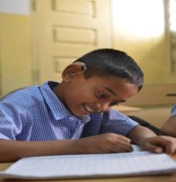
Provide Hearing Aids
The school actively encourages the children to use hearing aids to help them use their residual hearing power and trains them to listen and speak.

The students are assessed and evaluated at the hearing clinic run by Ashray Akruti by qualified Audiologist & Speech Language Pathologist (ASLP) We ensure right type of hearing aids are prescribed and provided to the beneficiaries.

Auditory training
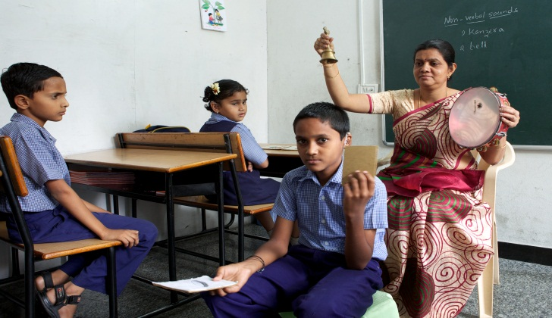
At Ashray Akruti, the students are provided regular, intensive training in developing listening skills.
Listening might seem easy to a person with hearing. But for a child with hearing loss, listening is often hard without proper training. Like other skills, the skill of listening must be learned.
Most children who are deaf have some hearing. This is called "residual hearing". The child is trained to use this residual hearing with the help of hearing aids or cochlear implants.

Speech therapy

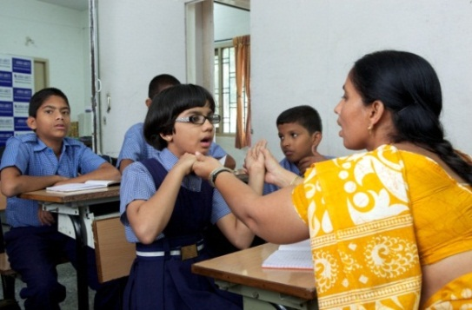
The speech therapist in the organization provides one-on-one therapy to children to speak and develop speech and language skills.

Speech therapy is a clinical program aimed at improving speech and language. The program focuses on improving

- Speech parameters like voice, articulation and prosody.

- Comprehension and expressive skills are developed through different activities.

Academics
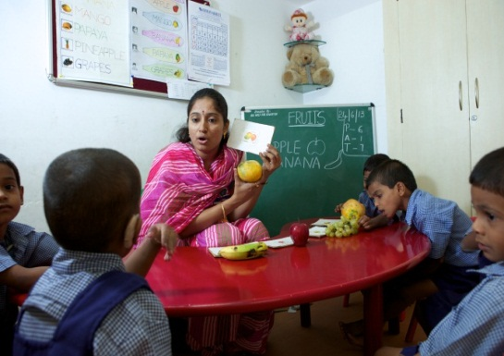
The school follows the oral aural mode of communication. At Pre Primary main focus is given on development of Speech and Language which is very important to success in academics and mainstreaming in the society. Pre School program assist parents in developing strategies to nurture their child language Speech, auditory and intellectual abilities. Parents are involved in the educational program so they understand the concepts and teaching methodology practice the same at home.
School follows state Board curriculum from Grade 1 to 10. Students of Grade 10 th at the end of the academic year appear the Common Exam which is conducted by Board of Secondary Education, Telangana State.
The Organization provides education through well qualified special educators by adapting the content of lessons and uses different techniques and teaching aids for better conceptual understanding. Individual attention is given to every child and remedial teaching is provided for the children who are performing low in academics in the school.

Special Educators as instructors: The school imparts the education through well qualified special educators to train the hearing impaired students. This training comes at the hands of RCI (Rehabilitation Council of India ) certified educators who provide much needed individual attention.
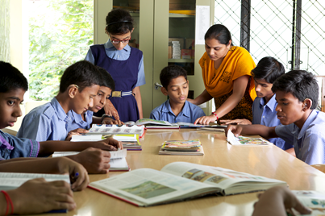
Trained mothers to train the children: The school involves the mothers of the hearing impaired students in the effective development and to promote further learning at home. Some of the mothers are encouraged to complete the certified Special Education course and they are now working with the organization as educators.

Low teacher student ratio: The Organization maintains low teacher student ratio of 1: 8 students to enable each student to get the individual attention they deserve.

Use of Visual Aids in Teaching: The Students relies more on the Visual teaching Aids to impart education.

Computer Lab

School has a full-fledged computer lab facility with trained faculty. There are workstations, network and internet that are available for the children to acquire the necessary computer skills.

Computer Syllabus
- Introduction of Computers
- MS Word
- MS Excel
- MS Paint
- Photoshop
- Internet

Science Laboratory
The School has a well-equipped Science laboratory for effective teaching and learning of science. It combines classroom teaching with laboratory experiments to ensure that their students grasp each and every concept thoroughly.

The students get a first-hand learning experience by performing various experiments on their own. Students are made to use the models and understand different scientific theories and concepts. Ashray Akruti School has the latest science lab supplies and equipment to make science interesting and effective for students and to encourage them to take interest in science subjects.

Sports Activities

Regular, vigorous physical activity is associated with physical, mental, and social well-being of people in general and more for children with disability. The organization has a playground for the children to play outdoor activities.

Students are encouraged to participate in sports activities in various sport activities under the supervision of Physical Education teacher. Children are given choice to choose the different games like Cricket, Kabaddi, Kho-Kho, Caroms, Chess and Badminton
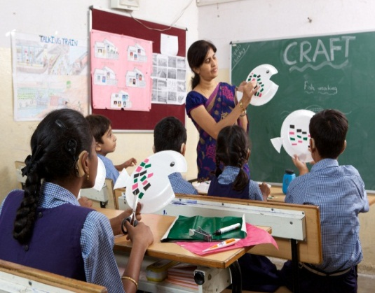

Art and Craft

School encourage students in bringing up their creativity and inborn abilities through Art and Craft. The school had dedicated drawing teacher ,crafts teacher to help the children improve their artistic abilities.

Pre Vocational and Skill Development Program

Ashray Akruti provides an opportunity to develop different skills through
Pre Vocational training according to the child’s interest. The children are taught

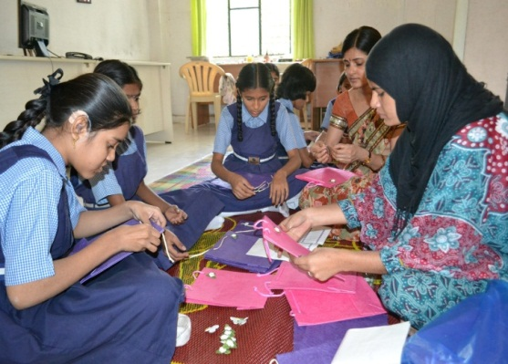
- Tailoring
- Carpentry
- Household electrical connections
- Spinning and Weaving
- Stone Art
- Glass Painting
- Mehndi designing
- Banjara Work

Indian Sign Language

Ashray Akruti provides opportunity to learn structured Indian sign language for communication with the help of Interpreter. The sign language helps the older children who may not be able to communicate through speech alone. A combination and speech and sign language help children express themselves in a better way.

Monitoring and Evaluation Plan

Objectives | Activity | Indicators for Outcomes | Time Frame | Sources of Verification  for activities
Provide Special Education to hearing impaired children | Academic training as per the state syllabus | Progress in reading and writing  Progress in understanding concepts  Progress in understanding subjects | 1 Year and continuous | Reports of the children  - Slip Tests  - Formative Assessment  - Summative Assessment  Pictures from the project  Videos
To provide quality hearing aids | Hearing Evaluation | Progress in listening skills | 1 year and continuous | Registers
Develop Listening skills among hearing impaired children | Auditory training by speech and language therapists | 1Ability to communicate  2.Clarity in the speech  3.Socialisation in the peer Group | 1 year and continuous | Reports from  - Speech Therapist  - Special Educators  Pictures from the project  Videos
Develop speech and Language | Therapy by speech and language therapist and special educators | 1.Improved Vocabulary among children | 1 year and continuous | Reports from  - Speech Therapist  - Special Educators  Pictures from the project  Videos
Co – curricular activities | Training in Yoga,Dance and Drawing and Painting. | Artistic skills of children improve,  Confidence levels improve | One year  (in progress) | - Records of the children  - Exhibitions  Pictures from the project
Training to mothers of Hearing Impaired Children | Training and counseling | Increased interaction with mother and family members. | Round the year in initial stages | - Records of Parent teacher meeting  Pictures from the project

Measurable Outcomes
- Academic performance improved in Hearing Impaired Children

- Listening Skills improved among Hearing Impaired Children

- Speech and Language Skills improved in Hearing Impaired Students

- Computer Skills improved among Hearing Impaired Children

- Parental skills improved to manage Hearing Impaired Children

- Improved Vocational Skills among 52 Hearing Impaired Children

- Students in progressing in extracurricular activities

- Students progressing in games and physical activities

Support Sought

We would be extremely grateful if you can come forward to extend support to the education of 40 hearing impaired children studying at Ashray Akruti School for the year 2019-20.

Budget Breakup

S.No | Particulars | No. of Children/No of units | Cost per child/unit per annum | Total Amount
1. | Special Education of Hearing Impaired children | 40 | 13,000 | 520000
 | Total support needed |  |  | 520000

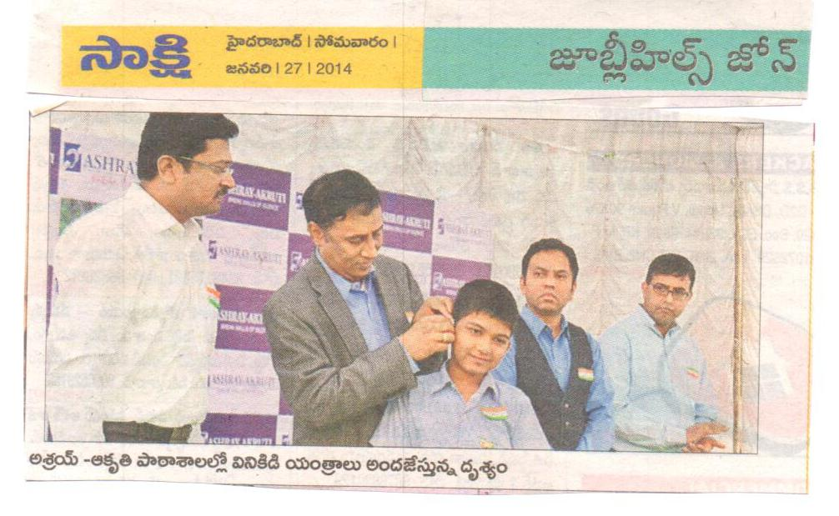
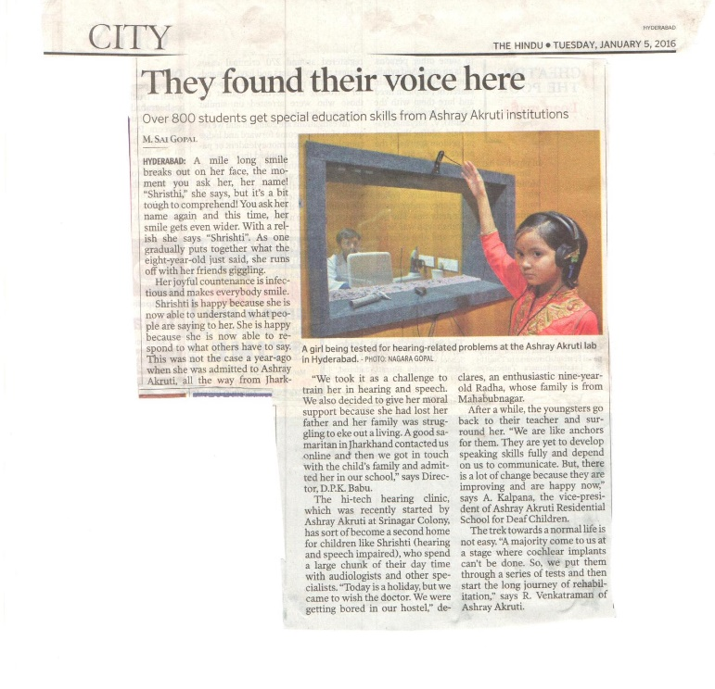
Newspaper Clippings
Sakshi News covered the news of Mr.Shasi reddy, VP – engineering ,Qualcomm India Pvt Ltd giving away Hearing Aids to the child.

Ashray Akruti’s impact covered by Times of India

Deliverables to the donors
- Financial Utilization Certificate
- Project Reports
- Annual report on projects
- Pictures & Video documentation
- Logo on the Website

About Ashray Akruti

VISION
Empower people with disabilities & people from underprivileged background, through quality education, health care and sustainable livelihood.
MISSION
To create institutional, non-institutional and community based interventions for the people to help them become independent self-reliant and contributing citizens of the country.
OBJECTIVES
- Provide comprehensive teaching and rehabilitation programs for children with disability
- Facilitate and promote ‘Inclusive Education’ in mainstream schools
- Provide market-aligned skill training for ‘hearing-impaired’ youth
- Provide ear and hearing screening, diagnosis and management through outreach programs for children in the age group of 0-14 years.
- Facilitate Cochlear Implant Surgeries / Aids, and appliances for hearing impaired children
- Develop human resources for the disability sector
- Work with corporates, to advance social responsibility and development

CORE VALUES
- Empowerment
- Innovation
- Accountability and Transparency

OVERVIEW
The organization currently implements programs, across Health, Education, and Skill Development, for people with disability and the marginalized sections of society.

our projects at a glance
Education:
Ashray Akruti’ s educational programs include:
- Government recognized special schools
Special education for children with hearing-impairment, at its three centers in Hyderabad.

- Early Intervention Centre
Intervention services to young children identified with hearing loss, with an aim to develop their speech and communication.

- Diploma in Special Education (Hearing Impairment)
D. Ed course in special education (Hearing Impairment) recognized by Rehabilitation Council of India, to develop special educators for the sector.

Health:
Health programs offered include:
- Cochlear Implant Surgery
Cochlear Implant Surgery for young babies with the support of organizations like National Institute of Hearing Handicapped, Max Foundation and Government sponsored Rajiv Arogyasri scheme.

- Hearing Diagnostic Facility
Advanced hearing screening facilities such as BERA, Impedance, and PTA to people from underprivileged backgrounds.

- Community Outreach Program
Hearing screening for new-born babies at government and charitable hospitals, hearing screening for senior citizens at old-age homes and ear health camps for students of Government Schools.

- Rehabilitation center for children with special needs
Rehabilitation center in the Borabanda area of Hyderabad provides services like speech therapy, physiotherapy, occupational therapy and behavioral therapy for children with various disabilities
Skill Development
Skill Development offered include

- Market aligned Skill Training: A unique skill based vocational training center for Hearing Impaired Youth in Computer Graphics, Multimedia and Animation.

- Pre Vocational Training: Pre vocational training in Tailoring, Banjara Embroidery, Mehndi designing, paper bag making for Ashray Akruti students.

Our projects at a Glance
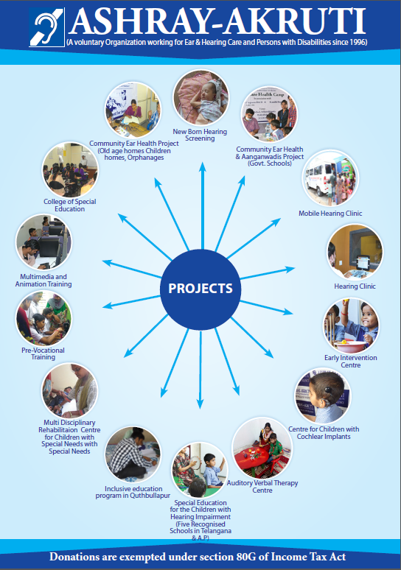

IMPACT since 1996
- 35 Children enrolled in inclusive education at Quthbullapur
- 180 hearing impaired youth trained in Multimedia and Computer Graphics and placed
- 85 Hearing impaired children supported with Cochlear Implant surgeries
- 250 Hearing Impaired children integrated in mainstream schools and colleges
- 550+ Hearing Impaired children provided special education
- 5300 + Patients were seen at Hearing Clinic and offered remedial rehabilitative services
- 10000+ Newborns screened for hearing at government and charitable hospitals
- 27000 parents counseled and guided in managing children with disabilities
- 37700 therapies conducted for children with disabilities
- 67482Children Screened through ENT & Hearing healthcare camps in Government schools & Aanganwadi
DUE DELIGENCE
- PWC
- E&Y
- DE SHAW
- HSBC
- Indian Institute of Corporate Affairs (Ministry of Corporate affairs)
- Credibility Alliance
- Give India
- Charities Aids Foundation India, USA, UK
- GuideStar
- TISS CSR HUB
- Tata Trust
- Tech Mahindra
AWARDS AND RECOGNITIONS
- Bagged ‘The Best Institution’ State award for its services in the disability sector. The award was presented by the Honorable Minister for Women Development, Disabled welfare and the Deputy Chief Minister, Govt. of Telangana on the occasion of International Day of Persons with Disabilities on 3rd December, 2017.
- Best NGO in the State Government of Telangana in December 2016
- Best NGO in the District of Hyderabad by Government of Telangana in June 2016
- Transparency award from Guidestar

Fact Sheet
Name of the Chief Executive: D.P.K. BABU, Secretary and Director
Address: 8-3-1027/A2, Srinagar Colony,
Lane opposite Indian Bank
City: Hyderabad 500 073
State: Telangana
Country: India
Telephone: +91 40 40042250 (Office)
Mobile: +91-9391021278
Website: www.ashrayakruti.org

Registration Information
Type of registration: Society
Registration number: 5489/96
Income Tax: 80G
Date of registration: October 24th 1996
FCRA No.: 010230590

