I Project Title:
Provide goats and hens to 100 widows and 100 orphans for education and incomes.
ii. Project summary:
The project is aimed at improving the incomes, and health status of: Households headed by women with orphans whose properties have been grabbed by relatives. This will be done through provision of 4 goats and 3 hens to the targeted family for income generation. 400 goats and 300 hens will be given to 100 widows and 100 hens. Then the women will be mobilized to establish savings and loan associations. They will be encouraged to save and then use the savings to provide loans as start up capital to association members to invest in other businesses to complement the goat and poultry projects. Beneficiaries will be trained on how to run these projects in a best way that can produce maximum benefits. Consequently, members’ incomes will increase and will be able to educate their children, acquire land and improve on their nutrition status.
Iii Project Needs and Beneficiaries:
Beneficiaries: 100 women who have lost their husbands and whose property like land, animals and shelter have been grabbed by relatives and 100 orphans will be targeted.
The said families have lost their land to either their relatives or rich people who connive with Government workers in ministry of lands to transfer landownership by altering land titles in their names.
During evictions, which are normally characterized by demolition of structures, cutting of animals and destruction of property by court brokers, these families have lost their property including animals and hens, a source of income for these families. As a result, they have lost the means with which to generate income to support their children education, provide quality medical care and at least 2 meals of nutritious food a day. In that way, these households are facing hunger, high incidence of diseases and poor health.
By providing them with income generation projects, the widows will use the income to educate their children, access quality medical care from well-equipped hospitals, and provided their family members with at least 3 meals of a balanced deity daily. Through savings and investment, widows will be able to buy land and construct good houses in the long run.
The project will be implemented in two sub counties namely, Nsinze and Kibale sub counties in Namutumba District, in Uganda-East Africa.
1v Project Activities:
100 women will be trained on how to provide proper care to goats and market their products. In so doing the beneficiaries will be able to identify and provide nutritious feeds to their goats, detect diseases and treat them in time, cost their animal products properly and market them at a competitive price that generates a reasonable net profit.
The widows will be provided with 4 goats each, for rearing and multiplication to generated income. Local goats are well suited to this area, reproducing twice a year and usually giving birth to two siblings at a time. An improved local goat when sold will fetch between USD 56 and 80 USD per year. Families getting this kind of income can buy exercise books, pens and a uniform for an orphan between grade one and seven for one year.
Caregivers will be trained in poultry management. The skills and knowledge they will gain will enable them provide proper care to their local hens, treat their diseases and market poultry products at good prices with a reasonable profit margin. Then the trained orphans will be provided with 3 local hens each. The three local hens are expected to lay over 30 eggs within a period of one month. So, it is anticipated that within 6 months the household will have over 30 birds.

A four -month old bird costs between USD 4 to 5. At that rate, a family with 30 hens will have a potential income of USD120 to $200 within six months, which is enough for buying food stuffs that can enable a family of 6 people have at least three meals a day for 40 days in this rural area of Nsinze and Kibaale sub counties.
Additionally, some eggs will be given to children during breakfast and evening tea daily, which will improve their nutrition status. Improved nutrition among the beneficiaries will strengthen their body immunity. In so doing they will not fall sick as frequently as before thereby increasing their lifespan. Nabisalu a caregiver to four orphans had this to say” Eggs have proved to be a cure for Kwashiorkor, because since I started feeding my grand children on eggs daily, their hair that used to look funny, has turned black and looks healthy”.

The government agricultural extension work will be provided with transport to go to these hard-to reach areas and provide veterinary extension services to women projects. In so doing, diseases among the birds and animals will be detected and treated in time. This will ensure healthy and productive animals and poultry birds.

100 Women will be mobilized to form, and manage village saving and loan association. They will be trained for 4 days on selection of projects, management of association, planning, saving and loan management, business management skills and human rights. They will be encouraged to save at least $ 10 out of their total income per month.
The savings will form a fund for the group members from which to borrow money at a smaller interest, for either investment or solving domestic problems including medication, school fees for their children etc. Members will share out their savings in addition to the accumulated income from interest on loans at an appropriate time as agreed upon by members. It is hope through savings members will be able to get enough money for buying land and construct permanent shelters and continue saving and giving loans to their members for investment long after the project official funding will have been stopped.

This is a wonderful way to work towards the weakest in the community being able help themselves and so improving their health, self confidence and future prospects.
V. Donation options:
- $10 will buy 2 hens for an orphan that will multiply to 20 hens worth $ 80 to $100 enough to buy 3 meal meals a day for a family of 5 people for 20 days within a period of six months.
- $ 15 will train 10 widows how to form saving and loan associations, save and invest savings in profitable business.
- $18 will immunize 20 birds against bird-related diseases so that they grow to multiply and generate more income
- USD 35 will buy a goat that will produce more two goats within 12 months worth USD120 to 160 enough to keep one child in primary school for one year.
- USD 36.44 will train one widow on proper management of goats and marketing their products with a reasonable profit margin.
Vi. Potential long term impact.
The project will directly benefit 100 widows and 100 orphans through increasing their opportunities to generate income. With increased incomes, the widows will be able to buy land, educate their children, provide them with quality medical care, and provide for their clothes, nutritional needs and shelter thereby improving their quality of life.
Vii Project Message:
Nabisalu said during the community consultation to support widows whose land hand been grabbed, “ If you help us you will have saved us and our children from exploitative labor and prostitution, if you don’t, we may not live to see our children grow because of AIDS”.
Monitoring and evaluation plan for the project:
Narrative | Indicator | Means  of verification | Frequency | Person responsible
Goal:  To increase the capacity of widows to access proper medical care, , land, quality child education, food and permanent shelter by 2010 | Percentage of women who can afford to provide proper medical care, education, adequate food | Impact evaluation report. | After three years | The project manager and donor
Outcome:  Increased incomes of Women with income generating projects. | Percentage of women with a shelter and a land to grow food. | Post-evaluation report | After three years | Monitoring and evaluation officer
Outcome:  Increased capacity of women to feed and educate their children | Percentage of orphans in schools | End of project evaluation report. | After twelve months | Monitoring and evaluation officer
 | Percentage of households who can have at least 3 meals of a balanced deity a day. | End of project evaluation report. | After twelve months | Monitoring and evaluation officer
Project Outputs:
Women trained on looking after goats | # of women trained to look after goats | Training reports, attendance lists, photos of trainees | monthly | Monitoring and evaluation officer
Women trained on costing and marketing skins, goat meat and goats | # of women trained in marketing of goat products | Training reports, attendance lists, photos of trainees | monthly | Monitoring and evaluation officer
Women provided with goats. | # of women with goat projects | Distribution lists for goats, acknowledgements for goats | monthly | Monitoring and evaluation officer
Orphans provided with local hens to 100 orphans. | # of orphans provided with hens | Distribution lists for hens, acknowledgements for hens | monthly | Monitoring and evaluation officer
Caregivers trained in poultry management. | # of women trained in poultry and marketing its products | Training reports, attendance lists, photos of trainees | monthly | Monitoring and evaluation officer
Agricultural extension work supported to provide extension services to women projects | # of agricultural workers supported to support women in animal husbandry and poultry. | Activity reports and supervision reports | monthly | Monitoring and evaluation officer
Women trained on how to form, manage village saving and loan association for self help groups | # of women trained in village savings and loan association. | Training reports, attendance lists, photos of trainees | monthly | Monitoring and evaluation officer
Women trained in relevant business management skills | # of women trained in business management skills. | Training reports, attendance lists, photos of trainees | monthly | Monitoring and evaluation officer
Monthly meetings conducted to review project progress | # of monthly review meetings conducted | project reports, attendance lists, photos of trainees | monthly | Monitoring and evaluation officer

Viii. Project funding requested for.
The project will be implemented using USD 37,798 for Seven months. Below is the break down of the budget.
BUDGET FOR 12 MONTHS FOR THE HOMELESS ORPHAN AND WOMEM PROJECT
 | Quantity of items | # of beneficiaries | # of days | Unit cost | Total
Train 100 women in looking after goats
Writing pads | 1 | 100 | 1 | 2 | 200
box of pens | 5 | 1 | 1 | 10 | 50
Masking tape | 7 | 1 | 1 | 2 | 14
Rolls of flip charts | 6 | 1 | 1 | 10 | 60
meals to participants | 1 | 100 | 4 | 5 | 2,000
Facilitator's allowances | 2 | 1 | 4 | 15 | 120
Training venue | 1 | 1 | 4 | 50 | 200
Train 100 women in costing and marketing skins, goat meat and goats |  |  |  |  | -
Writing pads | 1 | 100 | 1 | 2 | 200
box of pens | 5 | 1 | 1 | 10 | 50
Masking tape | 7 | 1 | 1 | 2 | 14
Rolls of flip charts | 6 | 1 | 1 | 10 | 60
meals to participants | 1 | 100 | 4 | 5 | 2,000
Facilitator's allowances | 2 | 1 | 4 | 15 | 120
Training venue | 1 | 1 | 4 | 50 | 200
Buy 400 goats for 100 women | 4 | 100 | 1 | 35 | 14,000
Transport 400 goats to distribution sites. | 2 | 1 | 1 | 100 | 200
Provide local hens to 100 orphans. | 3 | 100 | 1 | 5 | 1,500
Immunize hens against poultry diseases | 1 | 100 | 2 | 3 | 600
Transport hens to distribution centres | 3 | 1 | 1 | 50 | 150
Train caregivers in poultry management.
Writing pads | 1 | 100 | 1 | 2 | 200
box of pens | 5 | 1 | 1 | 10 | 50
Masking tape | 7 | 1 | 1 | 2 | 14
Rolls of flip charts | 6 | 1 | 1 | 10 | 60
meals to participants | 1 | 100 | 4 | 5 | 2,000
Facilitator's allowances | 2 | 1 | 4 | 15 | 120
Training venue | 1 | 1 | 4 | 50 | 200
Facilitate the agricultural extension work to provide extension services to women projects |  |  |  |  | -
allowance to extension worker | 1 | 1 | 48 | 10 | 480
Train women on how to form, manage village saving and loan association for self help . |  |  |  |  | -
Writing pads | 1 | 100 | 1 | 2 | 200
box of pens | 5 | 1 | 1 | 10 | 50
Masking tape | 7 | 1 | 1 | 2 | 14
Rolls of flip charts | 6 | 1 | 1 | 10 | 60
meals to participants | 1 | 100 | 4 | 5 | 2,000
Facilitator's allowances | 2 | 1 | 4 | 15 | 120
Training venue | 1 | 1 | 4 | 50 | 200
Train communty based trainers in village savings and loan association methodology and business management. |  |  |  |  | -
Writing pads | 1 | 100 | 1 | 2 | 200
box of pens | 5 | 1 | 1 | 10 | 50
Masking tape | 7 | 1 | 1 | 2 | 14
Rolls of flip charts | 6 | 1 | 1 | 10 | 60
meals to participants | 1 | 100 | 4 | 5 | 2,000
Facilitator's allowances | 2 | 1 | 4 | 15 | 120
Training venue | 1 | 1 | 4 | 50 | 200
Train women in relevant business management skills |  |  |  |  | -
Writing pads | 1 | 200 | 1 | 2 | 400
box of pens | 5 | 1 | 1 | 10 | 50
Masking tape | 7 | 1 | 1 | 2 | 14
Rolls of flip charts | 6 | 1 | 1 | 10 | 60
meals to participants | 1 | 100 | 4 | 5 | 2,000
Facilitator's allowances | 2 | 1 | 4 | 15 | 120
Training venue | 1 | 1 | 4 | 50 | 200
 |  |  |  |  | -
Provide transport to staff to monitor project work. | 1 | 1 | 48 | 15 | 720
Pay staffs to manage the project. | 1 | 1 | 240 | 6 | 1,440
Grand total. |  |  |  |  | 37,798
Xii Main project picture:
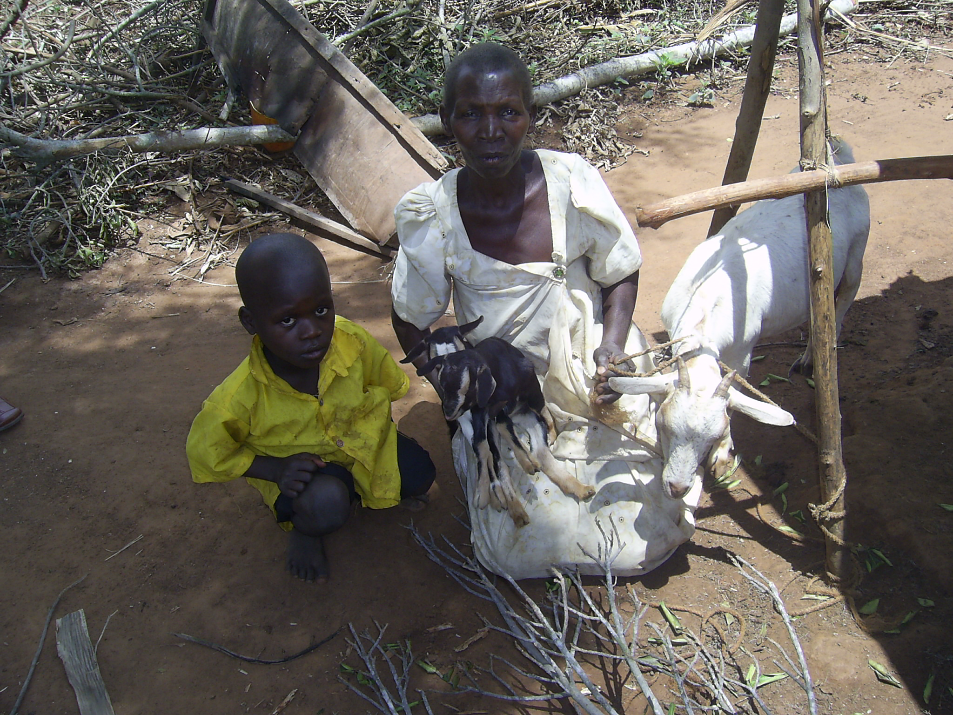
Figure 1 A widow holding a goat that was given by UPIMAC

