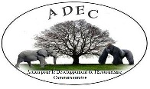**PROJECT IN SUMMARY**

**2019 – 2020 Anti-Encroachment Campaign around Volcanoes National Park**

The 2019-2020 Anti-Encroachment Campaign around the Volcanoes National Park in Rwanda takes an active, hands-on approach. Our first campaign will ensure the protection of endangered natural resources while working with ex-poachers. It is with high hopes that our organization will be able to involve current poachers as well. Through educational and conservation-oriented approaches, we hope to change their practices so that they conserve, rather than destroy, the natural world around them. The benefits of this campaign will have a positive, wide range effect across Rwanda, especially in communities bordering the Volcanoes National Park, home of the endangered mountain gorillas. Our organization will work with members of various local communities, allowing them to take active roles in ensuring the future of Rwanda’s conservation efforts. Ex-poachers, as well as current poachers, will have the opportunity to take an active part in our organization’s projects. Our projects will help develop ecotourism, conservation and humanitarian practices through education, socio-economic research and sustainability. Our Campaign, like ADEC, itself, is a proactive movement involving Rwandans and Rwandan communities to promote conservation efforts within their own country.

**Project summary**

This first phase of the project is planned to extend from 2019 to 2020, renewable based on funding. The project is operated by ADEC (Action for the Development of Community Ecotourism). ADEC, a Rwandan NGO, is an organization which has been granted provisional licensure through the Rwandan Government in order to operate in the area of conservation and community ecotourism. The overall strategy of ADEC is to establish partnerships with other wildlife conservation organizations while working closely with local communities. For this reason, ADEC has begun partnering with global giving accelerator. During its first annual phase, the project will cost 255,000 USD. The major players in this project, as well as ADEC as a whole, include local communities, namely ex-poachers, and Rwandan partners in wildlife conservation. The goal of the project is to be renewed on a yearly basis, allowing a continuous approach to our conservation efforts. Crowdfunding will be the major operating budget based on raised funds. On an annual basis, ADEC hopes to recruit, train and disseminate 600 community workers into this campaign against forest encroachment. It is our goal that each community worker will exercise the various, project activities and further involve, educate and recruit over 100 local, Rwandans in each of the communities we work in. Therefore, the project will extend throughout all of Rwanda’s National Parks and surrounding localities.

**Challenges**

ADEC is a unique organization because it is one of the few Rwandan run and Rwandan-based wildlife conservation organization. As Rwandans, we believe that the best practice for protecting our country’s natural environment and endangered species is through the direct actions of local populations. Being a Rwandan run organization has been challenging. However, we did receive approval and support from the Rwandan government as well as the local communities. Unfortunately, at such early stages, the organization has not raised sufficient funds to launch its project. ADEC continues to search for partners as well as networks designed in crowdfunding. Fortunately, we have partnered with Global Giving, an experienced organization that surrounds crowdfunding. Another major challenge includes the low level of education that most poachers and ex-poachers have. This will require creative, educational measures in order to sensitize them to our organization and the goals of this specific project. Since ADEC wants to involve Rwandan youth, as they are the very future of our country, the low education extends the challenge to them as well. Since ADEC will be working with people from various backgrounds and age-ranges, it will require efficient time and managerial skills and resources. The number one challenge that ADEC faces is the poverty of the people surrounding Rwanda’s National Parks. Mobilizing them will require a lot of social and economic incentives.

**Solutions**

The main approach that will be used by ADEC is partnering with local, national, and international community development workers and wildlife preservation agents. ADEC will grow through the experiences it has with its partners and collaborators. Currently, our principal partner is GlobalGiving. This partnership will make it possible for ADEC to access the necessary resources that it needs to grow and develop throughout Rwanda. The Campaign against Encroachment will benefit local communities in terms of promoting biodiversity and sustainability. The regrouping of community workers into associations and cooperatives will boost the socio-economic standards. The socio-economic incentives that will be distributed to local populations will enhance their livelihoods. ADEC plans on using educational projects, socio-economic surveys and humanitarian development to engage communities across Rwanda as well as important local people, including ex-poachers and current poachers, in order to take up the fight for conservation.

**Long-term impact**

The overall goal of ADEC is to secure the future of Rwanda’s natural environment. In order to achieve this complex but mandatory goal, we must address the issues of sustainability. How can we achieve this while ensuring the conservation of Rwanda’s biodiversity? It takes commitment, sincerity, perseverance and an overall ethical value that must involve Rwanda and its people! This is not a short-term or quick solution. One cannot come and go into a community and expect results. It will take a long-term dedication to achieve these goals. Local communities will be trained to cope with everyday life hardships by gaining various skill-sets while receiving socio-economic incentives in order to cherish, learn about and ultimately protect their own natural heritage. It is not just about protecting nature, endangered species and diverse habitats. It is also about ensuring the livelihoods and good practices of local communities. In the long run, the project will positively impact the overall conservation, sustainability and human development throughout Rwanda.

**PROJECT IN GENERAL**

**2019- 2020 Anti-Encroachment Campaign around Volcanoes National Park**

**CONTEXT/BACKGROUND:**



Map of Rwanda showing the targeted areas where ADEC will carry out and implement its conservation projects.

Today anti-poaching measures and conservation issues are at the top of Rwandan governmental agendas. In 2003, surrounding this agenda, Rwanda published its National Strategy and Action Plan for the Conservation of Biodiversity. In 2009, Rwanda published its tourism policy. Within the framework of Vision 2020, Rwanda has developed the SMART Rwanda Master Plan 2015 – 2020. This plan was approved by the cabinet on November 3, 2015. According to this framework, Rwanda intends to develop the necessary infrastructure and required skills in order to transform the country from a subsistence, agricultural-based economy to a service and knowledge-based economy by 2020. Parallel to this agenda, Rwanda issued its cultural heritage policy in 2015. The main objectives addressed in this document is to raise awareness about the deteriorating conditions of cultural assets and the ill management they are subject to. The main challenge includes the encroachment of people onto protected lands while damaging the country’s delicate, cultural and natural richness. On the same agenda, in 2016, Rwanda compiled its five- year strategic plan for the development of cultural tourism from 2017 – 2022. As set forth by the specifications of this compilation, the preservation, and management of cultural assets and sites will serve as a springboard for the development and improvement of ecotourism throughout the country. Furthermore, this will contribute to the diversification of existing tourism practices. Presently, poaching activities do not constitute a major threat to the national parks. Around Volcanoes National Park, there are about 20 cooperatives of former poachers regrouped into the associations Amizero. There are over 500 people in this association. However, encroachment issues and challenges have not been reported or properly studied and outlined around Volcanoes National Park.

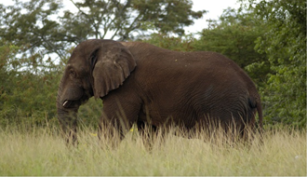

Adult female elephant peacefully walking across one of Rwanda’s National Parks, where ADEC will focus its efforts.

**CHALLENGES:**

Rwanda has issued and managed to set up frameworks and legislations that intend to further tourism and boost socio-economic situations for its citizens. Nonetheless, capacities, competencies, and skills are reported to be insufficiently developed. Both physical and soft infrastructures lack needed momentum putting the dynamics of tourism to the level of current and affordable feasibilities. Although Rwanda’s tourism administration has initiated the sharing of tourism revenues since 2005 while elaborating on various guidance documents for tourism development, the tourism development requirements remain insufficiently developed. The former poachers, now regrouped into associations and cooperatives, lack the required knowledge and skill-sets surrounding conservation initiatives, ecotourism activities and socio-economic practices for sustainable outcomes. This is the reason why ADEC has envisioned a project of anti-encroachment in order to boost both ecotourism and tourism activities in the vicinity of Volcanoes National Park. This project will be extended to other National Parks of Rwanda as well.

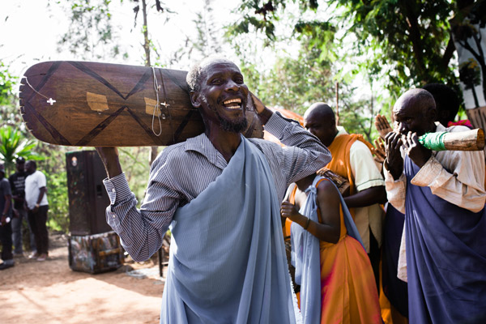

Local communities, surrounding core areas around the Volcanoes National Park, are needed in order to continue to fight for conservation in Rwanda. ADEC’s conservation plan surrounds protecting and ensuring the future of Rwanda’s natural AND cultural heritage.

**MAIN PROJECT OBJECTIVE:**

The main objective of this project is to equip at least 600 ex-poachers with necessary skills to raise awareness among local communities on issues of conservation and ecotourism potential and cost-effectiveness.

**SPECIFIC PROJECT OBJECTIVES:**

* To partner and raise necessary funds for awareness of anti-encroachment activities around Volcanoes National Park
* To equip ex-poachers and local communities with skills so that they can combat the consequences of poor, natural resource management
* To educate local communities with knowledge surrounding the consequences of over-exploiting and harvesting existing resources
* To incorporate alternative sources of socio-economic development into communities surrounding Rwandan National Parks
* To lead campaigns on anti-encroachment issues around Volcanoes National Park



ADEC’s ultimate goal is to ensure the survival of endangered species and habitats in Rwanda so that animals, like this endangered, infant mountain gorilla, will have a peaceful and safe future.

**APPROACHES AND METHODS:**

Through a partnership with GlobalGiving, ADEC will resort to crowdfunding internationally, across the globe. Through the Global Giving Accelerator, ADEC will elaborate sound and opportune projects eligible in the framework of GlobalGiving Vetting. As the qualified partner becomes a permanent member of Global Giving, ADEC will have the opportunity of membership to further and extend this project. Through crowdfunding across the globe, ADEC will be able raise the necessary funding to finance the trainings, events and practices in the framework of this agenda. It will recruit competent personnel on a permanent and temporary basis. Through this initiative and the proper resources, ADEC will surround itself with a strong membership of Rwandan collaborators, local community members and global supporters as it becomes a recognized, conservation organization, not only within Rwanda, but internationally as well.

Education is the key to development, no matter what the initiative, obstacle or goal is. ADEC will use educational strategies to implement its conservation policies. Local communities will learn about sustainable practices, current threats to conservation efforts, ecotourism programs and healthy living, amongst other initiatives. Through these educational projects, ADEC will help communities develop and implement various, socio-economic sustainable practices which will allow them to take active measures in conserving their natural heritage while maintaining cultural pride.

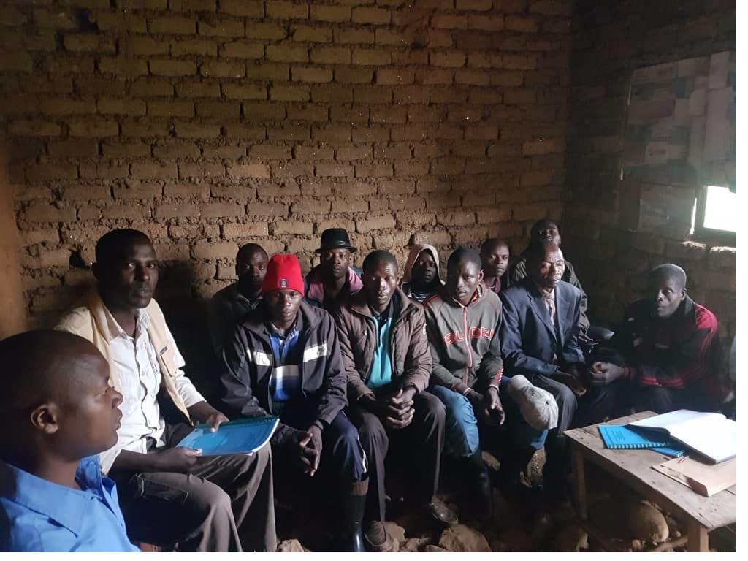

ADEC prides itself by being a Rwanda NGO, supported by the Rwandan Government, developed and run by Rwandans and working closely with local communities around Rwanda’s National Parks. ADEC works with all local individuals, no matter what their background, education or economic status is. The organization also focuses on working with ex-poachers.

**SUSTAINABILITY OF THE PROJECT:**

The sustainability of this project is rooted first in the firm determination of the Director to contribute, by all means, to conservation measures through community ecotourism development. Second, the project plans on incorporating the support of many actors at national and international levels to uphold actions in harmony with sustainable goals (SDGs). Lastly, certain activities of ADEC members will generate income benefiting local communities. These include various cultural activities, educational projects, ecotourism development and so forth.

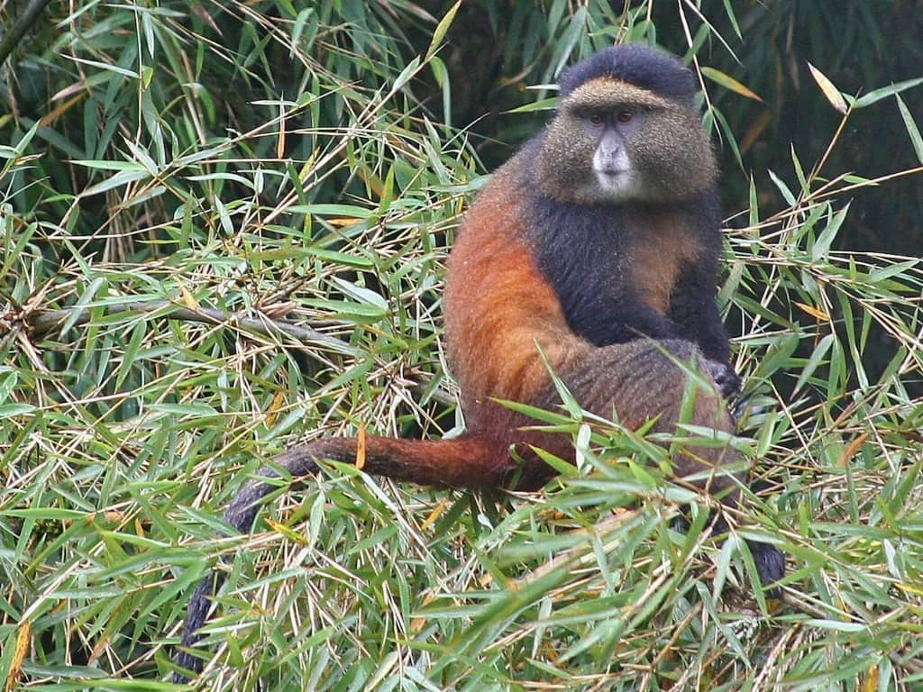

ADEC’s aim is to protect all of Rwandan’s wildlife, including this golden monkey.

**KEY PERSONNEL:**

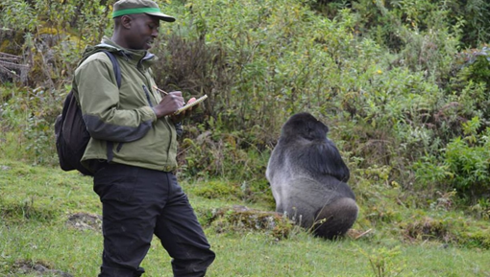

**Mr. John NDAYAMBAJE**

He is the Managing Director of ADEC. He is an expert in mountain gorilla conservation, behavior and ecology. He has experience of animal protection and research in the Volcanoes National Park. He was head ranger and Field Data Coordinator in DFGFI (The Dian Fossey Gorilla Fund International) where he studied gorilla behavior while protecting them. John Ndayambaje also participated in mountain gorilla census research in Uganda’s Bwindi Impenetrable National Park for almost 10 years.

“I spent many years working with the Dian Fossey Gorilla Fund International as a coordinator, organizing and leading their rangers and anti-poaching patrols. Working for the Fossey Fund, I also took part in many scientific research activities, such as observing gorilla behavior while ensuring their protection. Through my years working with the Fossey Fund, I made many scientific observations while taking a major role in gorilla conservation as a whole. I even observed a gorilla destroying a poacher’s snare. As a Rwandan National I believe in protecting all of the animals and the environment of my beautiful country. However, this can’t be done alone. Everyone must get involved in order to ensure that these animals are protected while working with local communities throughout my country. There has to be a balance so that Rwandans can thrive as well through such activities as education, research and health projects. This is why I decided, as a Rwandan, to develop and create my own wildlife conservation organization. ADEC was established in order to protect Rwanda’s natural environment and its unique wildlife while creating and ensuring a bright future for Rwanda’s people and country as a whole.”

-**Mr. John NDAYAMBAJE, Managing Director and Founder of ADEC**

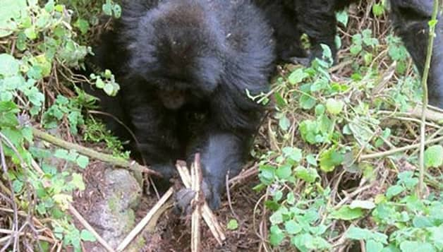

John Ndayambaje observed himself Gorillas destroying Snares in Volcanoes National Park

See link:

<https://africageographic.com/blog/young-mountain-gorillas-destroy-poachers-snares/>, <https://africageographic.com/blog/young-mountain-gorillas-destroy-poachers-snares/>, <https://www.facebook.com/savinggorillas/posts/10150518892715064>

**Mr. Jean Baptiste Mutuyimana**,

He is ADEC’s Finance & Operations Manager. He is an expert in Financial Administration. Jean Baptiste worked as a community development planner and financial manager. He has extensive experience in community development because he has worked with community developmental organizations for over 20 years.



|  |  |  |  |  |
| --- | --- | --- | --- | --- |
| **Detailed Budget per Category** | | | | |
| **Period:** | December 2019 to December 2020 |  |  |  |
| **Sub recipient:** | GG-ADEC/ECOTOURISM ACTIVITIES | | | |
|  |  |  |  |  |
| **GG Budget category** | **Detailed Activity description** | **Qty** | **Period/ one Year** | **Expenditures in US Dollars** |
|  |  |  |  |  |
| **NGO/ADEC** |  |  |  |  |
| **01.Investment** | Support to ADEC implementing organization for long term. Means that it will be used many years. |  |  |  |
|  | Vehicle | 1 |  | 55,000 |
|  | Computers | 6 |  | 3,000 |
|  | Printer | 1 |  | 1,200 |
|  | Scanner | 1 |  | 500 |
|  | Camera | 2 |  | 1,200 |
|  | Projector | 1 |  | 600 |
|  | Desk | 6 |  | 1,500 |
|  | Chair | 10 |  | 900 |
|  | Shelf | 6 |  | 1,200 |
|  | WIFI | 2 |  | 300 |
|  | BENCHES | 4 |  | 120 |
|  | Website Hosting | 1 |  | 500 |
| **Sub total** | |  |  | **66,020** |
| **02. Human Resources** | **Support to activity implementation and follow-up** |  |  |  |
|  | Managing Director | 1 |  | 18,000 |
|  | Operation Manager | 1 |  | 14,400 |
|  | Program Manager | 1 |  | 12,000 |
|  | Accountant | 1 |  | 9,600 |
|  | Cashier | 1 |  | 6,000 |
|  | Public Relations | 1 |  | 6,000 |
|  | Logistic | 1 |  | 6,000 |
|  | Driver | 1 |  | 6,000 |
|  | Cleaner | 1 |  | 2,400 |
|  | Guards | 2 |  | 4,800 |
| **Sub total** | |  |  | **85,200** |
| 03. n Activities Cost | **Training** |  |  |  |
|  | a) Hiring Room | 2 |  | 5,260 |
|  | b) Mission allowance | 2 |  | 4,500 |
|  | c) communication fee | 2 |  | 210 |
|  | d)Transport for participants | 2 |  | 31,579 |
|  | e) Hiring sound system | 2 |  | 210 |
|  | f) Allowance for sensitization mobilizers | 2 |  | 2,500 |
|  | h) Media | 2 |  | 1,060 |
|  | i) Allowance for trainers | 2 |  | 5,265 |
| **Sub total** | |  |  | **50,584** |
|  | **Training materials** |  |  |  |
|  | a) Note books |  |  | 350 |
|  | b) Pens |  |  | 75 |
|  | c) Stand flip chat |  |  | 130 |
|  | d) Flip chart |  |  | 130 |
|  | e) Marker pen |  |  | 80 |
|  | f) Training module (adaptation and multiplication ( Modules): 650 copies |  |  | 3,425 |
|  | g) Lunch for participants |  |  | 16,000 |
|  | i) Soft drinks |  |  | 3,200 |
| **Sub total** | |  |  | **23,390** |
| 04. Administration Cost | Support to ADEC implementing organization |  |  |  |
|  | Insurance and maintenance for vehicle |  |  | 2,500 |
|  | Fuel |  |  | 3,300 |
|  | Communication : internet |  |  | 900 |
|  | Office suppliers |  |  | 2,500 |
|  | Communication : Staff |  |  | 2,400 |
|  | Rent Office |  |  | 9,000 |
|  | Office maintenance |  |  | 450 |
|  | Water and electricity |  |  | 380 |
|  | Marketing |  |  | 6,000 |
|  | Auditing Accounts/Audit |  |  | 2,400 |
| **Sub total** | |  |  | **29,830** |
|  |  |  |  |  |
| **TOTAL** | |  |  | **255,024** |