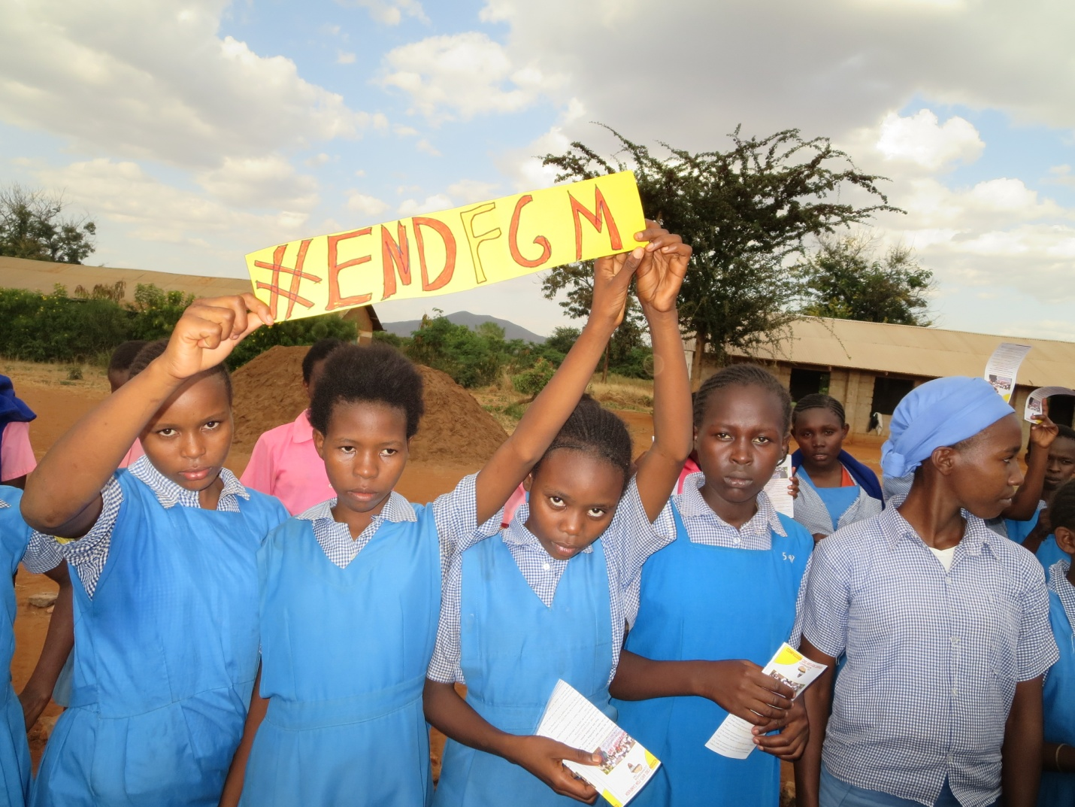PIONEERING APPROACH TO END FGM/C MAY 2020 REPORT

Already domestic violence has increased drastically due to COVID-19 because of loss of jobs and frustration. Family are now turning to FGM/C economy. Girls in our geographical area are CUT so that they get married in exchange of dowry. Girls in our culture are seen as a source of wealth to the girl family and clan. FGM/C will be in increase because many families want their girls CUT early to be given away to a bridegroom who will bring dowry to the family and clan of the girl. Many girls will be at risk of early marriage for the same reason of being a cashcows for the families. Many girls are brainwashed by cultural beliefs to pride in being CUT to get married in exchange of dowry

To counter increase in FGM/C during this COVID-19 Pandemic we have embarked on a number of measures.

* Sensitizing community members on rights of women and danger exposed to girls if they are Cut.
* Create a movement of stakeholders within the community to mobilize more leaders within the community to protect girls and women from FGM/C.
* Community members to be educated that girls and women are not part of family property to be used for gainful means through batter trade inform of dowry this will be done through Media, workshops, family gathering and through local and clan leaders.
* Partnering with Government to implement The Prohibition of **Female Genital Mutilation Act** 2011 which criminalizes the FGM/C..
* Empower women movement at grassroot level through capacity building to speak against FGM/C.
* Lobbying the government leaders those elected in positions of power to support volunteers and community social workers in eradicating fgm/c through allocating funds at sub national level for the task of Ending FGM/C.
* Use of helpline and social networks like whatapp and twiter to report cases of FGM/C before they happen or after so that the case may be followed and a law to take place.
* To educate young girls from early age about FGM/C dangers so that they know their rights and say no to FGM/C.
* Empower youths through training about their rights and their roles in protecting the rights of women within the community.
* Empower Uncut girls to reject being discriminated and stigmatized and stand up for their rights and claim them and to find their space in the community.
* Families to embrace education, farming and other sources of income and stop counting girls as source of wealth through accepting dowry.
* Sensitize the population that FGM/C can expose girls to COVID-19 through contact with mutilators and parents should not allow their girls to be exposed to that danger.
* During this pandemic we will use loudspeakers mounted on vehicles to reach villagers from their homes or use the current allowed 15 people workshops. Incase the ban will not be uplifted. We shall adhere to government regulation.
* Lastly we shall come up with tailor made initiatives instead of FGM/C where girls Cut a red ribbon instead of Cut in their bodies. If gap is left it has shown that those girls are cut when they get married because the community want that rite of passage as part of their heritage. Our red ribbon campaign has bridged the gap.