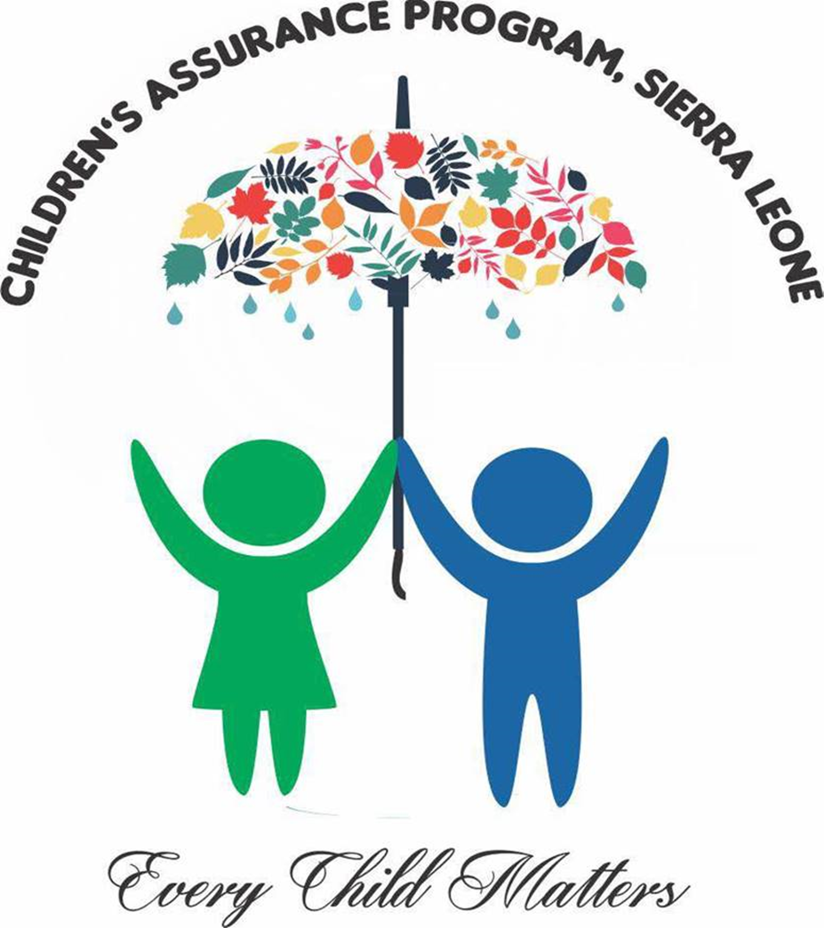

Business Plan for Children’s Assurance Program Sierra Leone
(CAP-SL)

Physical Address | Field Office |  | Administrative Office
 | #40 Hanga Road, Jui, Western Area Rural District. |  | #2 Hall Street, Brookfields, Freetown
Contact Information | capsl.online@gmail.com
URL | https://www.facebook.com/www.childrenassuramceprogramsl/?ref=aymt_homepage_panel&eid=ARCiKrz8xAsOiMCiSrX6fh8B1qKruLWS7yAdztlA-5PcpQfSvez5JbxhyvSy6cy-E1gYpk8n8D3SeLoM
Contact Persons | Baimba Osman Sheriff  Executive Director  +23278944994  sheriffosman872@gmail.com  bambasheriff@gmail.com | Ibrahim Sorie Jalloh  Position: Programs Director  Phone: +23276752354  jallohibrahimsorie10@gmail.com |  | Andrew Dauda  Executive Secretary and M&E Director  +23278092093  andrewdauda95@yahoo.com

Table of Contents

Executive Summary (Organization’s Profile)
Programs and Services (Organization’s Brand)
Marketing Plan (Intervention Areas)
Operational Plan (Administration)
Impact Plan (Projected Outcome)
Financial Plan (Organization’s Budget)
Appendix

Executive Summary (Organization’s Profile)

Children’s Assurance Program Sierra Leone (CAP-SL) is a community-based organization set up to promote universal access to education for children and and skills enhancement for young mothers in Western Area Rural District, Freetow, Sierra Loene. By extension, CAP-SL focuses on Goals 4&5 (Quality Education and Gender Equality) of the Sustainable Development Goals (SDGs). Our core mandate as an organization is to create sustainable, friendly and supportive environment, through establishing libraries and resource centres where children can have access to learning resources to improve their education and skills.
CAP-SL was founded in 2017, registered with the Western Area Rural District Council, Waterloo, Freetown, Sierra Leone. CAP-SL is working with the Ministry of Basic and Senior Secondary Education, the Western Area Rural District Council and schools in the rural district, scaling up access to education in hard-to-reach communities.

Children in the Western Area Rural District are faced with multiple social challenges ranging from lack of access to education, neglect, poor health, environmental hazards and cultural problems like Female Genital Mutilation (FGM) affecting young girls. Therefore, CAP-SL seeks to address these challenges and meet the needs of vulnerable children before they reach crisis point.

Mission
Children's Assurance Program Sierra Leone (CAP-SL)'s mission is deeply rooted in humanitarian endeavours to impact vulnerable children with access education and supporting young mothers with access to functional skills training, as a move to reduce or best eradicate intergenerational poverty, illiteracy and dependence in Sierra Leone.

Vision
Creating sustainable and friendly learning environments where children can acquire education and live happily to discover their potentials.

CAP-SL is committed to help limit endemic social problems children and young mothers are encountering in the Western Area Rural District. The drive to intervene "was initiated out of seeing children idle and expose to dangers whilst becoming exposed to odd activities with little or no supervision, care and control which are essential towards the holistic development and growth of child children".

Our projects are been financed through volunteer’s monthly subscriptions, donations from close networks, and stakeholders in-kind contributions within and our operational communities. CAP-SL is made up of a team of volunteers, capacitated with knowledge on needs assessment strategies, sustainability plans, community integration mechanisms, social entrepreneurship and capacity building with special focus on children’s and women’s development.

Six of CAP-SL’s members are alumnus of the President Obama’s Young African Leaders Initiative (YALI) from the Regional Leadership Center (RLC) Accra, Ghana. The team has over nine years professional voluntary work experience and a demonstrated history of working in the civic and social organization industries and we are skilled in non-profit organizations, working with rural communities.
The Africa Library Project (ALP) based in the United States, Rise Network, and the Library Development Initiative (LDI) are also strong partners and they help in book drives for CAP-SL. By doing so we are creating lasting impacts in the lives ofchildren. CAP-SL is also in affiliation with government ministries, departments and agencies such as the Ministry of Social Welfare, Gender and Children’s Affairs; the Ministry of Basic and Senior Secondary Education; and the Local District Council in the Western Area Rural District.

Programs and Services (Organization’s Brand)

CAP-SL’s humanitarian venture is purely based on volunteerism, and our programs and services are offered to targeted beneficiaries at zero cost. In 2016 we started off with identify children in our operational communities (Jui, Kossoh Town, Grafton, and Hastings) who have dropped out of school due to loss of a parent, relative, caregiver or children leaving with an adult who cannot afford to send them to school. For a start we supported eight (8) children with school and learning materials as well as tuition and other development charges. Presently, we have twenty 75 direct beneficiaries enrolled in four primary schools in the rural district.

On steady progress in 2018, we launched the “Peer Mentorship Program” (PMP) and the “School Talk Show” (STS) initiative, establishing partnership with four primary schools, Maynard Primary School, Rural Education Committee (REC) Jui Upper, REC Jui Barracks, and REC Kossoh Town Primary School. The PMP features children within primary and junior secondary school age who are well exposed and into advocacy to mentor and motivate their peers for greater impact. Whereas, the STS initiative enlightened and educate children on their rights and responsibility towards there mates, parents, communities and the nation at large. The STS initiative is well package, wherein pupils are also thought personal hygiene, civic responsibility, and storytelling to improve their public speaking ability and oratory skills.

One of CAP-SL primary objectives is to improve reading abilities among primary school pupils in the Western Area Rural District. On April 13th, 2019, we launched our self-funded community children’s library and resource centre in the Jui community, Western Area Rural District, Freetown. The library is open to children for use at no cost, CAP-SL partner schools are beneficiaries from this initiative, schools have included library hour in their timetables, and have a day in the week to make use of the facility. Hence, a teacher accompanies the pupils to the facility on their scheduled date, to have access to storybooks and are thought on the use and importance of library use. This initiative has created an equal opportunity to pupils within our operational community to acquire knowledge and skills necessary for the attainment of their desired aspirations.

CAP-SL is open to a partnership with other organizations and has recently partnered with two organizations to implement projects that promote children’s talents, as well as gender-based violence. In collaboration with Hope Children’s Foundation (HCF), we implemented the “Every Child a Dream” project which enable pupils to explore their talents and winners were acknowledged with worthy prizes and certificates. This project brought the best in children who witnessed the event in our library and resource centre.
In our drive to promote gender equality and eradicate continuous Gender-Based Violence (GBV) in the Western Area Rural District, CAP-SL in parttnership with the Young African Leaders Initiative – Regional Leadership Centre (YALI-RLC), West Africa Sierra Leone Alumni Chapter received suppport from the United States of America’s Embassy, Freetown to implement a project on Gender-Based Violence (GBV) from July 2019 to September 2019 in four communities in the Western Area Rural District, Freetown. This project supported 40 women GBV victims with skills training empowerment. This project focused on “Engaging Communities to Actively Prevent and Respond to Gender-Based Violence in Sierra Leone”. Sierra Leone.
Through a community-led approach organization were able to rollout the following activities:
- Stakeholders engagement
- Training of GBV focal persons
- Male engagement and
A strong network was created through the stakeholders engagement and trust has been established for future projects. The project trained forty (40) community members, ten (10) each from four (4) communities (Jui, Kossoh Town, Grafton and Hastings) on ways to identify and address GBV cases in their respective communities. The GBV project was wrapped-up with an open-air sensitization in major highways within the four communities to raise awareness on the dangers of GBV and its referral pathways.
The GBV project impacted the Western Area Rural District greatly, the community members trained are now focal persons and are responsive to GBV issues. The project reached 5,000 people including family members and friends of GBV focal person, as well as other community members, survivors of GBV, women and girls who seem to be potential victims, and adolescent boys and youth who have the potential perpetrators.

Marketing Plan (Intervention/ Focus Area)

Founders of CAP-SL saw the need to focus their interventions on creating access to education through a library and resource initiative and promoting gender issues with specific focus to addressing problems of teenage mothers in the Western Area Rural District of Sierra Leone. CAP-SL interventions were informed based on the feedback we got from community stakeholders in an interview exercise in 2015 prior to the establishment of the organization. The interview exercise was a form of research was done in four communities (Jui, Kossoh Town, Grafton, and Hastings). We interviewed 150 children with the consent of their parents, 100 young mothers and 95 adults to know the status of education in these communities. During the interview with children 60 seconds reading test was conducted using the “Saffie’s Mistake” a familiar textbook among primary school pupils. 3 out of 10 were able to read accurately taking notice of all punctuation marks and 6 out of 10 can read in slow pace counting words. With difficulties in punctuations, including all responses received from all participants including teenagers and adults informed our decision to embark on the library and resources centre establishments.
CAP-SL’s community children’s library and resource centre is the first that has been established so far for children in Jui Community and in the Western Area Rural District.
In an effort to help combat social problems in the Western Area Rural Districts CAP-SL, conducted a needs assessment on high dependency, illiteracy and poverty rate among young mothers in February 2018 using the focus group discussion, and interview techniques. The techniques were applied randomly in four selected communities, Jui, Kossoh Town, Grafton and Hastings. Total of 77 participants; 22 community stakeholders and 55 young mothers’ victims of teenage pregnancy. The information gathered revealed that most mothers mothers were highly dependent, poor, unhealthy and illiterate, and are grossly poor, malnourished and unable to take care of themselves and their children.
The findings match up to the initiate of having a resource centre as part of the library project. The resource centre now serves as a hub for counselling and mentoring young mothers and also seeking support to up-skill them.
In all our interventions, the beneficiaries have been primary school children (age 5- 12) and young girls (age 16 -19), some of whom have become mothers. Our work is presently within the Western Area Rural District and it has impacted the district positively. Approximately 15 children access the library and resource centre facility on a daily basis, the reading ability of children who are using the facility have increased backed with their with school performances.

The organization promotes and advertise it actives through the organization’s Facebook page and WhatsApp groups and contacts. CAP-SL’s interventions have been published by reputable institutions and systems - such as the United States Embassy in Freetown, YALI - RLC West Africa, and Africa Nakua. Quite recently, the organization has registered with the West Africa Civil Society Institute (WACSI) e-directory platform which will be used for more promotion and advertisement, in order to influence international partnership and get donors interested in our work and interventions.

Operational Plan (Administration)
The organization is registered with Western Area Rural District Council, Waterloo and operates on the following objectives:

- Improving access to education for children and provide mentorship for young mothers.
- Creating enabling access to livelihood supports for children
- Promoting the rights and dignity of children and women
- Advocating for better social services for children and mothers
- Creating pathways for employment for young mothers

The library and resource centre facility is in full operation under the management of a community member, hired as librarian.

The team is made up of 14 volunteers, 3 are based in the diaspora and the remaining in Sierra Leone. The leadership of the CAP-SL is run by the Executive Director, Programmes Director, Executive Secretary, Communications & Public Relations Director, and Financial Director.

Below are the names of volunteers:

- Baimba Osman Sheriff - Executive Director
- Ibrahim Sorie Jalloh - Programmes Director
- Andrew Dauda - Executive Secretary
- Joseph M Dombuya
- Alhaji Mamoud Sheriff - Financial Director
- Daniel Kamara
- Halimatu Kandeh
- Patricia Josiah
- Halimatu Kamara
- Dolly Delali Dotse (Ghana)
- Semeonett Thomas - Communications & Public Relations Director
- Isaac Bundu Bangura (Isreal)
- Mildred Smith
- Abubakarr Abron Pat-Sowe (UK)

Impact Plan (Projected Outcome)
CAP-SL is operates on a nonprofit with the goal to impact and positively transform the lives of our beneficiaries. The organization’s impact plan is categorized into three; short, medium and long-term impacts. Our goal for the short term (the next 2 years) is to see that every child in the Jui, Kossoh Town, Grafton, and Hastings community have access to books and can effectively read and communicate well. For our mid-term impact plan, CAP-SL wants to ensure there are additional 3 community children’s library and resource centre in major communities (Waterloo, Tombo and Regent) in the Western Area Rural District, thereby reaching more primary school children. CAP-SL’s long-term impact plan (ongoing) is to have a national face, establish similar facilities in the 4 regions of Sierra Leone with regional offices to monitor the effectiveness of such facilities.
The organization is committed to promoting the UN Sustainable Development Goals (SDGs) 4&5 (Quality Education and Gender Equality).

Financial Plan (Organization’s Budget)
CAP-SL has been engaged on several projects to intevene and address challenges of it target beneficiaries. The organization started with a needs assessment exercise to informed our operations spending $120 (rate at Le7,000 : $1). We then launched CAP-SL and started the library and resource centre to its completion and establishment. In the first phase of the construction, there was an expenduture of $2400 at the same rate mentioned above. Starting the second phase there was an increase of 5% in the dollar exchange, therefore the expendure increased with a budget of $ 2700, bringing the total library budget at $5100.
In continuation of it humanitarian drive the organization established partnerships with community schools to implement the PMP and STS projects with a budget.
The Sexual Gender-Based was implimented successfully spending $4,000 (at a rate of Le9,800 : $1).
To further support the organization’s drives, CAP-SL is working on a fund raising marathon, scheduled for December 14th, 2019 on a $1,650 budget. $2300 anticipated proceeds will go towards supporting more children and young mothers.

Appendix
Sheriff_Baimba_Osman_ResumeCV
Jalloh_Ibrahim_Sorie_ResumeCV
Dauda_Andrew_ResumeCV
Sexual_GenderBased_Violence_Project Report
CAP-SL_Library&ResourceCentre_Reprot

