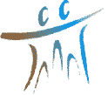

International Solidarity for Africa (SIA)
Kalaban-coura ACI, 586 throes, gate 174
TEL :(00223) 20778326/44238350
BP: 1657
Website: sia-mali.org Email: ongsia@gmail.com/contact@sia-mali.org
Bamako-Mali

I. PRESENTATION DE L’ONG/SIA

I.1. PRESENTATION

The NGO/SIA) is a Malian national NGO for the relief and development of poor rural communities. Created in 2005 under The No. Agreement Framework 02127, then renewed in February 2008 under the No. Agreement Framework 0219/002127, it is apolitical, secular and not-for-profit.
mission:
Promote the active and responsible participation of rural communities in the process of their development.

Program subject:
To contribute in a participatory way to the economic, social and cultural development of rural populations in all regions of Mali.

Target groups:
1. Men
2. Children (0 to 7 years) adolescents (7 to 18 years).
3. Farmers' organisations, youth organisations
4. Women's groups.

Management instrument
Strategic plan
Administrative and financial procedure manual
Income-generating business planning tools.
Operational plan
Human resources management software
How to intervene:
The fundamental principle is the participation of communities in their accountability in the execution of projects (identification of needs, design and delivery of programs and projects, decision-making). SIA works in all its projects with this participatory approach.
- The contents of the intervention strategy:
- Inter-community consultation
- Consensus on problems
- Training /Awareness of beneficiaries
Involvement of beneficiaries at all stages of interventions
Equity (respect for everyone's natural rights)
Evaluation of existing potential
Local contribution.

II. 2. ACQUISITION OF THE NGO/SIA OF 2016 TO OUR DAY
2.1. Projects completed in 2016:
Project to build a one hectare market garden inge for the benefit of the women of Yélékébougou with funding from the French Embassy.
Project to support the Women's Association of Kolé through market gardening on funding from the Belgian Technical Cooperation (CTB).

2.2 Projects completed in 2016:
Drinking water project, hygiene and sanitation promotion in the rural commune of Sobra, Kati Circle, Koulikoro region with funding from the Spanish Agency for International Development Cooperation (AECID);
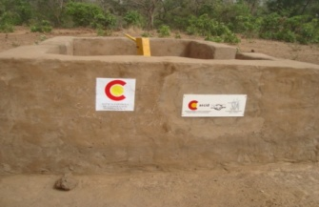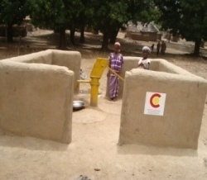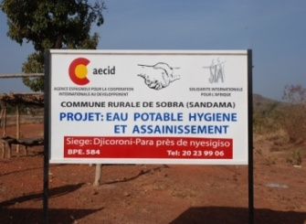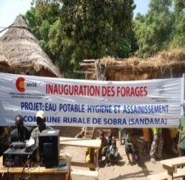
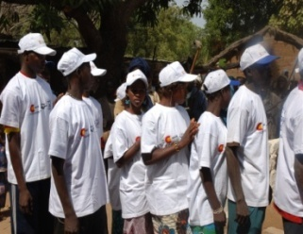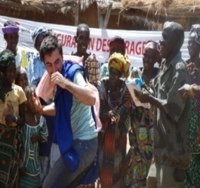
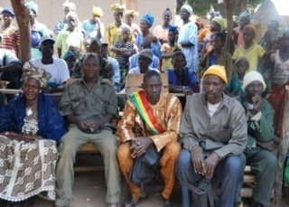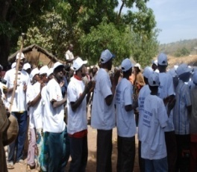

Project to restore degraded soils and adapt to climate change in the rural commune of Yallakoro Soloba, Yanfolila Circle, Sikasso region with funding from the World Environment Fund (WEF) Phase 1;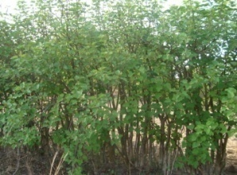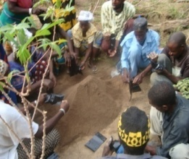

2.3 Projects completed in 2017:
Project to support the Mananbougou Women's Association through market gardening on funding for World Women's Prayer Day - German Committee (Germany).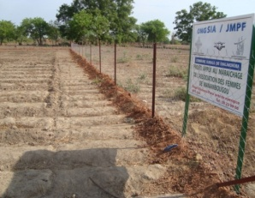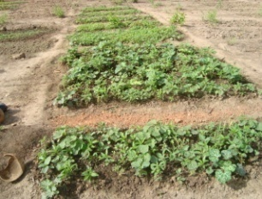

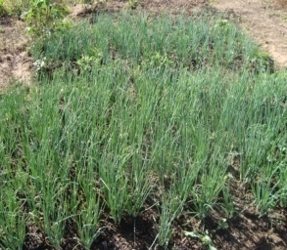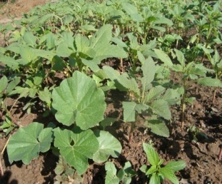
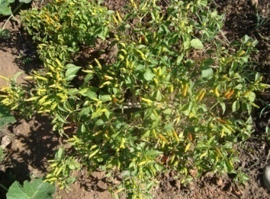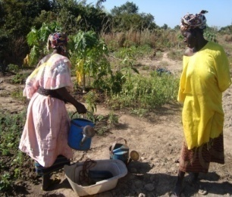
Project to restore degraded soils and adapt to climate change in the rural commune of Yallakoro Soloba, Yanfolila Circle, Koulikoro region with funding from the World Environment Fund (WEF) phase 2.
2.4 Projets exécutés en 2017 :
Project to inform and raise awareness among traditional, community and religious leaders on the consequences of the practice of female circumcision in the rural commune of Diakaloroba, Kati Circle, Koulikoro region.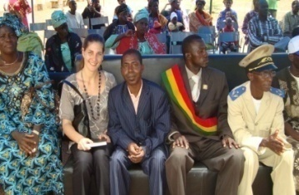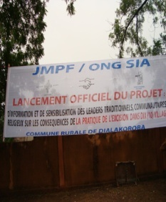
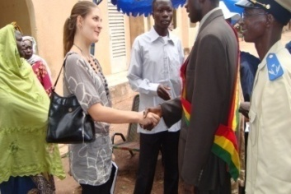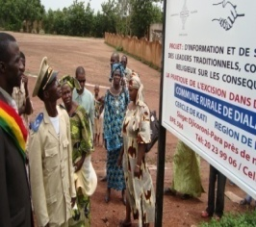

Market gardening support project at the Molobala Women's Group with funding from LAG Mali (Germany);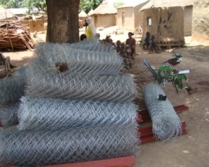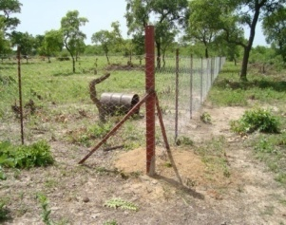
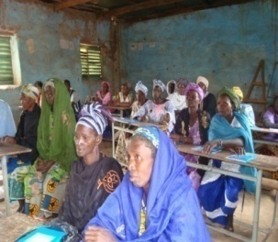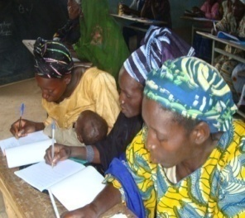
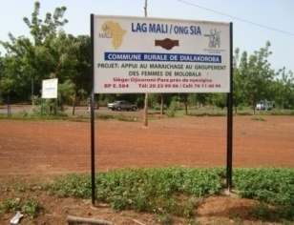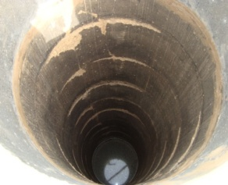

2.5 Projects completed in 2018:
Project to support the Four Income Generating Activities (04) women's associations in commune IV of the District of Bamako on funding of AECID through the Habitafrica Foundation (Spain).
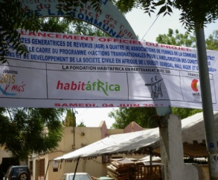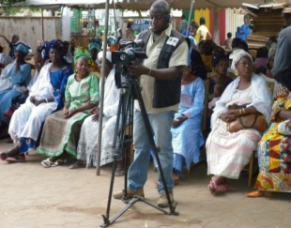
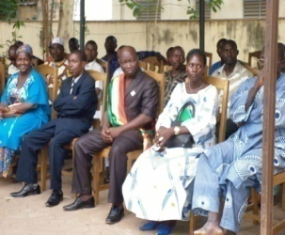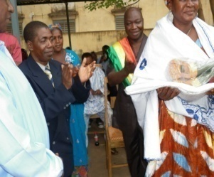
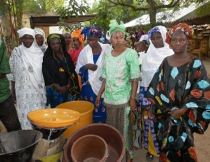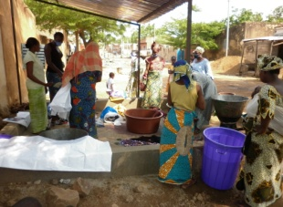
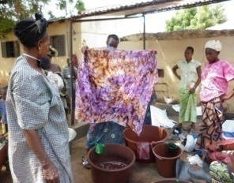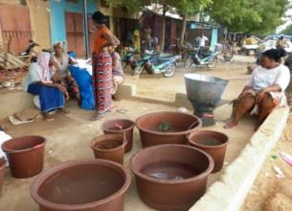

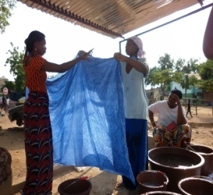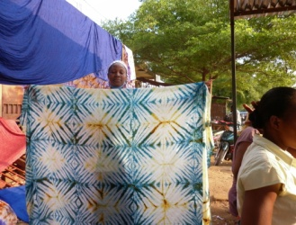

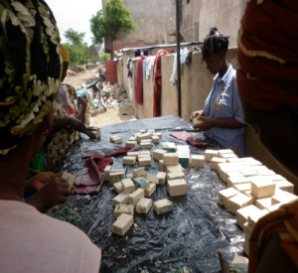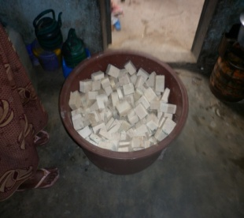

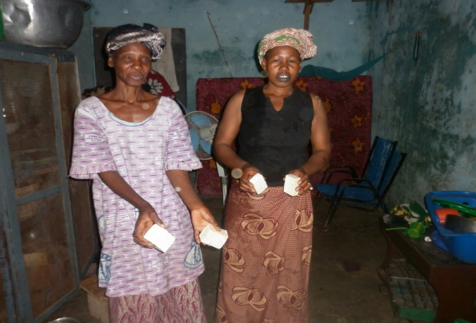

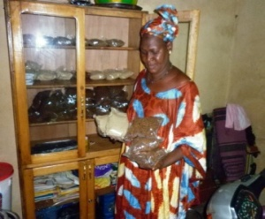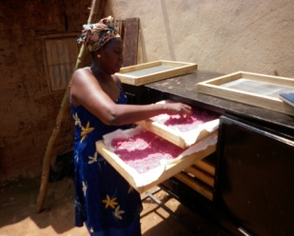

Project to modernize and expand the airport of Bamako Sénou AIR BO2 HIV/AIDS component on funding of the Chinese company Sinohydro.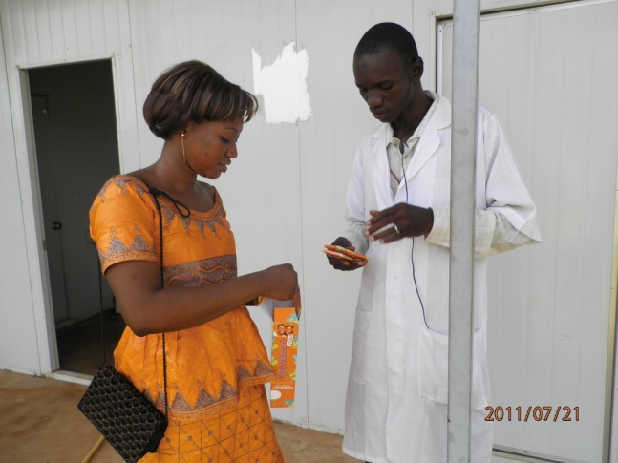
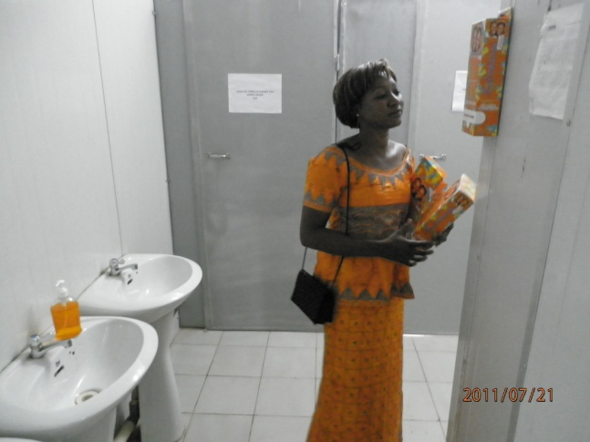

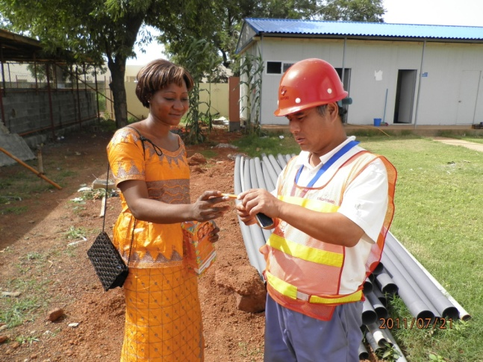
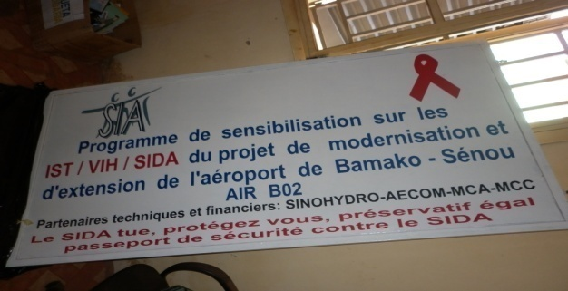

Networks:
Since 2006, SIA has been a member of the National Programme to Combat Excision (PNLE);
Also a member of SECO/NGO, CAEPHA, a member of the food security, education, protection, nutrition and agri Hub Mali cluster.

Staff: SIA has a staff of 12 people including 5 women, 2 trainees, 1 volunteer.

SIA operates throughout the country and our areas of intervention are: Agriculture, Health, Education, Social Support, Fishing, Livestock.
Capabilities:Agriculture: market gardening, distribution of agricultural equipment, distribution of market gardening equipment, distribution of fertilisers, organisation agricultural technical training, training organization in market gardening techniques, digging of wells in large diameter, income management training for women's associations, training in associative life, training of agricultural management committees, promotion of certain plant species, restoration of degraded soils and adaptation to change climatic.
Santé :
Construction of health centers with equipment, fight against STIs/HIV/AIDS, combating the practice of excision, awareness of early marriages, training of management committees, training of socio-health workers on techniques animation on female circumcision, drinking water supply, promotion of hygiene and sanitation, training of water management committees, fight against malnutrition among children aged 0 to 59 months and in lactating and pregnant women, drilling, large diameter wells for the benefit of the population, distribution of food ect....
Education: Construction of classrooms with equipment, construction of literacy centers with equipment, training of women's associations in literacy, training of youth associations in literacy...

Social support: Support for emergency operations for populations affected by natural disasters or crisis

Fishing: Equipment support for fishing associations, formation of management committees.

Breeding: Distribution of small ruminants to women's associations, distribution of ploughing oxen to needy farmers, training of herders, support in bovine feeding.
Environnement : Restoration of degraded soils and adaptation to climatic conditions, protection of species in the process of disappearing.

