Foo
FOUNDATION FOR JUSTICE DEVELOPMENT AND PEACE

jdpckatsinaaladiocese@yahoo.com

Access to Education for 100 Children in Buruku
A Project submitted to Globalgiving
Project Title
Barriers to education and learning to 1000 children orphaned and displaced in internally displaced persons camp (IDP) camps in Ukum Local Government Area of Benue State, Nigeria.
URL
Education-and-learning-for-1000-children-in-Borykto
Project Summary
This project is to provide free and basic universal access to quality education and build 4 blocks of classroom for 1000 out of school children orphaned and displaced by conflicts in Benue State, Nigeria

Requested Funding Amount

The project will be needing $19000 to provide adequate and basic education for 1000 out of school children through provision of support such as school uniform, writing materials and books, table and desks, one meal per day to encourage school enrollment and retention and ultimately build a 4 block classrooms to accommodate pupils in schoool.

Resources Needed

$1500 will support 1000 children with school uniform

$9000 will be needed to pay salary/stipend of volunteer teachers

$1500 needed to print tools/materials for enrollment of children on the project

$2000 will provide books and writing materials for 1000 students

$2500 will help provide table and desks for 1000 pupils in a class

$3000 will provide school feeding for 1000 per term

$13000 will be needed to build a 4 block classrooms to accommodate 1000 pupils

What is the issue, problem, or challenge?

The 2015 TIV and Jukum conflict that took place in wukari, Taraba State rendered most children orphaned and displaced from their families. The Tiv ethnic nationality of Benue state flee from Taraba state and were repatriated and accommodated in an Internally Displaced Camp (IDP) in Zaki-Biam, under Ukum, LGA. Lack of money by their parents due to their situation has made access to education difficult but with this initiative ,it will encourage parents to enroll their children in school in order to achieve their full developmental potentials.

How will this solve the problem?

According to UNICEF, 13million children of school age are not in school, therefore, the project will support the efforts of government in order to ensure children of school age are enroll in schools with increased retention and completion of studies especially, for girl child

Potential Long-Term Impact

The overarching goal of the project is to improve school performance, access and retention among vulnerable children and adolescents while ensuring that adolescents steer out of social vices including drug addicts, helping them get out of poverty and contribute their quota to national development.

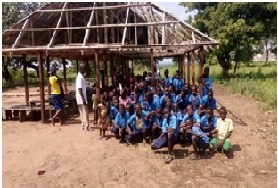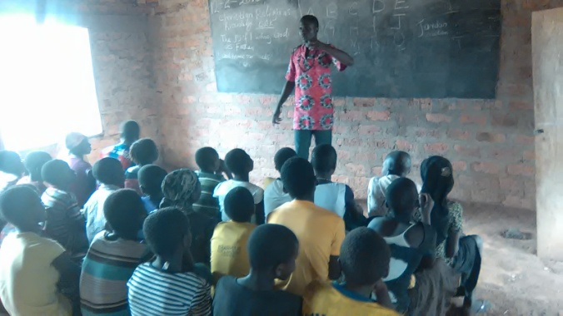
Figure 2 Makeshift classroom for teaching Figure 3 Dilapidated classroom for learning

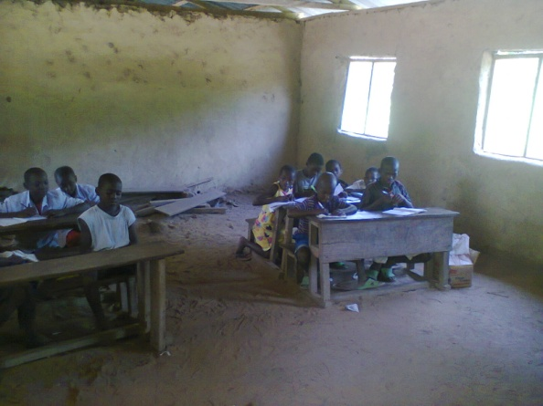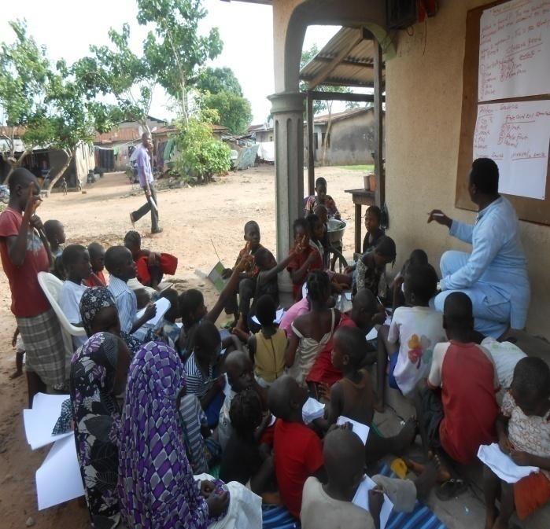
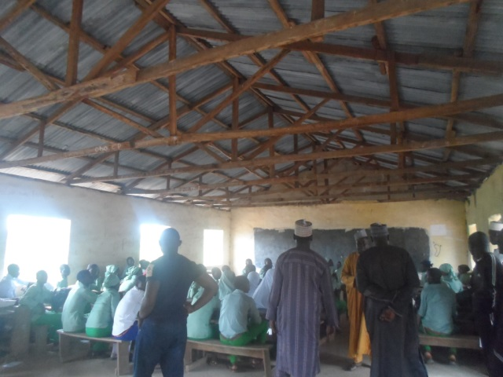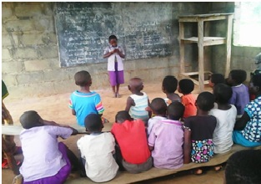
Figure 4 Uncompleted classroom Figure 5 Pupil demonstrating learning in class

