MOBILIZATION FOR EMPOWERMENT AND DEVELOPMENT ASSOCIATION OF NIGERIA (MEDAN)

Organization Profile
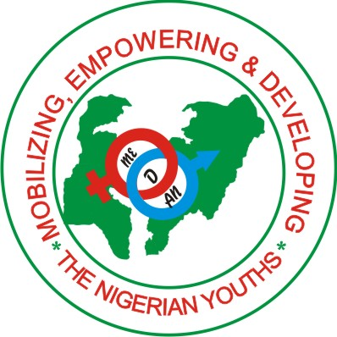

Mobilizing, Empowering and Developing the Nigerian Youths

January 2015

Contents
Title Page i
Content ii

Introduction 1
Corporate Information 1
Our Mission 1
Our Goal 1
Our Team 2
Contact Information 2
Activities of Mobilization for Empowerment and Development Association of
Nigeria (Medan) NGO 3
Our Success 7
School of Free Skills Acquisition Training 9
MEDAN Volunteers 15
Our Partners 15

Introduction
Mobilization for Empowerment and Development Association of Nigeria is a non-governmental, non political, non profit oriented Organization created 2010 to serve as intermediary between the masses, charitable organizations, philanthropists and government by reaching the less privileged for their needs using all measures in our capacity to know their actual needs and convey these needs to their helper and give back to the masses all what is given to us as their needs.

Corporate Information
Mobilization for Empowerment and Development Association of Nigeria (MEDAN)
Vision is to make the less privileged live a standard life equal to the rest of the people in the developed countries. Although Nigeria is rich in natural and human resources, 7 of every 10 Nigerians can be proud to belong to and grateful to inhabit, a Nigeria that rewards hard work, protect its people and their properties and offer its children better prospects than those they may be tempted to seek in Europe or the United States.

Our Mission
To encourage and show people how to grow individually and collectively by developing their entrepreneurial skills needed to generate positive changes to their lives and the world at large.

Our Goal
To develop an indigenous entrepreneurial class capable of competing in a global market in which skills play a dominant role.

Our Team
Mr. Ishaq Dayo Shittu - President/Founder
Mr. Abdullateef Agboola - Vice President/National Coordinator
Mrs Maryam Adesola - Secretary
Instructors
Miss Bukayo B. Oyeniyi - Computer Training Section
Mrs. Elizabeth Inung - Catering Training Section
Mr. Abdullateef Agboola - Electrical Installation Training Section
Mr. Abubakar Umar - Poultry Training Section
Mrs. Fatima Omolola Sani - Soap Production Training Section
Mr. Abdulmajeed Aromasodu - Photography Training Section

Contact Information
Head Office: ZC 38 Rock Road, By Poly Road Tudun Nupawa, Kaduna
Tel: 07031233633, 08098327052, 08037522189
Website: www.medanorg.org
Email: medanorg@gmail.com

Activities of Mobilization for Empowerment and Development Association of Nigeria (Medan) NGO
Youths Empowerment
Joblessness has resulted in a rising incidence of social ills among young people. MEDAN activities target youth empowerment and development in order to reverse the negative consequences associated with the past pattern of development in our communities.

To meet the needs of our people and nation is the primary aim of Mobilization for Empowerment and Development Association of Nigeria, as well as people physical security and the means of making a living. At 5.3% the rate of urbanization in Nigeria is among the highest in the world, since manufacturing industries are stagnant, there are few jobs for the growing urban population and unemployment is currently estimated at 10.8%. The focus of MEDAN is therefore economic empowerment by training youths in skills relevant for the world of work, and by promoting integrated rural development.

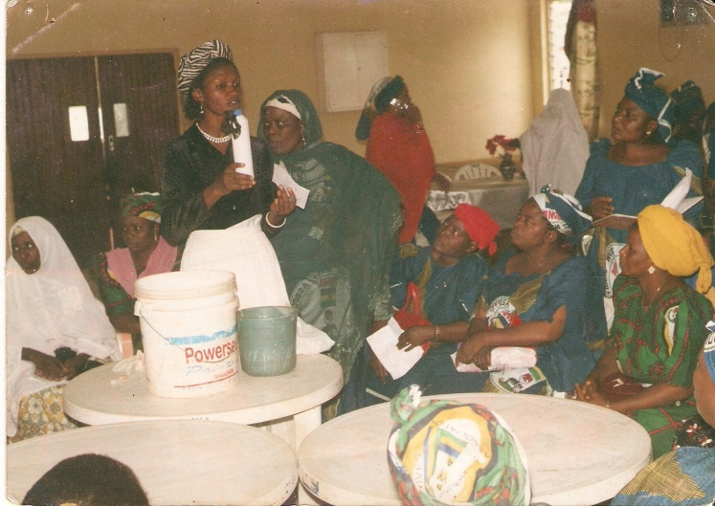
Women Empowerment
MEDAN seeks to fully integrate women by enhancing their capacity to participate in the economic social, political, and cultural life of the Nation. To do so we create free skill acquisition centers in local communities where intensive training is given to the less privileged, mobilizes youths and women to participate and also ensures starter pack is given to individual participant to enable them start what they have learnt to earn a living/income at the end of the program.

Youths Social Entrepreneurship
As the instability and difficult economic situation of the country persist, we introduce Social Entrepreneurship among the youths in all our local communities, enabling them to be self sufficient while making a difference in the society at the same time.

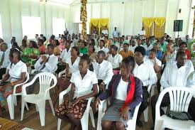
MEDAN support youths who possess the drive and desire to make a concrete difference in the country and the world at large by;
- Training the youths on programmes to equip them with basic and necessary skills such as management, leadership, and economics. These training programmes are ideally implemented in small groups (20 youths) we provide time for discussion, trainee involvement and exploration of various social issues and approaches to solve them.
- Networking, once our trained youths begin developing their own projects, we make sure they are connected to a network, with other young entrepreneurs of different levels of experience. Our Networking does not only provide a support system, but it also acts as a dynamic learning environment in which budding social entrepreneurs share their ideas, successes, and strategies with others and learn from their peers.
This medium did not only enables our youths entrepreneurs meet more people and spread their ideas further but they learn the value of tolerance and respect for people of different backgrounds.
- Mentorship; we provide a community of willing and knowledgeable social entrepreneurs (volunteers) with projects in similar fields to our youths social entrepreneurs, they act as advisors and teachers to the young people in an informal, collaborative setting.
- Resources; MEDAN provides information and classes about sustainable business and financial planning as well as methods of successful fundraising.
- Reflection; to keep us actively involved in the social entrepreneurial projects of our youths, after the initial training programme, large group meetings are held every two months in this meetings our youths social entrepreneurs provide feedback to us which create an ongoing dialogue between us. In these meetings the youths will reflect on the process, keep other students and tutors up to date on their projects, and we develop a plan to move forward, if they have any frustrations or concerns, these meetings enable us addressed them.

HIV/AIDS and STD Counseling
The overall goal of MEDAN on HIV/AIDS and STD is to control the spread of HIV/AIDS in Nigeria, provide equitable care and support for those infected with HIV/AIDS and mitigate its impact to the point where it is no longer of public health, social or economic concern.
Our targets on HIV/AIDS and STD.
The following targets have been set to guide program planning and implementation in all the communities we work.
- Achieve at least 25% reduction in the adult prevalence of HIV/AIDS and STD.
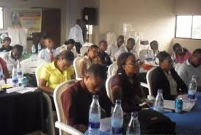
- Ensure that at least 20% of all local communities we operated are offered home base care to people living with HIV/AIDS and STD
- Ensure that 5% of communities affected by HIV/AIDS will have programs designated to provide social safety nets for people living with HIV/AIDS
- Ensure access to antiretroviral drugs in all communities we work.

MEDAN has really gone a long way in the increase awareness of and sensitivity about HIV/AIDS & STD among the general population. We have offered preventive programs to vulnerable groups, such as women and children, adolescents and youth, sex workers, long-distance commercial vehicle drivers, prison inmates, migrant workers and others.

Peace and Conflict Resolution
We promote and encourage peaceful co-existence among youths, women, religious/traditional leaders and the Government through the values of negotiation as well as active mediation for peace agreements in addition to facilitating post conflict stability and development while also enhancing conflict management capacity.

As a peace building organization, our focus is on various aspects of conflict management with emphasis on the less privileged communities and groups, especially women and youths. We work by identifying societies that are fragile zones where peace and stability are threatened or communities emerging from crisis and strive to help by preventing or resolving disputes for societal progress.
Our preventive initiatives include:
- Monitoring tense situations, intervening to stabilize potentially violent conflicts before their outbreak, initiating activities that address the root causes as well as the triggers of disputes, establishing mechanisms to detect early-warning signs and monitor specific indicators that will help to predict impending violence.
- Sensitization/social mobilization through communication for behavior chan community dialogues, rallies, drama and media towards electoral violence prevention.
- Strategic partnership and networks with NGOs/CBOs.
- Direct intervention through skill acquisition and empowerment.

Our Success
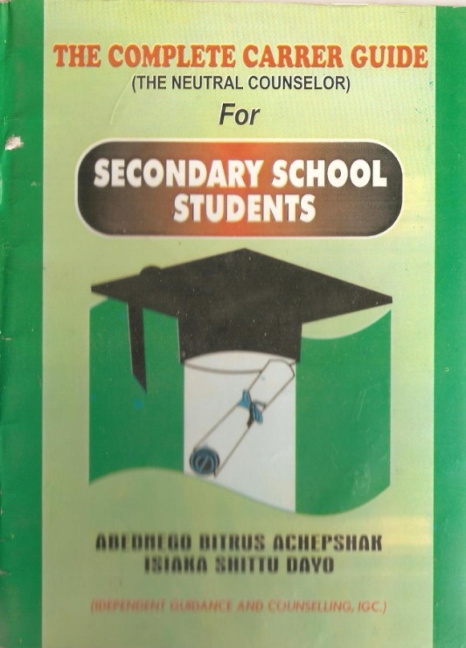
Mobilization for Empowerment and Development Association of Nigeria held a One Day Career Guidance and Counseling Seminar tagged “Guidelines towards proper choice of course and Future Career”. The seminar was open to all secondary schools in Kaduna state on 26th March, 2011 in Sheikh Abubakar Gumi College, Tudun wada Kaduna. Some of the dignitaries in attendance are, The chairperson of the occasion, a representative of Honorable Commissioner of Education, Kaduna State, The Special Guests of Honor; Director SAG Alli Ayilara B. Abdulkareem, Presenter; Malam Ukashali Bin Uthman Abu Jannali, Dr. Adetutu Adetunji, Head of schools, parents, students and press men.

The seminar was the first of its kind in Kaduna state and all school representatives give a tremendous remark on the seminar, paper presentation was delivered by the founder, on the book title “The Complete Career Guide (The Neutral Counselor) written by one of the MEDAN Volunteers; Abdnego Bitrus Achepshak & FOUNDER Isiaka Shittu Dayo. The book was forwarded by Professor Julius Atama Gwani (Dean, Faculty of Education, Ahmadu Bello University, Zaria).here is the forward content of the book and quote:
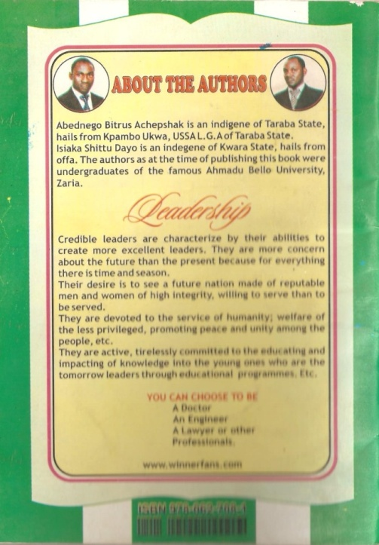
“Acepshak and Dayo, in this piece of work have looked critically at wise choice of career as an important construct of life which promotes comfort and peace of mind; without which frustrations, regrets and misery has an upper hand in the individual life.
In “The Complete Career Guide” (The Neutral Counselor) the authors have shown their concerns how that students at all educational level are not adequately equipped to be able to choose desired subjects/courses and subsequently choice of career.
The strengths of this book are many and too numerous for a list to be all-inclusive however, few of the main attributes appear to be:
- Two constructs to consider in the choice of career
- A brief discussion on guidelines towards proper choice of course and career in future
- Presentation of the importance of the book
- Discussion of courses and their job opportunities
- Inclusion of subject combinations at UTME (JAMB)
The authors have succeeded in capturing information needed for selection of courses, course combinations and thereby making wise decision on choice of career.
The book is recommended to all secondary schools, their students, parents and guidance”

More so, New Nigerian Newspaper page 3 of the publication dated 27th March, 2011 published the Seminar programme.

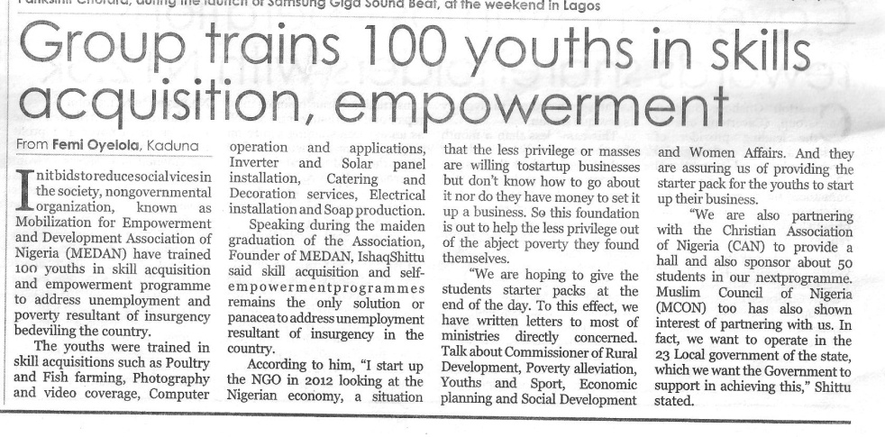
School of Free Skills Acquisition Training
To meet the needs of our people and nation is the primary aim of Mobilization for Empowerment and Development Association of Nigeria, as well as people physical security and the means of making a living. At 5.3% the rate of urbanization in Nigeria is among the highest in the world, since manufacturing industries are stagnant, there are few jobs for the growing urban population and unemployment is currently estimated at 10.8%. The focus of MEDAN is therefore economic empowerment by training people in skills relevant for the world of work, and by promoting integrated rural development.

The free skill acquisition training program is schedule to hold every four months. The program runs on a continuous process 3 times in a year. The forth set of students training rounded up March 2015 and the fifth batch will commence by June, 2015.

In this school we train students on:
Computer Operation and Application

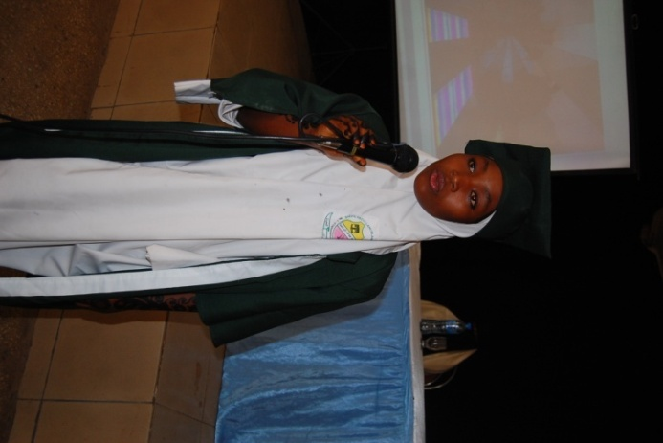

Electrical Installation
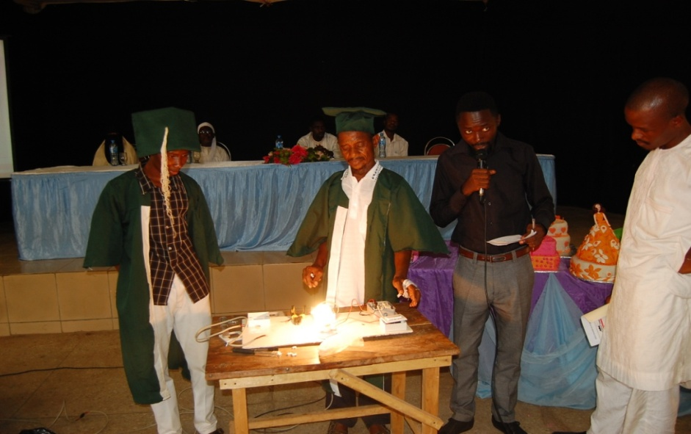
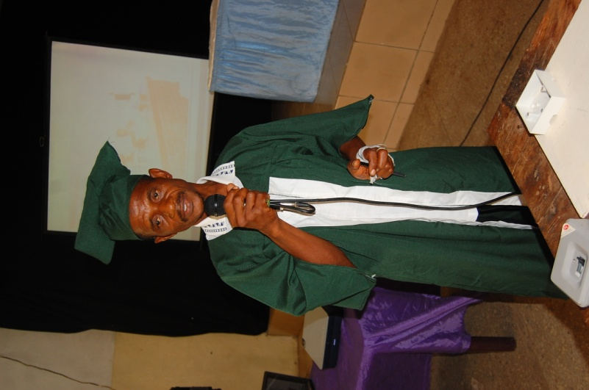

Photography and Video Coverage
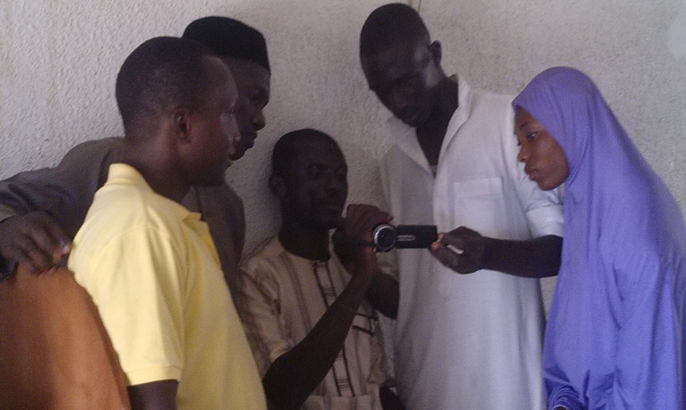
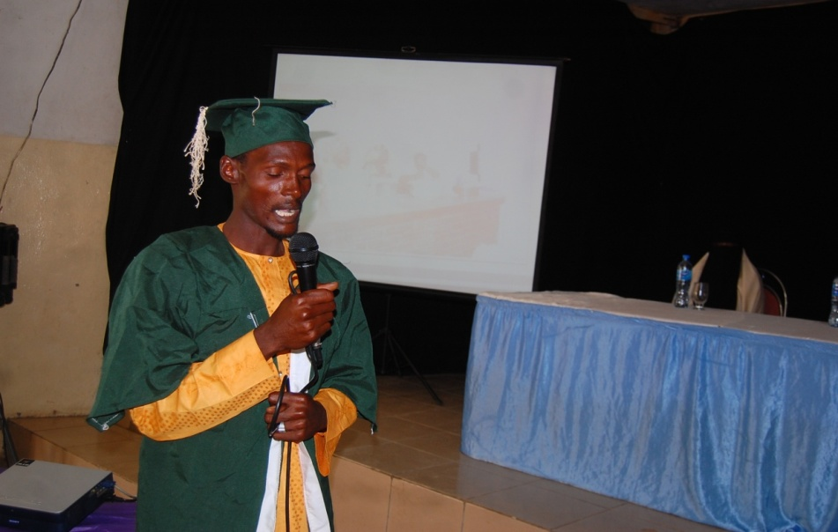

Catering & Decoration
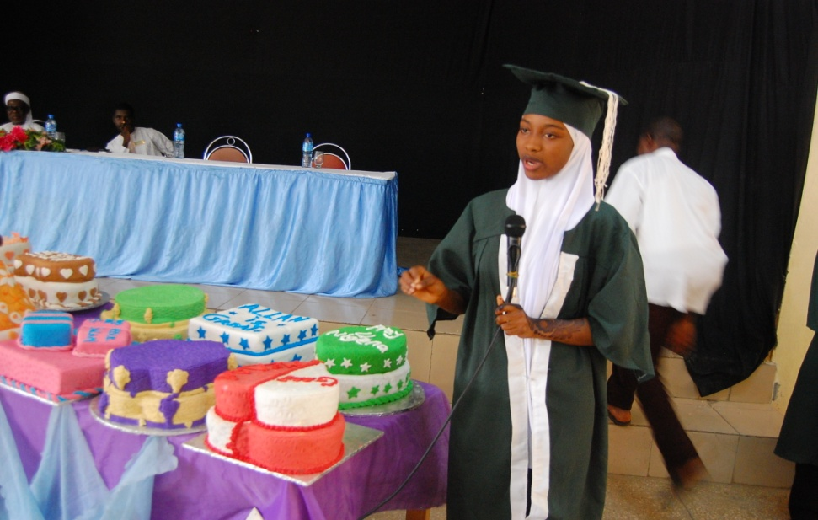
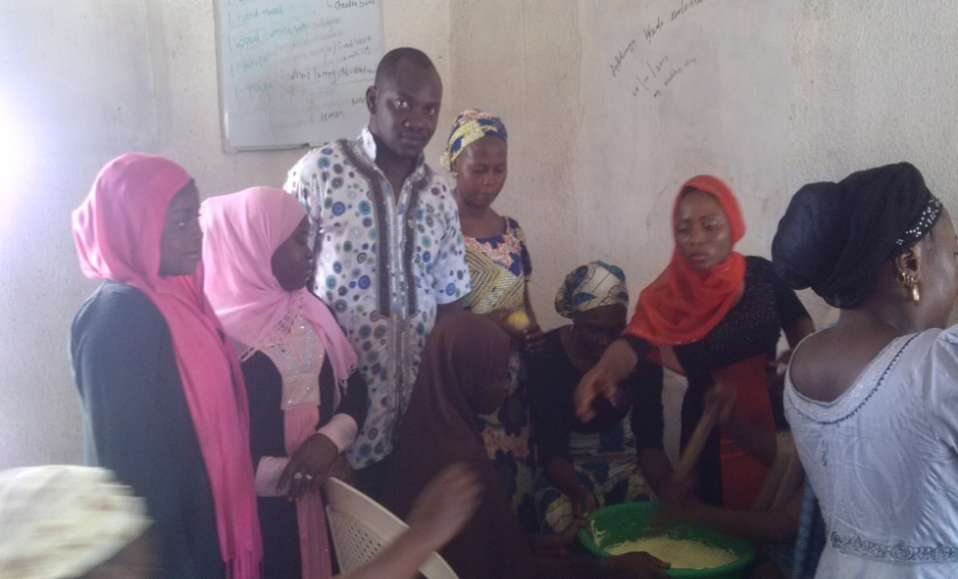

Soap production
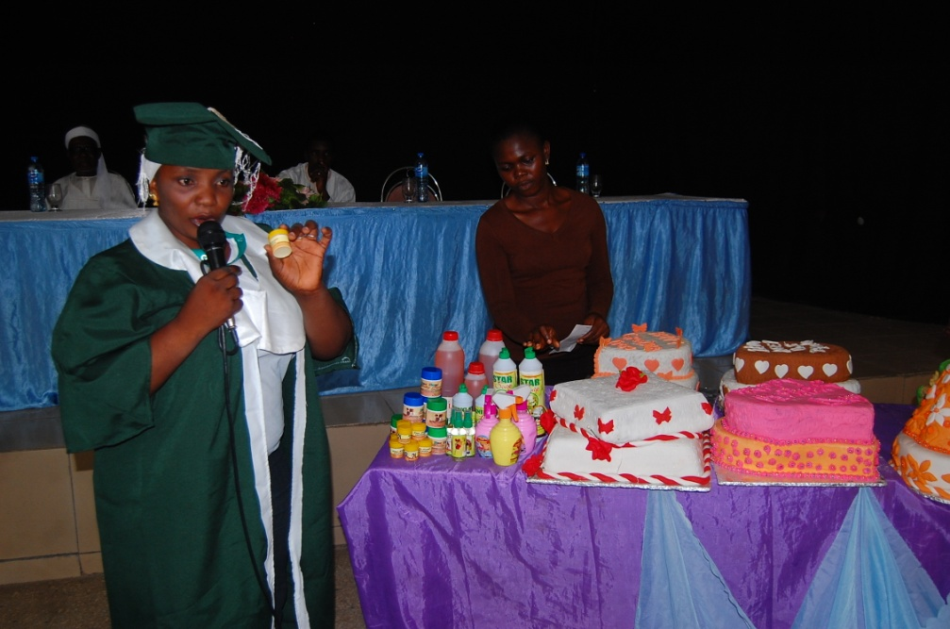

Poultry and fish farming
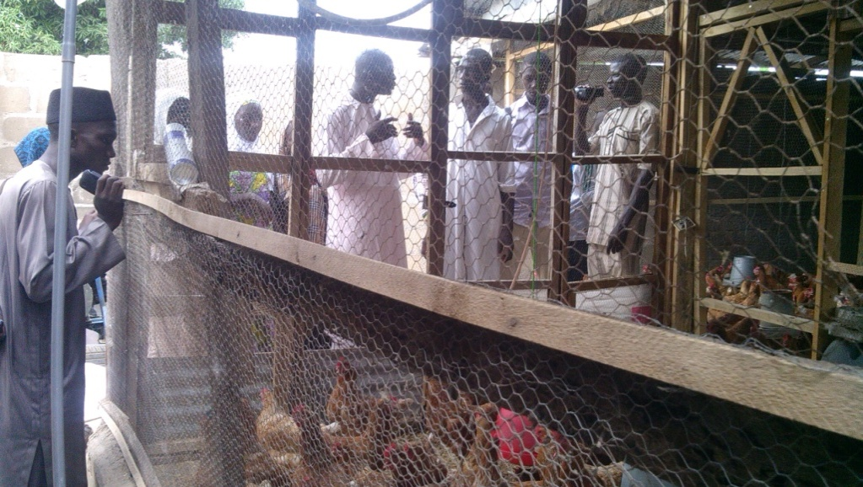
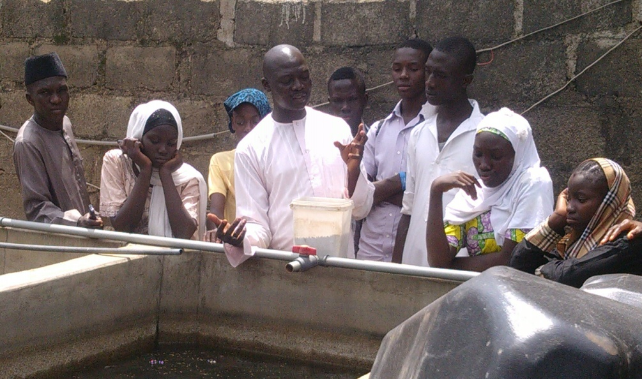

We graduated our first set of trained students on 22nd May, 2014 at Women Multipurpose Hall, Sokoto Road, Kaduna. Peoples Daily Newspaper published the news/event.
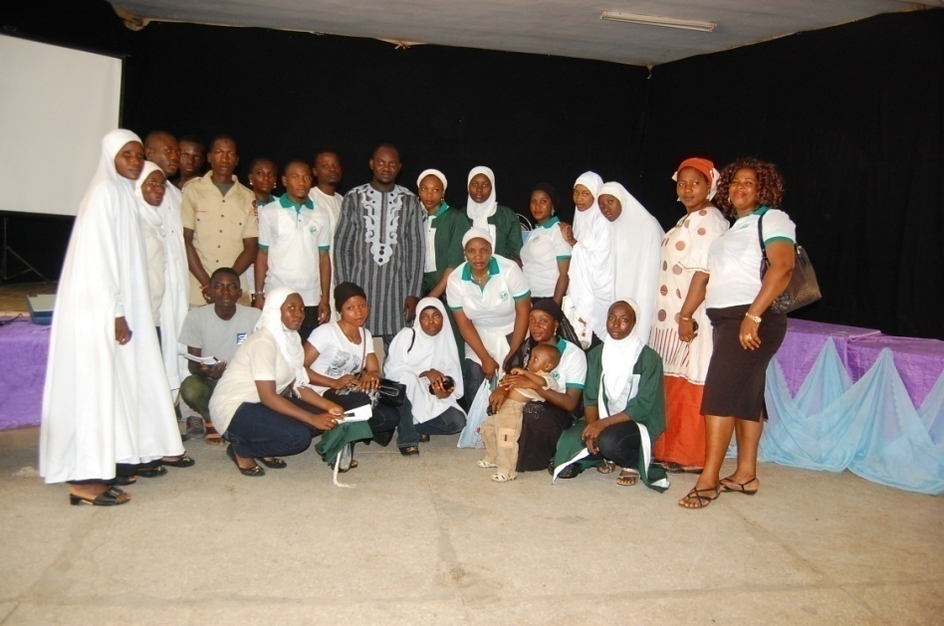
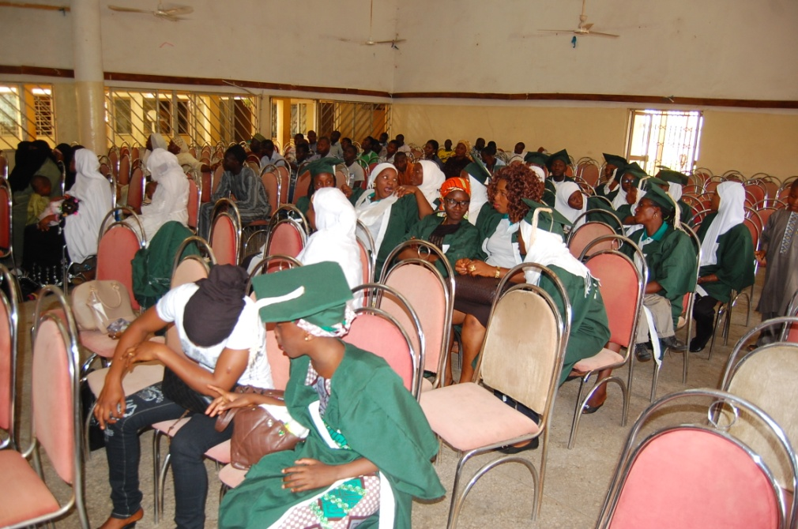
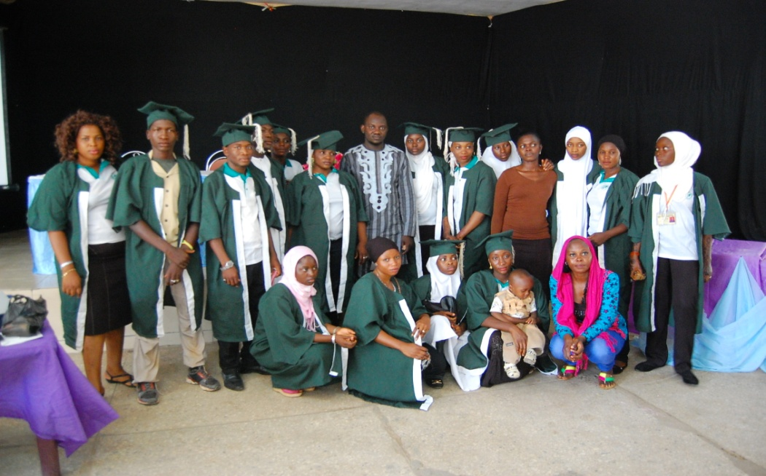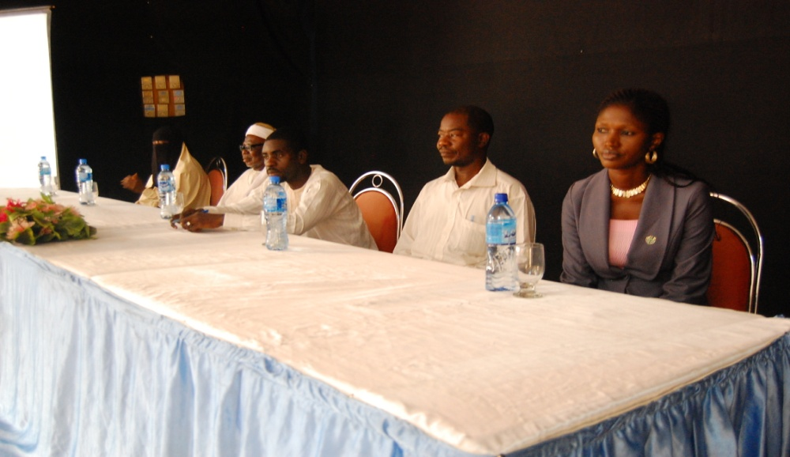
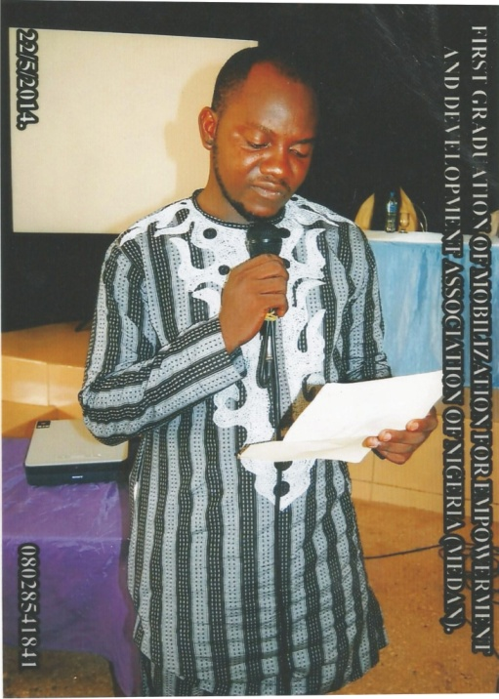

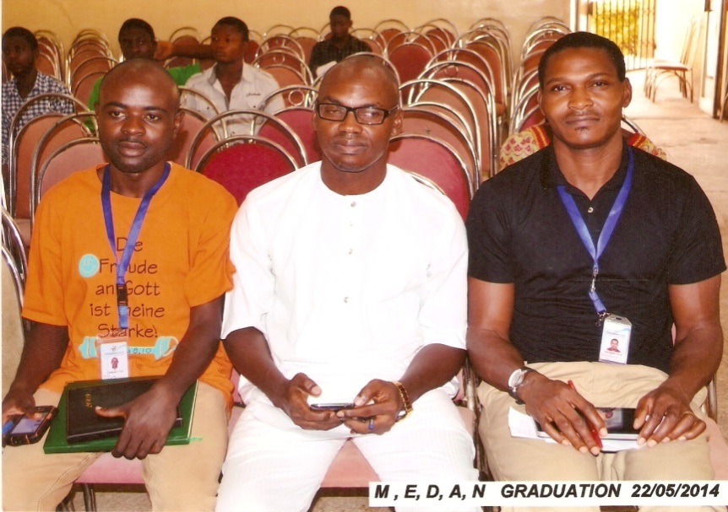
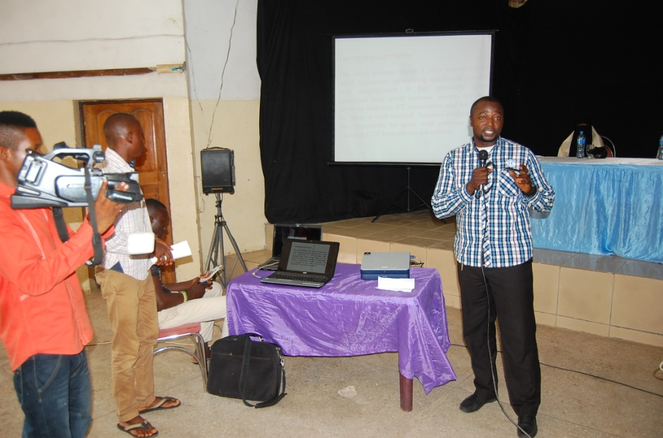

MEDAN Volunteers
Our volunteers work in different fields such as community services, agricultural labour, social work, teaching, event planning and organizing, community health care services, sexually transmitted disease awareness e.t.c and we have over 200 registered and active volunteers in the association.

MEDAN partner with Finest Youth Counseling Foundation for a conference programme (Inaugural One day Conference on Addiction) on “Addiction, Our Humanity Under siege” held at Arewa House, Rabah Road, Kaduna. During this programme our volunteers help in preparation, distribution of flyers, posters, handbills and the protocol section during the programme. Guest speakers at the event include Yemisi Abiona MSW, LCW (CEO Innovative Support Services, USA), Dr. Victor Olisah, MB, BS FWACP (Psych) Consultant Neuropsychiatries, Department of Psychiatry, ABUTH Zaria and Isah Sani Gachi, Narcortics Counsellor and Addiction Supervisor, Behman Hospital, Cairo Egypt.

Our Partners
Planned Parenthood Federation of Nigeria (PPFN) Kaduna
Lizzy International Multi-skills Limited
Elegant Fish and Poultry Farm
Christian Association of Nigeria (Kaduna State Chapter)
Desired Haven Academy
Kayo Computer Training Ventures
Traffic Driving Academy

