The psycho social and legal assistance for Women’s Empowerment in the groupment of Kaniola at Kaniola and in the groupment of Mbinga-Sud at Ihusi-Haut Plateaux in South Kivu Province, DRC
Brief summary of the project:
Name of the realization agency: ASSIT (Association Internationale Tujenge)
Address, telephone and email of the production agency: No. 15, Av. Tanganyika, Quartier Nyalukemba, Ibanda Commune, Bukavu, South Kivu Province
Name and title of the contact person: 1) Father HASSAN MOUCHI Jonas
Email: tujenge.2011assit@gmail.com
Telephone: +243897953945 (Director)
2) Sister NAMULISA BALALUKA Rose
Email: tujenge.2011assit@gmail.com
namulisabalalukarose@gmail.com
Telephone: +243891 334 959 (Coordinator)
+243 977 078 073 (Coordinator)
Total Project Budget (USD): $ 49,907.3 (forty-nine thousand nine hundred-seven point three US dollars))
Contribution from the applicant NGO (USD): 00 $ = zero
Duration of project implementation: 1 year (12 months)
Probable Start Date: January 1, 2020
Type of project: SGBV and protection of women.
Types and number of beneficiaries: 480 people including 300 women victims of gender-based violence and 180 community leaders and stakeholders
Number of indirect beneficiaries: 3,360 people who are members of direct beneficiary households and all entire communities.
EXECUTIVE SUMMARY
In the eastern part of the DRC, ravaged by repeated wars, particularly Walungu and Kalehe territories, women have endured decades of misdeeds and live in increased marginalization and poverty, and have difficulties to meet their family’s needs when they have become the first to be responsible for the context of their lives. Victims of a non-protective environment, young people and women become vulnerable to abuse, exploitation and other violations of their rights. They therefore need socioeconomic empowerment and capacity building without which they cannot escape the precariousness in which armed conflict has plunged them. Thus, through the proposed actions, ASSIT intends to contribute to reducing the vulnerability of the 300 women of the Walungu territory in Kaniola (Kaniola Groupment) of Kalehe territory (in groupment of Ihusi/Mbinga - Sud Haut Plateaux) by developing income-generating activities in agriculture, collective breeding, apprenticeships, literacy, but also by strengthening mutual solidarity and AVEC (village savings and credit associations), for their empowerment. This means, a center of attraction built into three large paillottes, bringing together 50 beneficiaries per site, including three sites per group, allows gathering these beneficiaries for training, exchanges and sensitizations during 12 months, i.e from January 1, 2020 to December 31, 2020. Given that the beneficiary communities are willing to make land of 40m² available to house the necessary facilities of the attraction Center in each Target Group, an amount of US$ 15,000 is required from the granter for the realization of planned activities: support of the running capital to AVEC of all groups, and the professions that young women enjoy, give them the opportunity to access resources, to be influential in their families of origin and in their living environments.

I. Analysis of context and situation
The Democratic Republic of Congo goes through a presidential, legislative and provincial post electoral period, and has yet to wait for an imprecise moment, the organization of local and municipal elections, but it does not guarantee the material independence of the woman or stop the violence of which these categories are victims in rural areas. In the greater part of the country, women experience inferiority that deprives them of access to resources and participation in decision-making.
The South Kivu Province in eastern DRC is an economic paradox. In the beginning of the 1990s, turning towards a more rigorous management of private initiatives and NGOs, has made the South Kivu province part of a positive and stable growth phase.
As the vocation of South Kivu is generally agricultural, this sector has demonstrated throughout the world its potentiality as the main source of creation of economic wealth.
Women experience a time when men are attached to tradition, morals, power of superiority and not allowing them to prove their forces of action contributing to the development of households but to remain continually victims of gender violence.
II. Justification for support
The people of South Kivu in general are struggling to recover from the effects of the war they suffered during the multiple armed conflicts. Conflict-related disruptions have led children, especially girls and boys, to remain without access to education and work, to the extent that they have begun to engage in the activities of armed groups and other criminals and even to be manipulated by some bad-willing politicians and therefore they constitute a great danger against the promotion of peace and sustainable development.
Women need socio-economic empowerment and capacity building without which they cannot escape the precariousness in which armed conflict has plunged them. The two entities that are the subject of our future actions were characterized by unprecedented atrocities during the presence of Hutu-Rwandans on the South Kivu province border in ​​the DRC and that the men perpetrated as a result of the culture and tradition related to their gender.
Organizations like "Action d’Espoir’, VOPAD, IRC, Women for Women" etc. have been worked with some of these target populations, but in terms of emergency activities such as caring for the needy and victims of sexual violence, WFP has oriented its interventions in humanitarian assistance in Food according to crises, in the rehabilitation of agricultural routes in terms of "food for work". But ‘Women for Women’ has been working on the abilities of some women for some time and in some entities.
ASSIT wants to help reduce the vulnerability of 300 women, by developing income-generating activities in agriculture, livestock breeding, apprenticeships, adult literacy, but also by strengthening mutual solidarity and Village Savings and Credit Associations to access resources and to participate in decision-making at levels of peace and security of their respective entities and families for their empowerment.
III. Results and Resources Framework
The expected results in this project relate to six areas of attraction designed to accommodate 3,000 women, training and literacy facilitated by six Focal Points employed full-time and recruited for the six sites. With regard to the links, the women, through the specific regular exchanges related to their problems will consolidate their relationships and consequently each group, sees its capacities improved by the acquisition of the new knowledge. Professional trainings are organized and this leads them to develop technical skills for their lives, which leads to socio-professional integration. Because of training, women defend their rights in the community. The community fields for learning are equipped with seeds and the livestock made of pigs, chickens and sheep-goats, raised in stabulation, thus contributing to the economic improvement of the beneficiaries under the accompaniment of two agro-veterinarians. Twelve AVECs in six sites are operational after having received the working capital; it leads to more sustainable empowerment. Monitoring and evaluation missions are organized to reassure the smooth running of activities.
IV. Partnerships
ASSIT cannot work in isolation. Collaboration dates back first to local development initiatives (LDIs), community leaders and stakeholders who participate in meetings related to project implementation and execution. ASSIT participates in Cluster meetings and women's rights movements. The organization works in close collaboration with the "Provincial Division of Gender, the Cartel of Political Women of Majority and Opposition, the Women's Caucus, the 50% Women's Movement in decision-making bodies, Movement Nothing Without the Woman, Civil Society of South Kivu ". This interaction is a guide for the organization in updating and researching new solutions that relate to women's issues.
Presentation of ASSIT
Creation
• The DRC has particularly experienced decades of wars that have claimed many lives among which women and girls. All of this violence has caused serious human rights violations, especially since they are based on gender. The same reality is experienced in the sector of Makoulahé in the extreme north of Cameroon where the Boko Haram commits similar abuses.
In this context, the negative effects are manifold:
• Deterioration of the social, economic and cultural conditions of these populations.
• Difficulties of access to primary health care, lack of adequate psychosocial support, malnutrition, proliferation of sexually transmitted diseases and HIV-AIDS ...
Faced with the overflow of existing structures within the Catholic Church, some clergymen joined the laity to create ASSIT to provide relief to these vulnerable populations.
ASSIT's vision is to promote women and girls by offering them economic opportunities through IGAs with the aim of promoting a just and equitable society; reduce poverty in all its forms;
Primary objective:
Support women and mother-girls for a better socio-economic reintegration
Secondary objectives:
• Document the advocacy of human rights abuse cases, especially those related to GBV;
• Promote the chain of solidarity for community well-being;
• Support IGAs of women and girls-mothers for their empowerment.
The target population
• Women and girls victims of GBV and other forms of discrimination (economic, political, structural, etc.), their close relatives, Children of victims of gender-based rape and sexual violence, other vulnerable people.
Covered areas are the provinces of South Kivu and Maniema; in Kinshasa, Kwilu and Kongo-central (to cover)
Great achievements
• Agricultural revival in the Walungu Territory financed by FAO;
• Livestock of cattle and goats on the Mukunamwa Road in Mazigiro;
• Accompanying girls in emergency "ECOMOG" in Mwenga and Bukavu (Partnership with Pasco)
• Socio-economic integration of "Ecomog" girls or sex slaves in the ASSIT professional center;
• Equipment of the learning center for vulnerable young children;
• Distribution of food to the malnourished at the health center "Mapenzi ya Mungu ya tosha" in Cirhundu / Territory of Kabare / Province of South Kivu.
Current activities
• Preparation of a survey on the perception of female leadership in secondary schools in the DRC;
• Identification and supervision of minor girls in emergency "ECOMOG phenomenon in eastern DRC and / or UJANA in Kinshasa”;
• Harvesting of seed products (beans and maize in the Walungu territory) of the agricultural season B;
• Development of training modules on women's leadership;
• Grouping of women and girls in AVEC (village savings and loan associations).
- Drilling the Vergnet water pump in the Makoulahé in the Far North Cameroon
V. Monitoring, reporting and management systems
Monthly meetings, involving the project's direct beneficiaries and project staff, will be convened by ASSIT to evaluate and plan the activities, and set the next steps. One Focal Point per site is responsible for community exchange of beneficiaries, monitoring and reporting at their level. The Project Manager reassures himself daily of the evolution of the activities, communicates with the Program Manager and the Coordinator for a possible adjustment if necessary. The documentation of the project to the granter is monthly but the organization of AVEC requires weekly reporting. The donor provides follow-up during the self-assessments and the final assessment including an international representative of his choice.
VI. Sustainability of the project
The AVECs supported with working capital for all women beneficiaries, by experience, the members of these organizations are always aware of the question relating to the organization of their structure which is the AVEC. The members wish and want, even when the project ends, to continue with the investment or savings and credit in order to see themselves with funds that turn to the benefit of their respective families, from which they solve the various problems related to medical care, schooling, clothing, etc. Another element that encourages users of AVEC services is that "women have power within the family, the community and in front of the husband because of money production". Men, seeing the impact of funds produced by women, eventually join the system, either by contributing to their wives, or by creating a male AVEC. Agro pastoral activities give a hand to microfinance and each activity remains linked to the other as long as the funds rotate and return. This proves that the project will be sustainable. Once the cycle of the first AVEC ends at 12 months and there is a sharing of the stakes of each plus the benefit generated, the members continually renew the cycles so that their new organization does not end. To sustain the actions undertaken, ASSIT finalizes the formalities of belonging to the centres of attraction to women's groups in each site so that they have a definite meeting place and where they discuss their problems.
Appendix A: Results Framework
Results | Indicators | Means of verification/ sources of Information | Activities | Budget
Effect  Women in two groups positively influence men in reducing violence and discrimination against women by considering their contributions to household development and involving them in the decision-making process at different levels.  AND  Human rights, safety and security of women are improved | Effect indicator  Indicator 6.1. Number of women's groups / groupmates and movements coordinated increased their efforts to defend human rights in the two SGBV focus groups  Indicator 6.2. Number of groups where there is a creation of accountability mechanisms by local women's structures to monitor and mobilize efforts to end discrimination and gender-based violence.  Indicator 6.3. Number of local women's rights organizations reporting and defending the upsurge of SGBV cases  Indicator 6.4. Number of new women's groups created in the context of economic empowerment | -Percentage of women who know how to identify SBGV made to them according to enquiries  -Percentage of men testifying to the positive economic and moral contribution of women  -Number of consultation processes convened by the women's group where men take part and the resolutions with positive impact  -Number of cases of violation of women's rights reported  -Number of new sites influenced by the creation of AVEC
Product 6.1  *Proportion of beneficiaries organized in village savings and loan associations having improved their economic capacities with respect to capacity and working capital to 50 beneciairies per site  Beneficiary women's groups improve their ability to take action and defend their rights and develop professional skills and techniques; | Product indicator  -Number of women whose capacities are improved and who defend their rights within the community of the project area | -Report of the project  -Visits on the ground  -Lists of presence  -Valuation survey | * Exchanges on the rights, the management of agricultural, pastoral, women's and youth affairs and provide vocational training to develop professional technical skills and provide literacy to the needy
Product 6.2  * The fitting out of the attraction areas facilitates the organization of specific community exchanges and literacy, women accompanied by the Focal Points allowing the consolidation of the links between the different groups. | Indicator 6.2.1  -Number of centres of attraction set up in six project sites and that receive women for literacy, Community exchanges relating to their situations and which are handled by the Focal Points | - Project report  - Photos  - Field visits  -Report of recruitment | * Set up six spaces of attraction and build health centre 300 women,180 community to welcome the women during their exchanges for the six sites made up of three sheds each
Product 6.3  *The AVEC groups with enhanced capacities undertake empowering activities supported with working capital activities and income-generating activities are selected based on economic and environmental sustainability criteria | Indicator 6.3.1  -Proportion of beneficiaries organized in AVECs having improved their economic capacities with respect to capacity and working capital | -List of presences  -Project report  -Pictures  -Field visit  -members’ booklets | *Organize sessions into 7 modules for 300 beneficiaries for the holding of the 25/25 AVEC and support the twelve AVECs in working capital for six communities
Product 4  *The accompaniment of women's groups in agro pastoral and professional activities increases their productivity | -Agro veterinary technicians are frequent alongside women's groups benefiting from agro pastoral and professional activities | -Report of recruitment  -Report project,  -visits field,  -Photos | *Distribute and equip the six community spaces with livestock (hens, pigs, goats) according to specificities, in veterinary pharmacies, rent community fields and develop the young people’s professional activities
Product 5  *Monitoring and evaluation, the functioning of the offices and the motivation of the staff assigned to the project are ensured | -The number of field missions organized reassures the progress of activities  -The number of self-evaluations and evaluation organized reassures the success of the project  *Operational offices and motivated staff | -Project report  -Field visits  -Pay list | * Organize monitoring-evaluation, self-evaluations, evaluation, ensure the functioning of the office and channel the disbursement of funds

Summarized Budget lines
N° | Description | Amount (USD)
1 | Construction 2 straw huts | $ 6,961.3
2 | Straw huts equipment | $ 1,720
3 | AVEC & Literacy functioning | $ 7,966
4 | ASSIT running costs | $ 4,380
5 | Travel costs | Zero
6 | Training | $ 5,100
7 | Livestock support to groups | $ 12,500
8 | Staff motivation | $ 11,280
 | Total | $ 49,907.3

Activity planning
N° | Activities | Activity for 2020 period in quarters |  |  |  |  |  |  |  |  |  |  |  | Responsible
 |  | 1 | 2 | 3 | 4 | 5 | 6 | 7 | 8 | 9 | 10 | 11 | 12
1 | Harmonization Meeting with Leaders | x |  |  |  |  |  |  |  |  |  |  |  |  | Coordinator
2 | Consultation meeting with beneficiaries | x |  |  |  |  |  |  |  |  |  |  |  |  | Coordinator
3 | Development / construction of 6 centres of attraction | x |  |  |  |  |  |  |  |  |  |  |  |  | Coordinator
4 | Recruit 6 Community Exchange Focal Points |  | x |  |  |  |  |  |  |  |  |  |  |  | Coordinator
5 | Organize Community Exchanges |  | x | x | x | x | x | x | x | x | x | x | x |  | Focal Points
6 | Organization of Vocational Training |  |  | x |  |  |  |  |  |  |  |  |  |  | Program Officer
7 | FP training in AVEC modules |  |  | x |  |  |  |  |  |  |  |  |  |  | Project Manager
8 | AVECs Training at Six Sites |  |  | x |  |  |  |  |  |  |  |  |  |  | Focal Points
9 | Organization of business management sessions for 300 beneficiaries: farm management, categorized livestock |  |  |  | x |  |  |  |  |  |  |  |  |  | Project Manager
10 | Recruitment of 2 Agro-veterinarians A1 for six sites |  | x |  |  |  |  |  |  |  |  |  |  |  | Coordinator
11 | Distribution and equipment of the six community areas in cattle (hens, pigs, goats) according to specificities |  |  | x |  |  |  |  |  |  |  |  |  |  | Project Manager
12 | Equip six veterinary pharmacies of sites in groups of Kalehe and Kaniola |  |  | x |  |  |  |  |  |  |  |  |  |  | Treasurer
13 | Selection of socio-professional orientation of beneficiaries |  | x |  |  |  |  |  |  |  |  |  |  |  | Project Manager
14 | Organization of community exchanges on the rights of children and women |  | x | x | x | x | x | x | x | x | x | x | x |  | Focal Points
15 | Rent six community fields and equip them with appropriate seeds |  | x |  |  |  |  |  |  |  |  |  |  |  | Project Manager
16 | Appuyer six AVEC en fonds de roulement en faveur de six communautés |  | x |  |  |  |  |  |  |  |  |  |  |  | Project Manager
17 | Provide follow-ups | x | x | x | x | x | x | x | x | x | x | x | x |  | Program Officer
18 | Organizing self-evaluations | x |  |  |  | x |  |  |  | x |  |  |  |  | Coordinator
19 | Evaluating the project |  |  |  |  |  |  |  |  |  |  |  | x |  | Beneficiaries, Donors

Abbreviations: FP = Focal Points; AVEC = Village Association of Savings and Credit;

- DETAILED PROJECT BUDGET in US Dollars
N° | Description | Unit | Qty | Freq | Unit Price $ | Total Price $ | Sub-total
 | I. Investment
 | Construction straw huts / places of attraction | Pce | 18 | 1
 | Acquisition of land / area of ​​attraction | Land | 1 | 1 | 5,923.3 | 5,923.3
 | Wood stick | Pce | 100 | 1 | 3 | 300
 | Planks | Pce | 100 | 1 | 3 | 300
 | Sheets BG 32 | Pce | 22 | 2 | 7 | 308
 | Stick & sheet nails | Kg | 10 | 1 | 3 | 30
 | Door | Pce | 2 | 1 | 50 | 100 | 6,961.3
 | II. Equipment
 | II.1. Equipment attraction space
 | Benches 3m | Pce | 18 | 1 | 25 | 450
 | Table 2,5m | Pce | 18 | 1 | 45 | 810
 | Chair | Pce | 18 | 1 | 20 | 360
 | Blackboard | Pce | 2 | 1 | 50 | 100 | 1,720
 | II.2. Support organizations equipment
 | PC computer | Pce | 0 | 0 | 0 | 0
 | Printer (multifunction: scanner, Xerox) | Pce | 0 | 0 | 0 | 0 | 0
 | III. Functioning
 | III.1. AVEC and alphabetization Functioning
 | AVEC working capital | funds | 12 | 1 | 425 | 5,100
 | A4 squared notebook | Pce | 6 | 1 | 3 | 18
 | Pens | Pce | 100 | 1 | 0.2 | 20
 | Correction pen | Pce | 6 | 1 | 3 | 18
 | Pad ink | Pce | 6 | 1 | 3 | 18
 | Stamp | Pce | 1 | 1 | 3 | 3
 | Seal | Pce | 1 | 1 | 3 | 3
 | Box (small case) | Pce | 1 | 1 | 25 | 25
 | Bassinet | Pce | 6 | 1 | 1 | 6
 | Handkerchief (in different colours) | Pce | 6 | 1 | 1 | 6
 | Box padlock | Pce | 6 | 1 | 2 | 12
 | Chalk for Literacy | Box | 3 | 12 | 5 | 180
 | Copybooks for Literacy | Pce | 300 | 1 | 0,141 | 43
 | Pens for literacy | Pce | 300 | 2 | 0,1 | 30
 | Pencil for literacy | Pce | 300 | 2 | 0,1 | 30
 | Eraser for literacy | Pce | 300 | 2 | 0,1 | 30
 | Pencil sharpener for literacy | Pce | 300 | 2 | 0,1 | 30
 | Copybooks covers | Pce | 300 | 1 | 0.08 | 24 | 5,566
 | III.2. ASSIT Running costs
 | A4 Duplicator Paper | Ream | 10 | 1 | 6 | 60
 | Printer Cartridge | Pce | 2 | 1 | 35 | 70
 | Taxes |  | 2 | 2 | 625 | 2,500
 | Electricity contribution |  | 1 | 12 | 20,8 | 250
 | Water contribution |  | 1 | 12 | 20.8 | 250
 | Office rent contribution |  | 1 | 12 | 20.8 | 250
 | Contribution meeting CA |  | 2 | 8 | 31.25 | 500
 | Contribution meeting CC |  | 2 | 8 | 31.25 | 500 | 4,380
 | IV. Training
 | AVEC Training in seven modules | Training | 12 | 7 | 00 | 00 | FP routine work
 | AVEC Training in FG in 7 modules | Training | 12 | 1 | 250 | 3,000 | Fence only
 | Training 2 groups on the chicken coop | Training | 1 | 1 | 1,500 | 1,500
 | Training 2 groups on pork | Training | 1 | 1 | 1,500 | 1,500
 | Training 2 groups on cattle | Training | 1 | 1 | 1,500 | 1,500 | 7,500
 | V Livestock support to groups
 | Poultry construction | Coop | 1 | 1 | 2,000 | 2,000
 | Pigsty construction | Pigsty | 1 | 1 | 2,000 | 2,000
 | Cattle building | Stable | 1 | 1 | 2,000 | 2,000
 | Chicken genitors endowment | Head | 1 | 1 | 3,000 | 3,000
 | Feeding Poultry | - | 1 | 2 | 500 | 1,000
 | Feeding swine | - | 1 | 2 | 1,000 | 1,000
 | Feeding cattle | - | 1 | 2 | 250 | 500 | 12,500
 | IX. Staff costs
 | Coordinator | Pers | 1 | 12 | 150 | 1,800
 | Project Manager | Pers | 1 | 12 | 120 | 1,440
 | Accounting and Financial Secretary | Pers | 1 | 12 | 100 | 1,200
 | Cashier | Pers | 1 | 12 | 70 | 840
 | Office worker | Pers | 1 | 12 | 50 | 600
 | Agroveterinary | Pers | 2 | 12 | 100 | 2,400
 | Focal Point | Pers | 2 | 12 | 100 | 2,400
 | Sentry | Pers | 1 | 12 | 50 | 600 | 11,280
 | Grand total |  |  |  |  |  | 49,907.3

Legend: FG = Focus Groups during AVEC Training, FP = Focal Points, Pers = Person, KG = Kilogramme
We say $ 49,907.3 (forty-nine thousand nine hundred-seven point three US dollars)
2. Logic framework
Narrative Summary | Objectively Verifiable Indicators | Means of Verification | Hypothesis
Overall Objective Contribute to the economic empowerment, knowledge of human rights, safety and security of 300 women and young people in the territories of Kalehe (Ihusi-Haut plateaux, in Mbinga-Sud groupments) and Walungu territory (Kaniola in Kaniola groupment) in the province of South Kivu, Democratic Rep. Congo.
Specific Objectives 1 Strengthen women's knowledge of their rights and their autonomy
Results  * Improved abilities of women to acquire autonomy and means to make choices in life;  * Increased practices to promote and defend the rights of children and women in the community | -300 self-employed women at the end of the project  -80% of beneficiaries defend their rights in the project area | -Project report  -Visits in the field  *Attendance lists  -Evaluation survey | Involvement of men in the process
Activities  * Organize community exchanges on the rights of children and women;  * Organize business management sessions for 300 beneficiaries: farm management, categorized livestock;  * Selection of socio-professional orientation of the beneficiaries | -100% women, girls and boys exchange on their rights once a week and trained on business management in the project area | -Report of the project  -Visits on the ground  - attendance list  -Photos | Determination of beneficiaries
Specific objectives2

Consolidate relationships between women through set up meeting spaces in each site for their meetings
Results  * Six spaces of attraction arranged to receive the women during their exchanges  * Focal points responsible for the animation of the community exchanges recruited  * Consolidated links between women  * Community exchanges specific to women organized according to the calendar of each group | -18 Straw huts of attraction built including three straw huts per site in the project area  -Six FP responsible for exchanges recruited  -300 beneficiaries in 12 groups of 25x25 participate in community exchanges each month in the project area | -Project report  -Photos  -Field visits | -Resistance of space materials  -Determination of participants
Activities  * Set up six attraction areas to receive women during their exchanges,  * Recruit six Focal Points responsible for animating community exchanges  * Organize specific community exchanges according to the schedule of each group | -Six developed attraction areas including a three-straw huts space in the project area  -Six PF recruited  -Community exchanges held once a week | - Project report - Photos  - Field visits  Recruitment report  - Project report - Photos  - Field visits | Availability of funds in time
Specific Objectives 3
Increase the capacity of women to generate income by strengthening the AVEC (Village Savings and Loan Association) with working capital
Results  * 12 groups of AVEC trained in 7 modules  * Income-generating activities were selected based on economic and environmental viability criteria  * Six AVEC belonging to six communities strengthened in working capital for the members’ autonomy | -90% of beneficiaries have improved their economic capacities  -A feasibility and profitability study organized in each project site  -12 AVEC groups organized and supported by 25x25 members in the six project sites | -List of presences  -Project report  -Pictures  -Field Visits  -Members’ booklet | Availability of funds
Activities  * Organize sessions in 7 modules for 300 beneficiaries for managing the AVECs  * Support six AVECs in working capital for six communities  * Conduct a feasibility study of the IGAs | -12 groups of beneficiaries of 25x25 participants present at the trainings  -12 AVEC groups organized and supported by 25x25 members in the six sites of the project  -A feasibility and profitability study organized in each project site | -List of presences  -Project report  -Pictures  -Field Visits | Determination of the beneficiaries in the entrepreneurship
Specific Objectives 4
Develop knowledge of specific agricultural and commercial techniques across the fields and community farms
Results  * Two Agro-veterinaries A1 recruited for six sites  * Community livestock distributed and raised within the enclosures of attraction: chicken coop, pigsty, cattle, stabling with women and youth  * Six community and learning fields developed and equipped with seeds  * Improved socio-professional integration for 150 young people (girls and boys) from poor families (single parent, other vulnerable situations)  * Community leased fields and equipped with appropriate seeds | -Two agro-veterinaries recruited  -Six community farms held according to specificities in six sites  -Six community fields exploited according to specificities in six sites  - Three types of professional learning for beneficiaries for their integration  -Six community fields exploited | - Recruitment report  - Project report,  -field visits,  -photos  -Project report,  -Field visits,  -Photos | -Determination of the parties in concern  -Implication of men
Activities  * Distribute and equip the six community spaces with livestock (chickens, pigs, goats) according to specificities  * Equip six veterinary pharmacies in Kalehe and Kaniola groupments  * Recruit 2 agro-veterinaries A1 for six sites | -Livestock and veterinary products acquired and distributed to the beneficiaries  - Veterinary agro technicians recruited | -Project report  -Field visits
Specific objectives 5
Ensure monitoring and evaluation
Results  * Follow-ups organized  * Self assessments and evaluation organized | -Number of organized field missions  -4Self-evaluations organized  -A final evaluation organized | -Project report  -Field visits | Flexibility of beneficiaries and the field team
Activities  * Organize the follow-up  * Organize the self-evaluations  * Organize the evaluation |  | -Project report  -Field visits | Availability of funds

BENEFICIARIES AND SOME ACTIVITIES
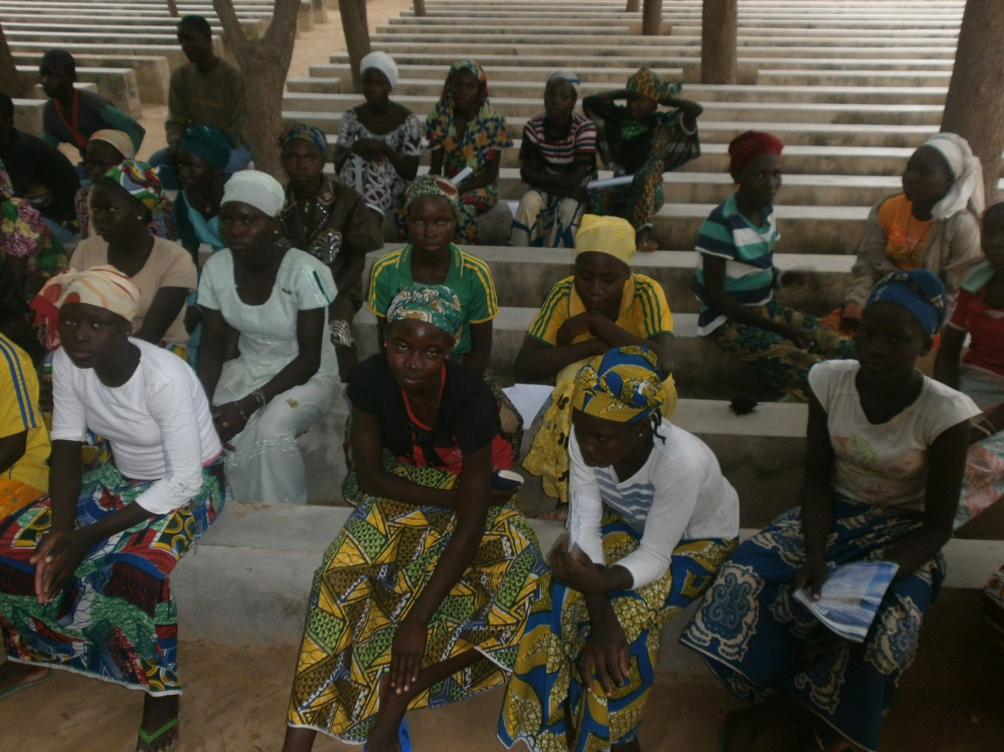
Children from rape and orphans
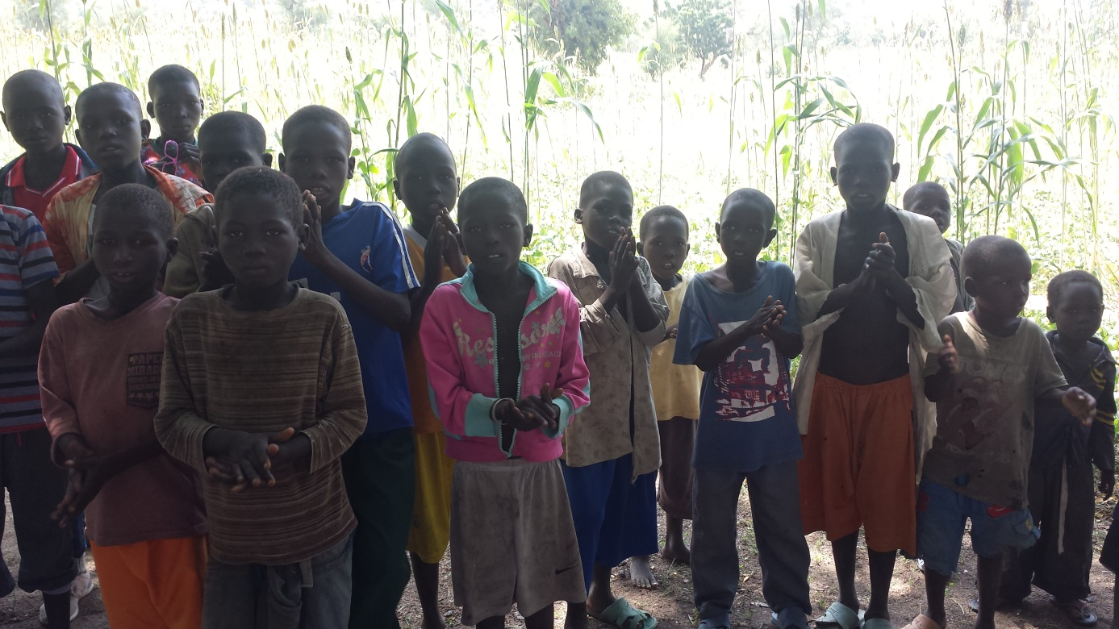

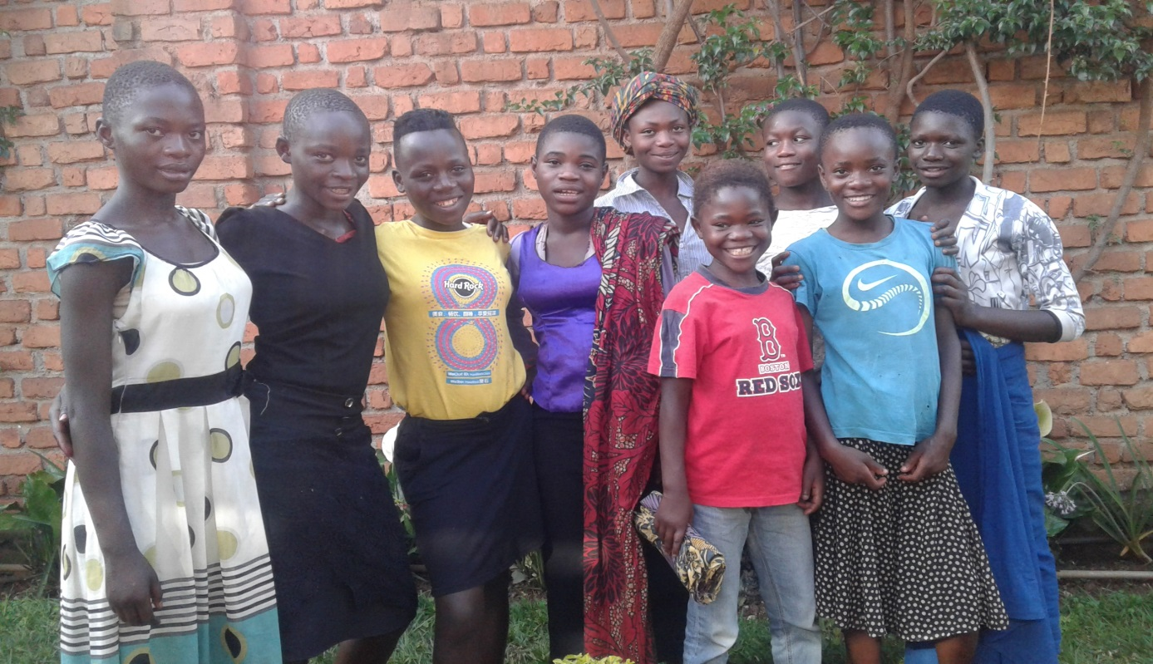
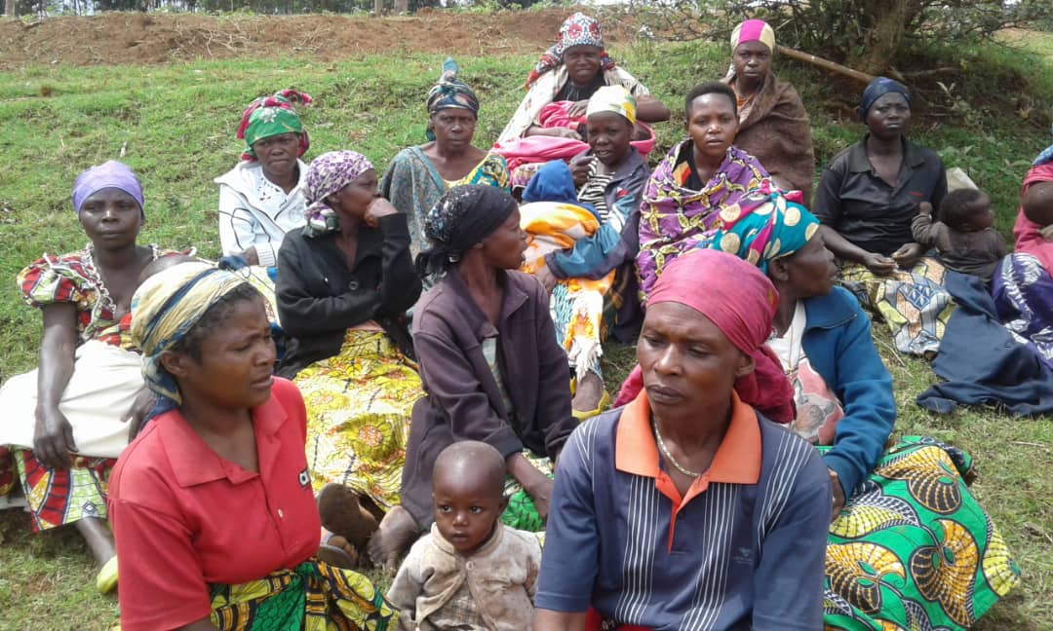

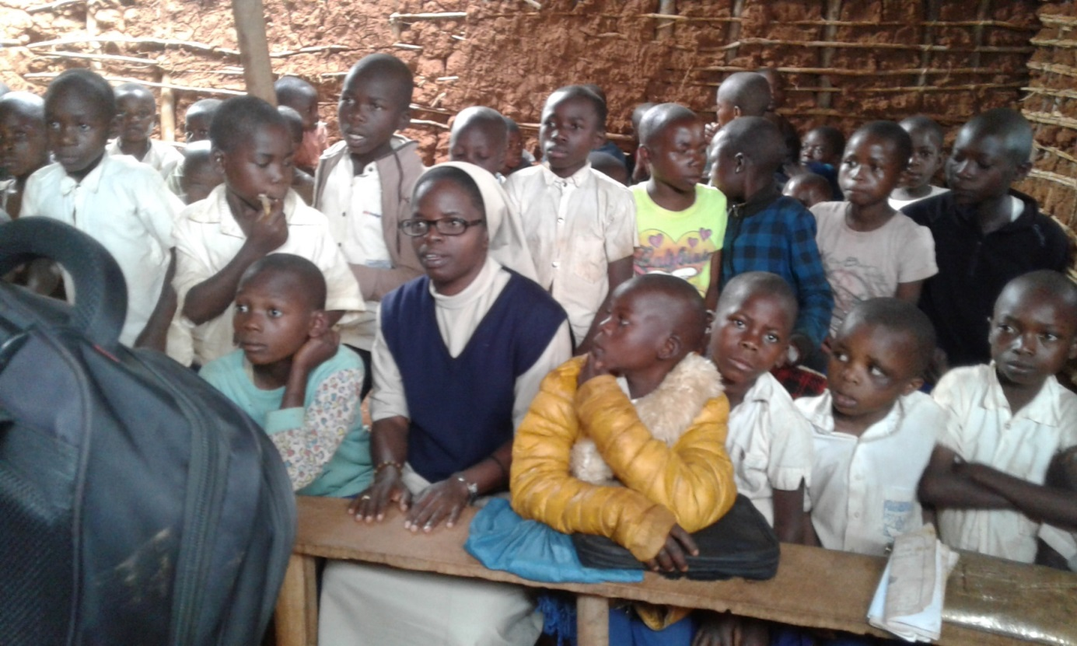
Our beneficiaries DR Congo paying visit and Evaluation of our activities

