[Document title]
INCREASING FOOD ACCESS AND IMPROVING THE LIVELIHOODS OF IDPs IN CAMEROON

PROJECT RATIONALE

Background
Cameroon is a Central African Nation located alongside the banks of the Gulf of Guinea. The country is encircled by the nations of Nigeria to the west and north, Chad in the northeast, the Central African Republic to the east, and Gabon, Equatorial Guinea and the Republic of the Congo to the south.
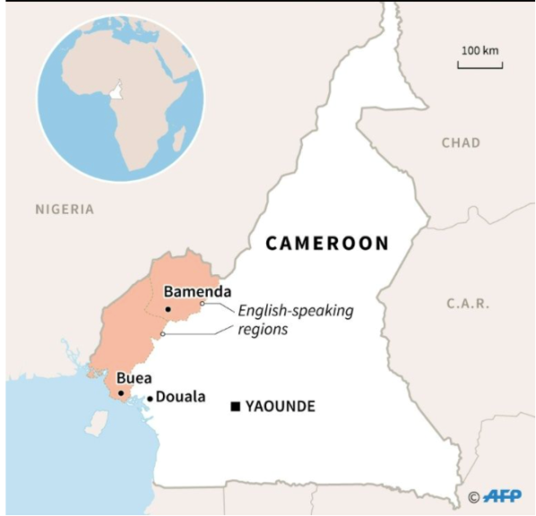
Map of Cameroon with the Anglophone regions highlighted in peach. Source: AFP Photo/Valentina Breschi
The bilingual nation of about 24 Million inhabitants is comprised of a French-speaking majority and an English-speaking minority. Cameroon has a longstanding history of hosting refugees and asylum-seekers, in light of the recurring crises in neighboring areas such as the violence in the Central African Republic and the Boko Haram insurgency in the Lake Chad region. Nonetheless, the 2016 crisis in its Anglophone regions (the Northwest and Southwest regions) has impaired the country’s ability to act as a safe haven for vulnerable migrants. The crisis started out as peaceful protests led by Anglophone teachers, lawyers, and activists who were decrying the government’s Francophile policies; it soon deteriorated into a bloody civil conflict when government forces used violent tactics to suppress the voices of innocent civilians. This in turn gave rise to a number of Anglophone militia groups fighting in favor of a breakaway state they call Ambazonia.
Map of Cameroon with the Anglophone regions highlighted in peach

To date, both sides igniting the crisis—namely government forces and militia groups—have been called out by prominent organizations such as Amnesty International and Human Rights Watch for committing grave acts against humanity. Government forces have resorted to torturing the innocents, conducted extra-judicial killings and performed arbitrary arrests and detention on civilians. They have sexually exploited women and girls and have abused the disabled. Moreover, they have conducted large-scale arson operations, which have caused the massive destruction of 170 villages in the Anglophone regions, leaving many without a home and means to survive. The militia groups on the other hand have used coercive strategies and barbaric tactics on civilians as a way to garner support from the local population and win over government forces. They have forcefully maintained a boycott on schools since late 2016 and have violently punished non-adherents to their boycotting efforts; they have also kidnapped and/or tortured—at times to death—people of authority or of relative influence, such as school principals and vulnerable people such as children, to solidify their stronghold in the affected regions.

The crisis has thus far claimed the lives of at least 1,850 people and uprooted more than half a million people from their homes—a stark contrast to the 160,000 figure reported back in May 2018,. Below is a highlight, in statistical format, of the ravages caused by the crisis:

536,000+ Internally displaced persons (IDPs) from the Northwest and Southwest regions
463,000+ persons deemed severely food insecure
39,000+ refugees in Nigeria

The issue of food security remains one of the priority areas for humanitarian relief, threatening the livelihoods of thousands of victims. The urgency to bridge the gap in food security is highlighted in the UN OCHA’s emergency response plan, where in 2019, the budget for food security increased to roughly $42,000,000 from the nearly $3,000,000 budgeted the year prior,.
IDPs have had to resort to negative food-related coping strategies, reducing the number of meals (to one meal a day) and adult consumption in order to feed the children.

Source: OCHA, “2018 Emergency Response Plan Summary: Cameroon North-West and South-West”, May 2018

Additionally, the sluggish state of the economy further compounds the problem of food security, with businesses crumbling in the face of a dwindling population. This contributes to increasing poverty rates, making it challenging for victims to afford buying food. The degradations of medical facilities, which have been the constant targets of government forces, is another factor that further exacerbates the state of food insecurity amidst the growing number of malnutrition cases.

In the face of this massacre, humanitarian efforts have been slow to roll out for several reasons. First, early on in the crisis, the government of Cameroon blocked INGOs from accessing the Northwest and Southwest regions. Currently, although this policy has been abandoned, the growing insecurity has been a significant deterrent for humanitarian organizations in their quest to provide life-saving necessities to persons in need,. Moreover, funding gaps have impeded the ability of humanitarian workers to meet the needs of vulnerable migrants in the affected areas..

REWAC’s Approach
As a grassroots organization with a large network of local partners, familiarity of local conditions and terrains, and expert knowledge of Cameroon’s judicial system and international human rights laws, REWAC has had much success in implementing humanitarian projects at a local level. The organizations’ efforts are guided by its mission, which centers around empowering vulnerable migrants—defined as refugees, asylum-seekers, asylees, and IDPs—towards the achievement of sustainable livelihoods. Since its inception in 2009, REWAC has helped more than 2,000 vulnerable migrants throughout the Northwest and Southwest regions in the areas of advocacy, food security and education. Within the context of the crisis, REWAC has shifted its operations to focus more on the ever-growing IDP population; the organization has leveraged its partnerships with local actors to maximize food security assistance operations, leading to 1500 IDPs receiving life-saving humanitarian assistance in the Anglophone regions. For this project, REWAC will implement a range of outreach activities aimed at alleviating the burden of food security, improving livelihoods, and providing legal assistance services in the wake of the grave human rights violations that have been committed against the victims. The target population will be 2,000 IDPs throughout the Northwest region.

PROJECT GOAL & ACTIVITIES

Project Goal: Alleviating the burden of food insecurity among IDPs in the Northwest region and improving their livelihoods
Objective 1: Increasing access to food and non-food items among IDPs and promoting human rights
Activity 1.1 Needs Assessment: Conducting a needs assessment is an essential step in determining the kinds of humanitarian kits that a given community will need. The assessment will use a focus group format that will target key informants of a given community as a way to collect qualitative data on the needs of the community.

Activity 1.2 Selection of Partners: REWAC relies on a network of local partners to facilitate the logistical aspects of the relief operations. These local partners are often faith-based organizations such as churches; they help to identify families and individuals in need and serve as a venue for such activities as the relief operations and community forums.

Activity 1.3 Training of 30 volunteers: Each relief operation will be carried out by a group of volunteers. In an environment as volatile as the Anglophone region it is imperative for volunteers to familiarize themselves with risk management techniques in order to avoid or minimize safety risks associated with the crisis.

Activity 1.4 Community Forums:. Since the onset of the crisis, victims have been living in an environment of fear and distrust; trapped between the lethal threats of government security forces and Anglophone militia groups, they no longer know who is a foe or a friend. REWAC has found that this level of distrust and fear plays in the victims’ ability to interact with representatives from humanitarian workers, as many display a level of reticence. Therefore, the primary goal of this activity is to enable an environment of trust between REWAC staff & volunteers and IDPs in order to empower the IDPs to voice their opinions and tell their stories without fear. It will also give REWAC the opportunity to provide legal counseling to refugees as many have lost important legal documents, such as birth certificates, in the crossfire of the crisis.

Activity 1.5 Relief Operations: Relief operations are the essence of the project. They are carried out by 11 staff and volunteers as a humanitarian response to the needs of IDPs. During each relief operation, a range of kits, whose specific type (i.e. hygiene kits, mobility aids, food item kits, emergency health kits, etc…) will be determined through the results of the needs assessment, will be distributed among 200 IDPs families over 10 months, covering 2,000 IDPs in total over the project implementation period. This will cover a total of 8000 persons, taking each family to have an average of 4 persons.

Activity 1.6 Evaluation: Two evaluations will be carried out over the course of the project in order to determine the effectiveness of the relief operations, using the needs assessment as the baseline.

“’These Killings Can be Stopped’: Abuses by Government and Separatist Groups in Cameroon’s Anglophone Regions”, Human Rights Watch, https://www.hrw.org/report/2018/07/19/these-killings-can-be-stopped/abuses-government-and-separatist-groups-cameroons, (July 19, 2018)
Ibid
“Cameroon’s Anglophone Crisis: How to Get to Talks?”, International Crisis Group Africa Report #272, https://www.crisisgroup.org/africa/central-africa/cameroon/272-crise-anglophone-au-cameroun-comment-arriver-aux-pourparlers, (May 2, 2019)
“Cameroon: A turn for the worse: Violence and Human Rights Violations in Anglophone Cameroon”, Amnesty International, (Index number: AFR 17/8481/2018) https://www.amnesty.org/en/documents/afr17/8481/2018/en/, (June 12, 2018)
“Cameroon’s Anglophone Crisis: How to Get to Talks?”, ICG, (May 2, 2019)
“Emergency Response Plan – Cameroon North-West and South-West – Summary”, UN Office for the Coordination of Humanitarian Affairs, https://reliefweb.int/report/cameroon/emergency-response-plan-cameroon-north-west-and-south-west-summary-may-2018 (May 27, 2018)
“Cameroon: Humanitarian snapshot in South-West and North-West regions”, OCHA, https://reliefweb.int/sites/reliefweb.int/files/resources/cmr_nwsw_snapshot_july_2019_final1.pdf (July 2, 2019)
“Cameroon: North-West and South-West”, OCHA, Situation Report #6, https://reliefweb.int/sites/reliefweb.int/files/resources/ocha_sitrep_ndeg_06.pdf (May 16, 2019)
“Emergency Response Plan – Cameroon North-West and South-West – Summary”, OCHA, (May 27, 2018)
Ibid
“Cameroon: Humanitarian snapshot in South-West and North-West regions”, OCHA, (July 2, 2019)
“Cameroon’s Anglophone Crisis: How to Get to Talks?”, ICG, (May 2, 2019)
“Cameroon: Humanitarian snapshot in South-West and Norht-West regions”, OCHA, (July 2, 2019)
“Cameroon Situation: Responding to the needs of IDPs and Cameroonian Refugees in Nigeria (Supplementary Appeal: January – December 2019)”, UNHCR, http://reporting.unhcr.org/node/22021 (March 2019)
“Cameroon’s Anglophone Crisis: How to Get to Talks?”, ICG, (May 2, 2019)
“Cameroon: Humanitarian Response Plan 2019 Summary (January 2019)”, UN Office for the Coordination of Humanitarian Affairs, https://reliefweb.int/report/cameroon/cameroon-humanitarian-response-plan-2019-summary-january-2019 (February 21, 2019)

