SAVE HAVEN COMMUNITY SERVICES PROJECT

PROJECT TITLE; Building an Outpatient Neurology Clinic in Liberia

URL: Epilepsy and neurology clinic for 100 000 Liberians
Project Summary:
Save Haven Community Services Project plans to build an 8 room outpatient neurology clinic with lab space and pharmacy for epilepsy and neurology patients who are the most stigmatized and ostracized and neglected in Liberia; also providing community education and broad public awareness throughout Liberia.

Requested Funding Amount:
$90,000 USD.
Donation Options:
$25 will pay for 3 bags of cement
$50 buys 40 bricks
$100 buys 3 doors
$200 pays for 3 bundles of zinc for the roof
$400 pays for flooring tiles for 3 rooms
$600 pays for 15 chairs , 5 desks; and 6 security locks
$1500 will pay for ¼ acre of land.
What is issue, problem and the challenge?
There are estimated 100, 000 people with epilepsy in Liberia. They have no access to regular medical care and seizure medication titration. They also suffer from a disproportion amount of stigmatization and ostracization leading many to be fired from their jobs or sent away from schools after every seizure episode because of fear of the contagiousness of the disease and worse, many are just ostracized. This leads to many medical and economic issues including depression, extreme poverty and severe lack of schooling which can be a way out of poverty.

How will this solve the issue?
Save Haven Community Services Project will provide expert neurologic and ancillary neurologic staff care to these patients by timely diagnosis and treatment. We will also carry out continuous anti stigmatization public awareness audiovisual broadcasts. Wewill educate educators, employers about the non contagiousness of epilepsy so these patients can be returned to their rightful roles in society, schools and the workforce to lift them out of poverty gradually.

Potential Long Term impact:
The clinic will potential impact about 100, 000 of the most vulnerable Liberians who are mostly ostracized and shunned from society. The affected children will be able to return to school in a timely manner without the risk of being bullied or stigmatized., reducing the rates of potential suicide in an already very depressed population. The women and men who are workers and caregivers will be able to seek gainful employment and contribute to their own self sufficiency and well as the nation’s economic sustainability.

Primary Project and Photo Gallery
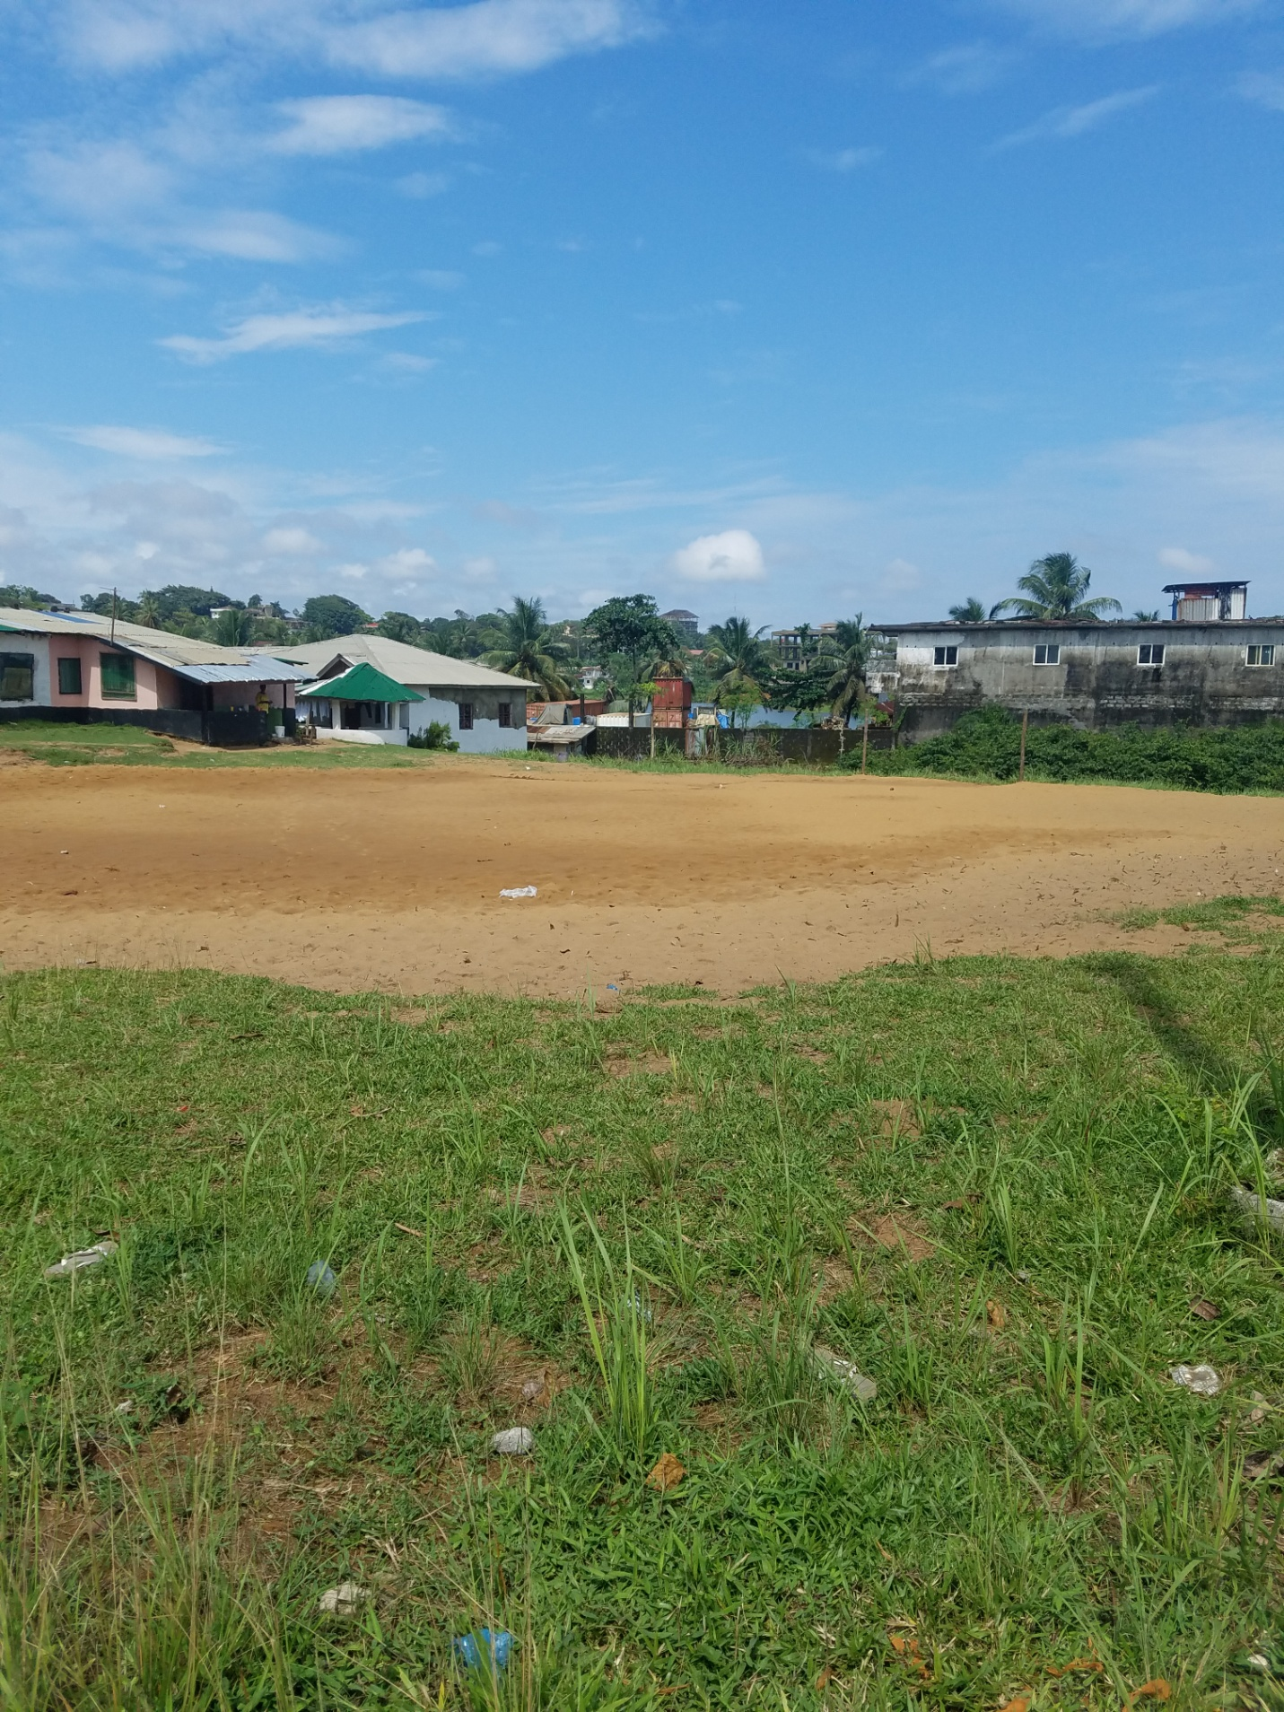

Web Resources
https://www.karger.com/Article/PDF/110507
https://www.who.int/mental_health/management/epilepsy_in_African-region.pdf
https://www.youtube.com/watch?v=PZYZIU5PEWU

