NEW BRIGHT COMMUNITY

DEVELOPMENT

CENTER

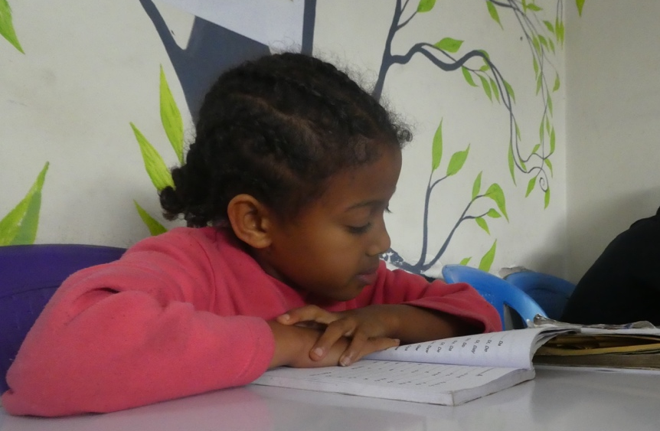

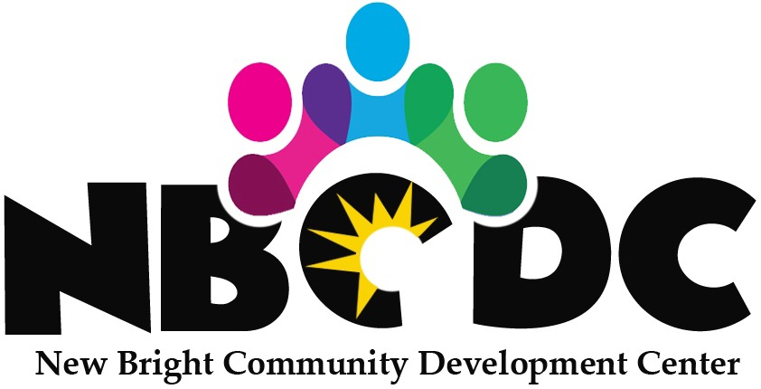

New Bright Community Development Centre (NBCDC) is a Non-Governmental Organization based in Addis Ababa, Ethiopia. NBCDC was established in 2016 with the purpose to support and protect the most vulnerable children, youth and women.

VISION
Aspire to see self-confident, self-reliant and empowered society in Ethiopia.

MISSION
Create educational and economic opportunities to vulnerable children, youth and families, to bring about positive and sustained social development at the community and household level.

GOAL
To contribute to the national efforts made in education, socio-economic development, community empowerment and poverty reduction in Ethiopia.

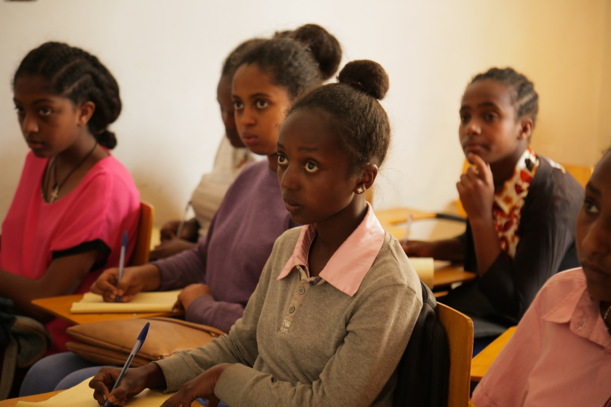
OBJECTIVES

- Provide educational and vocational support which includes school materials for orphan and vulnerable children (OVC) and youth. Therefore, NBCDC is making the children and youth competent and independent individuals.

- Support OVC and youth economically, socially and psychologically by creating a safe, friendly and educational environment.

- Support community members who are living in poverty and are routinely faced with social problems.

- Combat environmental degradation by creating awareness programs and planting indigenous trees around Addis Ababa.
AREAS OF CONCERN
- Educational Support
- Psychological Support
- Economic Empowerment
- Environmental Conservation and Awareness Raising

OUR VALUES

- We promote human potential.
- We strive for originality, resourcefulness and imagination in all projects.

- We believe the societies working with have a vital role to play in the future of our success.

- We believe in building a strong relationship with other NGOs and Governmental institutions within Ethiopia and internationally.

OUR STRATEGY

NBCDC seeks to utilize effective grassroots, community-based approaches that draw upon and support existing community resources and cultural practices.

NBCDC believes that local community efforts and challenges must be integrated in all of its programs to realize and attain its vision of sustainable development and to enhance the economic independence of our beneficiaries.

PROGRAMS

CHILDREN AND YOUTH EDUCATIONAL DEVELOPMENT CENTRE (CYEDC)

The CYEDC project is designed to assist beneficiaries of NBCDC and community members to further their education, business and life skills to enhance their capacity to become independent successful individuals.

WOMEN'S EMPOWERMENT THROUGH LEADERSHIP AND SOCIAL CHANGE (WELSC)
WELSC is designed to support the development of women and young girls’ skills and knowledge on gender equality, vocational training, provide leadership in areas of concern and health related areas while providing general trainings in technology and innovation.

ACTIVITIES
  - English, Computer and Art Training
  - Business and Life Skills Training
  - Psychosocial Support
  - Empowerment Classes
  - Leadership Activities
  - Income Generating Activities
  - School Tutorials
  - Educational / Vocational Sponsorship
  - Library and Snack Provisions

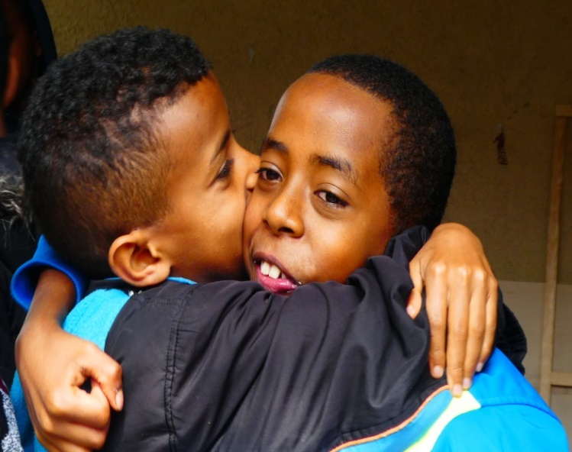

CONTACT US

New Bright Community Development Center
Tsedale Kinfu
Managing Director

+251 911 445 707
+251 118 124 810
newbright2017@gmail.com
www.newbright.org

www.facebook.com/newbrightorg

