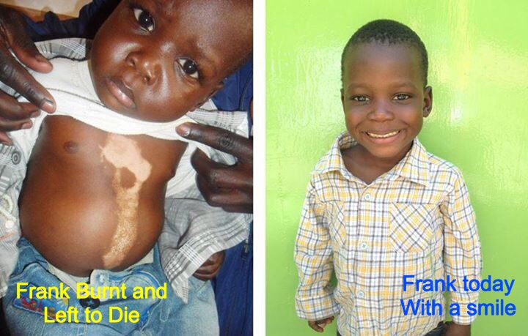
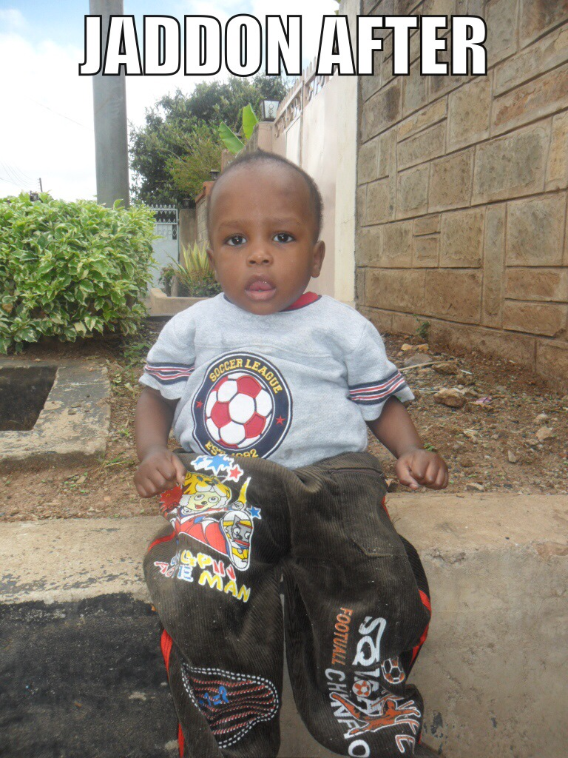
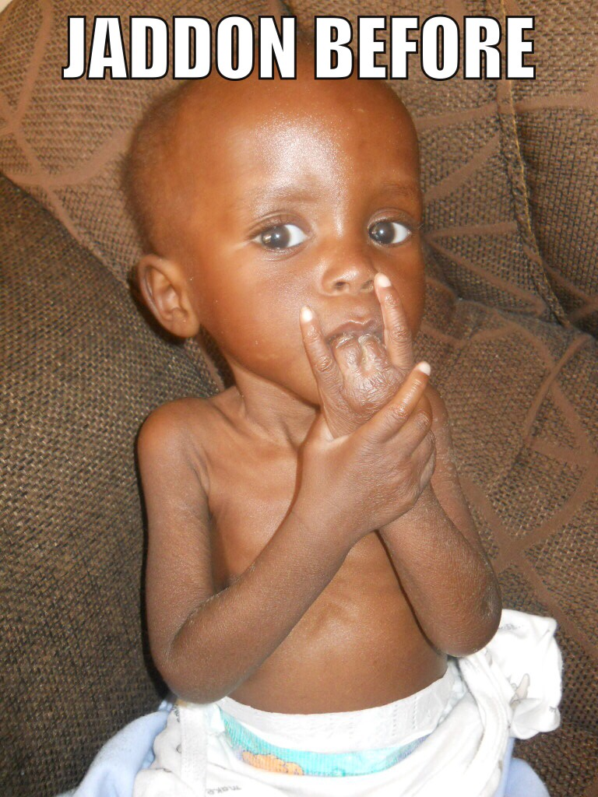
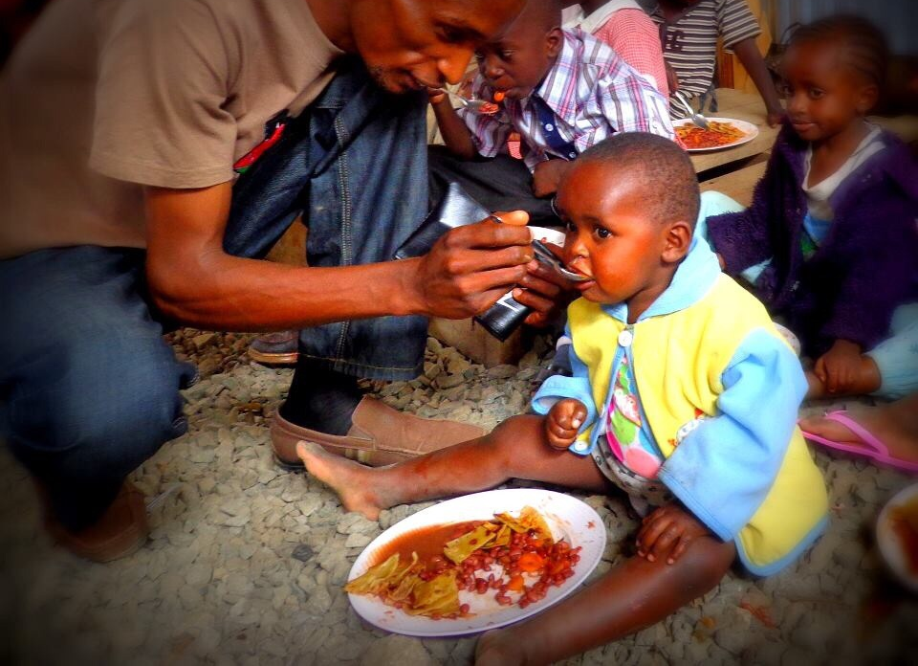
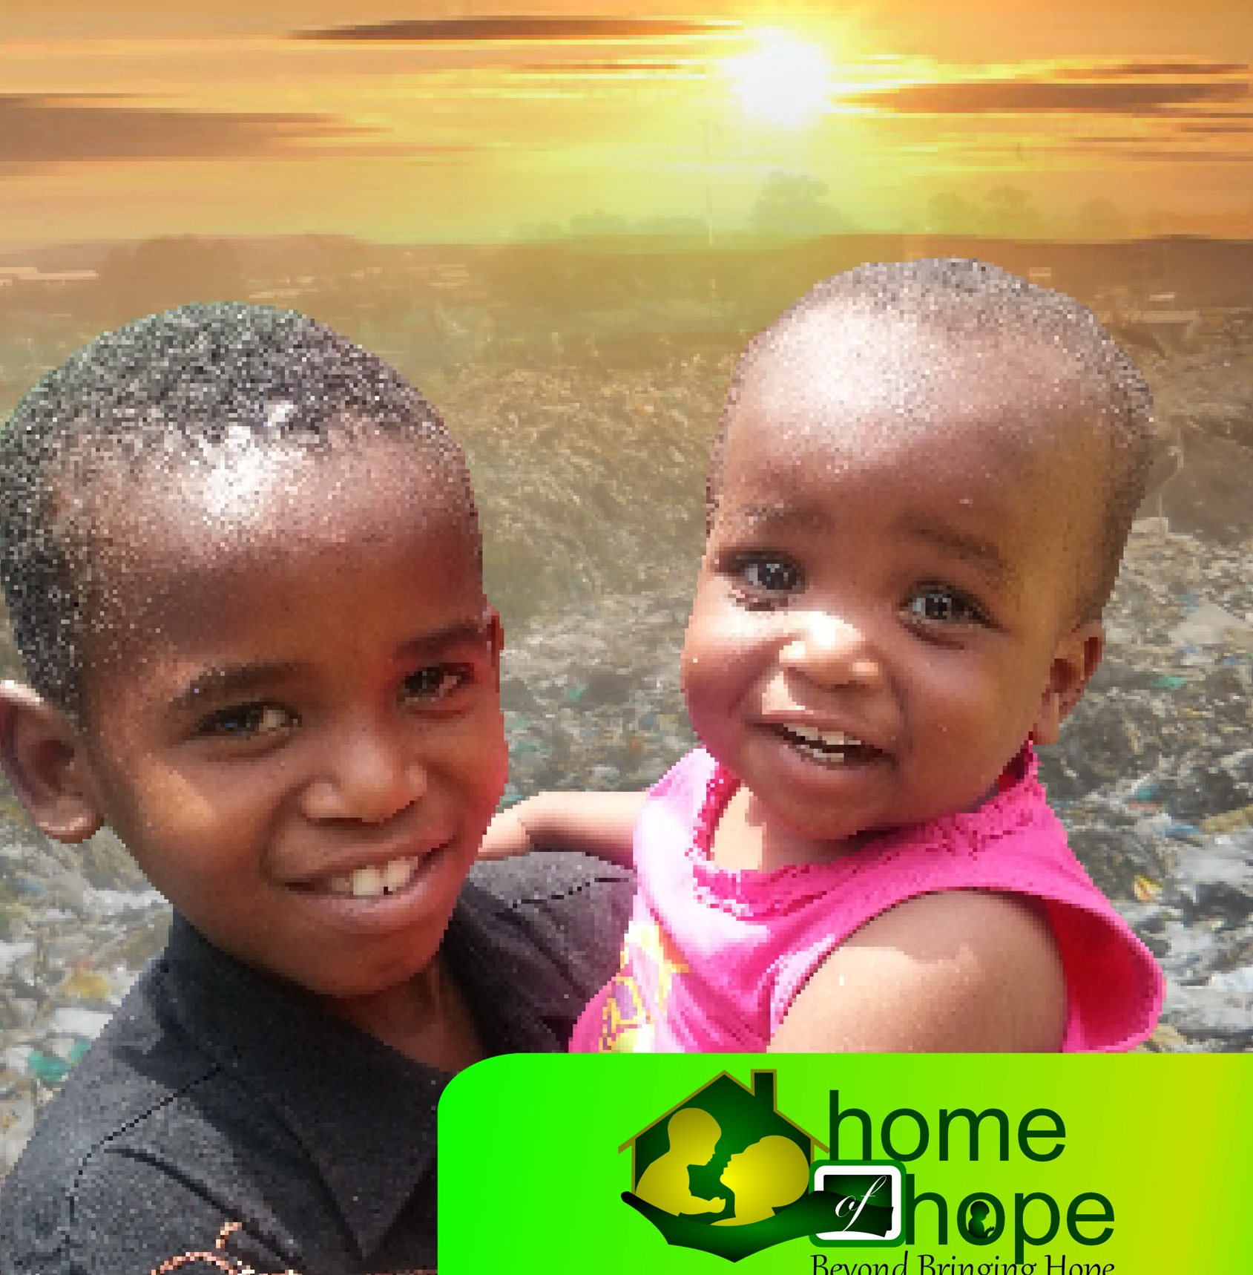

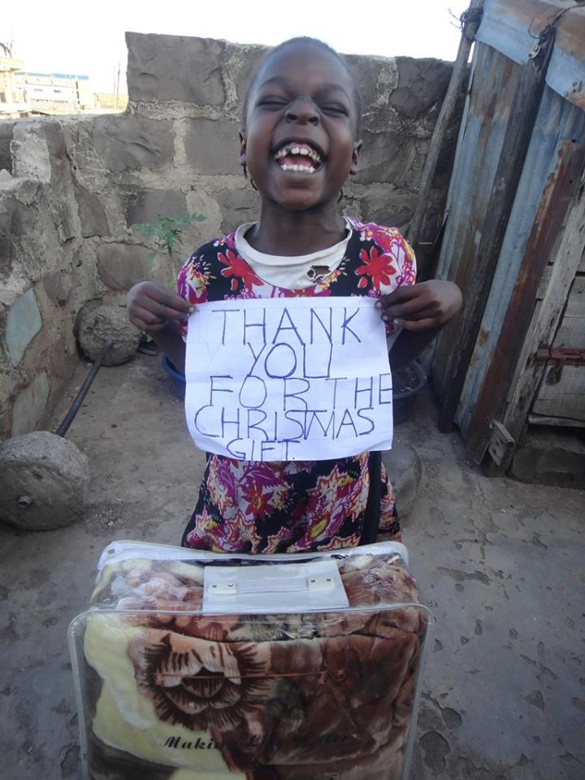
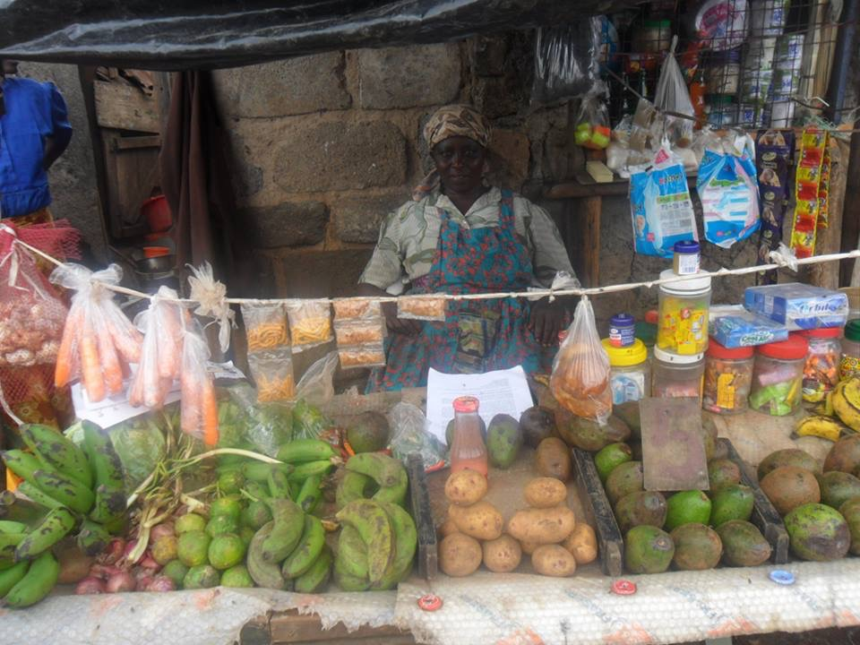
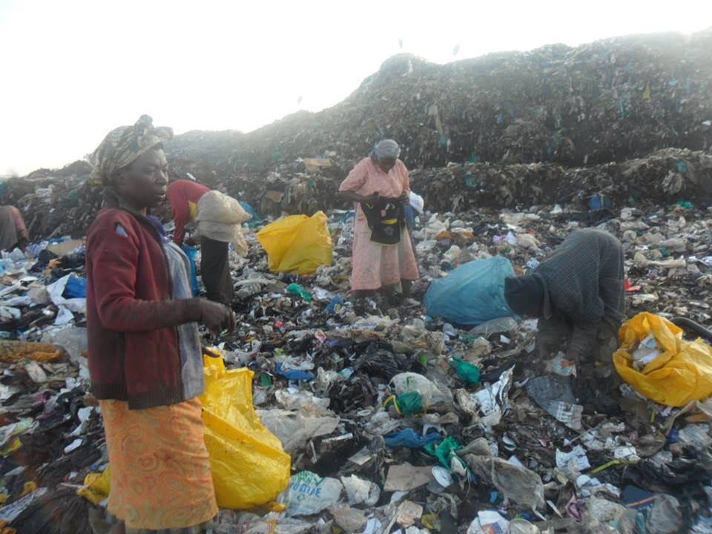
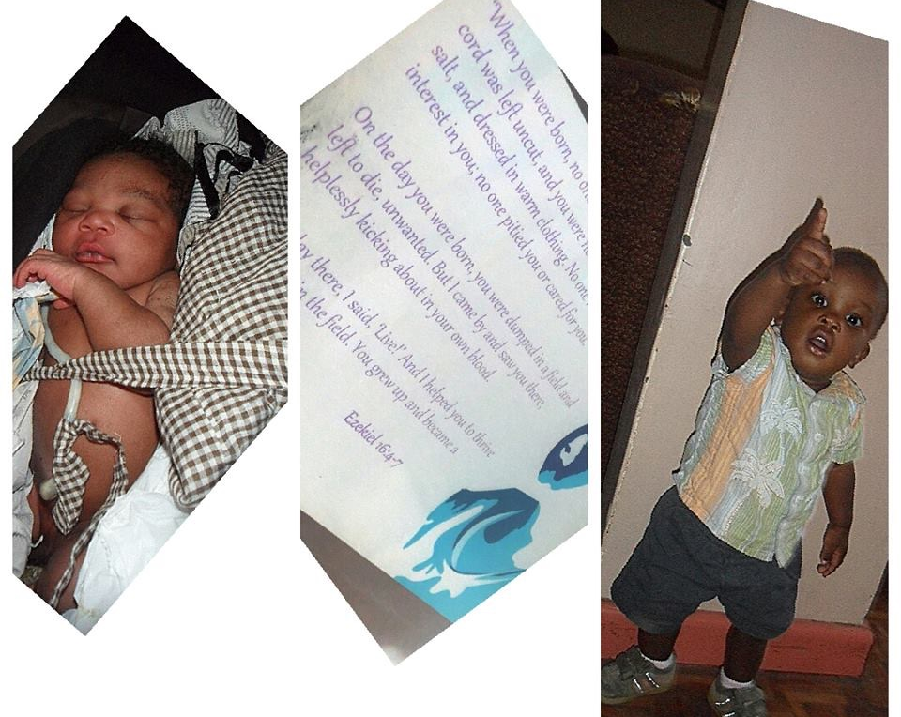
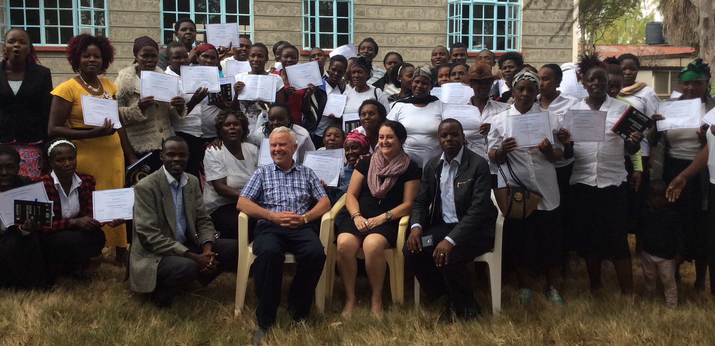
Home of Hope InternationalPlan

Home of hope kenya

BACKGROUND INFORMATION
Walking through into the depths of the slums in Kenya is a pathetic adventure of shock. Children live in the midst of a desperate situation that defies description. Every 14 minutes, a child is orphaned, abandoned aborted or thrown away. 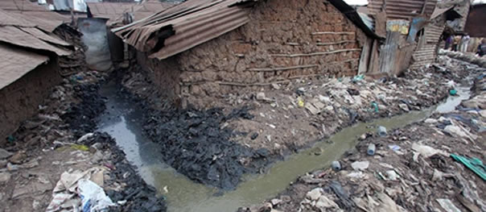

Home of Hope Kenya responds to the overwhelming number of abandoned, orphaned and vulnerable children and women in extreme poverty living in horrible slum conditions and raising them up to become leaders of sustainable change in the community.

HOH focuses on their real life needs physically, economically and socially. It is a holistic approach to providing tangible benefits such as rescue, shelter, education, health, and food, as well as developmental opportunities that can include formal and vocational education, health, counseling and emotional well-being and spiritual discipleship to bring about meaningful social life changes desired.

Home of hope kenya

Our Mission is “to provide loving care and hope to orphans, desperate children, destitute and poor women in the poor communities that helps to eradicate abject poverty and nurtures sustainable development”.

We envision “sustainable development through rescue, restoration and empowerment.”
To attain our vision and mission, we purpose to rescue babies from garbage dumps, slums and the streets as well as destitute women and desperate children from abject poverty or abandonment and raising them up to become champions of sustainable change in our society.
Our strategic framework is modeled around four (4) inter-related interventions:
    - Child rescue and care; (the Dream Centre)
    - Orphans and desperate children support; (Child Sponsorship Program)
    - Crisis intervention; (Stella Women project, Cart Business Project and Teen Pregnancy Care and Counseling Project)
    - Small business development Program; (Literacy training, Business skills training and Microfinance)

Our Core Values
Our organizational culture shall be shaped by the following five (5) fundamental beliefs/ and core values, which are modified Word if Life Core values.

- Driven by Compassion: To be actively involved in local projects of compassion.
- Engaging the Culture: We strive to create an atmosphere and attitude that engages every community that we serve. We constantly reach out to every aspect of our society in every possible way to help connect people with solutions.
- Living in Authentic Relationship: We strive to live in healthy authentic relationship with each other; being truthful and honest at all times and in all we do.
- Empowering Potential: To unlock, release the God given potential of every person we serve. Whatever sector of culture and society we seek to see potential in others, train and mentor them to fulfill their destiny on our team and their life purpose.

HOME OF HOPE KENYA
- For All Generation: We believe in longevity and strive to build sustainable projects and programs that reach and touch every age group of people. We also believe that projects and programs should last for generations in communities and serve as a pillar of stability in their communities

HOH KENYA INTERVENTIONS

1. DREAM CENTRE: BABY RESCUE AND CARE
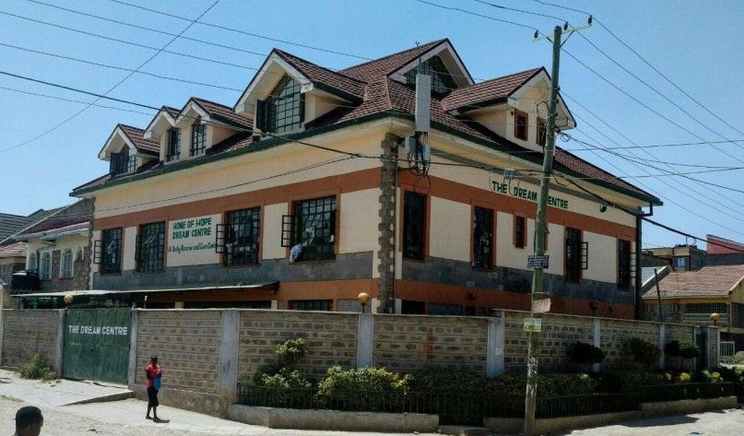
There are many vulnerable babies in Kenya who are wrapped up in plastic bags and thrown away in garbage dumps, abandoned in slums, streets or hospitals or orphaned due to poverty, lack of employment and the HIV/AIDS crisis. Majority of them fail to make it to their 5th year because of the much-needed intense care and medical attention that their immediate relatives cannot provide.
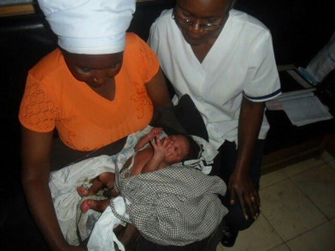
The Dream Centre rescues abandoned babies and provide acceptance, unconditional love and care they need. It is common for the babies to be aborted, premature, abused, neglected, malnourished and to have serious medical complications when they arrive at Dream Centre and so a need to equip the centre to meet the demands. From the moment they arrive, the Dream Centre does all it can to provide them with every opportunity to live healthy, fruitful and productive lives.
The babies come to the Dream Centre from a number of referral sources, such as hospitals, local authorities, Government Children office, ‘Community workers, and other homes and care organizations.
- RESCUE: We rescue abandoned babies from garbage heaps, trash bins, along the streets, in the slums, in hospitals and police stations. We first take them for medical examination, get legal custody papers and bring them home to the Dream Centre.
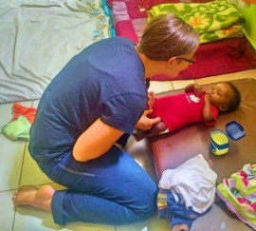
- THE CARE: The babies find acceptance and unconditional love. They await, adoption, foster or placed into our Family Unit homes where they are cared for by a house mother. The caregivers are trained to love the babies who already suffer rejection. The care involves general baby care, good nutritional food, medical care, education, clothing, shelter, social activities among others.

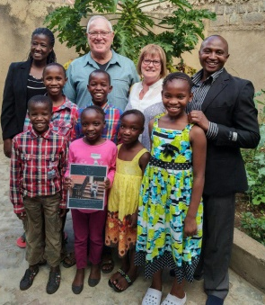
- RELEASE: we believe every child needs a home and a family. Our exit plan involves placing the children for adoption, in foster homes, reintegrated and forming a family unit. We partner with individuals and organizations or teams globally to create families and build homes for the rescued babies and to help raise the financial support to settle the families in the homes and sustain the recurring upkeep monthly costs.

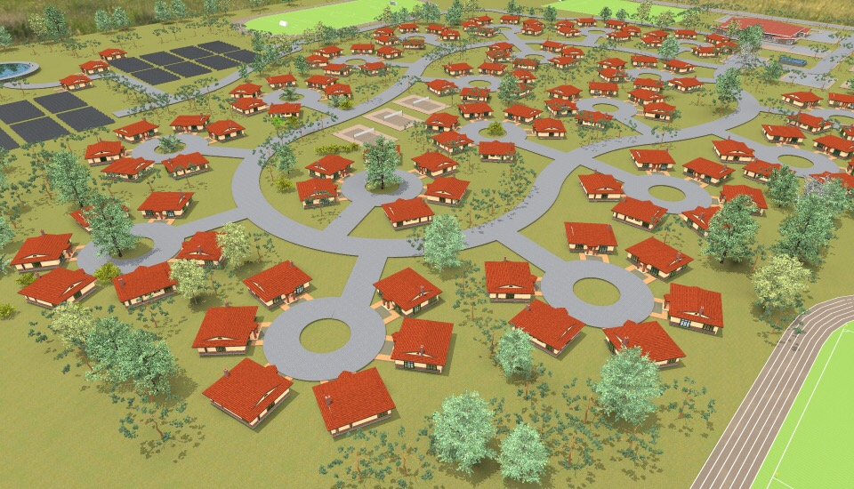
- FUTURE PLAN: Every rescued baby needs a decent, safe and affordable place to live. We welcome people to partner with us to build homes where 8 children live as siblings with a house mother or couple. We welcome volunteer labor and donations to build these homes as Our planned roll out “HOH Dream Village” concept. At the moment, homes are rented to house such families.

2. ORPHANS AND DESPERATE CHILDREN SPONSORSHIP

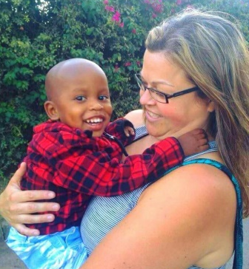
CHILD SPONSORSHIP PROGRAM: The Program empowers orphans and desperate children, their families, and their communities to build a foundation of action and hope for a healthy and sustainable future by offering every eligible child within HOH catchment areas access to education, protection, shelter, food security, psychosocial support, medical care and economic security.
With your Sponsorship, we address basic needs. You help ensure a child in need has the best chance for success — with a healthy life, the opportunity to learn, protection from harm and empowering the community every step of the way.
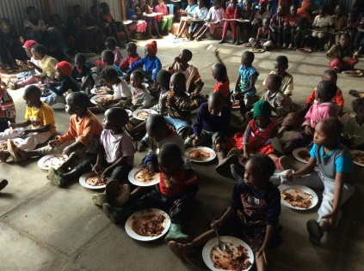
FEEDING PROGRAM: Poverty, diseases and hunger stalk many slum children. HOH started feeding program to ease the suffering to the many poor slum children who either have 1 or no meal for several days. A daily meal provides strong incentive to send children in slums to school and keep them there and allows children to focus on their studies rather than their stomachs.
Sponsor →
3. WOMEN IN CRISIS INTERVENTION PROGRAM

The most marginalized and wounded people in Kenya are women. They are left abandoned or widowed, many of them living in horrifying slum conditions and fending for themselves by working in the garbage dump or sex workers. So destitute and desperate, fear for their future and that of their children.

The program Targets women in crisis situation anchored on counseling and social support. The program aims at preventing abortion, abandonment or murder of babies and helping women mostly teenage girls overcome crisis situations. We strive to achieve this through counseling, advocacy, sheltering, increasing community awareness and changing social attitudes.
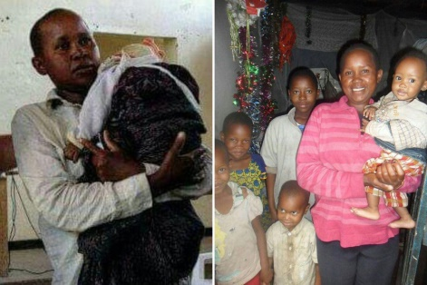
STELLA WOMEN PROJECT: Aims at rescuing single moms living with several children from the slum conditions and relocating the family to a decent home. The mother receives training in business skills and given soft loan to start small business that goes a long way in helping the family.

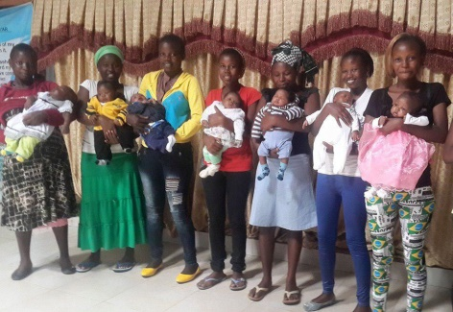
TEEN PREGNANCY CARE AND COUNSELING: We also act to prevent child abandonment by reaching out to target groups of teen girls and single mothers through counseling, training and economic empowerment. Care Counseling is designed to provide encouragement, insightful and guidance to teen moms, single moms during times of personal crisis or family difficulties.

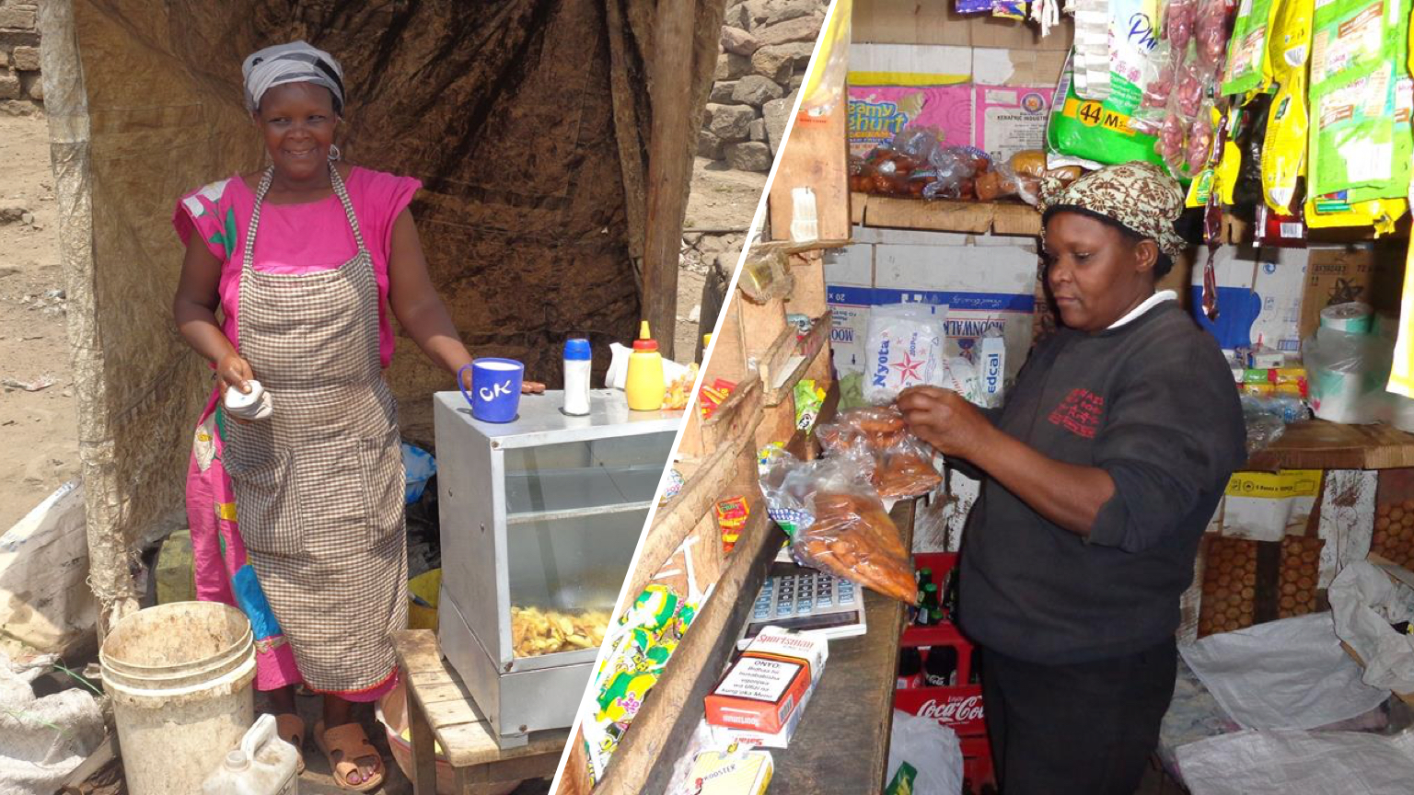
4. SMALL BUSINESS DEVELOPMENT PROGRAM (SBDP)
Micro-financing would ideally be a core strategy for women empowerment as post crisis support. The small business development Intervention specifically involves mobilization and organization of target women into groups, training them on basic business skills, and advancing them micro-loans under a low cost micro-finance scheme.

IMPACT
In 8 years we have worked with the communities to rescue, care, reintegrate, and support over 1,327 children. Most of who are in Schools and colleges. We’ve taken a proactive approach in preventing child abandonment menace in slums by supporting over 330 teen mothers and single mothers with counselling, life skills and business training as well as through grants and Microloans for business start-ups. Several quack abortion clinics have closed down as a result and the teenage girls’ pregnancy is reducing. 133 mothers trained in business skills and given microloans to be entrepreneurs. We look forward to producing doctors, lawyers, nurses, teachers, and community workers through education, capacity building and economic empowerment. HOH International is intentional to creating a society where poverty, disease and hunger is reduced and most important, establish strong family units that are able to train themselves and give our children a hope for future.

HOME OF HOPE INTERNATIONAL |  | Budget
INCOME |  | Budget
 | Projected Income | US Dollars
 | Home Church Canada | 213,700
 | Tellux AB Sweden | 75,000
 | Tellux Africa Limited | 53,000
 | Individual Donations | 123,000
 | Other | -
 | Total Operating Income | 464,700
 | Non-Operating Income
 | Gifts Received | 2,359
 | Rental Income
 | Donations | 3,670
 | Other | -
 | Total Non-Operating Income | 6,029
Total INCOME |  | 470,729
EXPENSES
 | Operating Expenses
 | Accounting and Legal | 1,800
 | Office Supplies and Operations | 1,620
 | Dream Centre Rescue & Care | 248,067
 | Orphans & Desperate Children Support | 132,375
 | Women in Crisis Interventions | 42,500
 | Pregnant Teen girls support | 47,500
 | Maintenance and Repairs | 10,800
 | Small Business Microloans | 35,250
 | Family unit set up and maintenance | 28,800
 | Salaries and Wages | 152,640
 | Taxes and Licenses | 38,160
 | Travel | 1,850
 | Web Hosting and Domains | 185
 | Miscellaneous | 1,260
 | Total Operating Expenses | 755,715
 | Non-Recurring Expenses
 | Furniture, Equipment and Software | 25,558
 | Gifts Given
 | Other
 | Total Non-Recurring Expenses | 25,558
Total EXPENSES |  | 764,365
 | Net Income Before Taxes | (293,636)
 | Income Tax Expense
Deficit |  | (293,636)

Prepared for Home of Hope International
By: SOL & ASSOCIATES certified Public accountants

