Business Name: FABULOUS INNOVATIONS LIMITED
LOCATION: Nyanama-opposite Nyanama Apartments
COUNTRY: Kampala-Uganda
Email: fabulousinnovations81@gmail.com
PHONE NO:+256776959131
SLOGAN: leveraging malaria through everyday consumer products with anti-malaria citronella.
FOUNDER: Tayebwa Monica

Table of Contents
Executive Summary 3
1. Introduction 4
2. The Product/Service: 6
3. Industry and Market Analysis: 7
4. Competition 8
5. SWOT Analysis 9
6. Operations Plan 10
7. Marketing Plan 11
8. Management 12
9. Financial Plan 13
10. Appendices 15

Executive Summary
There are very many challenges in this world but malaria is more than achallange, In Uganda, children below five years are the most affected with malaria. According to the Ministry of Health (Uganda), currently 90% of 100,000 recorded malaria deaths in Uganda are children, especially in rural areas who can’t access hospitals. The majority of people in rural communities are turning to enterprise as way to solving their problems. Fabulous innovations exists to contribute to the fight against malaria by using a designed social venture that targets infants, pregnant women, the elderly and tourists as our clients who can afford our products. We do this through the manufacture of locally organic mosquito repellent products such as soap, jelly and candles which are highly affordable by the lower rural class customers for home consumption.

Fabulous innovation limited is a registered partnership and is based in Kampala Uganda. We have moved from our product being an idea nor a prototype but rather to a business that has reached scale stage.

Our product offering.
Fabulous innovations Limited’s products are organic mosquito repellent soap, candles and body jelly. These are products that are manufactured with organic essential oils, citronella, eucalyptus, lavender which repel mosquitos up to six hours.

Industry and market analysis.
Fabulous innovations limited is an amalaria sesitization promotion company that emphasizes ending malaria, rooted in our capacity to organically produce environmentally friendly and highly affordable products such as mosquito repellent candles, soap and jelly for a clientele of mostly children, pregnant mothers and the elderly living below the poverty line. We are positioned in the local community to understand the problems of our customers the poor with whom we create vertical farms in which our team plants citronella, pepper mint, lemon grass from which we extract essential oils that repel mosquitoes to make consumable products that we sell on the local market.
We are committed towards eradicating Malaria in Uganda through a Social Business Model. Fabulous innovations limited aims to reduce malaria deaths by up to 20% in the first five years of operations in Uganda mainly in children below five years of age in rural communities through our product and active malaria sensitization work.
Competition.
Fabulous innovations limted is fully aware that there are competitors when it comes to selling mosquito repellent products. We made our research and we were able to highlight some factors that give us a competitive advantage in the market.
The factors are reliable and effective that this has helped us to compete favourably in the market; the contraction of Malaria can best be prevented by the prevention of mosquito bites. The available solutions to do so are repellents that are applied to skin, clothes or rooms as well as mosquito nets. Our solution solves the three biggest challenges with existing solutions:
· The non- or misuse due to lacking awareness of malaria cause and prevention possibilities
· Affordability
· Health hazards
Marketing plan.
We have perfected our sales through coming up with different marketing strategies that is we have made use of the internet where we market our product via social media platforms, we are also making use of community radios and barazas this is because we believe that communities play a very big role in marketing.

The Management team.
The CEO Tayebwa Monica holds a bachelor’s degree in public administration and management, diploma in project planning and management, with 5 years’ experience in social enterprise management, policy making and expertise in industrial chemistry. Ms Enid kyampeire who is the head of the marketing department holds a bachelor’s degree of science in marketing with 4 years’ experience in marketing and sales.
Irene Tinka holds a master of business administration with specific focus on financial management and with her skills in financial management in preparing financial reports.
Masitula Nakandi has four years experience handling organization and management of events of the organisation. She has wide experience in monitoring and evaluation of events to ensure that the projects have sustainable impact on the community

Financial plan.
Fabulous innovations limited is in the malaria advocacy,where we train the women how to grow citronella, lemmon grass on vertical farms with the purpose of eradicating malaria by 20% in uganda among children,pregnant mothers and tourists and at the same time generate profit. Currently the source of revenue available is through the sale of the mosquito repellent products. Other sources will be explored in the future to generate income for the business.
Total sales volume and revenue projections for the past one year of running fabulous innovations is 4,4700 mosquito repellent products generating revenue of 23,309,000 Uganda shillings.
Fabulous innovations limitedhas potential to grow according to the estimated cash flows and this is to be maintained with intensive marketing and increased production of the mosquito reprellent products. We are generating revenue by diversifying and adopting our pricing strategy to the market class. Presently our low income earners are buying our fabganic soap at 1.5 USD and the high income earners pay for the soap at 4USD. This gives us varying profit margins from selling to different clients. In addition our social business model enables us to economically sustainably provide cross-financed affordable organic mosquito repellent soap and malaria sensitization to rural communities through high-margin sales to resorts, hotels and guest houses at a high price and sale to the low income population at subsidized prices. We are actively engaged in malaria prevention campaigns and exhibitions where we showcase our products for sale and network with customers.

1. Introduction

Overview:

Fabulous innovations limited is social enterprise leveraging an everyday consumer product to fight Malaria, one of Africa’s biggest killer. All African families use soap,jelly and candles almost on a daily basis and with organic and locally sourced mosquito repellent ingredients fabganics soap and jelly are certified medical products rural mothers with children can afford through subsidies from sales to the tourism sector in East Africa. Awareness campaigns support the efforts in sensitizing rural communities on the causes and preventive measures of Malaria.
It was formed in 2014 and later registered in 2019, during the course of these two years fabulous innovations limited has changed from being predominantly slum women serving to being a general public serving company. In this we have decided to concentrate on fighting malaria in all parts of Uganda, fabulous innovations and her ,mosquito repellent products are neither an idea nor a prototype but rather a business that has reached scale stage.

Vision and mission Statement
We are committed towards eradicating Malaria in Uganda through a Social Business Model. Fabulous innovations limited aims to reduce malaria deaths by up to 20% in the first five years of operations in Uganda mainly in children below five years of age in rural communities through our product and active malaria sensitization work.

Objectives:
To increase sensitization and awareness to the Causes of malaria and provide Treatment Prevention of malaria in community through mosquito repellent soap, candles and jelly.

To avail and link at least seven million women in Uganda with platforms (artificial intelligence powered) to sell their mosquito repellent products directly to buyers without passing through middle men by 2025.

To Increase target groups economic self- sustainability through production of essential oils utilizing available resources (ie plants land) supported through our trainings and supply chain.

The Value Proposition:
Our value proposition is rooted in our capacity to organically produce environmentally friendly and highly affordable products such as mosquito repellent candles, soap and jelly for a clientele of mostly children, pregnant mothers and the elderly living below the poverty line. We are positioned in the local community to understand the problems of our customers the poor with whom we create vertical farms in which our team plants citronella, pepper mint, lemon grass from which we extract essential oils that repel mosquitoes to make consumable products that we sell on the local market. Our presence in the local communities and deeply rooted relationships with our customers have significantly allowed us to design our products with constant participation of our final beneficiaries through a design process that collects information and data that informs our idealization and prototyping process.

2. The Product/Service:
We use plants such as citronella have been used for years have been used to repel insects through both their vapour toxicity and the activation of odour receptors. We derived our formula from different kinds citronella. By incorporating these natural organic repellent mechanisms into everyday and affordable product, fabulous innovations makes malaria protection safe and accessible to everyone without needing to incur behavioral changes. We support affected mothers by providing organic mosquito repellent in form of soap. The soaps repellent nature can be utilized in three ways: 1. When mothers in malaria affected areas use the soap for bathing children, mosquitoes are repelled for up to six hours. 2. If used for washing, the repellent components stay in the clothes, also providing protection from bites. 3. The water after washing when poured in mosquito breeding areas prevents mosquitoes from breeding in stagnant water. Our soap is produced using organic essential oils. We train women from marginalized financial access, on growing herbs organically and methods of essential oil extraction. The women can then earn income and advance towards self-sustainability by regularly providing our production with herbs and essential oils. Fabulous innovations limited thereby not only attends one of the most pressing health issues in Uganda and Africa at large but simultaneously empowers women by providing them with a stable means to become economically independent and support their families.

3. Industry and Market Analysis:
Industry.
Fabulous innovations limited are leveraging an everyday consumer product to fight Malaria, one of Africa’s biggest killer. All African families use soap almost on a daily basis and with organic and locally sourced mosquito repellent ingredients fabganic soap and candles are certified medical product rural mothers with children can afford through subsidies from sales to the tourism sector in East Africa. Awareness campaigns support the efforts in sensitizing rural communities on the causes and preventive measures of Malaria.

Market size.
In Uganda, the total population is about 45 million people. Fabulous innovations market is the 45% of women who live in rural areas of kabala, Mbarara, Masaka, Hoima, Mityana, Isingiro who are about 10 million people. These contribute $32100 in revenue each paying $20 for malaria repellent products making a profit margin of $10.
We also target women in Kampala slums mostly these leaving in wet lands, these harbour 30$ of Kampala population and are about 2million people contributing a total revenue of $2500-

Stage | Target | Location
Testing | 15,300 | Rural areas slums
Scale up phase 1 | 1500 | Urban slums in Uganda
Scale up phase 2 | 25,000 | East Africa
98% of fabulous innovations’ customers are women and children in rural areas.

Indirect Competitors.
fabulous innovations limited also faces indirect competition from indirect competitors and these include social innovation academy and plan international who provide skill trainings of mosquito repellent products and vertical farms to orphans however, these don’t provide sensitization to schools and villages.

Youth for health human rights and development. These get vertical farms on loans for youth and go on to train them on the use of vertical farming mechanism.

Probability of new entrant in a market.
Uganda operates a free market policy where everyone is allowed to enter market leaving success of the new entrant on how much they work hard, market and the quality of their product. When we were entering market we took time to study a market and this made us know what the other players didn’t do and we exactly did it.
All in all I can say that chances are so high for a new entrant to enter market and succeed though the probability of failure is also high(Probability is ½).

Potential of new competitor.
New market entrants need to overcome a lot of barriers for them to capture customer trust and among them is the unfavourable government policy that favours foreign firms than local firms, the high cost of raw materials which in turn may affect the quality of the product, the high cost of marketing which end up limiting customer knowledge. If a new entrant can overcome this then the sky becomes a limit.

Cost of changing to a competitor
Like any other industry the customers are highly versatile they always run for new affordable and reliable products. If a competitor comes up with a smilingly new and improved product the customer may not count the cost the first time but rather moving to get what is better and most of the times end up incurring and paying a very high price in terms of reliability of the new product, customer care of the new entrant and quality at the end of the day. In the same way the customer who chooses to switch to a competitor may find a safe haven in terms of reliability and availability of the competitor. All in all the cost and price of switching to a competitor ends up being high because customers are not sure of the behaviours of the competitors.

How we achieve customer loyalty.
Fabulous innovations targets pregnant women, children, tourists and we have developed a slogan that says” it’s a woman who understands the problems of women” and this helps us to capture the market of every woman since we tell them buy from women support women. More so, our model of payment is not like any other. This favours us as stated above we are aware that women don’t have upfront amount of money for the products therefore giving them training paid for in instalment payment scheme attracts more new customers and maintain our already existing customers who want our product and service. We believe that selling quality products is the best advertisement we endeavour to maintain our quality so high and this helps us to convince new customers who most of the times are referred to us by the old customers.

5. SWOT Analysis.

Strength | Weaknesses
Customer care  Capacity of handling partners  Marketing  Human resource management | Fundraising  Branding
Opportunities | Threats
Free Movement of Goods in EAC  African Continental Free Trade Area. | Competition from nonprofit making organizations.  Unfavorable government policy.

Strengths:
fabulous innovations Limited’s has gotten strengths in the following fields;
Customer care; our staff are very good at customer care, this is evidenced by the responses we get through our suggestions and complaint boxes. This helps us to keep a good relationship with our customers.

Capacity of handling partners; We have skills and all it takes to handle our partners like operation wealth creation a government agency that provides seeds to our customers and this has helped us get recommendations and at the end of the day acquire more partners.

Marketing; Fabulous innovations limited has a very competent and experienced marketing team that has capacity to study the market and come up with the viable marketing strategy.

Weaknesses:
Below are the weaknesses that we encounter and these include:
Fundraising; our team still has a missing gap in fundraising for the enterprise and starting the year 2020/2021 we are to recruit the fundraising officer who will be responsible for fundraising.

Branding: This is also another weakness registered by fabulous innovations limited however with the knowledge I acquired as the Executive Director during the online mentoring I intend to use it and improve my business branding.

Opportunities:
Below are the opportunities that are available for Women Smiles.
Free Movement of goods in EAC; fabulous innovations limited being a Ugandan founded enterprise which is a member of the East African Community has got an opportunity with the EAC trade agreement this will enable us to extend our initiative to the rest of the East African countries.

African Continental Free Trade Area: The recently signed African continental Free Trade agreement is another great opportunity for fabulous innovations limited this is because we intend to use it to extend our market to the whole of African continent which in the end leads to fabulous innovations Limited’s growth.

Threats:
Competition from non-profit making organization; Non-profit organizations who are our competitors offer free services and products to people however fabulous innovations limited has managed to offer instalment payment platforms to our customers to enable even those without upfront to get the vertical farms.

Licenses and patents.
Fabulous innovations limited is licensed with various government bodies like the local governments where we are registered with the bunamwaya local government, the national drug authority among others.
Fabganic mosquito repellent products are made with organic essential oils like citronella, eucalyptus that help fight malaria.

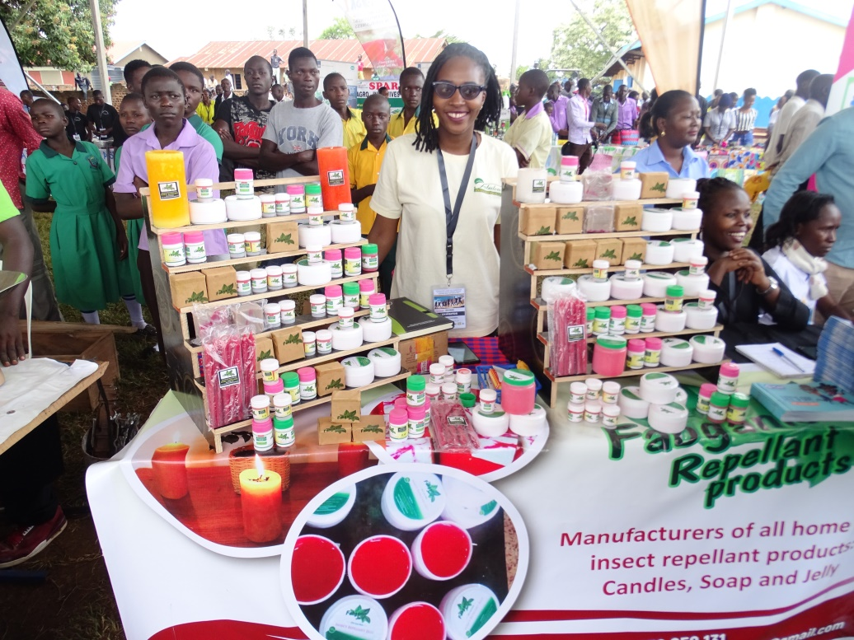
A photo showing different mosquito repellent products at national youth day in Uganda in 2019

Physical Assets
Just like any other business fabulous innovations limited has also got assets which include machinery, furniture among others. These were obtained from different suppliers.

Other Key resources.
Fabulous innovations limited is looking at acquiring patents for our products from the Africa patent body this is meant to ensure ownership of the design of the product.

Mode of product delivery.
A fabulous innovation limited has three ways of delivering mosquito repellent products to the consumers:
- A customer buys the mosquito repellent products and picks them directly from our work shop.

- A customer buys a few boxes of the products and pays an extra transportation fee to be delivered to any place of customer’ convenience.

- A customer buys in bulk is provided with transport to deliver the products to his premises if they are within Kampala.

Women Smiles Suppliers.
Supplier | Product they supply | Relationship
Afro plastic luzira | Plastic packages for jelly. | Customer(fabulous innovations limited), seller(afro plastic luzira ) relationship
General moulding 2 street industrial area | Jerry cans for packaging liquid soap | Customer(fabulous innovations)-seller(General mouldings)relationship
Desbro 6t street industrial area | Provide materials for manufacturing mosquito repellent products. | Raw materials for making products.
Country Consulting Group | Customer feedback gathering services. They do score cards on behalf of fabulous innovations limited on how customers feel should improve or maintain our products. | Customer-Service provider relationship

7. Marketing Plan
Customer awareness.
Our well versed marketing team has the profession and working experience to identify market potential and strategy in this we are aware that for the effective marketing to take place testimonies from the previous customers are very crucial. Fabulous innovations limited works hard to meet customer satisfaction of fighting malaria and in most cases our customers are referrals from our previous customers.

Secondly, due to the phone penetration and internet usage increment, social media is a way to go for effective marketing. fabulous innovations limited carries out social media marketing of our mosquito repellent products to our customers.

We also use community radios and baraza; In Uganda, community radios and barazas play a very important role in community mobilization. We are aware that some women may not have the social media and the smart phones but at least every family owns a radio and at least every woman in Uganda belongs to a certain women group who periodically carry out community gathering (baraza) this gives us an opportunity to reach out as many women as possible with information about our products.

Lastly, Uganda switched from analogue to digital that means that TVs cover a bigger coverage than ever before. We use televised talk shows to carry out malaria sesitization and adverts to educate and sensitize women about our products.

Pricing strategy.
The table below shows the pricing strategy and assumptions.
Pricing strategy | Assumptions
We always pip at what our competitors offer and at how much after discovering who sells at the minimum and who sells at the maximum we go back and come up with our own price that is medium(price that is not higher than the highest seller and something that is not lower than the lowest seller. More to that we again analyse and compare the costs involved in production of the same products by our competitors and how much it costs us to produce the same product. This helps us to determine how much to charge based on our production cost. | - Assume that our competitors will not change prices  - Assume that the estimated production cost will remain the same.  - We also assume that customers will adopt to our median price compared to what is on the market.

Incentives.
fabulous innovations limited has the non-cash incentives given to our customers to entice them to adopt our malaria sensitization and products rather than our competitors’ and these include; giving gifts like t-shirts,caps,umbrellas to whoever buys in bulk. More to that, if a customer buys more we provides free transportation.
Lastly, if you are a previous buyer and you refer more than two customers we give you mosquito repellent products at half price.

8. Management

Functions:
Fabulous innovations limited have determination to expand in order to compete favourably with leading anti-malaria in Uganda and the rest of East Africa. We know how important it is for us to build a solid business structure that can support the picture of the kind of world class business we want to own. This is why we are committed to only hiring the best people in and around Uganda.

At fabulous innovations limited we ensure that we hire people who are qualified, hardworking, dedicated, customer centric and are ready to work to help us build a prosperous business that will benefit all our stakeholders (the owners, workforce and customers).
In the first years of business, fabulous innovations limited decided to hire a few qualified and competent people that’s
Management-1 Executive Officer
Finance department-1 Finance officer.
Production -3 Business developers.
Human Resources-3 Marketing officers and Volunteers.
Monitoring and evauation-1 M and E
ICT department-1 ICT officer

Qualifications/Expertise:
Chief Executive Officer-CEO
Fabulous innovations limited’s Chief Executive Officer is Ms Monica Tayebwa with bachelor’s public administration and management, diploma in project planning and management, diploma in science and industrial chemistry on with 5 years’ experience in social enterprise management, policy making and expertise in fighting malaria.

Roles and responsibilities.
- Responsible for formulating company policies and supervising their implementation.

- Responsible for fundraising of the organization.
- Reports to the Board of Directors on a quarterly basis about the performance of the company.

- Responsible for increasing management effectiveness by recruiting, selecting, orienting, communicating values, strategies and objectives, assigning accountabilities, planning, monitoring and appraising job results and developing incentives.

- Evaluates success of the organization.

- Responsible for signing cheques and documents on behalf of the company.

Finance officer.
Fanulous inovations limited’s has a finance officer Ms Irene Tinka with a bachelors’ degree in science in accounting and CPA level two with 4 years’ experience in the finance management and accounts.

Roles and Responsibilities.
  - Responsible for preparing financial reports, budgets and financial statements for the organization.

  - Responsible for drafting invoices and approving purchase orders.

  - Responsible for developing and managing financial policies.

  - Ensures compliance with taxation legislation.

  - Responsible for administering payrolls.

  - Handles all financial transactions for the organization
  - Serves as an internal audit for the organization.

Business Developers.
These are specialized professionals that’s engineers who make the mabnufacturing of mosquito repellent products into physical product. These have 4 years’ experience in industrial chemistry.

Roles and Responsibilities.
- Responsible for creating the right fomulea of mixing in mosquito repellent products.

- Ensures consistence and sufficient production of the mosquito repellent production.

- Responsible for calculating the quantity of raw materials needed in production.

Sales and marketing officers.
Fabulous innovations limited has head of marketing department Ms Dorothy Nanteza with 4 years’ experience in marketing and sales and other two marketing officers with diploma in marketing and 3 years’ experience in sales and marketing.

Roles and Responsibilities.
- Identify, prioritize and reach out to new customers and other business opportunities.

- Identify business development opportunities, follows up on development, lead and contact prospect clients for the organization.

- Responsible for handling business research regarding market, make market surveys and feasibility studies for clients.

- Responsible for supervising, implementation and advocating for customers’ needs and communicate with customers.

- Develop, execute and evaluate new plans for expanding the market and increasing sales.

- Document all customers’ contacts and information.

Volunteers.
These are from finalist students in various fields of study from different universities who apply to volunteer in different departments of the organization.

Organizational Structure

Board of Directors
Executive Director
Business Developers
Finance Officer
Marketing Officers
ICT Officer
Volunteers

9. Financial Plan

Key Assumptions.
Fabulous innovations limited manufactures mosquito repellent product and sells them affordably to pregnant women and other beneficiaries in mostly rural areas. Reaching our customers directly and providing them with instalment payment platform enables us to make revenue out of the sale of the products to finance the business costs and at the same time make profits.

In one month with good marketing strategies we are able to sell 600 boxes of products to our customers making average revenue of SHS 108,000,000 per month and in a year SHS 1.29 billion.

Cost Estimations & Projections
The key factors that serve as a guide in calculating the cost of the mosquito repellent products are the raw materials used that’s citronella, eucalyptus, bee wax, sodium hydroxide, Shea butter, olive oil and labour.

Below are some of the basic areas we spend on during our operations.
The amount needed for raw materials is Uganda shillings 10,000,000 in the first year.

Salaries and wages for three months is Uganda shillings 7,950,000.

The amount required for utilities is Uganda shillings 700,000.This is for electricity and water in a period of one year.

The amount required for trading license is Uganda shillings 150,000.

Insurance for business property is Uganda shillings 400,000.

The table below shows direct and indirect costs for three years in business.
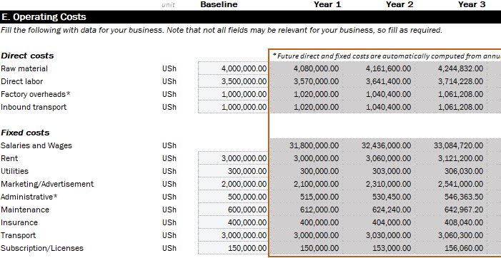

Financing
State how you will finance the cost:
- By your savings/personal funds (equity), by grants, with business proceeds (equity), by credit from suppliers (debt) or by borrowing (debt), by raising additional capital via the stock market or other forms like venture capital, private equity, etc
- Describe proportions if you are considering a combination of sources
- State exactly how you will use the money
- State how you will repay the debt

Revenue Projections.
We are generating revenue by diversifying and adopting our pricing strategy to the market class. Presently our low income earners are buying our fabganic soap at 1.5 USD and the high income earners pay for the soap at 4USD. This gives us varying profit margins from selling to different clients. In addition our social business model enables us to economically sustainably provide cross-financed affordable organic mosquito repellent soap and malaria sensitization to rural communities through high-margin sales to resorts, hotels and guest houses at a high price and sale to the low income population at subsidized prices. We are actively engaged in malaria prevention campaigns and exhibitions where we showcase our products for sale and network with customers.

Volume to be sold.
Every month in the first year we are to sell 105 boxes of mosquito repellent products making a total of 1260 boxes in the first year and as time goes by increase in manufacture and sale of mosquito repellent products increase in the following years.

Table below showing volume to be sold.
Year 1 Year 2 Year 3
Annual sales Volume# | 1,260.00 | 1,386 | 1,824
Price per boxes of mosquito repellent products | 540,000 | 550,800.00 | 561,861.00

Projected profit and loss.
Fabulous inovations limited has been in business and has already generated revenue.
The table below provides estimated statements for 2019, 2020, and 2021.

Income statement
 | unity | year 1 | year2 | year3
 |  | 2016 | 2017 | 2018
Revenue
soap,candles and jelly | Ush | 1,526,818 | 1,713,089 | 1,978,618
production service 2 | Ush | 0 | 0 | 0
production service3 | Ush | 0 | 0 | 0
total revenue | Ush | 1,526,818 | 1,713,089 | 1,978,618
direct costs | Ush | 9690 | 9884 | 10081
gross profit | Ush | 1,517,128 | 1,703,206 | 1,968,537
salaries and wages | Ush | 31,800 | 32,436 | 33,085
rent | ush | 3,000 | 3,060 | 3,121
utilities | Ush | 300 | 303 | 306
marketing/advertising | Ush | 2,100 | 2,310 | 2,541
administrative | Ush | 515 | 530 | 546
maintenance | ush | 612 | 624 | 643
insurance | ush | 400 | 404 | 408
tranport | ush | 3,000 | 3,030 | 3,060
subscription/licences | ush | 150 | 153 | 153
depreciation | ush | 1,115 | 1,115 | 1,115
operation profit | ush | 1,474,136 | 1,659,240 | 1,923,555
interest expenses | ush | 18 | 90 | 71
profit before tax | Ush | 1,474,118 | 1,659,150 | 1,923,484
taxation | Ush | 442,235 | 497,745 | 577,045
profit after tax/net income |  | Ush | 1,031,883 | 1,161,405 | 1,346,439

Projected cash flow.
The table below shows our cash flow projections.
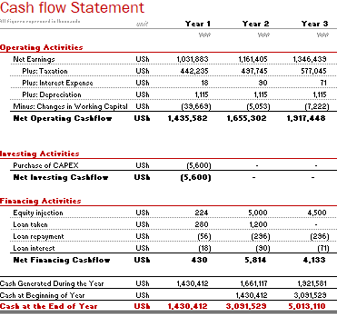

Projected Balance Sheet.

The following table outlines Women Smiles projected balance sheet for the years 2019-2021.
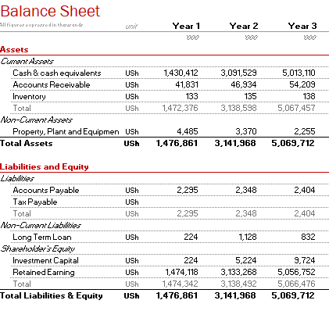

Milestones.
Number of mosquito repellent produced.
Fabulous innovations limited anticipates to achieve an increment in the production as shown in the graph below

People reached;
Based on our estimations fabulous innovations limited customer base is tremendously increasing as seen in the graph below.

Number of slums reached.
Fabulous innovations limited intends to reach a number of slums. In the first year 52 years and in year two 69 slums are projected to be reached. This is illustrated in the bar graph below with a break down per quarter.
Staff:
Just like any other business fabulous innovations limited works with a number of people that is year one we have nine employees of which six are full time and three part time.

Year two we intend to increase the number of staff to thirteen with nine being full time and four part time.

Revenue:
Fabulous innovations limiteds revenue has increased from year to year, quarter to quarter as illustrated in the line graph below.

OUR PROPOSED BUDGET FOR TWO YEARS
DESCRIPTION | UNIT | UNIT COST | TOTAL
OIL PRODUCTION MACHINE | 2 | $4000 | $8000
MOULDS AND CUTTERS | 4 MOULDS, 2 CUTTERS | $2500 | $5000
PACKAGING PRINTER | 1 | $1000 | $1000
SCALE AND MIXER | 2 | $1000 | $2000
FACTORY CONSTRUCTION | 1 | $10,000 | $10,000
RAW-MATERIALS | 3 | $1500 | $4500
TOTAL |  |  | $30,500

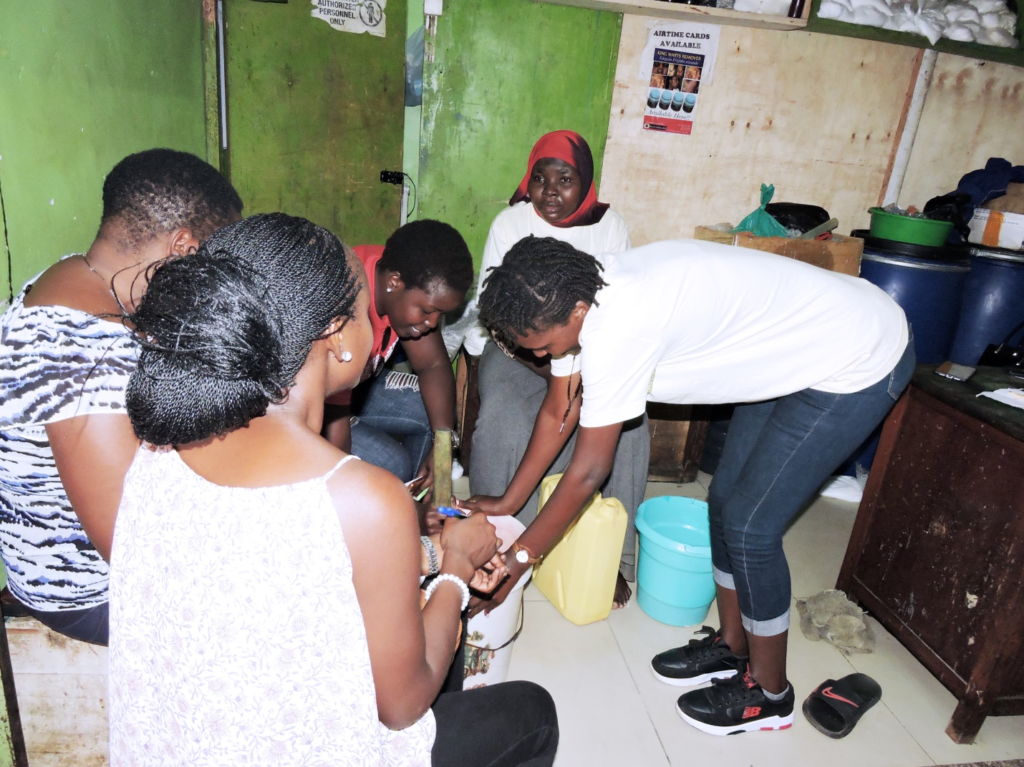
AT THE WORK SHOP TRAINING WOEMN HOW TO MAKE THE PRODUCTS

