GOOD360
Hurricane Dorian Report
12/30/19

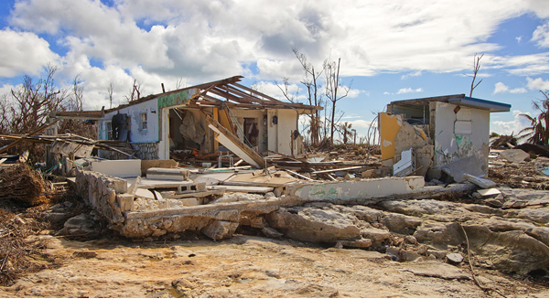

Hurricane Dorian was the most intense tropical cyclone on record to strike the Bahamas, and is regarded as the worst natural disaster in the country’s history. Dorian struck the Abaco Islands on September 1, 2019 with maximum sustained winds of 185 mph. Dorian went on to strike Grand Bahama at similar intensity, stalling just north of the island with unrelenting winds for at least 24 hours. The damage to these islands was catastrophic; most structures were flattened or swept to sea, and at least 70,000 people were left homeless. After devastating the Bahamas, Dorian proceeded along the coasts of the Southeastern United States up to the Outer Banks in North Carolina, leaving behind considerable damage and economic losses in those regions.

Good360 continues to distribute critically needed product in strategic locations in the Bahamas and in the United States. We were ready with needed goods for all stages of the recovery process and we are deploying those goods via our trusted nonprofit and response agency partners who are on the ground.

Hurricane Dorian UPDATE (12/30/19) –
- GlobalGiving Goals - $50,000 – GlobalGiving Funds Received - $50.00
- Overall Good360 Dorian Funding Received: $229,565
- Fair Market Value of Donated Goods Distributed: $850,000
- Estimated FMV Goal: $4 million
Amount of product prepositioned in ATLANTA: $52,000
To date, Good360 has distributed $850,000 in supplies. For example Grainger Hazmat suits valued at over $279,000 for 14 pallets. There is still a significant volume of work to be done related to rebuilding and product distribution, including:
- Unsolicited Goods Distribution with partners All Hands and Hearts, HeadKnowles, Hands for Hunger, IOM(project funded by additional UPS grant)
- Nassau Hotel Refurnishing with partners International Officeof Migration (UN agency) and Bahamas Housing
- Bahama Island Refurnishing with partners Grand Bahamas Port Authority, SBP, Red Cross, Salvation Army, Samaritan’s Purse

(details on our full program update are below).

Overall Good360 funding for Dorian to date is $229,565
- Foundations and Individual checks - This includes $50K from UPS, $25K from Park Foundation, $20K from GAF and $25k from various individual donor checks.
- FunRaiseonlineand employee matching donations - now above $63K - this includes $15K from CarMax, Exit Realty and Sage Therapeutics employees and company matches, along individual donations.

Good360’s Dorian Response Plan Details

- Grand Bahama Refurnishing- In Process
Problem: Almost all of the island faced 20+ foot storm surge washing away many of the homes right off their foundations. For the homes that remain, all have serious black mold throughout their entire home. Because there is only 1 shelter remaining, families have been forced to move back to their homes. Many have gutted most of the damage, but the mold remains throughout the wooden structures and families are still using their mold-filled furniture. If we do not begin sanitation soon, the island is at risk for a major public health crisis.

Goal: Provide furniture and household goods to these families who have homes identified.

Partner Organizations: Grand Bahamas Port Authority, SBP, Red Cross, Salvation Army, Samaritan’s Purse

Port Authority Warehouse
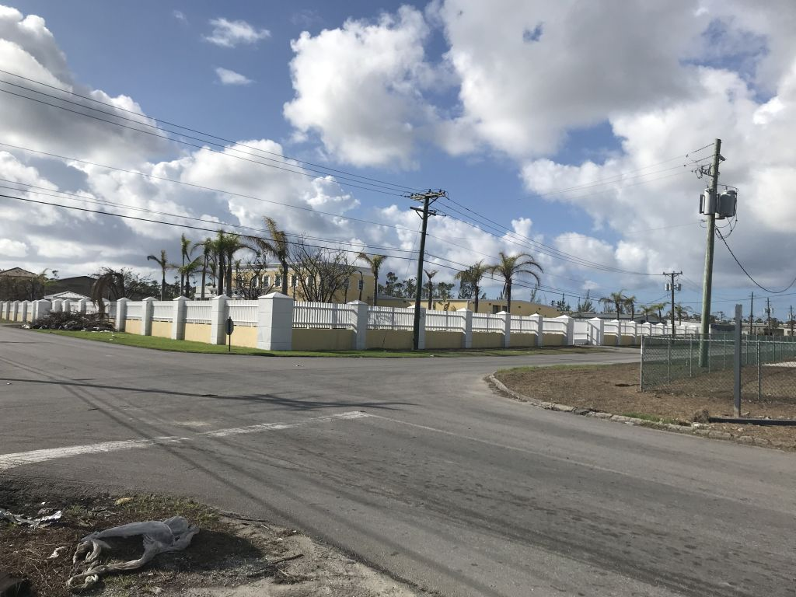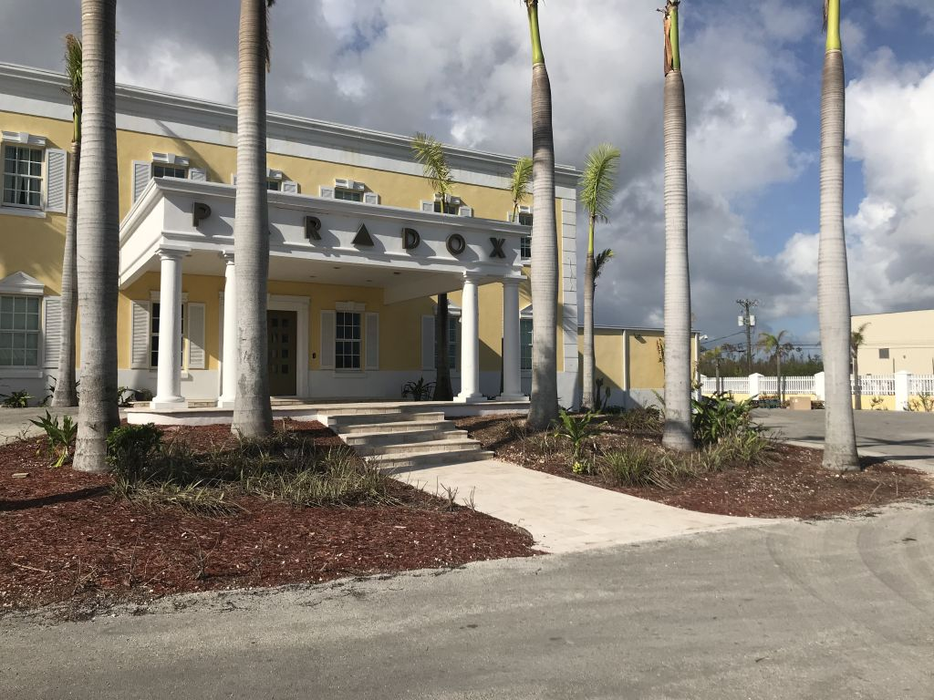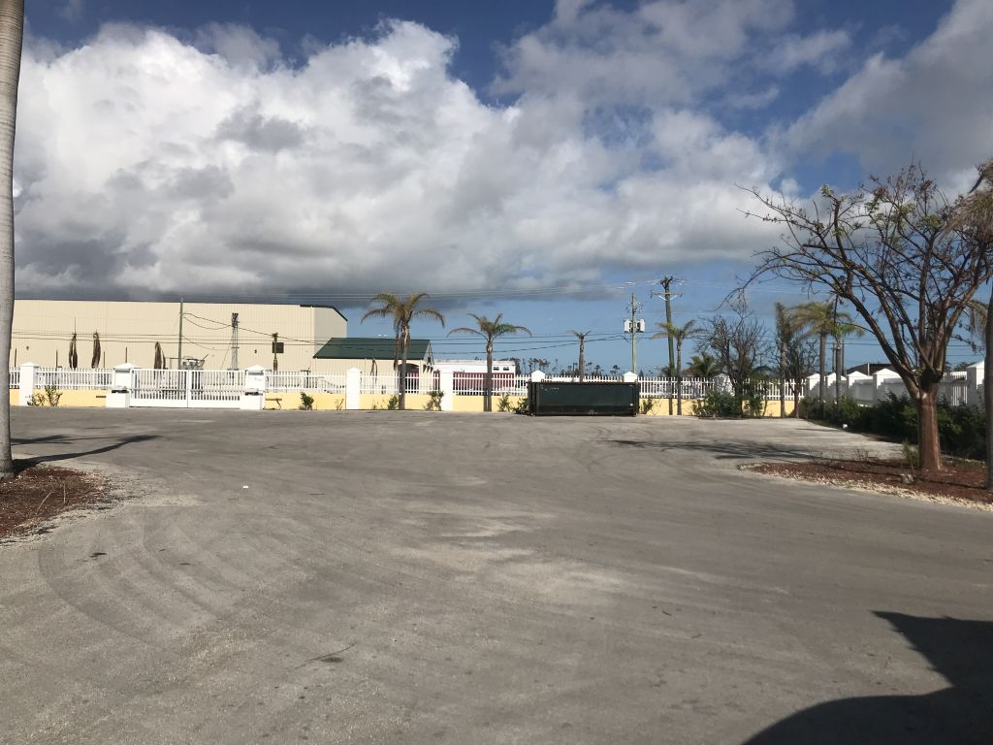

Bahamas Urban Youth Development Center
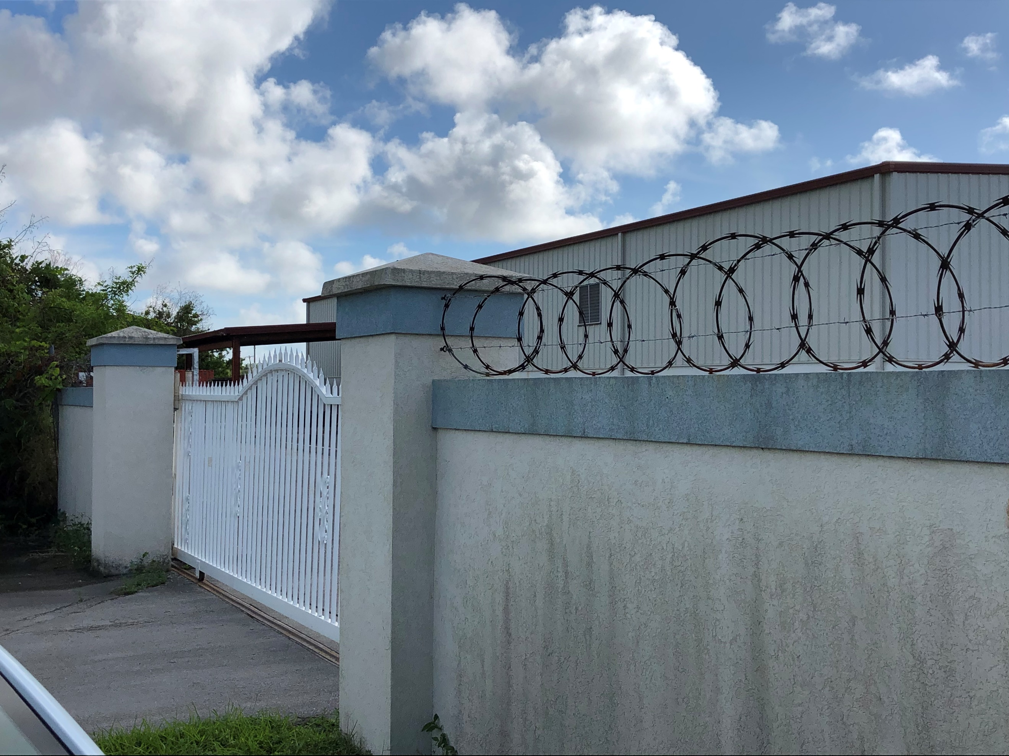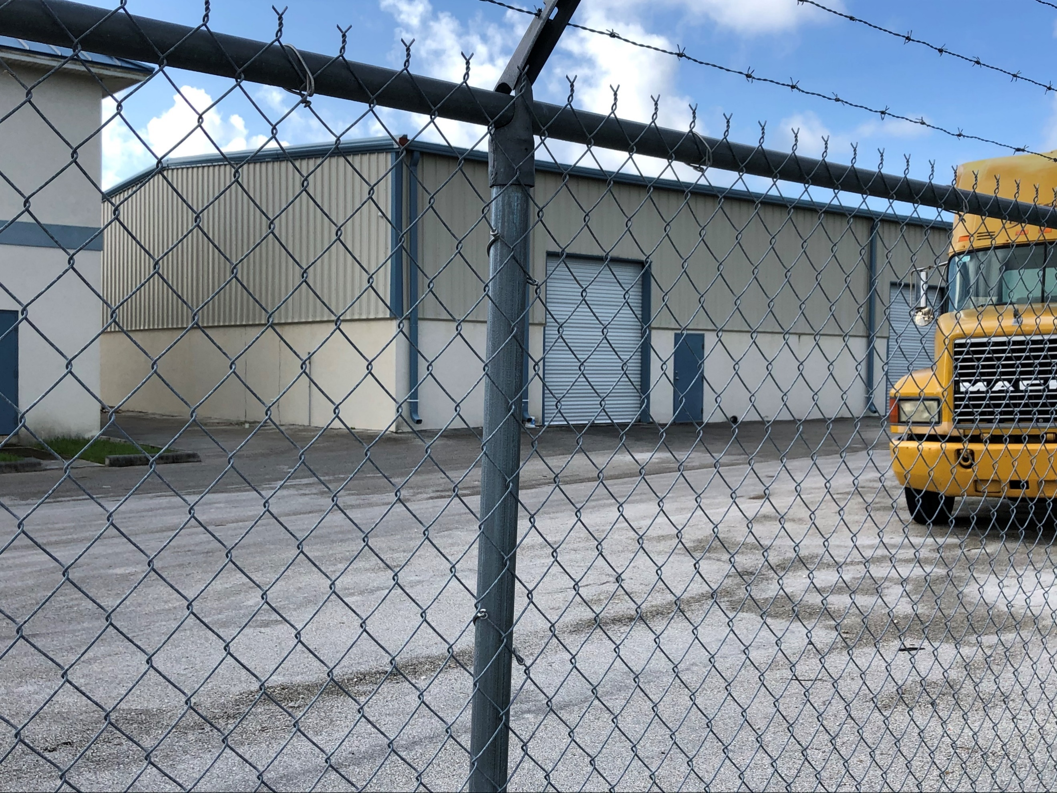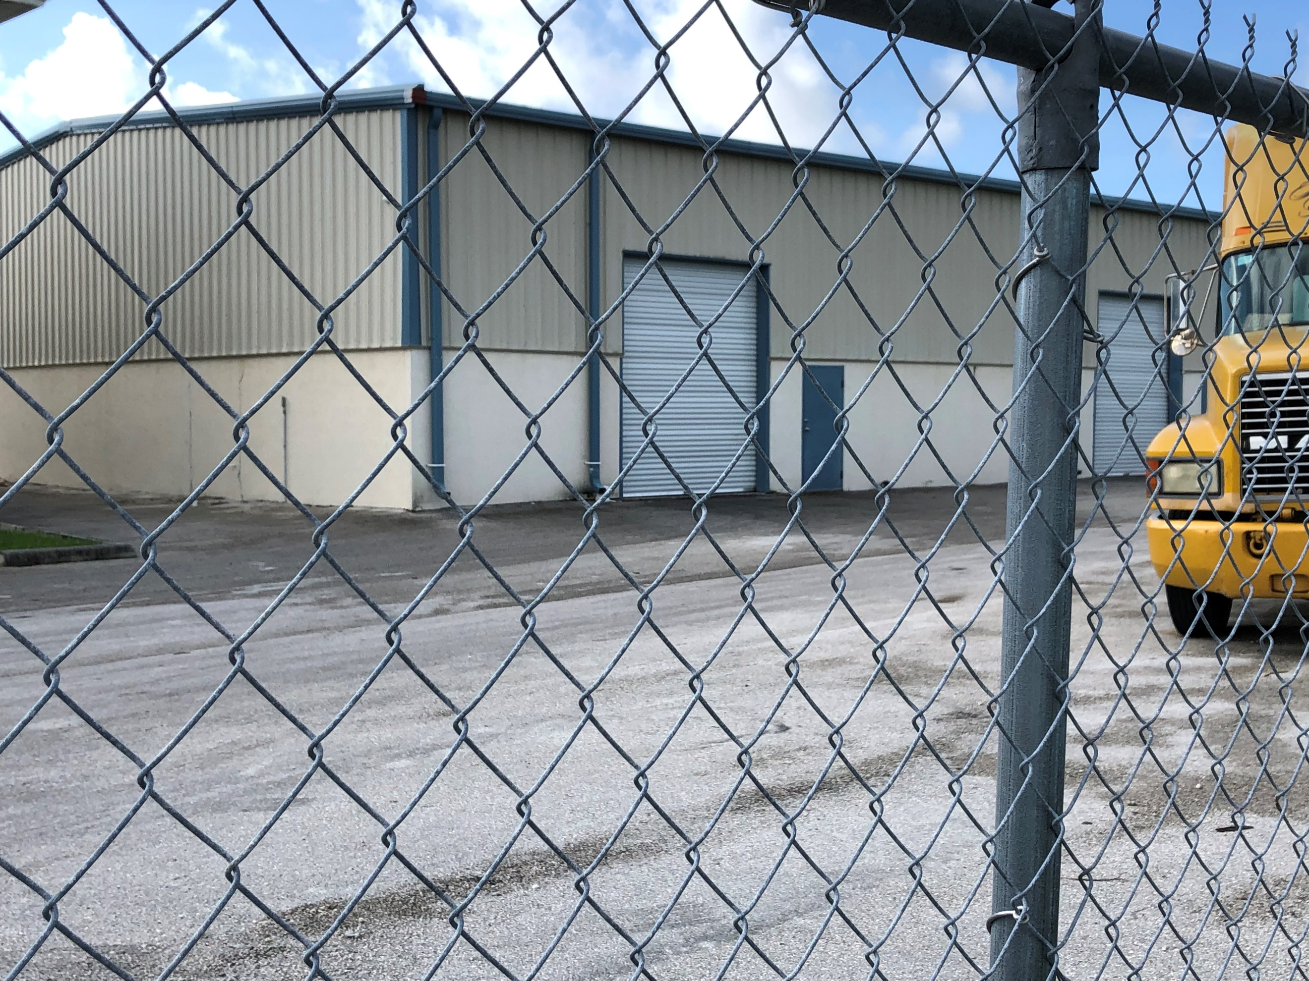

- HeadKnowles Inventory Management and Distribution Support:

Problem: Over 100 containers worth of supplies, unsolicited, ended up in Ft. Lauderdale consigned to HeadKnowles. HeadKnowles has little experience in dealing with product donations, warehouse management, product distribution, and last mile verification.

Goal: Create a model solution for unsolicited goods management and distribution.

Partner Organizations: All Hands and Hearts, HeadKnowles, Hands for Hunger, IOM

CHALLENGE: Unsolicited goods is always a huge issue in disaster response. It also poses the greatest threat to recovery efforts from a PR perspective. UPS funded Good360 to try and create an efficient distribution model with last-mile verification to ensure these goods are getting to the right people.

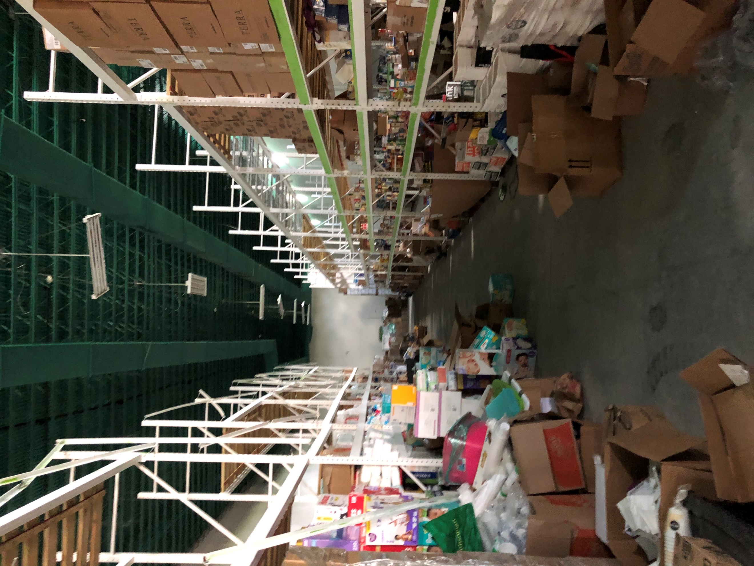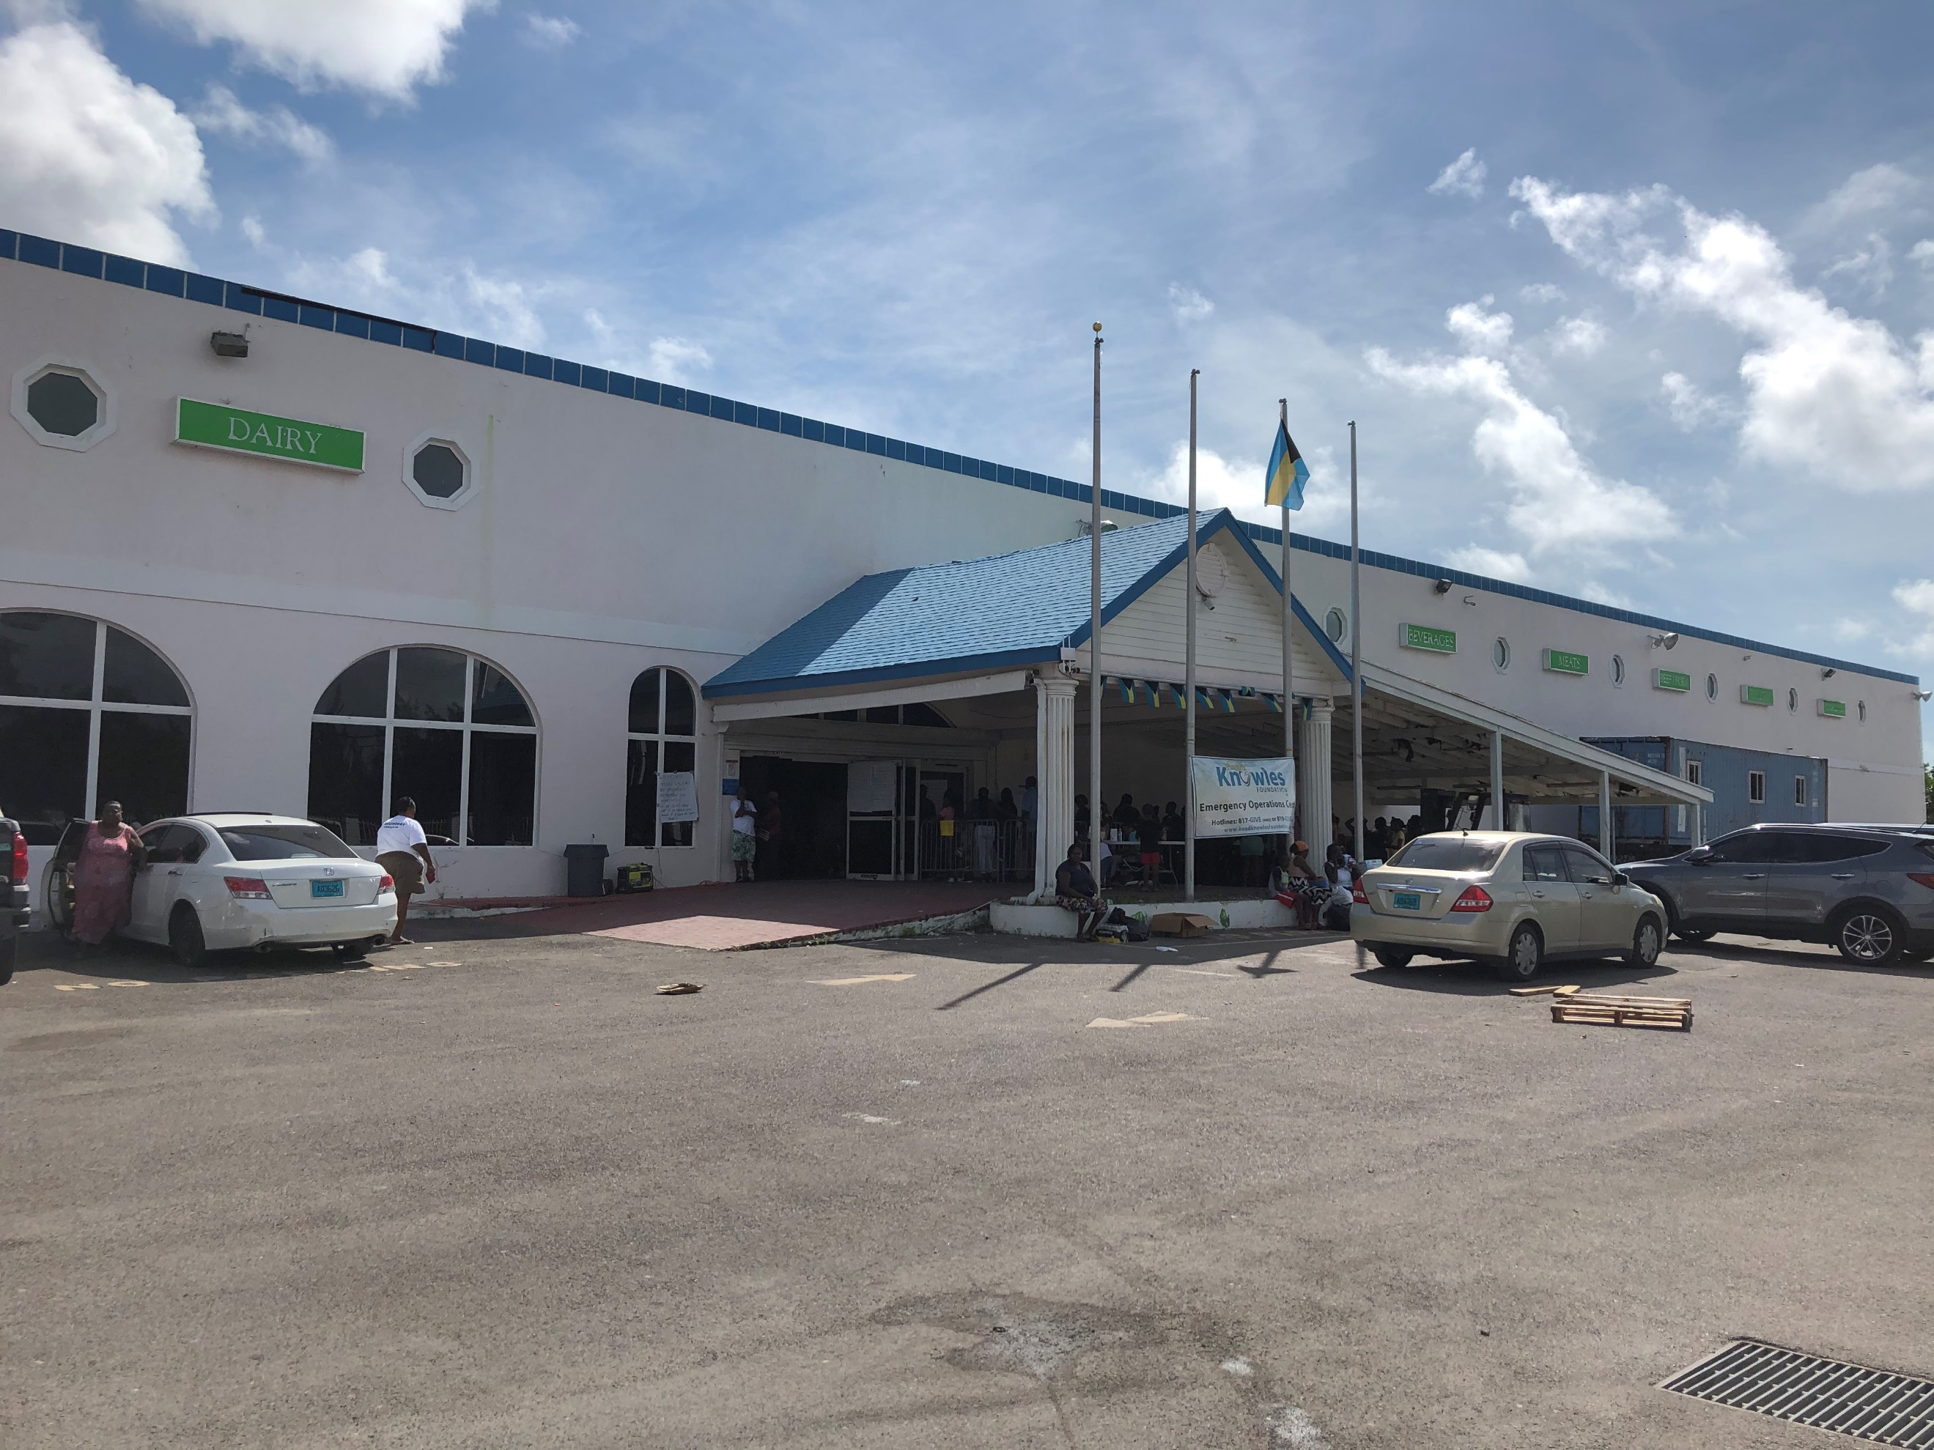

- Nassau Apartment Furnishing- Has not begun

Problem: Approximately 50,000 individuals are still displaced living in shelters or living with friends and family. IOM and the Bahama’s Housing Initiative and working to identify apartments for short-term housing while homes are being rebuilt on the various family islands.

Goal: Provide furniture and household goods to these families who have homes identified. Provide hope and dignity by giving them a filled apartment while they wait for permanent housing.

Partner Organizations: International Office of Migration (UN agency) and Bahamas Housing

Challenge: Been seen as a gap provider in unmet needs. No one does furniture in international disaster recovery.

- Abaco Refurnishing: Has not begun

Problem: 95% of the structures on Abaco are completely destroyed. Currently, INGOs and the government are working on debris removal and proper waste management. Due to many of the homes being rentals, government property or owned by internationals the land must be redistributed for rebuilding purposes. This island has a long way to go before furniture is needed widespread, but there is a short-term opportunity to work with IOM and the government on refurnishing their domes. 250 domes are being built to house families returning to the island. The government has no plans for furnishing these domes.

Goal: Provide mattresses for the initial 250 domes and furniture, as needed, once rebuilding has begun.

Partner Organizations: IOM, Bahamas Public Works, Samaritan’s Purse, All Hands and Hearts, Team Rubicon

Challenge: It has been stated by multiple INGOs that no organization provides what we do when it comes to refurnishing homes. There is a great opportunity with UN organizations and USAID to show the need for such a partner and build it into their recovery structure. The world’s attention is on Abaco. Helping this island will have a ripple effect on our reputation worldwide.

Responding nonprofits in need of product donations to serve disaster survivors should contact Kaitlin FitzGerald at kaitlin@good360.org.

How Companies Can Help the Bahamas NOW:
Donate cash: Cash donations are critical because they allow responding organizations like Good360 to provide exactly what support is needed in a timely fashion. Contact Jim Alvey at jalvey@good360.org or click here.

Make a commitment now to donate the right goods at the right time: Recovery in the Bahamas will take years and survivors’ needs will be diverse and long-lasting. Make a commitment with Good360 today to provide specific goods at the time when they are most needed – we will ensure your items have maximum impact. If you have goods to donate, contact Jim Alvey at jalvey@good360.org.

CURRENT PRODUCT NEEDS:
- Mattresses
- Clean-up Supplies
- Furniture
- Pillows/Sheets/Blankets

IMPORTANT INFORMATION
- CNN Interactive Storm Tracker: http://www.cnn.com/interactive/storm-tracker/
- Hurricane Preparedness Resources: https://www.ready.gov/hurricanes
- Florida Emergency Management Division: https://www.floridadisaster.org/info/
- Georgia Emergency Management and Homeland Security: http://www.gema.ga.gov/Pages/default.aspx
- North Carolina Department of Public Safety: https://www.ncdps.gov/
- South Carolina Emergency Management Division: https://www.scemd.org/who-we-are/state-emergency-operations-center/
- List of American Red Cross Shelters: https://www.redcross.org/get-help/disaster-relief-and-recovery-services/find-an-open-shelter.html
- SBP Information on Insurance Fraud: https://sbpusa.org/start-here/
- United Way 211:
  - For storm-related assistance and questions, contact 2-1-1 by simply dialing 211 from a cell phone or landline. 2-1-1 is a free, 24/7, hotline, available in many languages, that provides information to individuals seeking community resources like shelter, food and water, recovery support, and other basic needs, before, during and after disasters. More information about 2-1-1 can be found at 211.org.

ARE YOU A NONPROFIT HELPING COMMUNITIES IMPACTED BY HURRICANE DORIAN?
Good360’s platform allows you to identify and communicate your product needs as they change over time. We work with corporate donors to source the products you need and we can store product until you’re ready for it.
Email Kaitlin FitzGerald at kaitlin@good360.org to learn more.
EMAIL KAITLIN@GOOD360.ORG

ARE YOU A CORPORATION READY TO DONATE CRITICALLY NEEDED GOODS?
Good360 takes a holistic approach to disaster recovery, starting with the impacted communities’ immediate needs (even during evacuation stage) and committing to being there for the long-term, always focused on delivering the right goods to the right people at the right time.
Email Jim Alvey at jalvey@good360.org to learn more.
EMAIL JALVEY@GOOD360.ORG

