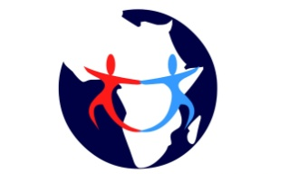

“…Heart of Orphans…”

PROJECT TITLE
INTEGRATED INTERVENTION PROGRAM FOR ORPHANS AND MOST VULNARABLE CHILDREN (O.V.C)

NAME OF THE ORGANIZATION
FURAHA YA MTOTO NA MAMA – AFRICA (CHILD AND MOTHER’S JOY AFRICA)
Location of the project:
South Ramba Sub location. Lake Region (Nyanza) Province-Kenya

Project Duration : 5yrs

AMOUNT REQUESTED FOR YEAR ONE: KHS. 11,311,000 (Eleven million three hundred and eleven thousand only)

TABLE OF CONTENT
- Executive summary ……………………………………………3
- Background …………………………………………………….4
- Problem statement………………………………………….…..4-5
- Justification ……………………………………………….……5
- Objectives………………………………………………………5
- Activities………………………………………………………..5-9
- Institutional capacity and project management……….………..9
- Monitoring and evaluation…………………………………….10
- Partners…………………………………………………………10
- Sustainability………………………………………….…..10
- Expected output……………………………………………10
- Budget……………………………………………….……..11-12

1.0 EXECUTIVE SUMMARY

Orphans and most vulnerable children (OVC) have increased substantially over the last four years in Kenya with Nyanza project ( area of this project) taking lead. Among orphans, 15% are double orphans.
Generally, orphans and most vulnerable children (O.V.C) face special challenges: rejection, lack of basic facilities, psychosocial torture, loneliness and hopelessness. Special attention therefore should be paid to OVC to prevent further vulnerability and ensure their well-being and development as they transition into adulthood.
Its is important to note that every Human being needs Economic spiritual, psychological and social atmosphere to grow well. However, orphans and most vulnerable children are often deprived these opportunities by their circumstances.
The government of Kenya and other urgencies have had intervention programs especially in the area of education. But other faculties like guardians economic empowerment, psychosocial emotional therapy have been neglected.
This program , FURAHA YA MTOTO NA MAMA ( CHILD AND MOTHER’S JOY) - AFRCA was initiated with the objective of providing an integrated intervention for both the OVC and their guardians for holistic development. It was began in 2006 in South Ramba, Siaya County,Nyanza province, Kenya,with an enrolment of 46. It has been able to offer educational material support ( uniforms, shoes, books, levies), food donations, psychological support, capacity building to guardians/parents ( economic and food security). The project plans to increase the enrolment to one hundred (100) for OVC of ages 6 to 18 ( school going) by June 2018.
Main objectives of this program are;
- To assist orphans and most vulnerable children (OVC) acquire access to education and other basic needs through provision basic items and facilities.
- To help the OVC heal from psychosocial injuries of life through organized counseling and guidance programs
- To capacity build and empower the guardians/parents in terms of economic development, food security, family life: for sustainability of the program
The children in this program continue to stay with their guardians/parents at home but report to a centre on weekends or designated days for provisions and capacity building.
The organization has partnered with a local church which provides a centre with facilities for the sponsored children

2.0 BACKGROUND
In Kenya, According to Kenya AIDS indicator Survey 2014, it is estimated that there are approximately 3.6million children aged<18 years who have been orphaned or who are vulnerable.( orphans, child headed families, extremely poor families, physically challenged).
Among orphans, 15% are double orphans. Forty-two percent of these double orphans lived in the Nyanza Region.
Over one-third of the orphans and most vulnerable children (OVC) were aged between 10 and 14 years. 22% of OVC households had experienced moderate to severe hunger. Receipt of OVC support service was low for medical (3.7%), psychological 4.1%), social (1.3%) , and material support (6.2%); Educational support was slightly more common (11.5%).
Generally, the orphans experience intense stress at the time of their parents’ death with their immediate concern being who would care for them. Most orphans are separated from their siblings, and this separation only compounds the stressors and difficulties encountered by orphans. Reports indicate that orphans have problems schooling and being treated differently as compared with the children with parents. Orphans adopt various emotion-focused and problem-focused coping strategies, which are reinforced by financial and social support provided by their caregivers and community-based organizations.
Special attention therefore should be paid to OVC to prevent further vulnerability and ensure their well-being and development as they transition into adulthood.
It is on this basis that this program transit compassion initiated a support program to mitigate the Orphans against ad versed effects of their condition:
FURAHA YA MTOTO NA MAMA ( CHILD AND MOTHER’S JOY) - AFRCA was began in 2006 in South Ramba, Siaya County,Nyanza province, Kenya. It began with an enrolment of 46. It has been able to offer educational material support ( uniforms, shoes, books, levies), food donations, psychological support, capacity building to guardians/parents ( economic and food security). The project plans to increase the enrolment to one hundred (100) by June 2018
The children in this program continue to stay with their guardians/parents at home but report to a centre on weekends or designated days for provisions and capacity building.
3.0 PROBLEM STATEMENT
Orphans and most vulnerable children ( OVC) have increased substantially over the last four year in Kenya with Nyanza province taking lead. The government and other urgencies have provided mitigation strategies to the orphans, though the effect is minimal in relation to the need.

It’s imperative to highlight the challenges orphans face: rejection, lack of basic facilities, psychosocial torture, loneliness and hopelessness. Thus they are more likely to be disoriented in life unless an intervention strategy to cushion them is implemented.
We do recognize and appreciate the effort by various NGOs in providing management structures in their centers for support to the orphans. They have also done well in providing educational support, basic health support and emotional care. However, they have not addressed well the spiritual development, psychosocial healing and career guidance . Still the guardians have not been empowered economically, spiritually, family life and food security. It’s in the interest of this program by the ACK to compliment the work done by the compassion international intervention for holistic development of the orphans.
4.0 JUSTIFICATION
Every Human being needs Economic spiritual, psychological and social atmosphere to grow well. However, orphans and most vulnerable children are often deprived these opportunities by their circumstances.
The government support and other urgencies intervention have been able to provide basic educational facilities to a good level, but for complete mitigation program to the orphan and M.V.C a more comprehensive, well-structured and multi-faceted approach involving the orphans , their guardians and staff is needed for holistic development of the under privileged.
5.0 OBJECTIVES
- To assist orphans and most vulnerable children (OVC) acquire access to education and other basic needs through provision basic items and facilities.
- To help the OVC heal from psychosocial injuries of life through organized counseling and guidance programs
- To capacity build and empower the guardians/parents in terms of economic development, food security, family life: for sustainability of the program
6.0 ACTIVITIES
Our activities targets OVC, and their guardians
- To Orphans

- Provision of educational support ( books, uniforms, shoes, school levies), domestic support ( blankets, mattresses), food donations and lunch program, personal effects to O.V.C

- To provide a systematic spiritual, psychosocial and emotional support and basic health care to the O.V.C

- Career guidance

- To Guardians/Parents

- Economic empowerment through provision of investment seed money and farm inputs
- Family Life trainings
- Food security trainings

PICTURES OF OUR ACTIVITIES

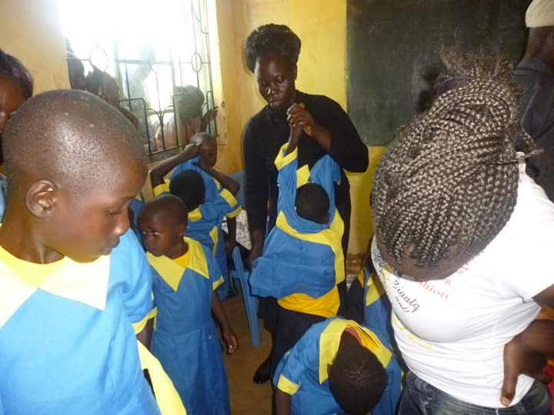
Project director – Mary Goretti distributing uniforms to the O. V. C

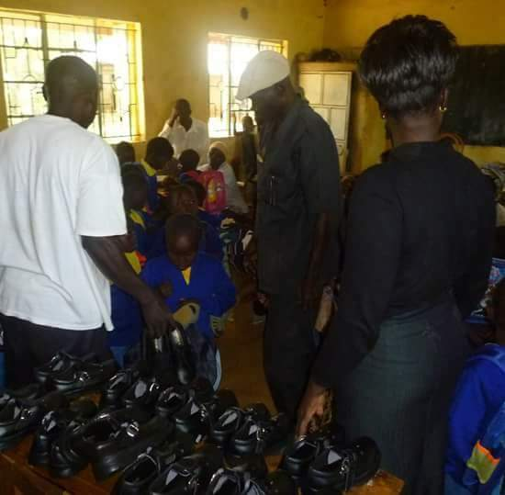

Project director – Mary Goretti distributing shoes to the O. V. C

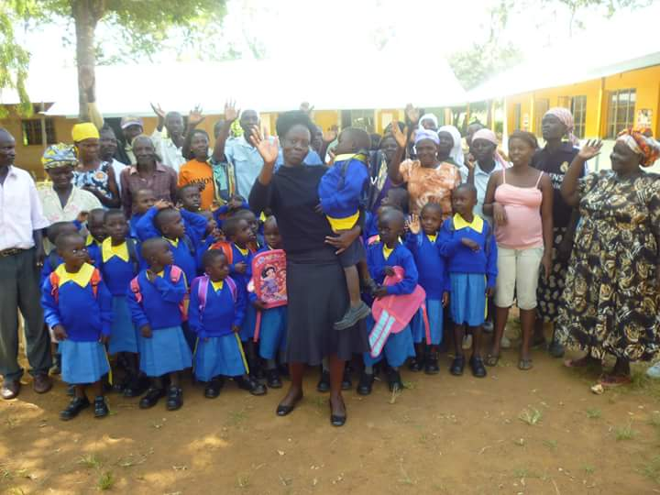

Project director – Mary Goretti poses for a photo with the parents/ guardians of the O. V. C

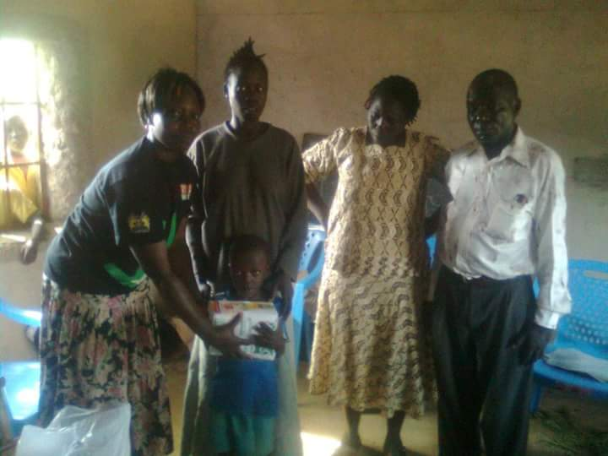
Project director – Mary Goretti distributing food to the O. V. C

7.0 INSTITUTIONAL CAPACITY AND PROJECT MANAGEMENT
The project has a board of management composed of seven persons. They include Project Director (chair), Program officer (Secretary), 2 church members, 2 community representatives and one government representative.
The board is concerned with advisory role and general oversight.
The project will be implemented by persons with integrity and professional back up in the areas of their specialization:
The project Director. She has a wide experience of dealing with the OVC for over 10 yrs .The Director is responsible for overseeing the program implantation, submission of Quarterly report, monitoring and Evangelism
The programs officer. He has professional background in agriculture and education. He is in charge of planning general operations of the program
The Social worker is in charge of trainings, home visits and general welfare of the program.
8.0 MONITORING AND EVALUATION:
Monitoring of the project activities is conducted by the project staff and board of management.. This is conducted on a day-to-day basis.
Quarterly project review meetings are held, bringing together project staff, guardians and board of management
Quarterly and yearly reports are prepared and submitted to stakeholders

Organogram
Board of management

Project Director
. Program Officer Accountant

Social worker Cook Security officer

9.0 PARTNERS
This program collaborates with local Anglican church , local leaders and government urgencies.
10.0 SUSTAINABILITY
In order to sustain this program we seek to empower the guardians with farm inputs and seed money for investment so that they can support their families in the absence of the donor funding.
The project will also undertake a sustainability investment in the field of agriculture and real estates. The income from which will be used to expand and sustain the project activities.
Support from other donors will also be sought to support to sustain the program.
11.0 EXPECTED OUTPUT
- Orphans who are healed and developing well in all faculties of life- spiritual, social emotional, economic and Academic.
- Guardians/parents with improved economic status, spiritually, social and raising stable familie

12.0 BUDGET FOR 100 M.V.C/ HOUSEHOLDS.
Part I
Item | No | Rate | Total/ year | Total/ Year
- Education Materials support  - Text books (Supplements)  - Exercise books (Supplements)  - Uniforms:  - Shoes (1 pair)  - Socks (2pairs)  - Sweater (1pair)  - School levies | 100  100  100  100  100  100 | 2 000  1 000  2 000  500  900  1 000 | 200 000  100 000  200 000  50 000  90 000  100 000 | 1 000 000  500 000  1 000 000  250 000  450 000  500 000
- Domestic Support  - Blanket  - Mattress  - Family food donation  - Sanitary/ Soap/ tissue etc. | 100  100  100  100 | 1 500  2500  3000  2000 | 15 000  250 000  300 000  200 000 | 750 000  1 250 000  1 500 000  1 000 000
- Lunch programs.  (at Centre/ weekends) | 100 | 300/ week x 48 weeks | 1 440 000 | 7 200 000
- Medication/ treatment (basic) | 100 | 1 000 | 100 000 | 500 000
- Special cases/ emergency intervention (Housing, death, illness, etc. |  |  | 300 000 | 1 500 000
- Children capacity building specialists’ facilitation costs.  (psychosocial, spiritual, emotional, academic support) | twice/ month | 10 000 | 120,000 | 600,000
- Guardians/ parents capacity building : Facilitation costs ( Investments, food security, group dynamics, parenting etc. | 1/ month | 5 000 | 60, 000 | 300, 000
- Guardians/ parents economic empowerment.  - Seeds  - Fertilizer  - Investment | 100  100  100 | 2 500  3 000  10 000 | 250 000  300 000  1 000 000 | 1 250 000  1 500 000  5 000 000
- Children playing equipment/ facilities at the center |  |  | 300 000 | 1 500 000
- Project sustainability investment |  |  | 500,000 | 2,500,000

PART II
Item | No | Rate per month | Rate per year (×12) | Rate in 5 years
- Board of Management  ( monthly meetings) | 07 | 2 000 | 168, 000 | 840, 000
- Children Centre maintenance (hygiene, water, electricity). | 01 | 15 000 | 180, 000 | 2,160,000
- Staff remuneration  - Project Director  - Program Officer  - Social worker  - Accountant  - Cook  - Security Personnel | 01  01  01  01  01  02 | 100 000  60 000  25 000  25 000  10 000  10 000 | 1,200,000  720, 000  300, 000  300, 000  120, 000  120,000 | 6,000,000  3,600, 000  1,500, 000  1,500, 000  600, 000  600, 000
- a) Transport (local)  b) Communication |  | 40 000  4 000 | 480, 000  48, 000 | 2,400, 000  240, 000
- Office equipment  - Computers  - Furniture  - Stationary | 3@100000 |  | 300 000  400 000  100 000 | 500 000
TOTAL |  |  | 10,311,000 | 49,315,000
Plus 10% miscellaneous costs |  |  | 1,000,000 | 4,000,000
GRAND TOTAL ksh |  |  | 11,311,000 | 53,315,000

