REPORT ON FIGHTING MALNUTRITION IN 10 VILLAGES OF NYANZA FOR THE PERIOD JANUARY -MARCH 2026
With the support of Global Giving donors and in close collaboration with Nyanza District and the National Child Development Agency (NCDA), Dufatanye Organization is actively working to combat malnutrition among vulnerable children and families.
This integrated effort combines nutrition-sensitive agriculture, household food security, and a comprehensive Early Childhood Development (ECD) program. By addressing both immediate nutritional needs and underlying causes, the partnership is strengthening household resilience, improving child health outcomes, and promoting sustainable pathways out of malnutrition
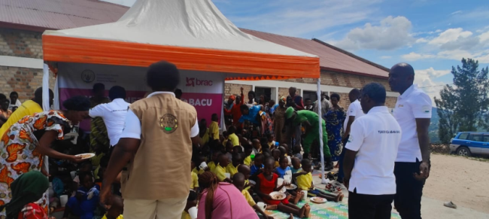
Children receiving balanced diet to support nutrition

What was done:
- Distributed 180 eggs and a balance meal to vulnerable children to improve protein intake.
- Conducted MUAC (Mid-Upper Arm Circumference) screening for 160 children to monitor nutritional status. In total, 340 children were supported through meals, screening, and stimulation activities.
- 145 kitchen gardens were constructed to enable families grow sufficient nutritious vegetables.
- Trained 295 participants, including caregivers, parents, and community health workers, on child nutrition, hygiene, and proper child care.
- Monitored 173 ECD centers to ensure improved feeding and hygiene practices.
- Conducted home visits to 241 households to provide guidance on nutrition and stimulation.

Results and impact
- Children and households are consuming more diverse and nutritious diets, including increased intake of protein, fruits, and vegetables, supported by both center-based feeding and household food production.
- Training has strengthened caregivers’ ability to monitor child growth, identify early signs of malnutrition, and provide balanced, and age-appropriate nutrition.
- The establishment of kitchen gardens has reduced dependence on market purchases while ensuring consistent access to fresh, nutritious foods.
- Hygiene promotion campaigns have reinforced positive behaviors that support better nutrition, contributing to improved child health and overall wellbeing.

Way forward
The next phase will focus on sustaining and scaling impact in the fight against malnutrition. Key priorities include:
- Expanding regular MUAC screening and supplementary feeding to ensure early detection and support for vulnerable children.
- Scaling up kitchen gardens and promoting climate-smart practices to strengthen household food security.
- Reinforcing caregiver training and behavior change on nutrition, hygiene, and child care.
- Strengthening support and monitoring of ECD centers to improve feeding and child development services.
- Increasing home visits and community engagement to sustain positive practices.
- Enhancing coordination with local authorities and health systems for long-term sustainability.
These efforts will help transition from immediate support to sustainable, community-driven solutions to malnutrition.
Thank you, Global Giving donors. Your support is improving child nutrition today while building resilient, food-secure communities for tomorrow.

