REPORT ON FIGHTING MALNUTRITION IN 10 VILLAGES OF NYANZA
With support from GlobalGiving donors, Dufatanye Organisation is tackling malnutrition among vulnerable children and families through nutrition-sensitive agriculture, household food production, and youth-led livelihoods. During this period, the project improved access to protein, fruits, and vegetables while strengthening long-term food security and resilience at household, school, and community levels.
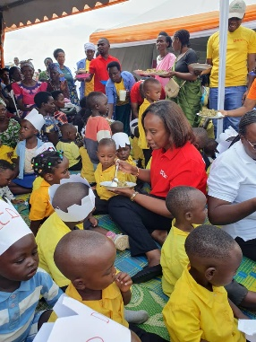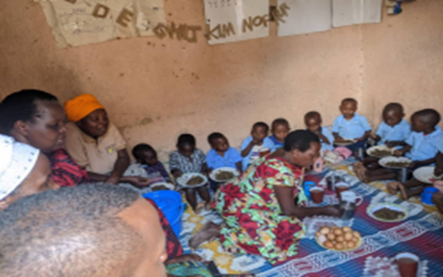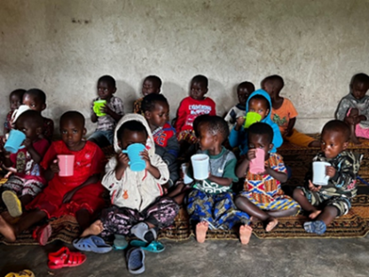
Children receiving eggs and balanced diet to support nutrition

What was done:
- Distributed 1,317 eggs to vulnerable children to improve protein intake.
- Constructed 346 household kitchen gardens enabling families to grow nutritious vegetables.
- Distributed 5,780 banana suckers and planted 13,222 fruit and agro-forestry trees to enhance food availability and income.
- Established 2 school gardens with 29 garden blocks at GS Mubuga and GS Rasaniro for nutrition learning and feeding support.
- Supported 130 youth to manage 7 agricultural demo plots producing vegetables (carrots, eggplants, amaranthus, cabbages).
- Supported 5 youth groups with 26 pigs and distributed 390 mushroom substrates to improve access to animal-source protein.
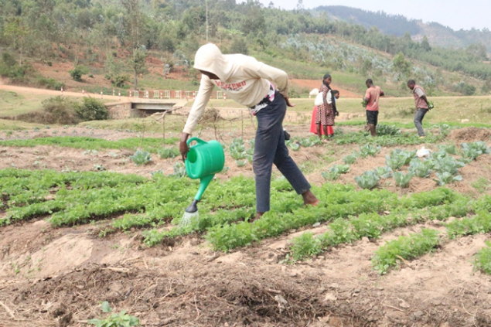
- Enabled children to receive 23 rabbits and 5 chickens through savings initiatives.
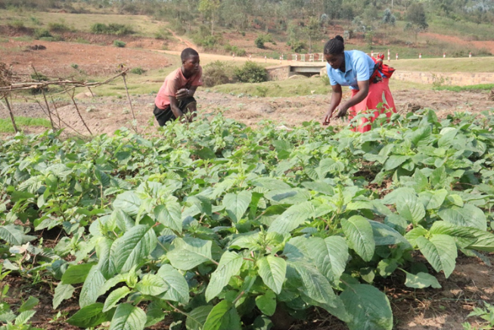
Kitchen gardens established to enabling families to grow nutritious vegetables.
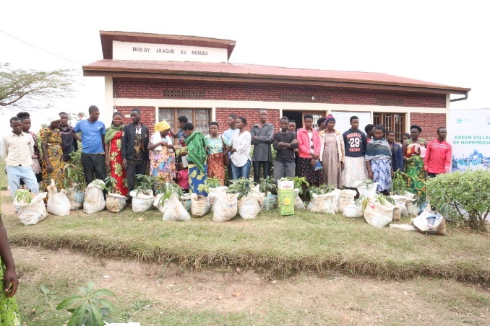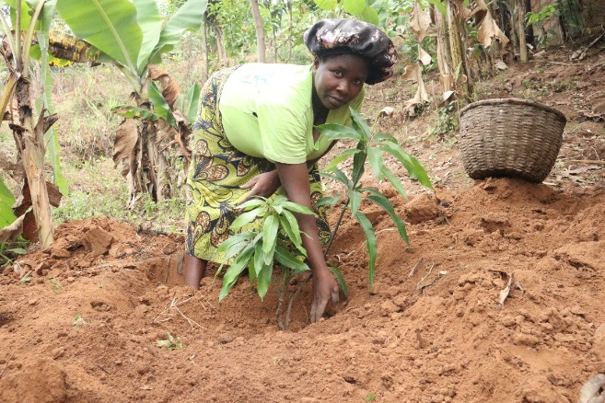
Fruit trees distributed for enhance food availability

Results and impact
- Improved dietary diversity: Children and households consumed more protein, fruits, and vegetables.
- Stronger household food security: Kitchen gardens and banana plantations reduced reliance on food purchases.
- Youth empowerment: Young people gained agricultural skills, harvested nutritious food, and earned income.
- Community awareness: School and community gardens promoted nutrition and climate-smart agriculture practices.
“The eggs and kitchen garden helped my child eat better and stay healthy. I can now prepare nutritious meals at home.” — Caregiver

Way forward
- Expand kitchen gardens and small livestock support to more vulnerable families.
- Strengthen school and youth gardens as nutrition learning hubs.
- Continue linking nutrition with climate-smart agriculture and livelihoods.
Thank you, GlobalGiving donors. Your support is improving child nutrition today while building resilient, food-secure communities for tomorrow.

