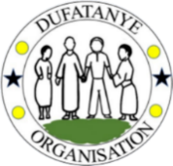

GLOBALGIVING QUARTERLY PROJECT REPORT

Fighting Malnutrition in 10 Villages of Nyanza
Strengthening child nutrition through ECD support, protein supplementation, kitchen gardens, caregiver training, hygiene promotion, and household coaching
REPORTING PERIOD: 1 APRIL – 30 JUNE 2026
Prepared by Archimede Sekamana
Head of Partnership, Strategy & Impact
Dufatanye Organization
Nyanza District, Southern Province, Rwanda

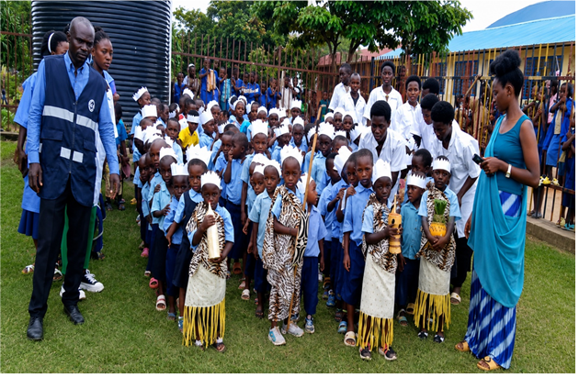
Children and caregivers reached through Dufatanye Organization’s ECD and nutrition interventions in Nyanza District.
With appreciation to GlobalGiving donors, Nyanza District, NCDA, caregivers, community volunteers, and participating households.

Report at a Glance
174 | 1,599 | 195 | 165 | 217
ECD centres monitored | Children reached | Eggs distributed | Children receiving eggs | Households visited in Nyamagana B

1. Executive Summary
From April to June 2026, Dufatanye Organization continued an integrated response to malnutrition in Nyanza District by linking child nutrition support in Early Childhood Development (ECD) centres with household food production, caregiver training, growth monitoring, hygiene promotion, and regular household coaching.
During the quarter, 174 ECD centres across 10 sectors were monitored and 1,599 children were reached through ECD services and nutrition-related interventions. Protein supplementation included 195 eggs provided to 165 children, while 81 children received balanced meals in four targeted ECD centres located in Kibirizi, Mukingo, Ntyazo, and Cyabakamyi. Thirty-five caregivers—29 women and six men—received training covering nutrition and child development, hygiene and sanitation, early stimulation, school readiness, and their responsibilities in quality ECD service delivery.
At household level, 217 households in Nyamagana B Village received visits and practical advice on vegetable production, kitchen-garden management, irrigation, banana plantation management, hygiene, and self-reliance. Field monitoring recorded 116 households with vegetables that required watering, 53 gardens reported as being in good condition or rehabilitated, and 48 gardens requiring further attention and technical follow-up.
The quarter built on the January–March 2026 GlobalGiving update, when the project distributed 180 eggs, conducted MUAC screening for 160 children, supported 145 kitchen gardens, trained 295 participants, monitored 173 ECD centres, and visited 241 households. The April–June period placed greater emphasis on consolidating ECD quality, maintaining food-production assets, improving caregiver capacity, and strengthening nutrition monitoring.

2. Project Context and Reporting Basis

2.1 Project purpose
The GlobalGiving project seeks to support vulnerable families in ten villages of Nyanza District through nutrition-sensitive agriculture, kitchen gardens, fruit and banana production, poultry, caregiver education, and child-focused activities. The model addresses immediate nutrition needs while helping households improve their ability to produce, prepare, and access nutritious foods over time.

2.2 Reporting period
This report covers implementation from 1 April to 30 June 2026. It follows the structure and narrative approach of the January–March 2026 GlobalGiving update while expanding the analysis, documenting data limitations, and focusing strictly on Nyanza District.

2.3 Sources used
- Dufatanye Organization Quarterly Programme Report, April–June 2026—Nyanza-specific nutrition, agriculture, ECD, WASH, and capacity-building sections.
- Village of Hope Nyamagana B Quarter 2 report—household monitoring, kitchen gardens, challenges, and the Uwimana Yosefa success story.
- Nyanza District ECD Quarterly Report—ECD monitoring, nutrition support, caregiver training, growth monitoring, hygiene, and consolidated indicators.
- The previously submitted GlobalGiving update for January–March 2026, provided as the continuity reference.
The Nyaruguru field report and Nyamagabe-focused report were reviewed but their results were excluded from the figures in this Nyanza report.

3. Key Results for April–June 2026
Result area | Indicator | Verified achievement | Interpretation
ECD coverage | Sectors reached | 10 sectors | District-wide supportive supervision was maintained.
ECD monitoring | Centres monitored | 174 ECD centres | Service quality, nutrition, hygiene, attendance, and child welfare were reviewed.
Child reach | Children reached through ECD services | 1,599 children | The figure covers ECD services and nutrition-related interventions; it is not a count of malnourished children.
Protein supplementation | Eggs distributed | 195 eggs | The quarter exceeded the 180 eggs reported in January–March by 15 eggs.
Protein supplementation | Children receiving eggs | 165 children | Nutrition support was targeted through selected ECD centres.
Balanced meals | Children receiving balanced meals | 81 children | The source chart identifies 81 children; a KPI table incorrectly labels the unit as ECD centres.
Caregiver capacity | Caregivers trained | 35 caregivers: 29 women, 6 men | Training covered nutrition, child development, hygiene, sanitation, stimulation, and school readiness.
Growth monitoring | ECD centres conducting growth monitoring | 81 centres | Measurements and monitoring records were reviewed as part of child health follow-up.
Household food security | Households visited in Nyamagana B | 217 households | Households received practical guidance on gardens, vegetables, bananas, irrigation, hygiene, and self-reliance.
Kitchen-garden status | Gardens in good condition / recorded as rehabilitated | 53 gardens | The field report uses both descriptions; this report does not double-count them.
Kitchen-garden follow-up | Gardens requiring attention | 48 gardens | These households require continued technical follow-up and rehabilitation support.
Water constraint | Households with vegetables requiring watering | 116 households | Water access was the most immediate threat to maintaining food production.

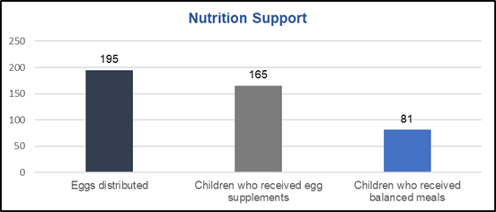
Figure 1. Nutrition support reported by the Nyanza ECD programme for April–June 2026: 195 eggs, 165 children receiving egg supplements, and 81 children receiving balanced meals.

4. Progress Since the Previous GlobalGiving Update
The January–March report documented the expansion of immediate nutrition support and household-level preventive measures. The April–June quarter continued the same pathway but shifted toward monitoring quality, consolidating ECD services, and protecting household food-production gains.
Indicator | January–March 2026 | April–June 2026 | Comparison note
Eggs distributed | 180 eggs | 195 eggs | An increase of 15 eggs, equivalent to 8.3%.
ECD centres monitored | 173 centres | 174 centres | Coverage was sustained at nearly the same district-wide level.
Nutrition screening | 160 children screened using MUAC | No verified quarterly MUAC total reported | Direct comparison is not possible; this is a priority data gap.
Kitchen gardens | 145 gardens constructed | 217 households monitored; 53 gardens good/rehabilitated; 48 needing attention | The indicators changed from construction to follow-up, so figures should not be added or treated as the same measure.
Training | 295 participants, including caregivers, parents, and CHWs | 35 caregivers trained | The participant groups and training scope differ; the figures are not directly comparable.
Household visits | 241 households | 217 households in Nyamagana B | The Q2 figure is village-specific and should not be treated as the Nyanza district total.

5. Detailed Implementation Progress

5.1 Child nutrition support through ECD centres
Nutrition interventions were delivered through selected ECD centres to improve access to protein-rich foods and balanced meals. Four centres in Kibirizi, Mukingo, Ntyazo, and Cyabakamyi were specifically identified for nutrition support. Across the quarter, 195 eggs were provided to 165 children, and 81 children received balanced meals.
This approach complements household food production by ensuring that young children receive direct nutrition support in a supervised setting. The ECD platform also enables caregivers and programme staff to connect feeding support with attendance, hygiene, stimulation, and routine child-welfare monitoring.

5.2 ECD monitoring and quality assurance
Supportive supervision reached 174 ECD centres in ten sectors. Monitoring reviewed child attendance, nutrition practices, hygiene standards, safe learning environments, caregiver performance, and compliance with minimum ECD service standards. The Nyanza ECD report states that more than 80% of monitored centres were operating effectively and meeting minimum standards.
A total of 1,599 children were reached through ECD services and nutrition-related interventions. Because this is a broad service-reach indicator, it should not be interpreted as the number of children who were malnourished or who received food supplements.

5.3 Child growth monitoring and early identification
Growth-monitoring activities were reported in 81 ECD centres. Programme teams reviewed child measurements, documentation, and the completeness and consistency of monitoring books. These activities strengthen the system for identifying growth concerns and following up children who may need additional support.
However, the quarter’s reports did not provide a consolidated MUAC-screening total, nutrition-status classification, referral count, or recovery rate. These omissions limit the project’s ability to demonstrate changes in malnutrition outcomes and should be corrected in the next reporting cycle.

5.4 Household kitchen gardens and food production
Household-level work remained central to preventing malnutrition by increasing access to vegetables and strengthening families’ ability to produce food. In Nyamagana B Village, 217 households received monitoring visits and advice on vegetable production, kitchen-garden management, banana plantations, irrigation, hygiene, and self-reliance.
Monitoring showed mixed performance. The field report recorded 53 gardens as being in good condition or rehabilitated, while 48 gardens required attention and rehabilitation. A further 116 households had vegetables growing but needed watering. These findings show that the project has established a base for household food production, but water access and garden maintenance remain decisive constraints.
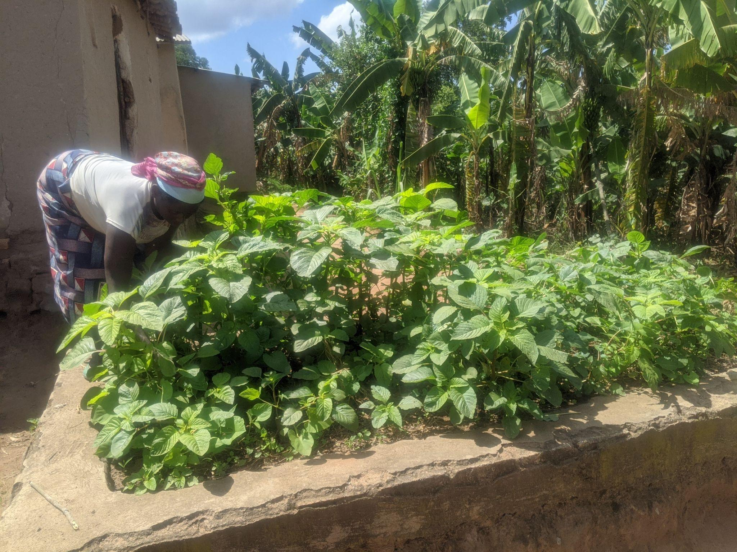
Figure 2. A productive household kitchen garden monitored in Nyamagana B Village, Nyanza District.

5.5 Caregiver capacity and behaviour change
One structured training reached 35 caregivers—29 women and six men. Topics included child nutrition and development, hygiene and sanitation, early stimulation, school readiness, and caregiver roles and responsibilities. Household visits and community sensitisation reinforced practical messages on balanced diets, vegetable production, food preparation, cleanliness, irrigation, and sustained child attendance in ECD services.
Caregiver training is essential because food availability alone does not guarantee improved child nutrition. Families also need the knowledge and confidence to prepare age-appropriate meals, recognise growth concerns, maintain hygiene, and seek timely support.

5.6 Hygiene, sanitation, and nutrition-sensitive WASH
Hygiene inspections were conducted in all monitored ECD centres, and the programme reported promotion of 518 handwashing stations. Thirty-five caregivers also received sanitation guidance. These activities are relevant to malnutrition prevention because repeated infection, diarrhoeal disease, and unsafe hygiene practices can undermine children’s ability to benefit from nutritious food.
The source reports also identify inadequate sanitation facilities in some ECD centres as an ongoing challenge. Continued investment in safe toilets, handwashing facilities, clean food-preparation areas, and hygiene behaviour is therefore required.

6. Emerging Results and Contribution to Change
The verified data demonstrate substantial service delivery and sustained community engagement, but they do not yet prove a reduction in district malnutrition prevalence. The strongest evidence of contribution during the quarter is visible in the following areas:
- More children accessed structured ECD services that integrated nutrition, hygiene, attendance, stimulation, and child-welfare monitoring.
- Protein supplementation continued, with 195 eggs distributed to 165 children and balanced meals provided to 81 children.
- Caregivers strengthened their knowledge of nutrition, child development, hygiene, and age-appropriate care.
- Households received regular coaching to maintain kitchen gardens and improve access to vegetables and bananas.
- Growth-monitoring records and child measurements received greater attention, creating a stronger basis for early identification and referral.
- The project identified specific households and gardens at risk from water shortages, poor maintenance, and limited manure, allowing targeted follow-up rather than relying on general assumptions.

7. Beneficiary Story: From Food Insecurity to a Productive Kitchen Garden

Uwimana Yosefa, Nyamagana B Village
Uwimana Yosefa is a 54-year-old widow living with her two children and two grandchildren in a five-member household. Before joining Dufatanye Organization’s activities, she relied on casual labour and struggled to purchase basic items such as soap and salt. Her household lacked adequate food, and she had limited knowledge of nutrition, saving, or kitchen-garden management.
Through training, encouragement, and continuous monitoring, she learned about household financial management, saving, good nutrition, and vegetable production. Dufatanye supported her to establish a kitchen garden and encouraged her to grow vegetables and bananas.
She now uses vegetables from the garden to prepare nutritious meals for her family and sells the surplus. During a monitoring visit, she was harvesting vegetables for sale at RWF 300 per bundle. By selling two bundles, she could contribute RWF 500 to her weekly savings group while retaining food for household consumption.
“My family eats healthy food every day, and I also earn income by selling vegetables and bananas. I no longer depend on asking others for help.”
— Uwimana Yosefa, Nyamagana B Village

Her experience illustrates the project’s intended pathway: technical knowledge and regular follow-up help a vulnerable household maintain food production; the garden improves access to vegetables; surplus production generates small income; and savings strengthen resilience. It is a credible example of contribution, although it should not be treated as representative of every beneficiary household.

8. Challenges, Risks, and Mitigation
Challenge or risk | Effect on nutrition results | Action taken during the quarter | Priority response
Water shortages and prolonged dry conditions | Vegetables wilt or fail, reducing household access to fresh foods. | Households were advised on watering, irrigation, mulching, and water conservation. | Expand rainwater harvesting and small-scale irrigation; prioritise the 116 households with crops needing water.
Limited organic manure and soil fertility | Lower garden productivity and weaker vegetable yields. | Compost preparation and organic-manure use were promoted. | Link households to manure sources and intensify compost demonstrations.
Inconsistent garden maintenance | 48 gardens required attention, threatening the sustainability of earlier investment. | Field officers provided follow-up and technical advice. | Prepare household-specific rehabilitation plans and verify completion.
Inadequate sanitation in some ECD centres | Infection and unsafe environments can undermine child nutrition and attendance. | Hygiene inspections and caregiver sensitisation were conducted. | Improve toilets, handwashing points, and food-preparation hygiene.
Incomplete nutrition-outcome data | The project cannot demonstrate changes in wasting, underweight, stunting, referral, or recovery. | Growth records and measurements were reviewed. | Standardise MUAC, weight, height, referral, and recovery reporting by centre and child.
Weak record keeping and digital constraints | Data inconsistencies reduce donor confidence and management usefulness. | Sector coordinators were trained on the Berulo digital tracking system. | Strengthen data validation, device access, internet connectivity, and monthly data-quality reviews.

9. Monitoring, Evaluation, Accountability, and Learning

9.1 Data collected
- ECD centre monitoring and supportive-supervision records.
- Child attendance, feeding, growth-monitoring, and measurement documentation.
- Egg-distribution and balanced-meal records.
- Caregiver training and coordination records.
- Household visits, kitchen-garden status, irrigation needs, and technical-support observations.
- Photographs and beneficiary testimony.

9.2 Key learning
- Nutrition support is stronger when direct child feeding is combined with household food production and caregiver behaviour change.
- Kitchen gardens cannot be sustained by distribution or construction alone; water, manure, maintenance, and repeated coaching determine whether they remain productive.
- ECD centres provide an effective platform for integrating nutrition, hygiene, growth monitoring, early learning, and caregiver engagement.
- Output numbers are not enough. The project needs consistent child-level nutrition indicators to demonstrate whether children improve.
- Success stories add depth, but they must complement—not replace—systematic outcome data.

9.3 Data-quality issues requiring correction
The Nyanza ECD report contains two different sex-disaggregation figures for the same total of 1,599 children and labels the 81 balanced-meal beneficiaries as 'ECD centres' in one KPI table, while the accompanying chart identifies them as children. This report therefore uses the total child reach without sex disaggregation and records 81 children receiving balanced meals, based on the chart and narrative context.
The kitchen-garden report describes 53 gardens both as being in good condition and as rehabilitated. The report treats this as one group of 53 rather than two separate achievements. A standard garden-status form should be used next quarter to prevent double counting.

10. Priorities for July–September 2026
Priority action | Rationale | Proposed indicator | Responsible actors
Restore regular MUAC and growth screening | Direct nutrition-outcome data are missing for Q2. | Number screened; green/yellow/red MUAC; referrals; follow-up; recovery status. | ECD team, community health workers, health facilities, MEAL.
Continue protein supplementation and balanced meals | Maintain direct support to nutritionally vulnerable children. | Children receiving eggs/meals, frequency, centre, age, sex, and vulnerability status. | ECD caregivers, field team, programme management.
Rehabilitate the 48 gardens requiring attention | Prevent loss of earlier household food-security investment. | Gardens rehabilitated and productive after verification. | Field officers, coaches, households.
Address watering needs in 116 households | Water shortage is the most immediate production risk. | Households adopting watering, harvesting, mulching, or irrigation solutions. | Agriculture team, households, local authorities.
Strengthen caregiver refresher training | Knowledge and practice must be reinforced regularly. | Caregivers trained; pre/post knowledge; observed feeding and hygiene practices. | ECD team, NCDA, Nyanza District.
Improve sanitation and handwashing in ECD centres | Reduce infection risks that contribute to poor nutrition. | Centres meeting minimum WASH standards. | ECD team, caregivers, district partners.
Conduct monthly nutrition-data quality reviews | Correct inconsistent labels, denominators, and disaggregation. | Reports passing completeness, consistency, and verification checks. | MEAL, project managers, sector coordinators.
Document household and child outcomes | Move beyond activity counts to evidence of change. | Dietary diversity, garden production, child growth, referrals, and recovery documented. | MEAL, field officers, community volunteers.

11. Conclusion and Appreciation
The April–June 2026 quarter demonstrated continued commitment to fighting malnutrition in Nyanza through a practical combination of child feeding, ECD monitoring, caregiver training, household kitchen gardens, growth monitoring, hygiene promotion, and field coaching. The project sustained broad ECD coverage and strengthened household-level food production, while identifying specific constraints that require targeted action.
The next step is not simply to report more activities. It is to prove whether vulnerable children are improving. That requires consistent MUAC and growth data, documented referrals and recovery, reliable beneficiary disaggregation, and verification that kitchen gardens remain productive across seasons.
Dufatanye Organization sincerely thanks GlobalGiving donors for making this work possible. Your support is helping children access nutritious food today while enabling families and caregivers to build more sustainable systems for nutrition, health, dignity, and resilience.

Annex 1. Source Reconciliation and Exclusions
Source | Use in this report | Treatment
Nyanza ECD Quarterly Report | 174 ECD centres, 1,599 children, nutrition support, caregiver training, growth monitoring, hygiene, challenges. | Included as the principal district-specific source.
Nyamagana B Quarter 2 Report | 217 household visits, kitchen-garden status, water and manure constraints, Uwimana Yosefa story. | Included as village-level Nyanza evidence.
Dufatanye Quarterly Programme Report | Narrative on integrated food security, nutrition, ECD, WASH, and capacity building. | Used only where the information was clearly attributable to Nyanza or corroborated by a Nyanza-specific report.
January–March 2026 GlobalGiving update | Previous-quarter figures and narrative continuity. | Included for comparison; non-comparable indicators are labelled.
Nyaruguru quarterly field report | Rasaniro Village results, including toilets, chickens, gardens, and VSLAs. | Excluded because the user requested Nyanza only.
Nyamagabe/Kitabi/Kibilizi field report | Home-based ECD and toilet-rehabilitation activities outside the confirmed Nyanza scope. | Excluded from results and figures.

Prepared by:
Archimede Sekamana
Head of Partnership, Strategy & Impact
Dufatanye Organization
Reporting period: April–June 2026

