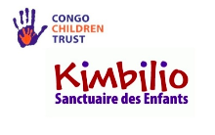

www.kimbiliocongo.org

Changing the lives of Street Children in D.R. Congo

Kimbilio (Swahili for ‘refuge’) is a grassroot charity raising funds through UK registered Congo Children Trust. Through it we support street-connected children in Lubumbashi, the second city in D.R. Congo with an aim to reintegrate street children with their families wherever possible. Due to poverty and the current political climate, the number of street connected children in Lubumbashi is rising. At Kimbilio. We see and help about 130 street children every week

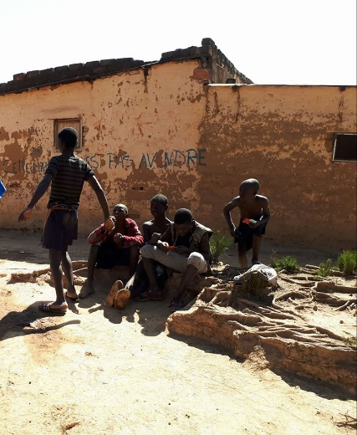

Life on the streets
Children find themselves abandoned on the streets for many reasons – the consequence of parental death, often due to HIV or malaria, their family may be too poor to feed them, or they may be stigmatised as child witches. On the streets, they are prey to violence, exploitation and addiction. The rate of HIV is high and if a child is not already a carrier of the virus the risk of soon becoming one is also high.

Changing Lives – How the Kimbilio Project helps

The Kimbilio project plays a key role in the local community of Lubumbashi. Over the last decade since becoming established in D.R. Congo we have set up projects in 5 main areas: a Day/Outreach Centre, a transitional home for Girls, a transitional home for boys, a long-term home for boys, and a long-term home for girls. Each of the four homes has trained carers with a Congolese family at the heart of it.
Congo Children Trust believes that the street is not an ideal environment for children to live. Instead we aim to provide children with opportunities to thrive in their family setting where possible or within small replica family groups. We focus our attention on ensuring that children are protected, well cared for, healthy (emotionally and physically) and receiving appropriate education and training.

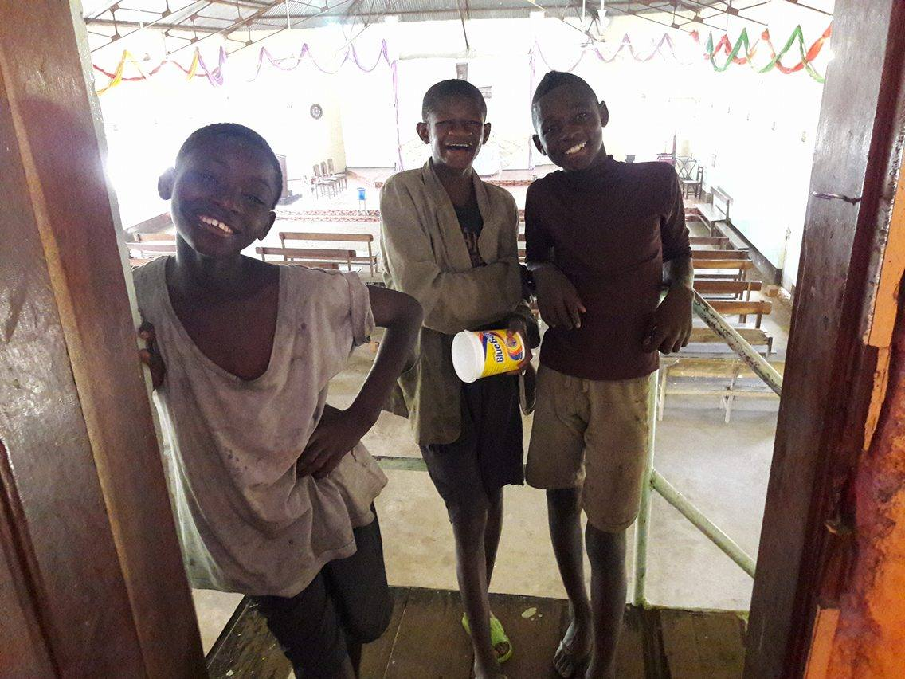
Kimbilio is a multi-faceted organisation that centres around the well-being of street-connected children. It provides a holistic, child-centred service, though care and support in the outreach centre, shelter in one of our four homes and a robust reintegration programme which seeks to reunite children with their families. The primary aim of Kimbilio is to reunite each child with their family if safe to do so. Kimbilio staff work closely alongside local agencies and social workers as a trusted part of the Lubumbashi community. Kimbilio also works in partnership with other charities to deliver opportunities for young people and parents to develop skills which will sustain them. At present we have two sewing schools and have just opened a training salon this month run with local partners. Kimbilio has also led the way by facilitating training to address the problem of children being accused of witchcraft. Congo Children Trust’s aim is to address the needs of street children and to also ensure that children do not end up on the streets.
In 2017, Kimbilio opened the doors to supporting children exploited in the artisanal mines near Lubumbashi which was featured in this Sky News report by Alex Crawford: https://news.sky.com/story/cobalt-mining-boys-given-hope-but-many-still-suffer-10871384 .

Current Project Priorities

July 2019 saw the breaking of ground for the Kimbilio Ecole Primaire. Our brand-new project is to open a school on the grounds of Maison Kimbilio. For our 10th Anniversary celebrations, the foundation stone for the school was placed and the building work has now started.
We currently have funding for two classrooms, with the aim of securing further funding for four more. The local diocesan Board of Education will be providing the staff and management of the school. This school will enable local children to attend alongside former street children in the care of Kimbilio. It will have good resources and well-trained teachers, able to engage children for whom this is their first experience of school. We aim to make it a flagship school, well known for the care and attention in helping each child achieve their potential. This project will not only help equality in education but improve community cohesion and the acceptance of stigmatized former street children. In line with Kimbilio’s core values, the school will welcome all children regardless of gender, race, religion, ethnicity, disability or sexuality.

Kimbilio is helping children build a future with hope

