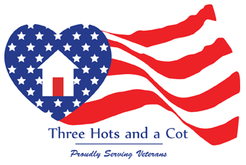 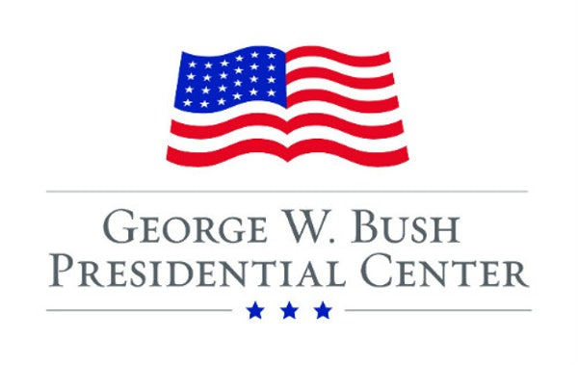 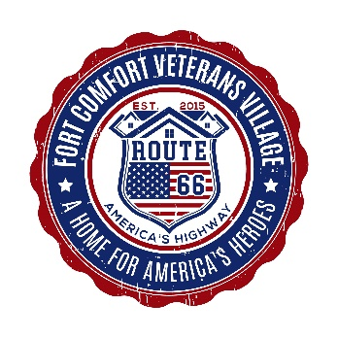

Comments from **George W. Bush Institute** Case Study (full report available on request)

**Passion to Serve Veterans** …person after person stated that what drives 3HAC is “passion.” Many spoke of the passion of the founding team, and particularly the passion of JD Simpson, Co-Founder, President and CEO. The passion of the founders isn’t hard to see. “We all do everything,” or “We do whatever needs to be done.” The boundaries of personal and professional lives are deliberately blurred or erased. “Passion”—the watchword used by most people interviewed—provides abundant motivation, long hours and inspiration.

**Transition to Civilian Life** - *One of the things that bothers me are those TV commercials where the guy is walking through the airport and everyone applauding. You know, that’s great. Everybody loves that. It brings a tear to everybody’s eye. What it doesn’t show is how many of those guys who are walking through are going to commit suicide; how many are going to try; how many are going to end up on the street; and how many are suffering from PTSD. And because of that—America has such blinders on. They see the glory; they see the uniforms; they see the heroes. But they don’t see the damage inside. I think that is our biggest issue. (Lynette Simpson, Co-Founder, COO & Board Secretary)*

**Needing a Voice** *- I plan to keep this going as much as possible by continually reaching out to anyone who will listen. Would love to have a budget item for marketing - the bill boards, the radio spots, and all that. But for now - we pay the bills and buy gas - everything else - we keep yelling to the world hoping someone is listening. Probably not the most professional business plan option out there - but it is all I have for now. One day I will have us a celebrity who hears of us and will stand on the front porch of the Veterans Center and tell the world about the plight of our veterans across the country. (JD Simpson, CO-Founder, President & CEO)*

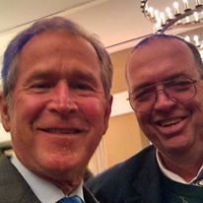 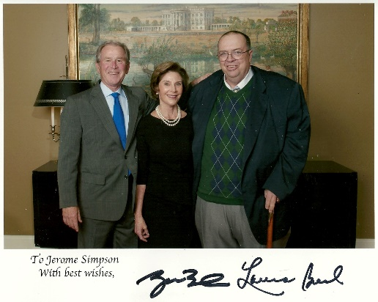

PO Box 1410, Seligman, AZ 86337 Phone: 928-499-9031 [jdsimpson@cotsforvets.org](mailto:jdsimpson@cotsforvets.org) [www.cotsforvets.org](http://www.cotsforvets.org) [www.veteran-village.org](http://www.veteran-village.org)

Arizona will be home to

Fort Comfort Veterans Village

*A Home for America’s Heroes On America’s Highway*

**Fort Comfort Vision:** Fort Comfort will offer affordable housing in a community for our veterans (and spouses). Units will be available to accommodate veterans with disabilities. At Fort Comfort our veterans will find the camaraderie in a community of their brothers and sisters who have also served our nation. Please see our website at [www.veteran-village.org](http://www.veteran-village.org) for more information. Also, our web site [www.cotsforvets.org](http://www.cotsforvets.org) for the work we have successfully completed and continue to do in Alabama.

Let’s make affordable housing a reality for our veterans

We are available to speak to your civic club, organization, business or church.

Contact JD Simpson at [jdsimpson@cotsforvets.org](mailto:jdsimpson@cotsforvets.org) or call 928-499-9031

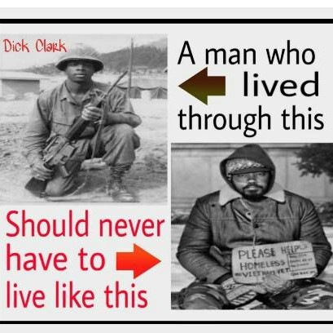

**A 501c3 recognized organization All gifts are tax deductible Tax EIN # 81-1018293**

**Mail gifts to**

**Fort Comfort Veterans Village PO Box 1410 Seligman, AZ 86337**

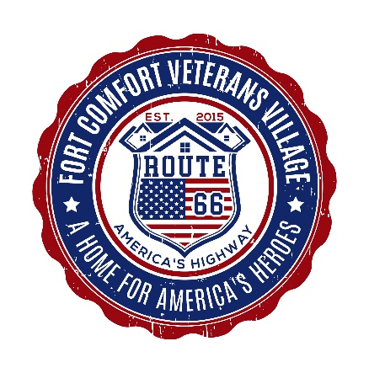

Fort Comfort Veterans Village PO Box 1410 Seligman, AZ 86337 (928) 499-9031 [jdsimpson@cotsforvets.org](mailto:jdsimpson@cotsforvets.org) [www.veteran-village.org](http://www.veteran-village.org) ***A home for America’s Heroes on America’s Highway – Route 66***

***Proposed One Bedroom Home***

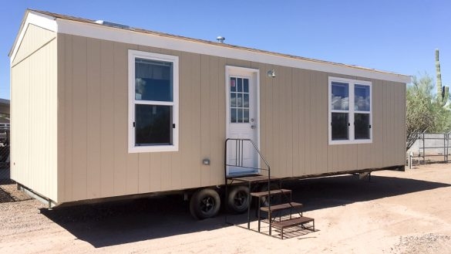

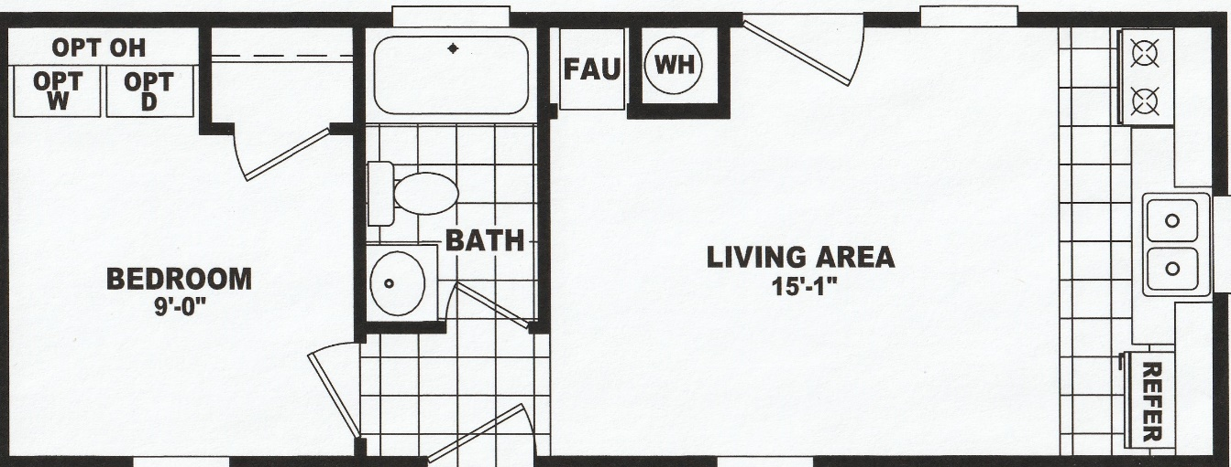

Home will be placed on a private lot with fenced backyard, front porch added, carport and a garden shed. Total cost for each home including everything is $30,000 – please help today.

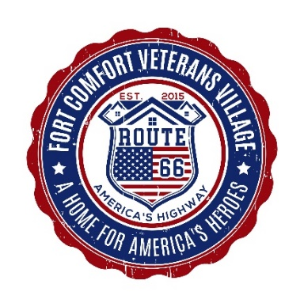

Fort Comfort Veterans Village PO Box 1410 Seligman, AZ 86337 (928) 499-9031 [jdsimpson@cotsforvets.org](mailto:jdsimpson@cotsforvets.org) [www.veteran-village.org](http://www.veteran-village.org) ***A home for America’s Heroes on America’s Highway – Route 66***

**The “Not Pretty” Stuff Needed**

Estimated cost of $253,000, and not a single home in place for a veteran

 



***Have to do this before we can serve our veterans – they are waiting on us.***



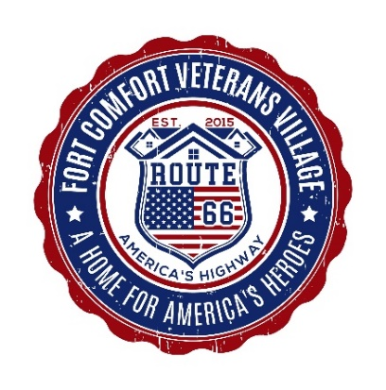***Jerome D. Simpson – Accomplishments & Milestones***

Fort Comfort Veterans Village PO Box 1410 Seligman, AZ 86337 (928) 499-9031 [jdsimpson@cotsforvets.org](mailto:jdsimpson@cotsforvets.org) [www.veteran-village.org](http://www.veteran-village.org) ***A home for America’s Heroes on America’s Highway – Route 66***

*President & Founder of Three Hots &A Cot & Fort Comfort Veterans Village*

* US Navy Combat Veteran 1977-1987
* Bachelor of Science Degree in Business Management from Bryan College
* Transportation & Logistics Manager 1988-2009
* Founded Three Hots & A Cot [www.cotsforvets.org](http://www.cotsforvets.org) 2009 a 501c3 to serve Homeless Veterans
* Opened first transitional house for veterans in 2010
* Since opening first house Three Hots & A Cot currently operates two transitional homes and six independent homes servicing over 50 veterans and family members each night.
* Organization has helped over 1750 veterans gain independence from homelessness since 2010.
* Achieving 82% success rate with program participants in Three Hots & A Cot
* Built Three Hots & A Cot from $37 in 2009 to over $1,000,000 in assets in 2015
* Raised over $4,500,000 to support homeless veterans since 2009
* Managed $500,000 annual budget or larger each year.
* Named one of Birmingham Alabama’s Top 50 over 50 citizens in 2014
* Selected by President George W. Bush as one of 25 organizations in the nation out of 46,000 nonprofits to work with George W. Bush Institute on Military Service Initiative for Post 9/11 veterans in 2015 – continues work to this date.
* Featured on CNN Anderson Cooper show in 2012 for work with homeless veterans.
* Founded Fort Comfort Veterans Village [www.veteran-village.org](http://www.veteran-village.org) in 2016 a 501c3 to provide affordable housing for veterans in Arizona.
* Advisor for founding of the HER Foundation in 2017 a 501c3 to serve homeless veterans in Florida.
* Developed leadership team for Three Hots & A Cot to continue work in service to homeless veterans.
* Public Speaking at over 175 local organizations and clubs in the Alabama area ensuring continued public awareness around needs of veterans in Post 9/11 world.
* Developed relationships with national organizations to provide continued funding and volunteers to serve veterans to include: AT & T Pioneers, Home Depot, Lowes, Regions Bank, Tamaki Foundation, Marine Corp League, American Legions, Thompson Foundation, Wal-Mart, SAMS Club, and others.
* Began developing planning and fund raising for $3,500,000 project to provide Homes for Americas Heroes on Americas Highway – Route 66 in 2016
* Both Three Hots & A Cot and Fort Comfort Veterans Village are qualified as GOLD Participants on Guidestar,org
* Qualified Three Hots & A Cot as a Combined Federal Campaign organization & raised over $250,000
* 2017 Recipient of Alabama Vulcan Community Hero of the Year Award for work with veterans.
* Currently serve as Commander American Legion Post 123 in Seligman, AZ
* Currently serve on Seligman Unified School Board in Arizona
* Ready to do what is NEXT – to serve those who have served our nation……

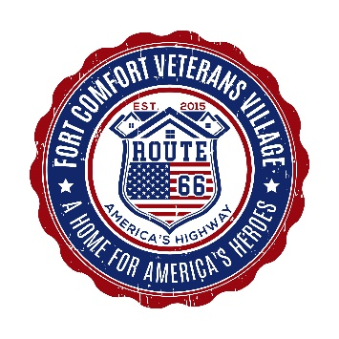

Fort Comfort Veterans Village 22245 N. Pine Street PO Box 1410 Seligman, AZ 86337 (928) 499-9031 [jdsimpson@cotsforvets.org](mailto:jdsimpson@cotsforvets.org) www.veteran-village.org ***A home for America’s Heroes on America’s Highway – Route 66***

***Credibility – a question worth asking***

*This is another word for trust – for reliability - for dependability. How credible is the organization you are supporting with your passion, your time, and your money? A little about Fort Comfort Veterans Village – and Three Hots & A Cot – both companies – although independent of each other – were founded and operated by the same group of people.*

* Both organizations recognized by the IRS as 501c3 organizations.
* All financial records are submitted to Guidestar each year for review – Guidestar is one of the top independent organizations that rate nonprofits. Financial documents are then posted on Guidestar.org for public review and consideration.
* Guidestar has rated both organizations as GOLD Level Participants.
* Financial records are sent to both board of directions each month for review.
* Financial records are reviewed each year by an Independent Auditor and results of review are made public.
* Both organizations submit full IRS 990 filings each year and these documents are also open for public review.
* The President of both organizations does not take a salary from either organization.
* Three Hots and A Cot has been reviewed by Syracuse University, John Hopkins University, University of West Florida, and the George W. Bush Presidential Institute for ethics, financial, and legal standard compliances and has passed with flying colors each time we are reviewed.
* Fort Comfort Veterans Village was founded in 2016 because of a meeting with the President George W. Bush Institute and immediately adopted and put into place these same standards.
* Board meetings of both organizations are open to the public.
* 90-95% of all funds raised goes to the program – less than 5 – 10% goes to overhead on average over 8 years.
* We have partnered successfully with some of the largest organizations and corporations in America – to include: American Legions, Legion Riders, American Legion Auxiliary, Marine Corps League, AT&T Pioneers, Soldiers Angels, Home Depot, Wal-Mart, SAMS Clubs, Bank of America, BBVA Compass Bank, Regions Bank, Woodforest Bank, Gold Star Families, Yates Corporation, Lowes, Harley Davidson, Vettes-4-Vets, Toyota and Hendricks Motorsports.
* Our organization has been used as a model organization for others to follow by the US Department of Veterans Affairs, the US Congress, Office of the Vice President of the United States, British Military Attaché of Veterans in the USA, and the Royal Household of the United Kingdom.
* We have been called on to act as founding advisors to over 15 nonprofit organizations and our program has been duplicated in three different states by three independent offshoot organizations.
* We stand ready to be graded on what we do – legally, ethically, and morally to serve the needs of our veterans nationwide.
* President George W. Bush
* Selected JD Simpson’s organization as one of 25 nonprofits out of 46,000 in the USA he wanted to work with on his Post 9/11 Veterans Military Service Initiative.
* The Vision of Fort Comfort Veterans Village is a result of that meeting with the President.
* 
* JD Simpson (President & Founder of Fort Comfort Veterans Village) with President George W. Bush

INTERNAL REVENUE SERVICE

P. O. BOX 2508

CINCINNATI, OH 45201

DEPARTMENT OF THE TREASURY

Date: **JA N** 2 1 **2016**

Employer Identification Number:

81-1018293

DLN: 170530153180.16

Contact Person: MS. LEE ID# 31208

Contact Telephone Number: (877) 829-5500

Accounting Period Ending: December 31

Public Charity Status:170 (b) (1) (A) (vi)

Form 990/990-EZ/990-N Required: Yes

Effective Date of Exemption: May 1, 2015

Contribution Deductibility: Yes

Addendum Applies: No

FORT COMFORT VETERANS VILLAGE

300 81ST STREET SOUTH

BIRMINGHAM, AL 35206-3830

Dear Applicant:

We're pleased to tell you we determined you're exempt from federal income tax

under Internal Revenue Code (IRC~ Section 501(c) (3). Donors can deduct

contributions they make to you under IRC Section 170. You're also qualified

to receive tax deductible bequests, devises, transfers or gifts under

Section 2055, 2106, or 2522. This letter could help resolve questions on your

exempt status. Please keep it for your records.

Organizations exempt under IRC Section 501(c) (3) are further classified as

either public charities or private foundations. We determined you're a public

charity under the IRCSection listed at ~he top of this letter.

If we indicated at the top of this letter that you're required to file Form

990/990-EZ/990-N, our records show you're required to file an annual

information return (Form 990 or Form 990-EZ) or electronic notice (Form 990-N,

the e-Postcard). If you don't file a required return or notice for three

consecutive years, your exempt status will be automatically revoked.

If we indicated at the top of this letter that an addendum applies, the

enclosed addendum is an integral part of this letter.

For important information about your responsibilities as a tax-exempt

organization, go to www.irs.gov/chari.ties. Enter "4221-PC" -in the search bar

to view Publication 4221-PC, Compliance Guide for 501(c) (3) Public Charities,

which describes your recordkeepinq, reporting, and disclosure requirements.

Sincerely,

Jeffrey I. Cooper

Director, Exempt Organizations

Rulings and Agreements



Fort Comfort Veterans Village 22245 N. Pine Street PO Box 1410 Seligman, AZ 86337 (928) 499-9031 [jdsimpson@cotsforvets.org](mailto:jdsimpson@cotsforvets.org) www.veteran-village.org ***A home for America’s Heroes on America’s Highway – Route 66***

Fort Comfort Veterans Village

**Board of Directors**

*January 23, 2016*

JD Simpson – President (928)499-9031

*CEO – Fort Comfort Veterans Village*

Lynette Simpson – Executive Vice President (205) 639-2065

*CFO – Fort Comfort Veterans Village*

Gregory Johnson – Vice President Operations (863) 860-2764

*COO – Fort Comfort Veterans Village – Retired US Army*

Courtney Racey – Board Secretary (205) 572-9155

*Volunteer Administration – Fort Comfort Veterans Village*

Justin Simpson – Member of Board (928) 200-5017

*Outreach Director – Fort Comfort Veterans Village*

Darren Simpson – Member of Board (317) 385-6261

*Disney Animation Studios*

Andrea Johnson – Member of Board (850) 305-3260

*Legal Assistant – Becker & Poliakoff, PA*

Fort Comfort Veterans Village 22245 N. Pine Street PO Box 1410 Seligman, AZ 86337 (928) 499-9031 [jdsimpson@cotsforvets.org](mailto:jdsimpson@cotsforvets.org) www.veteran-village.org ***A home for America’s Heroes on America’s Highway – Route 66***



Funding committed and requested 2018

Committed Funding

* 3HAC LLC $42,000
* G & B Davis Family $10,000
* Celebrity Auctions $15,000
* Total $67,000

Submitted Grants

* Trump Foundation $126,500
* Clinton Foundation $126,500
* Lockheed – Martin $50,000
* Tamaki Foundation $50,000
* BNSF Foundation $25,000
* Fluor Foundation $50,000
* Celanese Foundation $50,000
* Harold Simmons Found. $20,000
* JC Penny Fund $50,000
* Gene & Jerry Jones Found. $50,000
* Perot Foundation $50,000
* AT&T Foundation $50,000
* BBVA Compass Found. $50,000
* Alwalheed Philanthropies $250,000
* Joseph Craft III Foundation $50,000
* Enterprise Holdings Found. $50,000
* Gesner-Johnson Foundation $50,000
* Andre & Alice Fischer Trust $25,000
* William & Ruth Pendleton $25,000
* Total $798,000