REASON FOUNDATION SCHOOL
Freedom Centre-Uganda Education program
Freedom Centre-Uganda values the role that secular education plays in shaping the destiny of individuals, instilling values and culture of enquiry, critical thinking and raise one’s self and also be useful to others. We also believe that the early discovery of oneself is the beginning of wisdom –wisdom for living and we complement academia with ethical-based teaching for all our children.
Freedom Centre-Uganda education program targets children who are orphaned or found on the street and unable to be placed back with their families. The children may have physical or mental health conditions, learning difficulties, or have been cast out as “spirit children”
Reason foundation School
Reason Foundation School is an initiative of Freedom Centre-Uganda. It is opened to reach out to our community with affordable but yet quality secular education for children-at-risk and orphans, from poor families and those with special needs.
We have sponsored children in a sister school called Child Hope Foundation school
At the moment, we rent a small house and a wooden structure as class rooms. We provide part of the school fees and scholastic materials including uniforms, exercise books, and pencils etc. the management team gets most of the supplies from well-wishers, fundraising and income generating projects
Currently there are 80 children enrolled to lower primary school sections these include vulnerable community children and children abandoned. Our teaching and non-staff know first-hand how delicate these precious lives are and are specially trained to play ‘father-mother’ figures to these children.
We have future plans to purchase land and construct a standard school with more decent classroom blocks to accommodate more paying children to make it sustainable to run the school.
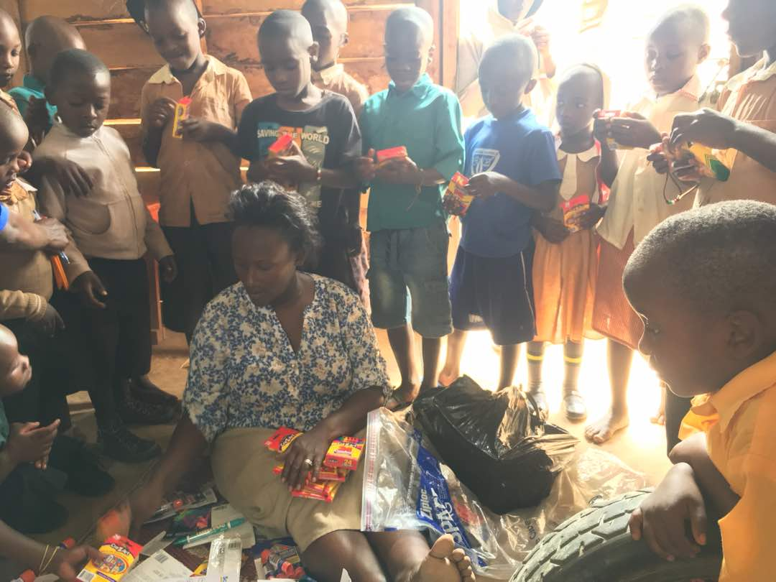
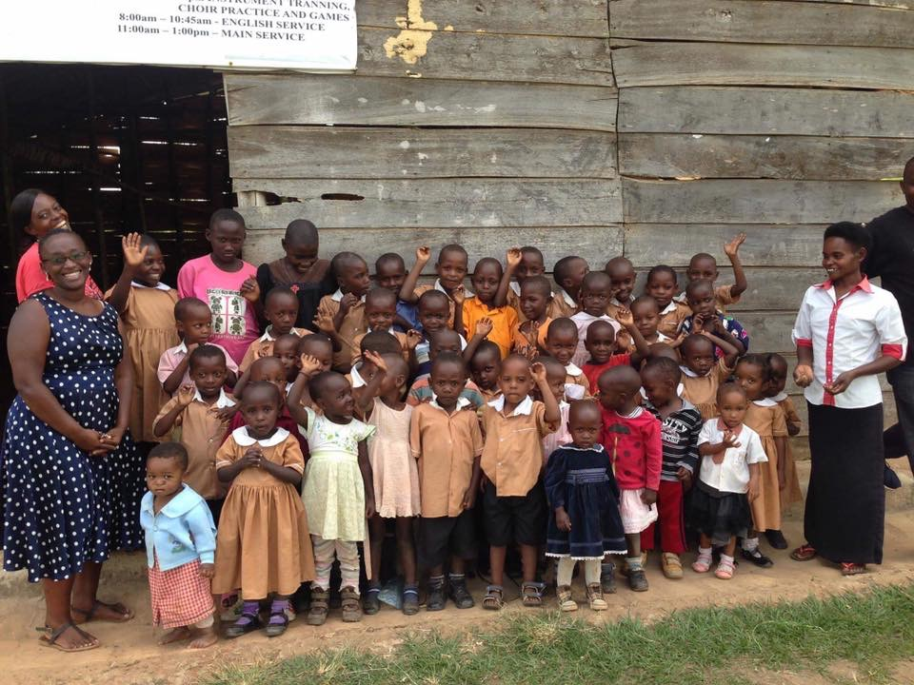

Our school Vision: “To raise a generation of children who are transformed through reason and equipped to be change makers”.
Our school Mission: “To transform lives of vulnerable children and youth through secular education, critical thinking and discovery learning thus rising a generation of future humane leaders and citizen in Africa
Our school motto: We Pride in Enlightenment
STRUCTURNG OF THE RFS-SCHOOL
BOARDS OF THE SCHOOL
Mr Batekateka Milton –Board Chairperson
Mr Kamugasha Louis-Secretary Board
Miss Tumukunde Loyce-Treasurer Board
Miss Numberone Irene- board member
Mr. Isingoma Innocent board member
HEAD MASTER OF THE SCHOOL
MR James Betungura
DEPUTY HEAD TEACHER
Miss Ayebazibwe Patience

FUTURE PLANS
We envision Reason Foundation School (REFO-school) to be a centre of excellence in offering secular education in Uganda and Africa. This can be achieved if we strategically plan, mobilize support and work hard. To that effect, we have put in place an ambitious plan to have Reason Foundation School fully established. In this we wish to have future fundraising campaigns to raise funds that can enable us purchase land, construct modern class blocks, office block, school library, kitchen, dining room etc
We will be grateful if Reason foundation school is supported to grow into a fully-fledged secular and Humanist led educational institution in Uganda and Africa

