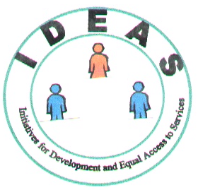

Ngara Area Program
C.C.M Building
P.O BOX 13, Ngara.
TANZANIA
Tel.+255-28-2223670
Mob. +255-784-306787
E-Mail : ideaskrg @ yahoo.com

``Working Together for Changes´´
====================================================

PROJECT KEY NOTE

I. Name of Project: Protecting 150 Albino persons in N.W Tanzania from contracting Sun radiation induced Skin Cancer through provision of recommended Skin and Eye protection gears that reduce their exposure to dangerous Tropical sun radiation.

II. Project Implementing Agency: IDEAS –Ngara Program
P.O BOX 13, Ngara
Kagera Region, Tanzania.
East Africa.
Tel. +255-784-307787
E-mail: ideaskrg@yahoo.com

III.Amount requested for Project: USD 7,520. 00

IV. Project Contact Person: Deo P.Mwombeki
Program Coordinator
IDEAS-Ngara Program
P.O BOX 13, Ngara, Kagera, Tanzania.
EAST AFRICA

Tel. +255-784-306787
E-mail: ideaskrg@yahoo.com

V. Project expected impact: Improvement in health of the persons with Albinisms, will
lead to the increased participation in the economic and social activities in the society and hence improved quality of life of this marginalized group of people .

VI. Project Duration: One Year: January –December 2010.

Registered in Tanzania as Charity Organization SO. No. 11603

- Introduction

Albinism is a rare genetic condition occurring in both genders regardless of ethnicity. In North America and Europe it is estimated that 1 in 20,000 people have some form of albinism. In Tanzania however, it is 5 times as common with 1 in 4,000 people being affected
There have been since last year albino killings in Tanzania as the albino organs, particularly genitals, limbs, breasts, fingers and the tongue are reportedly in high demand by people involved in mining and fishing activities in the Lake Victoria Zone, especially Mwanza, Shinyanga,, Kagera and Mara regions.

Besides the albino killings these four lake zone regions are also notorious for killing people believed to be witches or wizards. A mere rumour that one is a witch is often enough justification for an angry mob to kill a suspect of witchcraft. So, killings associated with superstition are not new in the country especially in rural areas.

This unimaginable evil is driven by the belief (in some areas of the country) that the body parts of people with albinism possess magical powers capable of bringing riches if used in potions produced by local witchdoctors. To date, since last year reports indicate that over 70 people with albinism have been brutally murdered and their body parts hacked off and sold to witchdoctors. However, leaders in the albinism community believe the number of deaths to be between 100 and 150. Reports also indicate that albino body parts are being exported outside of Tanzania. In one instance, a Tanzanian trader was caught traveling to the Democratic Republic of the Congo with the head of an albino baby in his possession. He told police that a businessman there was going to pay him for the head by its weight.

To show how serious the problem is, recently buried albino dead bodies are sometimes exhumed at night by unidentified people in search of the 'magical organs'. Since the mining and fishing industries are currently enjoying an unprecedented boom, so the two sectors are attracting people from all walks of life and cultures and this factor has increased the albino risks.

Those who seek instant riches are by hook or by crook hunting for the albinos, who according to World Health Organisation (WHO) sources hardly exceed 200,000 people in the country.

As the organs are still in high demand, so the killings are most likely to increase unless the Government members of the public and other Samaritans from over the world collaborate to fight against the beliefs that encourage the albino killings. Given their small number and vulnerability, Tanzanian albinos need adequate social and legal protection so that they too can fully enjoy their right to life and freedom to move freely without fear as other Tanzanians do. This is what needs to be urgently done.

Unfortunately, the mysterious killings have caused apprehension among the albino community as they now feel very insecure under the circumstances. They are even afraid of staying, walking or traveling alone to avoid potential risks. It is indeed astounding to see how some people can selfishly use others as means to their end and are, therefore, ready to kill anyone at anytime provided doing so increases their material well being.

In this funding request which we are submitting through this project, we envisage to give a hand to the Albino people and their families in this remote corner of the world, where barbaric beliefs are putting the lives of the Albino people in danger and we are seeking to reduce their exposure to the risky environment . One the favorable spots where majority of the Albinos hunters have succeeded to catch their killings is at the natural water springs which are normally located in the forested valleys under the hills where the rural communities go to fetch their fuel wood and water for their domestic uses and their livestock. By providing means to Albino families to harvest and store rain water, their exposure to the dangerous environment and the scorches of the tropical suns will have been reduced by over 50%, which is significant in saving the lives of the Albino communities while also other legal and protection measures are being taken by to save their lives.

In this project with a total USD 7,520 requested donations, which we are seeking to raise, when obtained, some essential medically recommended Skin care and protection gears together with Vision improvement and protective goggles will be purchased and provided to some 150 persons with Albinism , especially the school going children to improve their studying ability.
Specifically., the Project will be providing Albino persons with low vision aids, essential skin ointment and protective wearing against the burns of the scorch tropical suns that lead them to contracting the skin cancers (their skin lack the essential pigment that protect the human body against dangerous sun rays).

1.2 Background of The Organization

Initiatives for Development and Equal Access to Services (IDEAS) is a Non Governmental Organisation whose mission is to cooperate with other development partners and the local communities, in particular the rural poor communities of Tanzania in supporting the local initiatives. IDEAS is aiming at reducing poverty and promoting sustainable use of resources found in various areas in the community. IDEAS also seek to empower people to develop capacity and means of accessing equally to the basic social services as a requirement in the efforts to contribute to their own development, with an understanding that it is through participation and empowerment of the people that sustainable development can be achieved.

IDEAS believe that properly mandated, empowered and informed, marginalised communities, and in particular the women, can contribute to decisions that affect them and play an indispensable role in creating a securely based, sustainable and equitable society.

The Organisation was established in 1998, initially operating as a Community Based Organisation (CBO), and as its activities expanded, it was transformed and received registration as a Non Governmental Organisation(NGO) SO No. 11603.

It was established to operate within Tanzania, and it started by establishing some development programs in Karagwe and Ngara districts in collaboration with the local communities and other partners in respective villages.

To support local initiatives of the communities and empower them in their efforts to fight poverty and access basic service equally, through awareness raising, animation, groups formation, leadership and training in management skills, assisting the disadvantaged individuals and groups to gain greater control over local resources and decision making, and of their ability and right to define collective goals, and participate in making decisions on matters that affect their daily lives.

The core areas of activities are in the fields of economic development, basic social services, Environment, Vocational Training, Appropriate Technologies, Women and Youths, Justice and human rights advocacy and awareness raising , and other assistance to the disadvantaged groups in the society. IDEAS has gained some experience in running and managing various Community involving development projects, working in particular with the groups of Women and Youths in particular.

The Board of Trustees controls administration and Management of the Organisation affairs and its projects, with the assistance of the project teams and seek external consultancy where necessary. Its financial reports are prepared periodically and gets annually audited. The General Assembly is the supreme organ and meets every year to deliberate on the Organisation matters and Policies.
In carrying out its programs, IDEAS is supported by the services of Volunteer experts, and this proposed credit scheme is to be implemented with the support of the international volunteer.

- Description of the Project.
2.1 Problem Statement.
There have been since last year albino killings in Tanzania as the albino organs, particularly genitals, limbs, breasts, fingers and the tongue are in high demand by people involved in mining and fishing activities in the Lake Victoria Zone, especially Mwanza, Shinyanga, Kagera and Mara regions.
The albino killings are essentially associated with superstition. Whenever people experience hardships in life they tend to consult traditional healers to find out what could be the cause for the hardships or misfortunes and how to redress them. The solution has been often to look for short-cuts that end up causing more problems in the community.
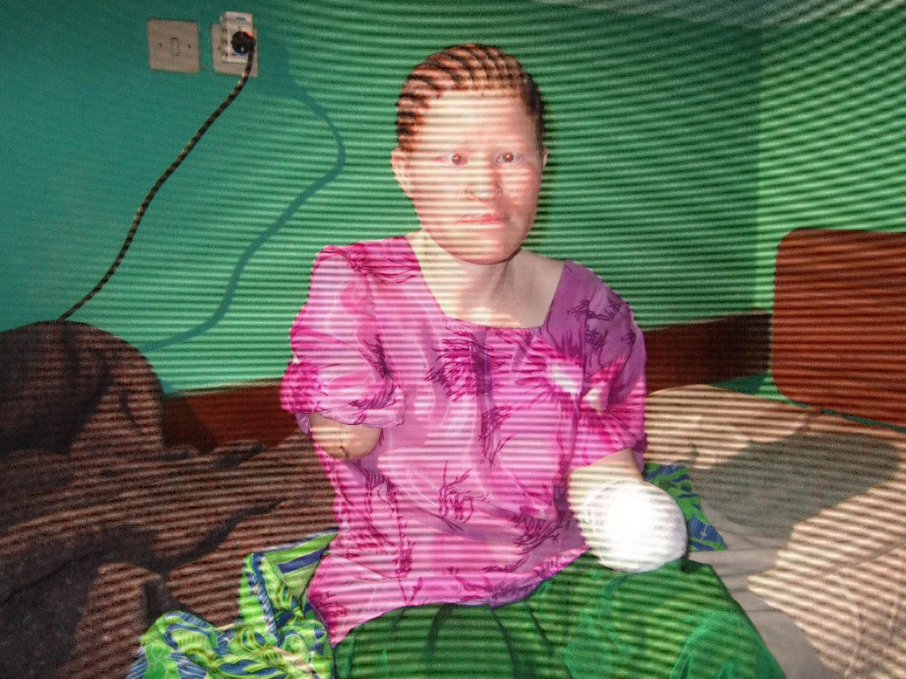
Mariam (28) from Ntobeye Village in Ngara district, Kagera region, was lucky enough to have survived after she was invaded last year at her home by two unknown people who entered through the window while sleeping and chopped her both arms. She cried for help and neighbours turned up on time and the inviders disappeared with one of her arm, while the second one was left hanging and had to be cut off at the hospital as could not be re-attached. By then she was six months pregnant and the bleeding was threatening not only her life but also her unborn baby, who is now doing well with her hand caped Albino mother. She might have survived this attack, but the real threat of Skin Cancer from constant direct exposure of her vulnerable skin remains with her to date, and this further hand caps her living and participation in the economic and social systems in her society.
Unfortunately, these strange killings have caused fear among the albino community as they now feel very insecure under the circumstances. They are even afraid of staying, walking or travelling alone to avoid potential risks. The fear and horror among the Albino families, also has significantly reduced their participation in the production and economic activities they have been undertaking to support their livelihood and as results more have become dependant as they now forced to concentrate more on their safety and security than in the productive activities. The life has become even harder to those albino families from the rural areas whose livelihood depends on farm works, fuel woods from forests for home energy and cooking and water from natural springs and rivers located away from homes (in some place covering a walking distance of about 1-2 hours through dense forests and bushes under the dangerous uncompromising tropical sun with dangerous radiation for their skins which lack the essential melanin pigment that filter the dangerous rays from harming the human skin.

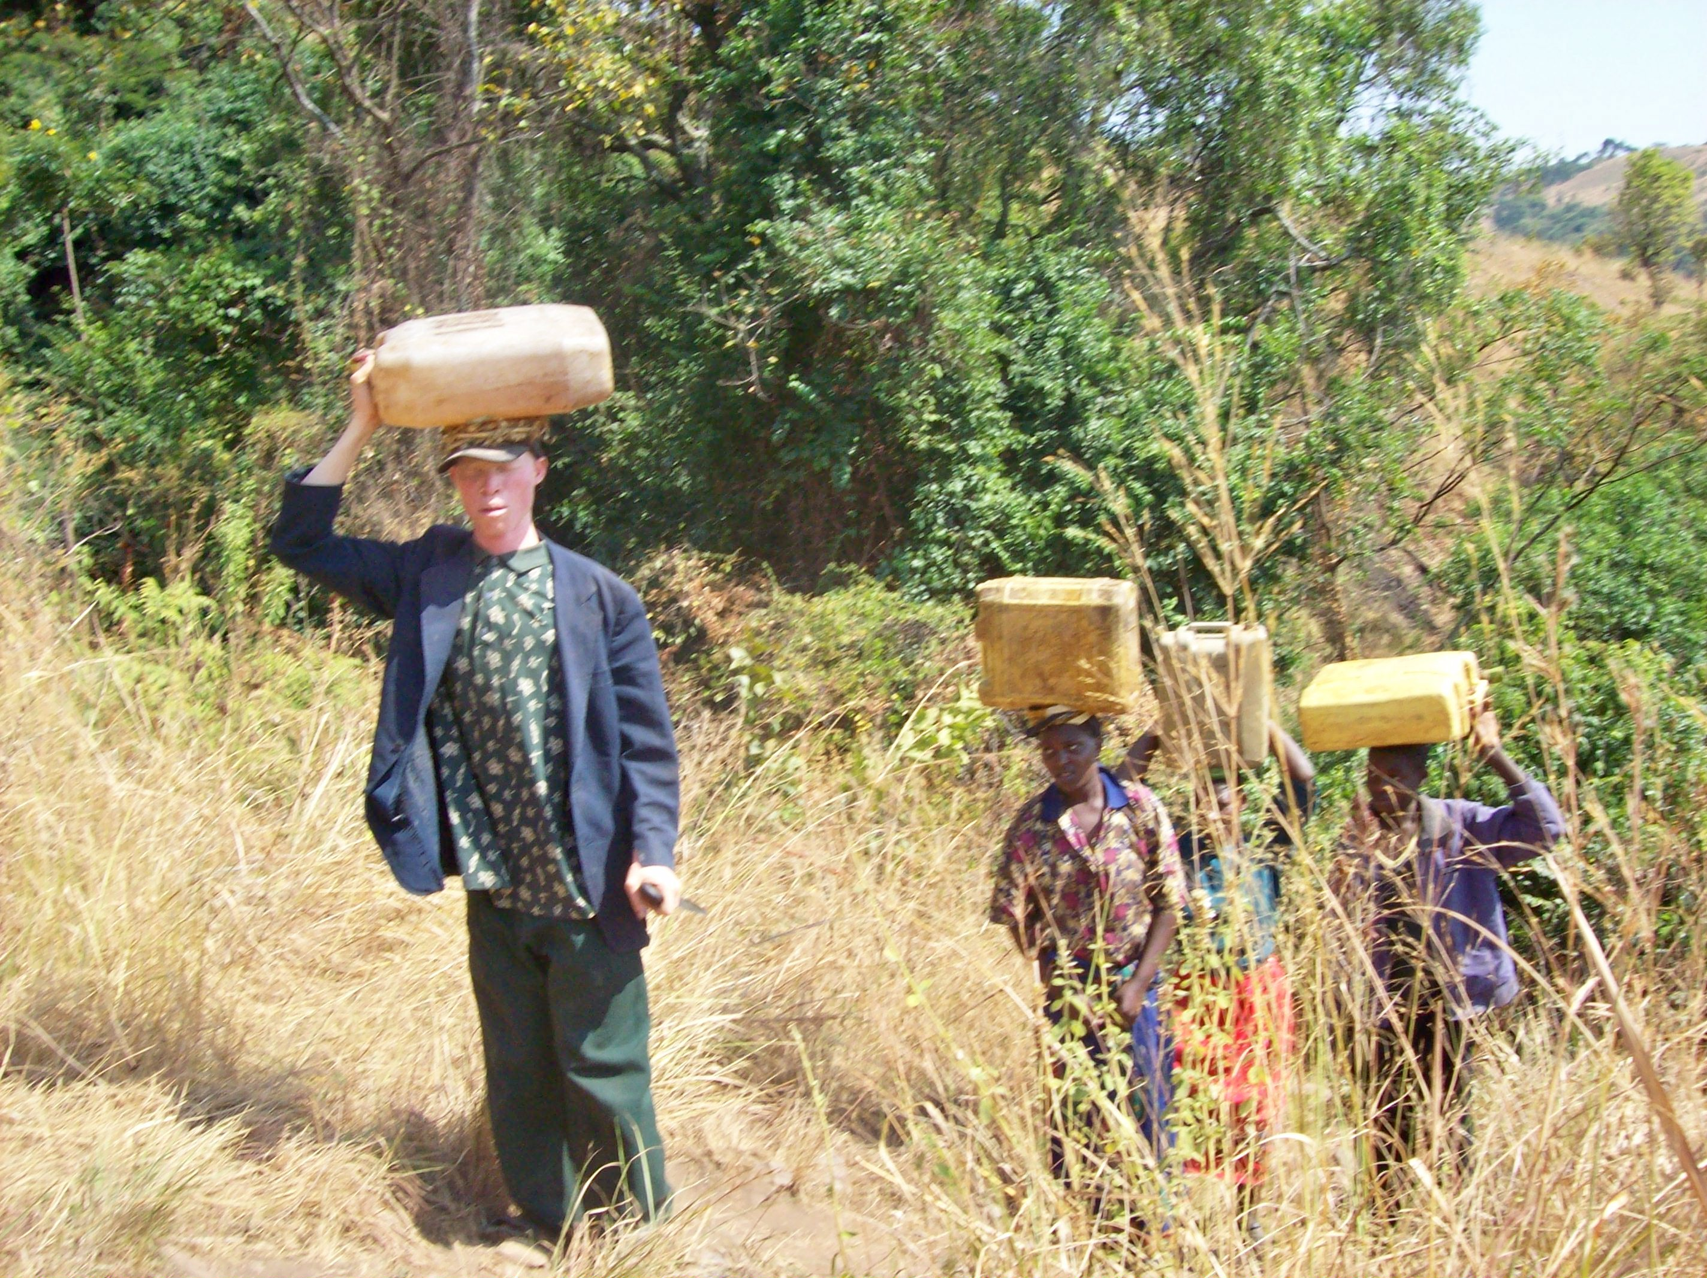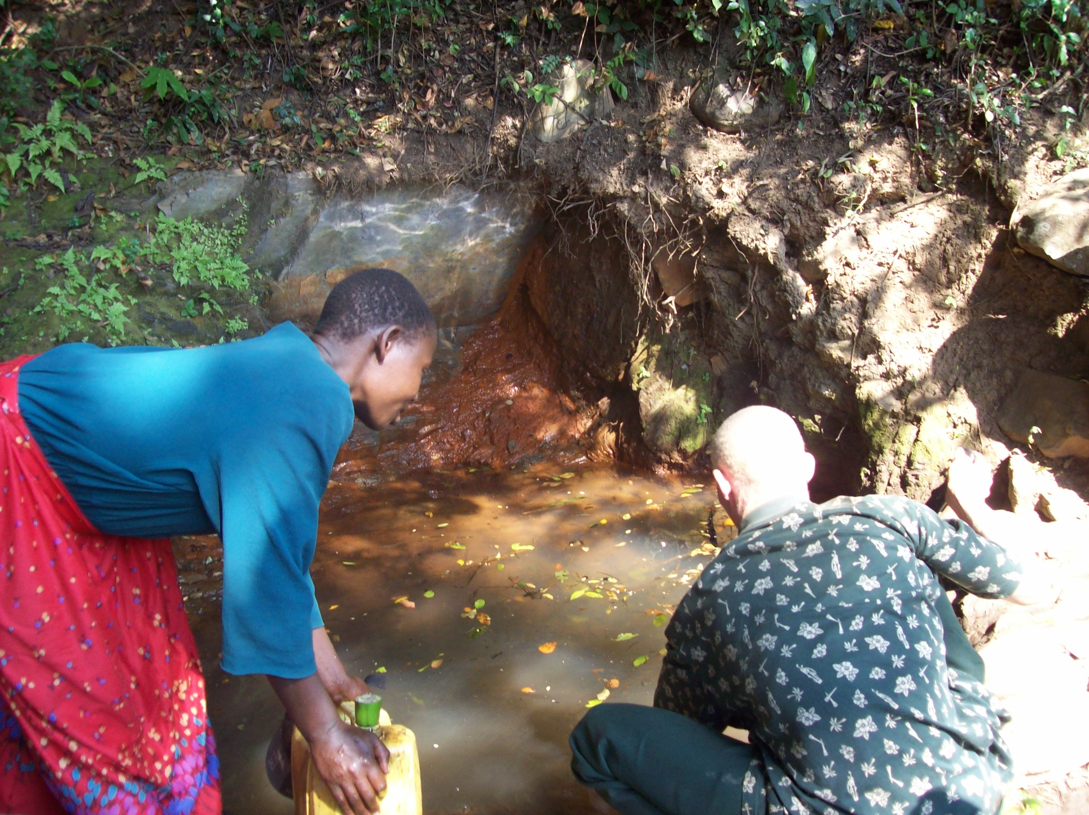
For an Albino in Tanzania, fetching water from a natural source and getting home safely, one needs to be extra lucky , even when is armed with a machete .

Above: Mr Ignius Laurian from Igurwa Village, coming from the Spring water source together in the company of some neighbor and family mebers to fetch water for his family uses (For an Albino person walking such a distance of over 2.5 Km through the bushes and hills, exposes them too much to the hot tropical sun radiations that induces Skin cancer to their vulnerable skins.

2.2 Major Challenges Facing Persons with albinism in Tanzania.
2.2.1 The horror of a rapidly growing industry in the sale of albino body parts.
There has been since last year albino killings in Tanzania as the albino organs, particularly genitals, limbs, breasts, fingers and the tongue are in high demand by people involved in mining and fishing activities in the Lake Victoria Zone, especially Mwanza, Shinyanga , Kagera and Mara regions. The murders are the result of seemingly conflicting beliefs spread by witch doctors, who are still consulted by many of people in the named regions. Some fishermen believe that, if they weave the red hair from an albino into their nets, fish will be attracted by the golden glimmer. Miners for gold, rubies and tanzanite are reported to pay large sums for juju (magic) amulets, which they wear around their necks or strapped to their arms and which are made up with a potion mixed from albino body parts. Others are said to bury the bones of albinos in the ground they are digging
2.2.2 Lack of Low vision aids
Lack of glasses, magnifiers and specialized computer equipment. This results in extreme difficulty in completing educational programs, resulting in chronic poverty and unemployment.
2.2.3. Epidemic Rates of fatal skin cancer:
Lack of protective sunscreens, wide brimmed hats and proper clothing resulting in epidemic rates of death due to preventable skin cancer. The lack of melanin in the skin creates high risk for skin cancer. Average life expectancy for persons with albinism in Tanzania is 30 years, with only 2% living beyond 40 years.
In western countries persons with albinism have the same life expectancy as the general population.

2.2.4. Widespread social and economic discrimination fueled by powerful myths.
There is long standing and widespread lack of public awareness of albinism. Powerful myths surround albinism in Africa. Some of these are:
- People with albinism are evil or are a curse from God and will bring bad luck on the household People with albinism never die - they simply vanish People with albinism are born to black women who have slept with a white man
Albinism is believed to be a contagious disease - as a result many employers avoid hiring persons with albinism due to fears that their customers and staff will "catch" the condition, or that food would be contaminated if touched by a person with albinism.

- Project Goal and Objectives.

  - Goal of the Project.

The general goal of this project is to reduce the risks environment under which the Albino people are exposed to in their daily life, both social and physical.

  - Project Specific Objectives

    - To process and raise some USD 42,500 required for this project that is required to acquire essential supplies for the Albino community in the rural villages of Karagwe and Ngara districts, in North western corner of Tanzania.

    - In the next six months, to construct and provide some 60 rain water harvesting and storage tanks (4,000Lts capacity) to some sixty Albino families from rural areas to reduce their exposure to risky physical environment as they go out in the search for this essential life ingredients which is located away from most homes in the remote rural areas of the country.

    - To acquire and provide some 60 photoelectric solar light portable lamps to the Albino families living in the remote rural villages for domestic use to improve lighting in their homes to beef up their poor vision during the nights, which are now becoming even more dangerous for their lives as night falls.

    - To process acquisition of the essential skin care ointment and medicated skin lotions , protective wearing and low vision aids for provision to the poor Albino families .

    - To continuously work with the Albino people in the project area, government and other partners to identify other key issues that face the albino society in Tanzania that require intervention and mobilize required resources for these activities.

  - PROJECTED EXPECTED BENEFTS AND IMPACT.

  - Families are able to access and use Safe and clean water for their drinking and other domestic needs, that reduces their risks to the contraction of water borne diseases like cholera, dysentery and bilharziasis.

  - Reduced risks and time saving as rain water harvests and storage reduce the need for going out long and dangerous routes in the search for water from natural sources (springs and streams) which are becoming easy hunting sites for those looking to kill the Albinos for their body parts.

  - The provision of safe and clean water, clean home lighting, together with the protective skin wears, low vision aids and appropriate medicated ointment will improve the health and well being of the Albino people in their respective areas, giving them the energy and strength they need to counter all the challenges they are facing in the society and their environment.

  - As the Albinos are given an initial helping hand and be able to access the essential health services (skin protection and care), Low visual aids and other basic needs and productive support to make them live a humane life and get self-reliant , their social status in the society and threats towards them , changes as people beliefs and attitudes towards them starts to change for the better as are viewed as normal human being living and enjoying normal life in the society without much worries because of their skin pigment (lack of melanin).

  - Appropriate Skin Protection dresses and wearing protect the skins (which lacks melanin) from direct sun rays which some of it are cancer inducing rays, which is a common problem to majority of the Albinos in the tropical parts including Tanzania.

- FINANCING AND COSTS

Project Major Component | Materials | Total Quantity | Unit | Unit Cost  (USD) | TOTAL (USD)
1. Construction of 60 Tanks for Domestic Rain water harvesting and storage | -Stones  -Burnt Bricks  -Cement  -Technical works  -Laborers | 30  30  480  60  60 | Lorry  Lorry  Bag  Tanks  Tanks | 60  200  20  100  75 | 1,800  6,000  9,600  6,000  4,500
Sub Total |  |  |  |  | 27,900.00
2. Provision of Photoelectric Solar Lamps(60) | Solar Lamps Complete units with Panel for charging | 60 | Solar Lamps with Charging Panel | 65 | 3,900
Sub Total |  |  |  |  | 3,900.00
3. Provision of Low vision aids, Skin care medicated ointment and body protective dresses | -Low vision aids  -Skin med- ointment  -Protective wears | 150  450  600 | Pcs  Pcs  Pcs | 8  3  10 | 1,200  1,350  6,000
Sub Total |  |  |  |  | 8,550.00
GRAND TOTAL (USD) |  |  |  |  | 40,350. 00

Note: Sub component no 3 of the Project is the one whose funding is being requested through GlobalGving Open Challenge donations.

