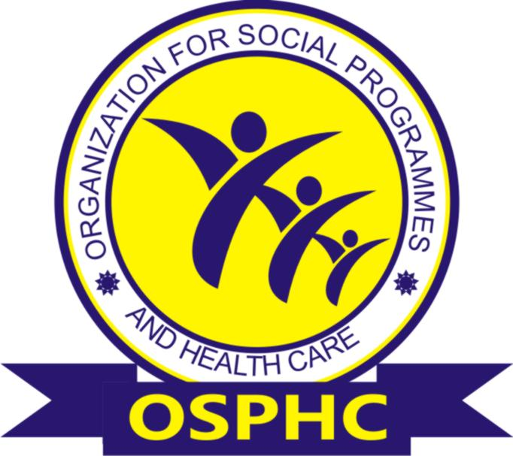

ORGANIZATION FOR SOCIAL PROGRAMMES AND HEALTH CARE (OSPHC)
Email: osphc_ng@yahoo.com
Telephone: +2348037364660 or +2348034939287
Address: 34 Olubadan Avenue, 7 Up Road, Oluyole Estate Ibadan, Oyo State.

ORGANIZATION FOR SOCIAL PROGRAMMES AND HEALTH CARE
(OSPHC)

ORGANIZATIONAL PROFILE
CONTACT PERSON: OKOLI OGOCHUKWU

TEL. +2348037364660, +2348034939287 OR +2347046041651

Personal email: ogoo_okoye@yahoo.com

- INTRODUCTION
OSPHC is a grass-root non-governmental organization established in 2014 to support the Nigerian Government efforts in the actualization of its Community Development and Public Health initiatives. OSPHC activities focus on promoting the quality of life of Women, Children and Youth through quality Education, Health, Secure Livelihood and Humanitarian Services in Nigeria. To this end, we have implemented projects on public health interventions in the areas of HIV/AIDS, Malaria, TB and other social activities that improve the quality of lives of individuals.
OSPHC collaborates with the communities, non-governmental organizations (NGOs), Community based organizations (CBOs), civil society organizations (CSOs), federal, state, local governments and other networks for more prominent impact. The NGO was registered under the Corporate Affairs Commission (CAC), federal republic of Nigeria in December 2014.
- VISION

We envision a nation where all individuals live healthy lives and hold the power to create opportunity for themselves and others.
- MISSION
To improve the quality of life by implementing sustainable programmes that creates positive changes in education, health and human development.
- GOAL
To promote and deliver cost effective, culturally acceptable & sustainable Health Services, Education and Social development programmes that impact vulnerable people.
- AIMS AND OBJECTIVES
- To promote and implement activities designed to control and prevent communicable and non-communicable diseases.
- To improve access to existing and/or new services instrumental to increasing women’s social and economic protection and wellbeing and their participation in economic growth.
- To contribute to country needs as regards strengthening health systems for communicable disease prevention and control.
- To work towards achieving complete literacy and promotion of education.
- To promote moral and ethical values in the girl child through educational institutions.
- To solicit and receive financial support from National and International organizations for welfare activities and to organize workshops/ programmes in backward rural areas as well as for women.
- To create awareness and implement activities designed to promote effective Sexual Reproductive Health and Family Planning.
- To support and implement activities designed to promote maternal and child health (MCH)
- OPERATIONAL STRATEGIES OF OSPHC
OSPHC focuses on the following operational areas:
- Behavioral Change Communication (BCC)
- Advocacy
- Monitoring and evaluation
- Home/Community Based Care
- Trainings
- Health care activities
- Women development programs
- Girl child empowerment programs
- Education awareness programs
- OSPHC CORE VALUES
OSPHC’s Core Values are:
▪ Integrity
▪ Teamwork
▪ Transparency
▪ Respect
▪ Punctuality
▪ Innovation
▪ Service Excellence
- AREAS OF EXPERTISE:
- Advocacy
- Training/Capacity Building
- Community Outreach
- Resource Mobilization
- Social Mobilization
- Monitoring and Evaluation
- Finance Management

- PROGRAMME AREAS:

- Health
- Family Planning
- Malaria
- Nutrition
- HIV/AIDS
- Tuberculosis

- Education
- Girl Child Education
- School Infrastructural Development and Monitoring

- Humanitarian Services
- Quality Education Services for Vulnerable Children and adults
- Economic Empowerment
- Sexual Reproductive Health

- Social Marketing
- Distribution of Long Lasting Insecticidal Mosquito Net (LLIN)
- Distribution of subsidized Malaria Drugs

- AFFILIATION/NETWORKS:
- Civil Society Action Coalition on Education for All (CSACEFA)
- Civil Society in Malaria Control, Immunization and Nutrition (ACOMIN)
- TB Network
- Civil Society on HIV and AIDS in Nigeria (CISHAN)
- Expended Civil Society Initiative on Immunization (ECSII)
- Civil Society Scaling-Up Nutrition in Nigeria (CS-SUNN)
- State Agency for the Control of Aids (SACA)
- Child Protection Network (CPN)

- BOARD OF TRUSTEES (BOT)
S/N | NAME | POSITION | PROFESSION | PHONE CONTACTS
1. | Engr. Okoli Ugochukwu Benneth | Chairperson | Banker | +2348034939287
2. | Mr. Sogunro Elijah Olusoji | Member | Developmental Worker | +2348033732013
3. | Engr. Alumona Chuka Franklin | Member | Group Manager @ P&G | +2348065077931
4. | Dr. Adebola Karim Mohammed | Member | Rtd. Col and Developmental Worker | +2348033063472
5. | Engr. Amadi Chukwunonso | Secretary | Group Manager @ P&G | +2348141323354
6. | Mr. Ayeni Oladapo Emmanuel | Member | IT Specialist | +2348023115360
7. | Mrs. Okoli Ogochukwu | Member | Developmental Worker | +2348037364660

PROJECT TITLE
Computer Laboratory for 180 Students in Nigeria
Thousands of public Secondary School Students in Nigeria graduate without acquiring basic computer skills like Microsoft office package, a major requirement by employers thus depriving them of needed jobs. Organization for Social Programmes and Health Care (OSPHC) is helping to solve this by providing computer laboratories for public schools starting with 180 students in Nigeria. OSPHC will also ensure availability of appropriate human resource through the National Youth Service Program (NYSC}.
There are currently hundreds of thousands of Tertiary Institution graduates who are being denied job opportunities owing to lack of knowledge of basic computer skills in Nigeria. Students who miss acquiring especially the Microsoft Office package skill at Secondary School level, may not be able to close this gap even in higher institutions. Hence Employers require these skills in modern job environments, most of these graduates end up with inadequate or no jobs at all.
By providing 10 Computer units and a laboratory at Jericho High School in Ibadan Oyo State for 180 students for a start, OSPHC plans to scale up this intervention to more Schools in the Future. The Organization will be equipping students with the needed computer skills through the use of qualified computer tutors who will be sourced from the National Youth Service program. As more graduates possess these computer skills, there will be increase in employment rates and improved job standards.

As the intervention gets to more schools in future, there will be a reduction in the number of computer skills deficient higher institution graduates. The school system would have recorded an improvement in computer education. There will also be a positive impact to the larger Country's economy. Priority will be given towards engaging more youths from the National Youth Service Program which may ultimately lead to these youths securing permanent appointments in these schools.

PROJECT BUDGET
S/NO | Items | Quantity | Cost per unit ($) | Total cost ($)
1 | Brand New Desktop Computer Units | 10 | 361 | 3610
2 | Uninterrupted Power Supply Systems | 10 | 71 | 710
3 | Desktop Computer Tables | 10 | 50 | 500
4 | Provision of Burglary Proofs for Laboratory Doors and Windows | 1 | 278 | 278
5 | Extesion Sockets/ Circuit Breakers | 10 | 13 | 130
6 | 1.5 HorsePower Airconditioner | 1 | 211 | 211
7 | Logistics (Transportation, Contingency and manpower) | 1 | 333 | 333
 | GRAND TOTAL |  | 1317 | 5772

