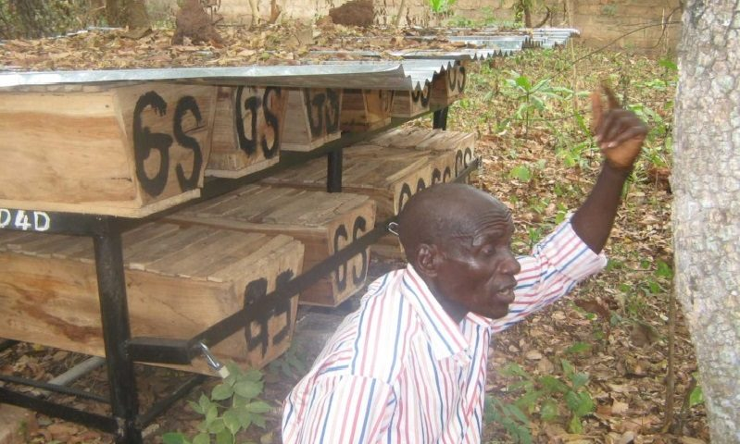

BEEKEEPING: An Effective Means To Eradicate Poverty
Posted on October 25, 2016 by UNSDN 1
The problems of underemployment and environmental degradation have been major causes of widespread poverty in Nigeria, especially communities in the Niger Delta region. This is because the rural population, mainly farmers, have poor yield from their farmland and also have no means of tackling continuing environmental pollution. Both affect their earnings and capacity to live above poverty line.
A logical solution to underemployment is for people to engage in activities that increase their earnings and one of those activities is beekeeping. Beekeeping is the management of colonies of bees for the production of honey and other bee products. Beekeeping provides an effective opportunity for poverty eradication because it requires a very low cost to establish, as beehives and other equipment can be made locally. Also, the bees feed themselves and beekeeping activity does not disturb normal work.
Where there are beekeeping activities, other people in the community generate income from making and selling beekeeping equipment, and selling bee by-products as well as making and selling other secondary products.
Using Beekeeping to Eradicate Poverty:
Beekeeping is a vehicle to sustain the environment and improve the earning capacity of poor rural people. Honey production per hive increases steadily as apiary management improves. A working hive produces minimum of 10 litres of honey and 3 kilogrammes of beeswax per harvest in the first year; 15 litres and 4.5 kilogrammes the second year; 20 litres and 6 kilogrammes the third year and so on.
In 2004 with financial support from Bees Abroad, Poverty Alleviation for the Poor Initiative, through its Sustainable Livelihood Programme selected and trained 40 rural farmers experiencing extreme poverty and established four bee farms each with 20 hives in four communities. Each of the beekeepers received two bee hives and other beekeeping equipment. Today the story has changed for 30 of those farmers, who now earn more income from their own bee farm (with 50 to 170 working hives).
Among the 30 farmers is Mr. Ikuru Godspower, an indigenous person from the Effurun Otor community. He owns 170 working bee hives and produces an average of 3,400 litres of honey and 1,020 kilograms of beeswax annually. With his wealth of experience, Mr. Ikuru also earns additional income by providing services to young beekeepers around his community.
Crop farmers and skilled people in their communities also increased their earnings through the production and sale of beekeeping equipment. Entrepreneurs earn additional income through the production of bee by-products, e.g. candles, shoe polish, body creams and ointments and propolis (used to make mild anesthetics for toothaches, sore throats, wounds and internal infections). These products are sold to provide more income for farmers.
Other crop farmers also benefit from bee pollination, as many crops are improved if bees are kept nearby, as larger and more profitable fruits can be grown. When beekeepers plant trees that provide a source of nectar for bees, they also help to prevent soil erosion and landslides. Keeping bees also encourages people to value and preserve the forest.
RECOMMENDATIONS:
The enormous benefits gained from beekeeping are largely unexplored in Nigeria compared with Kenya, Cameroon and in Asian countries. Rather than using scarce resources to import bee by-products, Nigerians should exploit the local beekeeping resources nature has provided to sustain the environment, and at same time resolve rising unemployment and poverty in the country.
There is urgent need to raise awareness about the importance of honey bees as pollinators and as an income generator in Nigeria. People should be encouraged to undertake beekeeping training so that more poor people can generate an income and contribute to sustainable rural development.

