**Food Security & Community Banking – Manyenje/Mwandika**

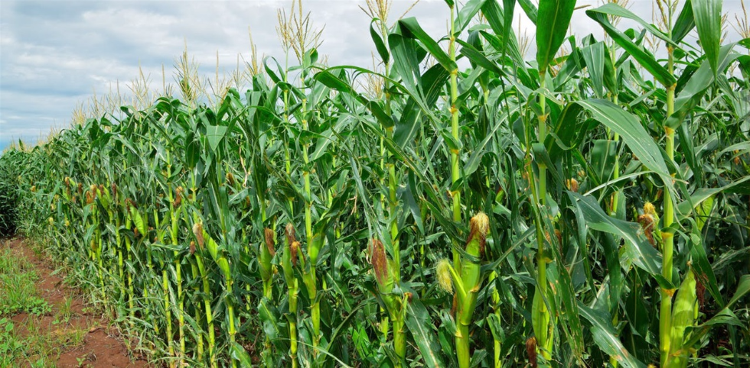

**Farmers Group in Blantyre Rural – Mpemba & Mwandika Areas – Manyenje Village – T/A Somba**

**Food Security & Community Banking**

**SIPACIO – Malawi**

1. **The Project’s Main Lines**

|  |  |  |
| --- | --- | --- |
| **1** | **Name of the Project** | Farmers Groups in Blantyre Rural for Food Security & Community Banking |
| **2** | **Organization Physical Address and Extra information** | SIPACIO - Malawi  Physical address: General Vision & Screen Printers Building, Floor No. 3 Rooms No. 12 & 16. Along Zalewa Road, Chilimba – Blantyre, Malawi  Postal address P.O. Box 1049, Blantyre - Malawi  Phone number (Executive Director) +265 999635912 / +265999250125  E-mail: [queen.maneya@gmail.com](mailto:queen.maneya@gmail.com)  Phone numbers (Board Chairman) +245 96 6368545  Phone Number: (Programs Manager) +245 95 5279117  E-mail: [Tembo.Pilirani@Sipacio.org](mailto:Tembo.Pilirani@Sipacio.org), [pilirani77@gmail.com](mailto:pilirani77@gmail.com) |
| **3** | **Partners in Development** | Blantyre District Commissioner  Ministry of Agriculture  Ministry of Education  Ministry of Health |
| **4** | **Geographical Operation Area** | 3 Group Village Headmen in Blantyre District TA Somba |
| **5** | **Contact Person** | QUEEN MANEYA |
| **6** | **E-Mail Address** | [Queen.maneya@gmail.com](mailto:Queen.maneya@gmail.com) |
| **7** | **Project Manager** | PHILLIP GEORGE CHIMTENGO |
| **8** | **E-mail** | [Phillipgc1411@gmail.com](mailto:Phillipgc1411@gmail.com) |
| **9** | **The Idea of the Project** | The project focuses on empowering Small-Scale Farmers in Blantyre Rural economically by raising the value of their products through value addition, organised marketing and creation of groups for Village Banking. The farmers will start to participate in organized group life, where they build their production capacities through: model fields for their farming practices; field checks by the Project Farming Instructors, Lead Farmers and Group Management Committee; the introduction of Community Banking Systems; Technical Innovations; Business Skills and the exchange of collectively gained experiences. |
| **10** | **The Current Challenge & the Solution** | Currently, the Small Scale Farmers in Mpemba and Mwandika, Manyenje Village T/A Nsomba, Blantyre Rural District are practicing monoculture type of farming along Mudi River in the area. They have low and poor quality yield yearly with no markets to sell their produce which make them poorer than before. Some of these farmers are women (widows) who lost their husbands to different reasons like diseases and natural death. Instead of them to be un-productive and lose the utilization of the natural resources (Mudi River and the land given), CIPACIO – Malawi will provide them with value addition to their farming activities, identifying markets for them and it will introduce Community Banking Groups to create a saving culture in them and train them in Marketing Skills and Financial Skills with the aim of changing their mind-set to consider sustainable development in their different communities. |
| **11** | **The People at the Project** | The project reaches to 351 farmers from 3 Group Village Headmen in T/A Somba in Blantyre District. There is 1 Project Coordinator at the project who is responsible for coordination of all activities in the project; 1 Office Manager who is responsible for organizing the documentation of the project; 2 Farming Instructors who will be working in organizing the farmers and carrying out training and campaigns on different issues regarding Farming and Community Banking. |
| **12** | **The History and Timeline of the Project** | The Farming Groups and the Community Banking is the first project to be implemented by SIPACIO – Malawi as part of its objective as stated in its Concept Note. The project will carry out its activities in the newly opened Farming Groups and Community Banking operation area in T/A Somba, which will be focusing on adding value to their farming activities and Community Banking by introducing Marketing Techniques and Financial Skills in an organized manner.  The project, has 11 Farmer Groups and 9 Community Banking Groups, targeting vulnerable groups especially women who are on training on how to manage the groups and create the saving culture as well as improving the living standard. |

1. **The Condition in the Project**

The Project, Farmer Groups and Community Banking in Blantyre will be based in capacity building of the small-scale farmers in key areas like the growing of Vegetables, Maize, Groundnuts, Cassava, Sweet Potatoes and organised marketing of the mentioned products. Not only that, but also equipping them with knowledge in Financial Skills and carrying out events and actions in the communities to make sure that the farmers have changed their mind-set and they are able to resolve their own problems. The main reasons for carrying out these activities are to; maintain resilience in the community, improving the productive situation of the farmers, and the economic situation through best practices marketing of their agricultural products.

1. **The Two Year Project Plan**

The 2-year program focuses on establishing Farmers Group and Community Banking to increase the value of the farmers’ products and their financial skills. During 2019-2020, the project will be in the First and Second Semester of the implementation period. The project will start with Project Introduction to the Community Leaders, establishment of the community groups, conduct trainings of new farming techniques/Knowledge Skills, establishment of modern demonstration gardens, election of Lead Farmers, group’s meetings and connecting the farmers to the market. The project will continue to promote additional production by continuing the intercropping systems to reduce the dependency on monoculture.

Furthermore, the project on the area of community banking will also establish the Community Banking Groups, where vulnerable women will be trained on the importance of Saving culture, how to elaborate business plans so that they are able to support their families. The 9 Community Banking Groups members will be trained in the financial skills, credit management, how to make a family budget, market research and linkage.

Through its activities, the project will directly reach out to 351 farmers who are organized in productive groups of 20 members in each productive group. In total, there are 11 Farmer Groups and 9 Community Banking Groups (productive groups). In each group, there are be a management committee, which will be composed of five members known as Lead Farmers who will be the driving force for the Productive Groups and the Community Banking Groups.

**MAIN ACTIVITIES DURING THE TWO YEAR PROJECT:**

**1. Training of the Project Team in Community Development Skills**

The project will carry out different training sessions for the project team in order to equip them with the capacities in community development activities as well as how to create and organize the farming groups and community banking groups.

**2. Training the Small Scale Farmers in Crop Production (Vegetables, Maize, Groundnuts,**

**Cassava and Sweet Potatoes)**

The farming instructors for the two years will train the farmers in different areas of crop production such as: Best practices of crop production, which include, respecting the agricultural calendar, weeding, intercropping, crop rotation, green house cropping systems, production of the compost manure; identification of pests and diseases and their treatment and prevention; post-harvest treatment of vegetables, ground nuts, maize, cassava and sweet potatoes; methods to reduce post-harvest loss. Also the farming instructors will train the small scale farmers in usage of the Compost Bin

**3. Training of Lead Farmers and Community Banking Management Committees**

The project will train the Lead farmers and the Community Banking management committees to secure the operation of the community banking groups and farming groups. The training will include information about leadership skills, financial and economic skills, new framing technological skills and promote income generation and saving culture.

**4. Action and Back to School campaign**

The project will carry out specialized campaigns on sensitizing the youths and vulnerable population who dropped out from school due to different reasons, to go back to school and participate actively in the development of their communities.

**5. Common events and actions in Nutrition, Hygiene, Gender Equality, Reproductive Health**

**and HIV/Aids**

The project instructors, Lead farmers and management committees will carry out activities for both men and women/the youths about gender equality, encouraging them to be involved in management activities. The project will carry out training sessions in nutrition, hygiene, reproductive health and HIV/Aids.

**6. Establishment of the Demonstrations Fields and Community Banking**

**Groups**

The project will facilitate the establishment of the demonstration fields, for both agricultural and horticultural crops as well as Community Banking Groups composed of the Women Chiefs and help in linking the farmers to different markets and establishment of Commercial Cold Storages.

**7. Training of the Community Banking Management Committees in different**

**Knowledge skills and capacity building in Credit Management, Risk Management and**

**Marketing**

The Community banking management committees will receive special training on how to manage the credit risks and uncertainties and market research for the success of the project.

**8. Community open days and Talk-shows on the benefits of the Community**

**Banking systems**

The project instructors will assist in organizing the Open days, talk shows and Agricultural Fairs to encourage each other on the benefits of the project and their families

1. **Project’s expected results**

|  |  |  |
| --- | --- | --- |
| **No.** | **Description of the activities** | **Project goals** |
| **1** | The project team received training in community development skills | 8[1] |
| **2** | The Small Scale Farmers are trained in crop production (Vegetables, Maize, Groundnuts, Cassava and Sweet Potatoes) | 40[2] |
| **3** | Training of Lead Farmers and Community Banking management committees | 80[3] |
| **4** | Action and Back to School campaign | 4[4] |
| **5** | Introduction of Early Childhood Education Centres (Preschools) | 35[5] |
| **5** | Common events and actions in nutrition, hygiene, gender equality, reproductive health and HIV/Aids | 16[6] |
| **6** | Establishment of the Demonstrations Fields | 40[7] |
| **7** | Training of the Community banking management committees in different knowledge skills and capacity building in credit management, risk management and marketing | 40[8] |
| **8** | Community open days and Talk-shows on the benefits of the Community banking systems | 4[9] |
| **9** | Number of students transiting to another class increases by 25% due to the existence of solar energy lumps | 25% |
| **10** | Improving communication systems and business connection of the farmers with their clients due to the solar energy lumps, which will enable them to charge their phones all the time. | 350 phones charge weekly |

1. **The effects of the project**
2. The project team will acquire the knowledge and skills on community development and be able to carry out better implementation of different activities in the operational area.
3. The small scale farmers will start to grow different crops and use different systems such as intercropping, green house, crop rotation and hence restoration of the soil fertility which will result in bumper harvest and sufficient food for the year round per family, hence food security.
4. The Lead farmers and the management committees will be able to carry out their jobs as leaders and hence enforcement on the implementation
5. The number of School Drop outs will be reduced by 15%. Girls and boys who dropped out from school will change their mind-sets and make decisions to go back to school after the sensitization campaigns.
6. The information and events about nutrition, hygiene, Gender and others will enforce the participation of all people in the targeted community and project.
7. The demonstration fields will enable the farmers to learn new techniques and ways of doing farming, both Horticulture and Agriculture, thus improving their yields.
8. The beneficiaries for the Community Banking System will acquire knowledge, capability and ability to develop different micro-projects in their groups and the income from the projects will help to improve the living standards of the community members
9. The community members will be able to show-case their products, attract new customers, create community relations and Social Community Development.
10. The beneficiaries will have access to new markets to sale their products
11. 351 farmers and vulnerable population will have access to Green Houses effect training for Continuous production
12. Will yield to more passing and brilliant students since they will have enough light for their studies.
13. Improve in communication systems amongst the farmers and the clients
14. **Budget in main figures of Farmers Group in Blantyre for**

**Food Security & Community Banking**.

|  |  |  |
| --- | --- | --- |
| **Exchange Rate: 1 USD =** | | **Budget Figures**  **in USD** |
| **Income** | |  |
| 1 | **Granted Partnerships** | **19,987.78** |
| 2 | **Other** | **11,007** |
|  | **Total Income In USD** | **30,994.78** |
| **Expenses** | |  |
| 1 | **Human Resources**  *Expenses for program staff, supporting staff, including volunteers. Capacity building of staff.* | 5,905- |
| 2 | **General Operation of the Project**  *Building expenses, vehicles and transport,*  *Communication, information, insurance.* | 5,102- |
| 3 | **Programme Expenses**  *Training, Community Banking start-up expenses, travels and excursion as part of program, meetings, materials, equipment, manuals, transport, monitoring and evaluation.* | 17,114.98- |
| 4 | **Administration and Audit**  *Audit expenses, staff & administration expenses for*  *Accounts Evaluations.* | 2,872.8- |
|  | **Total Expenses in USD** | **30,994.78-** |

1. Team will be trained on every 3 months
2. The Project will carry out 2 trainings every year
3. The project will train 40 mgt Committees of which 20 are for farming and 20 for CB
4. The project will conduct 2 BTS Campaign very year
5. One Pre-School in every GVH.
6. There will be 2 actions for each activity for a year and then in two years
7. There will be 40 fields for Agricultural crops and 40 for horticulture production
8. There will be 40 committees trained in different skills
9. There will be 2 open days in each year and the groups will combine in their organising system