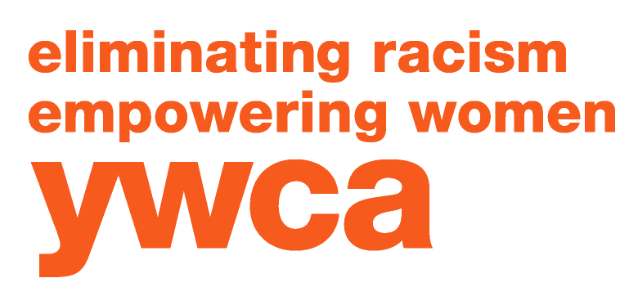
YWCA of Boulder County T: 303-443-0419
2222 14th Street F: 303-443-5098
Boulder, CO 80302 www.ywcaboulder.org

You, Women, Children, All of us

YWCA of Boulder County Children’s Alley

Children’s Alley – Boulder County’s only temporary, drop-in childcare center. The program provides families with a convenient childcare option when there is a sudden or short-term need for childcare.

The program serves children ages six weeks to 12 years old and offers extended hours including evenings and Saturdays.

The center served nearly 800 children last year through 8,000 child visits.

All families are welcome and fees are based on a sliding scale.

Voted #1 Childcare Center in the Boulder County Gold Awards for three years in a row.

Reasons for using Children’s Alley: 67.7% of the parents used Children’s Alley to maintain employment and to attend job interviews. 7.4% used our services to attend classes and job-readiness trainings. 19.5% of the 43,491 visits to Children’s Alley this year were to de-stress from demanding care-giving duties, avoiding potentially abusive or neglectful situations. 5% of the parents used our services to attend medical, counseling, and legal appointments.

All children receive quality childcare and at-risk children are enrolled in school readiness programs. Children’s Alley offers safe care and enjoyable, age-appropriate activities for children, including music, art, cooking and science projects, language development, and time on the Children’s Alley playground. We serve three hot meals a day, three snacks each day and have a cook on duty who prepares almost all the food. In some instances, the meal we provide is the best food the children will get that day.

