RUFIT Human Stories from The Field
(Note that for purposes of protection we have not used real names)
- Mary landed in the hands of an irresponsible husband who abandoned her.
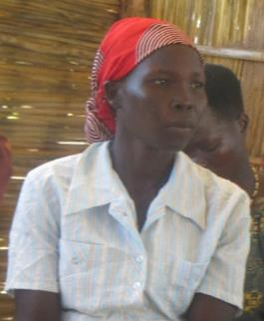
Mary Muja joined the group this year. She ran to Palorinya from South Sudan with her mother (her father is dead) and was married in the camp. Her husband is a drunkard and takes no responsibility. Her mother took her to her home to deliver the baby. She was finding it difficult to care for the child and her situation and considered leaving the child with her drunkard husband who had abandoned her. She found WASW which helped her and gave her guidance and she has begun changing her life. The women sit together and do other activities and share and build each other up. She now feels she has courage and can take care of the child. She is presently learning tailoring and how to use a machine and looks forward to becoming self-sufficient.

- Jane Kuyang got married when she was 14 years old. She is now a mother

Jane Kuyang came to the camp with her brother’s wife and not her parents. She was 14 and wanted to go to school but there was no money for this. So she decided to get married (at 14) and when she was pregnant her husband left her alone to return to school in Arua so she stayed with her husband’s brother. At the time of delivery, she returned home but the child was quite sick and the husband didn’t take any responsibility. She went to her parent’s home but they refused to help her and the child. She is back in the husband’s home and the child is still sick. She needs money to help pay for medications. She is now 18 and registered for school. The chairperson and group have helped her with guidance and she has changed, has hope and her child’s health has improved.

- Emma (Not real Name) had to be engaged in sex business to survive
Survival Sex—15-year-old Emma said, “I go to the night club because I am a talented dancer and singer. I attract visitors to the club and the owner makes money. I look after six children. They demand to eat fish, eggs, and pasted foods. I work to meet these demands. It is hard when I am forced to dance all through the night even when I’m tired. There is always fighting. The other girls are jealous of me. Sometimes the boss does not pay me.” Emma’s neighbour adds: “This lodge business is a big problem. Men are using them to defile young girls.” (UNHCR Moyo February 2019)

- Numerous cases of Violence against women are also reported
Domestic Violence—A man beat his wife unconscious then fled to South Sudan fearing he had killed her. On 3 April he returned to Palorinya after learning that she did not die. The case had been reported to the police; he was to face the law. However, the wife pleaded with the village leaders not to hand him over because he had asked for her forgiveness. Cases of alcohol induced-domestic violence are common. Women tend to pardon their spouses making it a challenge to bring perpetrators to book. (UNHCR Moyo April 2019)

- Rose Kojijo at their shared sewing machine. Funds raised here have helped her educate their children.
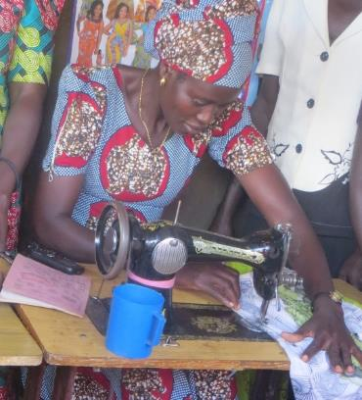
Rose Kojijo is in a polygamous marriage. Her co-wife went mad and Rose had to take her children as well as her own. She is presently caring for 11 children and has no-one to help her. She stopped the children going to school because the teachers asked for money for them. One day her sister saw the children at home and asked why and counselled Rose. Her sister encouraged Rose to join WASW. She joined the Tailoring training and she is one of the eight people who have hired two machines and are working together as a group. The children are now at school because of the advice and support she has received and she said she won’t give up.

- Shared machines lower the production narrow profit margin of the ladies
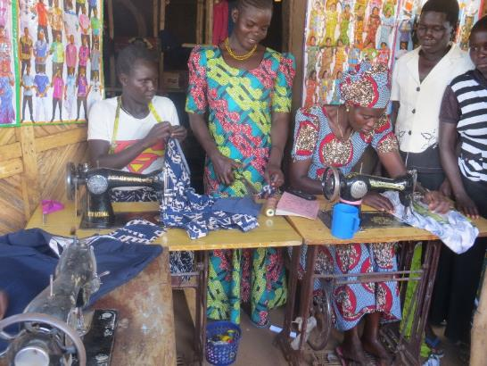
Whilst visiting the groups the women showed us sewing machines they are hiring to make clothes at this time. Unfortunately, they can only hire 1 machine between 4 women, which results in lower production levels than if they had 1 machine between 2. Also, if they hired any more that would eat further into their already meagre profits. They have a number of schools already requesting uniforms whose orders they are unable to fulfil due to lack of machines and materials. In addition, they have opportunities to make cardigans for schools if they had the necessary weaving machines. These women also need two overlocking machines for the nine sewing machines being requested. This would greatly improve the quality of their work for better markets and profit. Nevertheless, the women were very proud to show how they were using the machines and some of the clothes they had already produced.

Stories from UNHCR Reports
- STORIES PUBLISHED BY UNHCR; MOYO OFFICE IN REPORT “A Festering Protection Crisis; April 2019”
Arson—Marco burnt his wife’s house with all the belongings inside after picking up a small quarrel while under influence of alcohol. 35-year-old Lois, a mother of two has a severe chronic illness. Her husband had threatened that if she did not leave he would burn all the houses on the compound. When her brother intervened, Marco turned on him and beat him until neighbours came to his rescue. The husband then pulled out a Panga and threatened to cut anyone who got involved. He later told the Police that he did not burn the house intentionally. The village leader said he took all his belongings out before burning the house, and that was not his first time to punish Lois. The police released Marco from custody because, they said, he has TB and cannot share the cell, putting others’ health at risk. (UNHCR Moyo April 2019)

Suicide A 34-year-old mother of nine killed herself leaving the community in shock. She was a productive member of a farmers’ group and had struggled with alcohol addiction. Her husband works in a neighbouring District to support the family. Their five-year-old son said he woke his mother up to give him food. She gave the children UGX 1,000 to buy pancakes. When the boy returned, the mother chased him away and locked the door. He said he looked through the window and saw her drink from a bottle of pesticide which was placed under the grass thatch. She was later found dead. (UNHCR Moyo April 2019)

Suicide—A 34-year-old mother of nine killed herself leaving the community in shock. She was a productive member of a farmers’ group and had struggled with alcohol addiction. Her husband works in a neighbouring District to support the family. Their five-year-old son said he woke his mother up to give him food. She gave the children UGX 1,000 to buy pancakes. When the boy returned, the mother chased him away and locked the door. He said he looked through the window and saw her drink from a bottle of pesticide which was placed under the grass thatch. She was later found dead. (UNHCR Moyo April 2019)

Domestic Violence—37-year-old Mary fled South Sudan with her five children. In Palorinya she began a relationship with another man and is three months pregnant by him. The man has become a perpetual drunkard and battered Mary several times. When she reported him to local leaders, he attempted to kill her using a Panga. He threatened he would hire a gun and finish her up. This time she went to the police. He was taken into custody while attempts were made to reconcile the two. As a result, the husband was released. Immediately he got back home, he burnt down the hut with all the belongings. He ran away and has not been seen again. Mary and the children were moved to a safe house in another settlement. (April 2019)

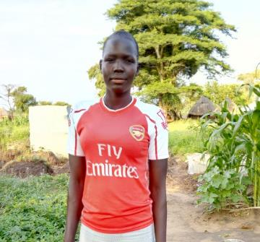

Letters of Appreciation from Beneficiaries

Lilian Poni is a 14-years of age
Lilian is a teen mother of one child. The father of the baby abandoned her before she gave birth. Her parents have also rejected her. At this point she attempted suicide. Her neighbour helped her out of her dilemma and introduced her to our program. Now she is learning tailoring and attending the group, but would be happier back in school
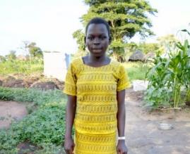
Charity Munuku; 19 years of age.
Charity’s mother was divorced and she was brought up by her step- mother. She was made to take care of her step mother’s children and could not go to school. She eventually got married and produced a child at the age of 15. Currently she has completed the tailoring course with us and needs some start up to concentrate on her trade.

