Project Proposal.

Name of Organization; Lema Plan International.

1.Name of Project and location
A project proposal for school building planning and construction of the Future Star Academy at Imo state, in Nigeria.
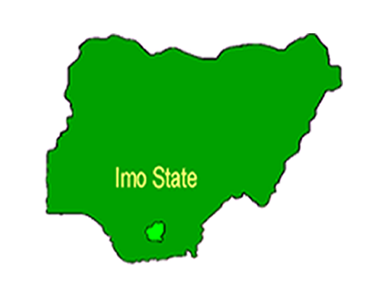

2.Background and Introduction.
Lema Plan International is an association which was established on 26 September 2018, our headquarter is in Le Locle, Switzerland and our others office are in Lome, Togo and Nigeria.
Our mission is to ensure all children mostly in developing countries have access to quality education. We support them with school materials and offer short training courses such as computer. We protect and defend children. We offer scholarship to vulnerable children. We renovate and constructs schools and children's playgrounds. We promote children rights and ensure that teachers are well trained and equipped in developing countries.
We rely on contribution from members of the association, private donors and the government, our main focus is on giving our children the best education. We believe education is the right for every child.
The Future Star Academy is nursery and primary school with approximately 200 students. Imo state is a deprived rural community in Nigeria, it lacks enough and affordable school for the majority vulnerable population. Future star is private school which was built with the aim of helping students not to walk long distance about 5 kilometers per day to the community school established by the state.
In January 11,2019 our team visited the Future Star Academy at Imo State in Nigeria for charity donation. We donated school materials and offered scholarship to five students of Future Star Academy. We were deeply touched to see students learning at a very poor environment. We all know negative environment adversely affect children's mental state and performance.
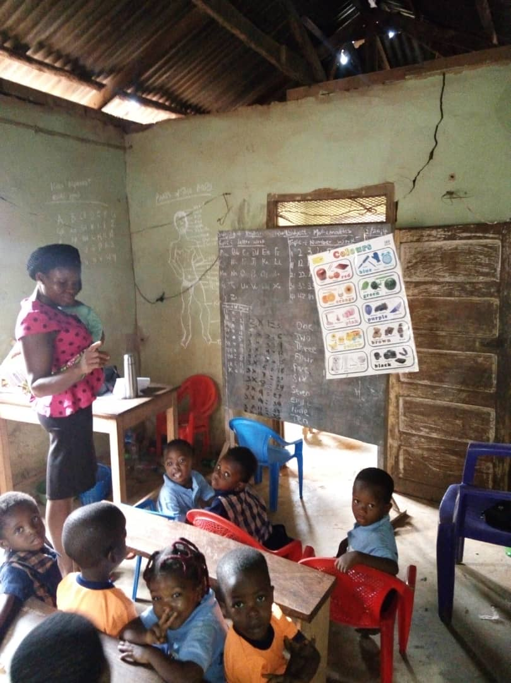
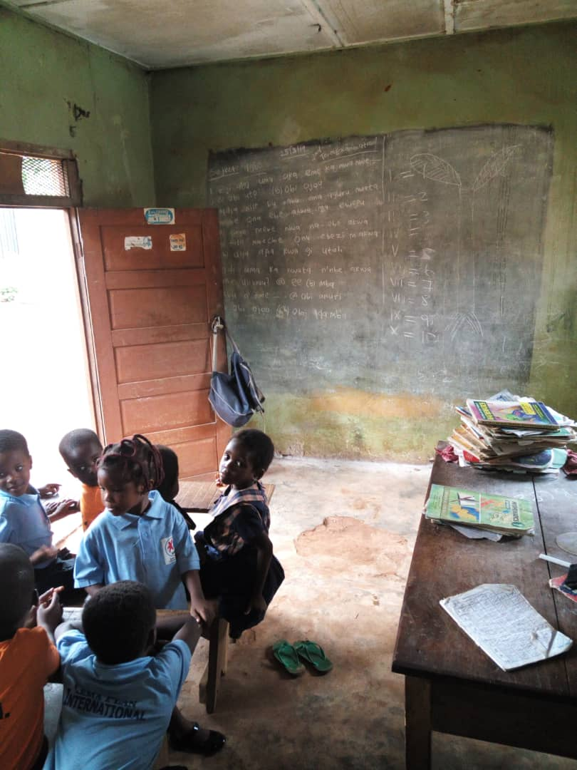

3. Goal/Objective
Our third priority is to create a healthy lifestyle, by installing a better playground facility. We envision better playground equipment with climbers, slides, connecting walkways and other features that will meet the needs of many students.

3.Problems of the Project site
The Future Star Academy is facing the following challenges.
- Inadequate classroom resources, such desks and tables.
- Inadequate classrooms.
- Inadequate toilets.
- Lack of library.

4.Expected outcomes of the project.
- Adequate classrooms and classroom resources.
- School offices and staff rooms.
- A library with adequate resources for both students and teachers.
- More toilets and sewage disposal.
- Improved children's playground.
- Over 200 children will be enrolled at the school.
- Future star academy will become a public school for the benefit of the community

5.Project beneficiaries.
The direct beneficiaries of this project will be over 400 children of Imo state. They are basically vulnerable group of deprived children including the disabled and the less privileged parents.
More employment opportunities to the Imo state community during and after the project.

6.Activities
The project supports to construct two storage building with3 rooms in each floor. The project will be carried out in different steps as mentioned below.

Action Plan.
- Coordinating with stakeholders
- Survey with an engineer and develop a design to construct
- Recruit skilled manpower and labor
- Training to manpower
- Construction
- Monitoring and Evaluation
- Develop a project report
- Handover to the community
- Follow up

Step-1 Coordination with stakeholders
Lema plan international Team in Nigeria will be in charge of the project. It will coordinate with the future star academy management committee, local people and Imo state education office. Coordination will be done from the beginning to the end of the project.

Step-2 Survey with an engineer and develop a plan for the construction
Lema plan International Team in Nigeria will recruit an engineer for the survey and survey of the school building. Cost estimation of the project is attached with the proposal.

Step-3 Recruit skilled manpower and volunteers
As soon as lema plan international receives grants, we will recruit local youth and skilled manpower through construction employment agencies in Nigeria. Special priority will be given to the trained people of Imo state so as to provide them more employment opportunities.

Step-4 Orientation training to local youth and skilled workers.
Lema plan international will arrange a day to train all volunteers and skilled workers, both theory and practical course construction training will be provided. The short training course contents will be as follows;
- Volunteerism and volunteer’s role in disaster management
- Team work and communication
- First aid, risk and hazard while working in site
- Job description
- Technical skills-how to use tools

Step-5 Procure materials
Procurement unit will make a list of material and procure all needed materials from the local market. We will ensure they purchase quality materials at an affordable price. Procured material will be transferred to the site.

Step-6 Construction.
The construction will immediately begin after delivering materials to project site. Construction will be on several phases as follows;
- Stage 1- Foundation to DPC
- Stage 2- DPC to levelling
- Stage 3- Deckling slab
- Stage 4 Deck to roof
- Stage 5 -Roofing
- Plastering and painting

Step- 7 Monitoring and Evaluation.
Lema Plan has 10 full time staffs in Nigeria and 5 volunteers, who continuously working for social development. They are well skilled and competent on the implementation of social projects. They will be full responsible for recruitment, supervision, transportation of materials and workers and keeping records of worker’s attendance and performance. An engineer will visit the project site at the completion of each phase.

Step-9 Prepare and submit the report
As soon as the construction is complete, Lema plan international will develop a report with its output result and submit it to the partner organization within a month.

Step-10 Follow up and support through Lema plan international development projects.
Lema plan international will continue supporting the future star academy by supplying educational materials and organizing short training courses. Students will be motivated through sports competition club programs. We will provide training programs and teaching materials to teachers. Other health, educational and extracurricular activities will be carried out for the betterment of the students.

7.Output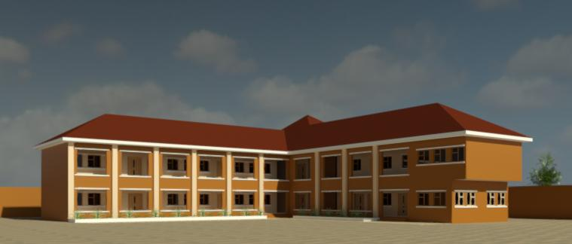

Timeline
Tentative timeline of the project
 | 2019 |  |  |  | 2020-2021
Activities | Dec | Jan | Feb | March | Jan | Feb-Nov | Dec
Expected grant Notification
Communication with stockholders
Procure the materials
Recruit manpower
Training manpower
Construction
Monitoring and Evaluation
Handover to the community
Report Writing and Submission

Estimated budget for the project

Preliminary Costs
 | Nigeria Naira | UDS
Clearing of site | 40,000 | 110.574
Temporal shed/storage | 250,000 | 691.085
Provisional sum for security of the work/water/light | 300,000 | 829.302
Transportation of materials to the site | 100,000 | 276.434
Setting out | 200,000 | 55.2868
Total Cost | 890,000 | 2,460.26

Stage -1 Foundation to DPC
Materials | Quantity | Unit price | Amount in Naira
9’’blocks | 3300 | 160 | 528,000
Cement | 400 | 2500 | 1,000,000
¾ strips | 6 trips | 140,000 | 840,000
Sharp sand | 8 trips | 25,000 | 200,000
Reinforcement bars- 16mm | 60 length | 4,500 | 270,000
Reinforcement bars- 12mm | 108 length | 2,500 | 262,500
Reinforcement bars- 8mm | 60 length | 1,300 | 78,000
Binding Wires | 2 rolls | 8,000 | 16,000
1’x12’’x12’’woods | 120 length | 1,200 | 54,000
3 nails | 1 bag |  | 8,000
Filling sand | 15 trips | 15,000 | 225,000
Total | . | . | 3,481,500
Amount in USD | . | . | 9,624.05

Labour
Excavation | . | . | 280,000
Casting | . | . | 300,000
Block work | . | . | 280,000
Iron Work | . | . | 80,000
Carpentry work | . | . | 70,000
Foundation filling and compacting | . | . | 150,000
Logistic and Supervision | . | . | 300,000
Total | . | . | 1,460,000
Total USD | . | . | 4,035.94

Stage-2 DPC to Levelling
Materials | Quantity | Unit | Amount
9’’blocks | 7800 | 160 | 1,248,000
Cement | 320 bags | 2500 | 800,000
¾ strips | 3 trips | 140,000 | 420,000
Sharp sand | 5 trips | 25,000 | 125,000
Reinforcement bars- 16mm | 204 length | 4,500 | 918,000
Reinforcement bars- 12mm | 120 length | 2,500 | 300,000
Reinforcement bars- 8mm | 100 length | 1,300 | 130,000
Binding Wires | 4 rolls | 8,000 | 32,000
1’x12’’x12’’woods | 270 length | 1,200 | 324,000
1’x9’’x12’’ woods | 40 length | 750 | 30,000
2’x2’’x12’’ woods | 50 length | 300 | 15,000
3’’ nails | 3 bags | 8,000 | 24,000
Total | . | . | 4,366,000
Amount in USD | . | . | 12,069.1

Labour
Block work | . | . | 650,000
Concrete work | . | . | 180,000
Iron Work | . | . | 150,000
Carpentry work | . | . | 180,000
Logistic and Supervision | . | . | 300,000
Total | . | . | 1,460,000
Total USD | . | . | 4,035.94

Stage 3 Decking Slab
Materials | Quantity | Unit price | Amount in Naira
Cement | 450 bags | 2,500 | 1,125,000
¾ strips | 7 trips | 140,000 | 980,000
Sharp sand | 8 trips | 25,000 | 200,000
Reinforcement bars- 16mm | 120 length | 4,500 | 540,000
Reinforcement bars- 12mm | 650 length | 2,500 | 1,625,000
Reinforcement bars- 8mm | 100 length | 1,300 | 130,000
Binding Wires | 5 rolls | 8,000 | 40,000
1’x12’’x12’’woods | 815 length | 1,200 | 975,000
1’x9’’x12’’ woods | 20 length | 750 | 15,000
1’x6’’x12’’ woods | 150 length | 600 | 90,000
2’x2’’x12’’ woods | 320 length | 300 | 62,500
3’’ and 2’’ nails | 8 bag | 8000 | 64,000
Bamboo | 250 length | 250 | 62,500
Total | . | . | 5,945,500
Amount in USD | . | . | 16,435.4

Labour
Concrete Casing | . | . | 400,000
Iron Work | . | . | 350,000
Carpentry work | . | . | 400,000
Logistic and Supervision | . | . | 350,000
Total | . | . | 1,500,000
Total USD | . | . | 4,146.51

Stage -4 Deck to roof beam
Materials | Quantity | Unit price | Amount in Naira
9’ block | 7,800 | 160 | 1,248,000
Cement | 320 bags | 2,500 | 800,000
¾ strips | 3 trips | 140,000 | 420,000
Sharp sand | 5 trips | 25,000 | 125,000
Reinforcement bars- 16mm | 204 length | 4,500 | 918,000
Reinforcement bars- 12mm | 120 length | 2,500 | 300,000
Reinforcement bars- 8mm | 100 length | 1,300 | 130,000
Binding Wires | 4 rolls | 8,000 | 32,000
1’x12’’x12’’woods | 270 length | 1,200 | 324,000
1’x9’’x12’’ woods | 40 length | 750 | 30,000
2’x2’’x12’’ woods | 50 length | 300 | 15,000
3’ nails | 3 bags | 8000 | 24,000
Total | . | . | 4,366,000
Amount in USD | . | . | 12,069.1

Labour
Block work | . | . | 800,000
Concrete work | . | . | 250,000
Iron Work | . | . | 200,000
Carpentry work | . | . | 220,000
Logistic and Supervision | . | . | 300,000
Total | . | . | 1,770,000
Total USD | . | . | 4,892.88

Stage-9 Roofing
Materials | Quantity | Unit price | Amount in Naira
3x4x12 wall plates-Hard | 50 | 120 | 60,000
2x4x18 rafters-Hard | 250 | 900 | 225,000
2x4x12 rafter -Hard | 300 | 500 | 150,000
2x3x12 Purlin-Hard  2x3x12 Noggin-Soft | 350  400 | 350  250 | 122,500  100,000
Wood-Facial board | 40 | 1200 | 48,000
Solighum | 5 cans | 3,000 | 15,000
0.45mm aluminum footing cover METCOPO | 850 meters |  | 1,785,000
Roofing accessories | . | . | 50,000
Transportation/loading/offloading | . | . | 50,000
Total | . | . | 2,605,500
Amount in USD | . | . | 7,202.49

Labour
Carpentry work | . | . | 400,000
Installation | . | . | 250,000
Logistic and supervision | . | . | 200,000
Total | . | . | 850,000
Total USD | . | . | 234.969

Plastering
Materials | Quantity | Unit price | Amount in Naira
Sharp Sand | 10 trips | 25,000 | 250,000
Plastering Mud | 5 trips | 20,000 | 100,000
Cement | 350 bags | 25,000 | 875,000
Total | . | . | 1,225,000
Total USD | . | . | 3,386.32

Labour-Ground Floor.
 | Quantity | Unit price | Amount in Naira
External Walls both floors | 75.5 partitions | 2,500 | 188,750
Staff Room | 10.5 partitions | 2500 | 26,250
Stair Case | 6 partitions | 2,500 | 90,000
Class 1-3 | 25.5 partitions | 2,500 | 63,750
Lobby 1 and 2 | 22.5 partitions | 2,500 | 56,250
Nursery section | 23.25 partitions | 2,500 | 58,125
Crèche | 7.5 partitions | 2,500 | 18,750
Toilets | 15.5 partition | 2,500 | 38,750
Pillars both floors | 7.75 partitions | 2,500 | 19,375
Total | . | . | 5,600,000
Amount in USD | . | . | 15,480.3

Labour- Under the deck
 | Quantity | Unit price | Amount in Naira
Staff Room | 5 partitions | 4500 | 22,500
Stair Case | 2 partitions | 4,500 | 9,000
Class 1-3 | 13.5 partitions | 4,500 | 60,750
Lobby 1 and 2 | 7 partitions | 4,500 | 31,500
Nursery section | 8.25 partitions | 4,500 | 37,125
Crèche | 7.5 partitions | 4,500 | 15,750
Toilettes | 4 partition | 2,500 | 18,000
Total | . | . | 194,625
Amount in USD | . | . | 538.010

Labour-Upper roof
 | Quantity | Unit price | Amount in Naira
Directors Office | 4.5 partitions | 2,500 | 11,250
Reception | 3.75 partitions | 2500 | 9,375
General Office | 8 partitions | 2,500 | 20,000
Stair Case | 6 partitions | 2,500 | 15,000
Class 4-6 | 25.5partitions | 2,500 | 63,750
Lobby 1 and 2 | 22.5 partitions | 2,500 | 56,250
I.C.T | 11.25 partitions | 2,500 | 28,125
Library | 8 partition | 2,500 | 20,000
Toilets | 15.5 partition | 2,500 | 38,750
Logistic and Supervision | . | . | 300,000
Total | . | . | 562,500
Amount in USD | . | . | 1,554.94

Painting
Materials | Quantity | Unit Price | Amount
Emulsion Paint | 521 buckets | 22,000 | 1,142,000
Total | . | . | 1,142,000
Total USD | . | . | 3,156.88

Labour
Materials | Quantity | Unit Price | Amount
Internal and External Walls | 302 partitions | . | To be negotiated
Under the deck | 45 partition | . | To be negotiated
Total | . | . | To be negotiated
Total USD | . | . | To be negotiated

ESTIMATED TOTAL AMOUNT NEED;120,000 dollar

A Project on school
Building of the Future Star Academy

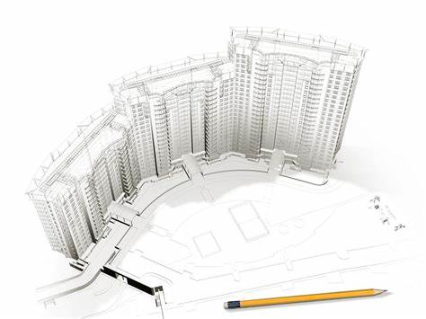

Submitted by Lema Plan International

Table of contents
Table of Contents
1.Name of Project and location 1
2.Background and Introduction. 1
3. Goal/Objective 2
3.Problems of the Project site 3
4.Expected outcomes of the project. 3
5.Project beneficiaries. 3
6.Activities 3
Action Plan. 4
Step-1 Coordination with stakeholders 4
Step-2 Survey with an engineer and develop a plan for the construction 4
Step-3 Recruit skilled manpower and volunteers 4
Step-4 Orientation training to local youth and skilled workers. 5
Step-5 Procure materials 5
Step-6 Construction. 5
Step- 7 Monitoring and Evaluation. 5
Step-9 Prepare and submit the report 6
Step-10 Follow up and support through Lema plan international development projects. 6
7.Output 7
Timeline 7
Estimated budget for the project 8
Preliminary Costs 8
Stage -1 Foundation to DPC 8
Labour 9
Stage-2 DPC to Levelling 9
Labour 10
Stage 3 Decking Slab 11
Labour 11
Stage -4 Deck to roof beam 12
Labour 12
Stage-9 Roofing 13
Labour 13
Plastering 13
Labour-Ground Floor. 14
Labour- Under the deck 14
Labour-Upper roof 15
Painting 16
Labour 16

