ACTION FOR COMMUNITY CHANGE ORGANISATION (AFCC)
PROJECT PROPOSAL

I. Project Identification

Title : Building CBCC learning shelters

Location : Chimgonela Village, T/A Masumbankhunda, Lilongwe, Malawi

Sector : Education for Children

Implementing Agency : Action for community change Organisation (CBO);

Project Duration : 6 Months.

Starting Date : As Soon as Funds are Available;

Funding Requested : $30,000.

Recipient Organization : Action for Community Change Organisation.

The Overall Objective
Of the Program : Provision of quality education foundation for the children of Chimgonela and surrounding Villages through provision of nursery school education and nutritious meals.
Contact Person : Mr. Mike Phineus | +265882334065 | Phineus.mike@gmail.com

II. Background:
AFCC is a community based organization (CBO) that is registered in Lilongwe District council. The CBO is located at Chimgonela village about 2km from Phiri la njuzi trading center and 20km out of Lilongwe City.

Objectives of the organisation
- Help protect and preserve the rights of the voiceless, women and children through early detection and prevention of rights abuses
- Carry out projects that can lead to real empowerment of citizens so that they can instead meaningfully contribute towards the country’s sustainable development
- Conduct citizen anchored studies that bring out that information that helps provide that missing link to the decisions that can lead to better attainment of Sustainable Development Goals
- Provide physical support to the needy
- Carry out sustainable activities that have a positive impact on the Community and the Environment.
- Contribute to the government and the NGOs’ efforts in eradicating poverty.
Currently activities that we are doing:
We are operating in Group Village Headman Chimgonela, Traditional Authority Masumbankhunda Lilongwe district. Our target groups are Children, women and girls, youths and elderly people. Our current programs include:-
- Children’s corner
- Community based child care (CBCC)
- Feeding program
- Home based care (HBC)
- Child protection
- Supporting elderly people
- Economic empowerment through Village Savings loans
- Capacity building
This project poses to enhance the basic education of children in the village of Chimgonela T/A Masumbankhunda and surrounding villages. Currently the center is serving hundred children from the villages around Chimgonela and the figure will arise as more children are coming to attend school at the center.
Basic education for the children is a backbone of any community therefore it is a human right since education contributes to the reduction of both absolute and relative poverty. Basic education, in particular, helps to alleviate poverty by helping poor people improve their lives. Mothers with some education raise healthier families.
Problem statement

Currently Children under the early education and feeding program are using debilitated church building as a classroom which is also not enough for the children and the condition of the building is not conducive for learning as you can see on the photo below thus why we are asking for assistance to build learning center building, a kitchen, toilets and staff room which will cater the problem that the center is facing. Currently the center has three hundred children but the number is increasing day by day as children are coming to attend the school.
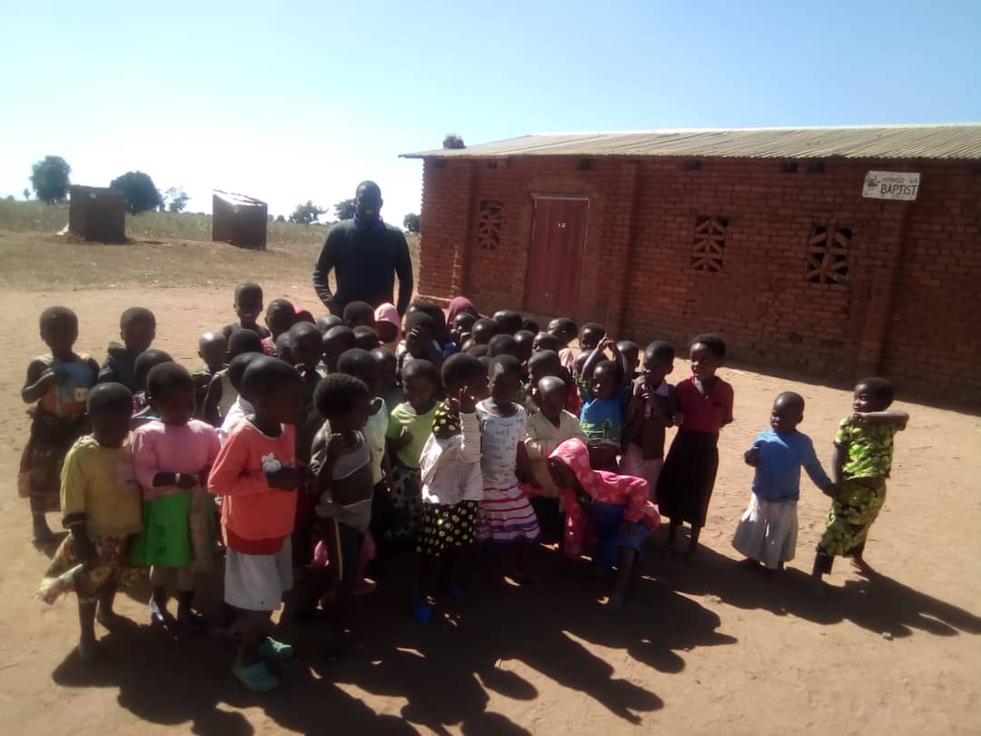
Part of children at the center

III. Justification:

The local communities elders have requested participation from us to take part the task of establishing education skeletal and the framework of basic education and buildings through the development program.
IV. Project Goals.
The objective of this project is to build two learning shelters buildings and four toilets initiating the basic education of children villages and mobilize the community. AFCC will offer education to the very poor, disadvantaged village community where there not preschool establish schools in Encourage communities to use the school as a center for education
- To build two school buildings of the two villages
- To build the basic educations of the two villages
- To equip the classrooms and office to required standards
- To employ qualified and skilled teachers to teach
- To employ a dynamic school director able to act, think and act outside the box.
- To educate each child as per his/ her unique needs
- To meet national education standards
- Demonstrate the desire to obtain and provide education.
- Demonstrated ability to unite and work together to a school
- Willingness to recruit boys and girls in equal numbers
VI. Program Implementation Strategies
The projects work plan is laid out and the establishment will depend on the finances they will set accurate the strategies and work in effective educational development in these areas and surroundings.
AFCC will build the project in phases depending on the regularity of the funds inflow from the sources of funding. It is expected and estimated that the schools will take 6 months to be completed. After the learning shelters are completed and the school activities run smoothly, plans may be made for building kitchen and store room for School feeding program. The Project Work plan or implementation plan may change as deemed necessary and the budget revised accordingly.
VII. Expected Results for Project Delivery:
The most important expected results of this project will be to get buildings of schools and started basic educations in children.The main objective of the project is to encourage sustained community investment in the project while simultaneously enhancing community education.
- Capacity building and effective training for administration and teachers
- Strengthening educational achievement and improving schools in Chimgonela Village and surrounding communities increasing educational expectations for all children.
- Fostering lifelong learning in Chimgonela Village and surrounding communities

VIII. Main activities to be conducted:
- Construction of staffroom
- Construction of learning environments i.e. shelters.
- Construction of latrines/toilets.
- Recruitment of more support staff i.e. non-teaching (volunteers)and teaching staff
- Supervision of the project running services by the board members and Donors.
- Installation of project requirements.

X. Proposed Project Costs:
The project proprietors have been able to provide the following in the establishment:
- Land to allow the project’s operation is very much available
- Provision of a number of trustees who look after the project.

IX. Local Community Participation/ Contribution:

- Provide about 20% of total required funds by Contribution;
- Elect the committee of the implementing Organization which in turn appoints the management staff;
- Generally supervise the project and have the authority to recommend change and reform.

XI. Monitoring and Evaluation:

A Progress indicator tools will be used to monitor and evaluate the project on regular basis.
Donor and partner organizations have the right to monitor and supervise the project to assess performance and progress.
Key Qualifications and Experience for monitoring and Evaluation

Dumisani .D Chirwa
Dumisani D. Chirwa who is project monitoring and Evaluation officer he will be the overall in charge of the project responsible for monitoring and evaluation the project he has vast experience in construction field over 25 years working in different institution naming a few Has worked for a Contractor, Consultants, a Donor and the Malawi Government, Working career began in 1988 in Zambia where I worked for a Contractor and then for a Quantity Surveying Office. In Malawi, has worked as a Manager of the Christian Service Committee’s Construction Department and then as Scheme Manager of the Government’s Village Housing Scheme. Also worked as a Maintenance Officer of the then Infrastructure Management Unit (IMU) of the Department for International Development (DFID) Malawi Office. After DFID, worked for the Malawi Government’s Ministry of Education, Science & Technology (MOEST’s) Infrastructure Management Unit (EIMU).Worked as a Programme Manager and Quantity Surveyor. Duties included Contract Management, Budgeting, and Co-ordination with stakeholders, and Liaison with Donors. Has gained considerable work experience and understanding of contract and project management and performance from the Contractor’s, Consultant’s and Client’s perspective. Currently working as Technical Advisor-Construction for GIZ Malawi’s NAPE (Nutrition and Access to Primary Education) programme. Duties include Project Planning and Management. He is a holder of MSc. Degree in Construction from Northumbria University, New Castle, U.K. (2011) from that he is also a holder of Bachelor’s Degree in Building Science from Copperbelt University, Kitwe, Zambia. (1988)
Professional Membership

Surveyors Institute of Malawi – Graduate Member
Architects and Quantity Surveyors Registration Board of Malawi – Graduate Member
QUALIFICATION OF THE PERSON TO ADMINISTER FUNDS
Monika fenias profile
Monika fenias who is a PROJECT Accountant for the project. She will be the overall in charge of the project responsible for ADMINISTRARING FUNDS she has vast experience in accounting field over 23 years working in different ministries naming a few she has worked with Ministry of Education Science and technology, Ministry of Health and Population, Central government stores-treasury fund as Account assistant Currently she is working with Ministry of Agriculture in the department of extension services and her responsibilities include Budget consolidation for the department and reporting to secretary to the treasury, preparing financial statement, managing the department’s asset include warehouses offices and institutional houses, heading finance department and preparing organizational performance reports for Estates Management section and finance section. She is a holder of MSc. Degree in Business and Administration from ESAMi Business School apart from that she is also a holder of Bachelor’s Degree in Business and finance from Share Word Open University.
Contact Person:

Mr. mike Phineus Director.
Malawi Southern Africa, Lilongwe Central Region.
Likuni Street, chinsapo - chigwiri area.
Email: mikephineus32@outlook.com or Phineus.mike@gmail.com.
Tell: 00265 88 233 4065 / 885946444
Tweeter: @mike Phineus
Skype: mikephineus
Facebook: @action community change page

