BRIQUETTES A SOLUTION TO
DEFORESTATION AND POVERTY
EAST AFRICA, UGANDA - 2019

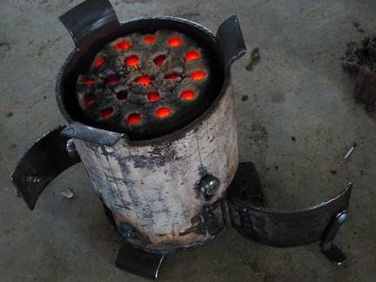
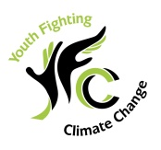
CONTACT PERSON:
LILLIAN NKWENGE
VISION BEARER
0772971267 / 0701030080
e-mail: info@yoficc.org
lilynkwenge@gmail.com
www.yoficc.org

1.0 INTRODUCTION

Youth fighting climate change (YOFICC) Organization is registered under Mutungo Lweza Municipality, Kyaddondo County, Wakiso District, in Central Uganda. The Organization’s mission is “To inspire the Youth to engage in solutions for climate change in their Communities”. The vision of the organization is “A youthful generation with equitable solutions to climate change.”

YOFICC’s goal is interact and train the different categories of women and youth in various institutions and communities in order to create a model for learning, researching and sharing ideas. These ideas will then be linked with hands-on projects that others will fight climate change as well as empower the women and youth economically and socially. YOFICC will work to have at least one meaningful project in every region of Uganda by 2020.

The impact of deforestation in Uganda has caused diverse climate challenges which have led to loss of income and thus poverty among the communities. It’s against this background that this project is initiated to address those challenges.

YOFICC has been engaged in a project to create a sustainable briquettes energy market in Uganda for women and the youth. The project encourages rural women and youth to actively participate in this value chain as a means to generate much needed income. The proposed model allows women and youth to train in briquette making, get financial literacy and environmental awareness as one of the forms of fighting climate change and poverty at the same time through sustainable agro-forestry practices.

Such can be made possible through the establishment of briquette makers’ associations. The project will be implemented in 3 districts in North-East of Uganda in the regions of Amuria, Soroti and Katawi with an objective to reach out to 5000 women and youth.
One of the outcomes of this project is to market sustainably produced briquettes for the sale and replacement of conventional charcoal in Uganda.
The production process of this conventional charcoal is at a highly inefficient rate, resulting in a ratio of 1 to 7 of wood into charcoal. This is extremely wasteful and is resulting in ever growing rates of deforestation. The YOFICC Briquettes Project aims to introduce a modern torrefaction technology to exponentially increase the efficiency of briquette production.

2.0 BACKGROUND

Briquettes for energy consists of any organic material that can be used as a fuel; including firewood, forest wastes, dung, vegetable matter and agricultural residues. Energy from briquettes accounts for 15% of global energy consumption yet in Uganda it supplies more than 90% of the country’s energy needs. Briquettes have historically been a cheap and accessible source of fuel for Uganda’s population but this is unlikely to continue as a high dependency is raising concerns for the sustainability of the resources as human populations and competing demands increase.

2.1 Demand

With only 5% of the rural population having access to electricity, more than 90% of the country’s total energy needs in Uganda come from biomass sources. Of this, wood accounts for 80%, charcoal 10% and crop residues at nearly 4%¹. The use of dung for fuel is rare, although recent implementation of a national biogas programme is seeking to utilize it more on a domestic scale.

For households specifically, the 2009-10 Household Survey conducted by the Uganda National Bureau of Statistics provides a more detailed analysis, reporting that 82% of households use firewood for cooking while 15% use charcoal. Firewood was most commonly used by rural households (86%) while charcoal is commonly used in urban areas (70%). In Kampala, 76% of the population use charcoal as their main source of fuel for cooking.

As quantities, the household consumption of firewood and wood for charcoal was estimated at 22.2 million tonnes in 2006², with small industries consuming a further 5.5 million tonnes creating a total annual biomass demand of 27.7 million tonnes nationwide. Annual biomass consumption per capita is estimated, for rural and urban areas respectively, at 680 kg and 240 kg of firewood and 4 kg and 120 kg of charcoal.

Approximately 4 million tonnes of wood (15% of the total) are consumed to meet the annual demand for charcoal, which in 2010 was estimated by different sources to be between 700,000 and 850,000 tonnes³. In Kampala alone charcoal demand was 205,852 tonnes. Used mainly in urban areas, charcoal use is estimated to increase at 6% per year, which matches the rate of urbanization.

2.2 Supply

Following a comprehensive study⁴ into the biomass resource during the 1990s, the total biomass stock (air-dry, above ground) in Uganda in 2002 was estimated to be 468 million tonnes. Of this, approximately 33% was in protected forest areas leaving the amount available for energy uses around 312 million tonnes. While predicting that Uganda can expect a total annual growth of 50 million tonnes of biomass per year, the study concludes that despite a positive growth rate in protected areas, the biomass stock on private lands (and thus available for wood fuel) will soon face a deficit.

Such a detailed study has not been carried out since; however more recent estimates support its conclusions. The FAO reported that between 1990 and 2005 Uganda lost 26% of its forests (78% in areas around Kampala), estimated now to be 24% of total land cover, and the National Environment Management Authority (NEMA) State of the Environment Uganda 2008 report predict that this deficit will lead to complete depletion of the nation’s forests by 2050. What is clear is that Uganda’s heavy dependence on biomass is severely impacting the destruction of the country’s forest cover.

While wood from trees constitutes the greatest amount of biomass stock available in Uganda and consequently the most used form of biomass by locals, agricultural residues are also utilized. Crops can produce biomass energy from agricultural residue made available from growing, harvesting and processing food crops such as cereals and roots as well as cash crops such as tea, cane sugar and coffee. Data provided by the government in the Uganda Renewable Energy Policy 2007 suggests that 1.2 million tons of agricultural residues are available each year.

Table 1: Annual production of agricultural residues. Source: Uganda Renewable Energy Policy, MEMD, 2007

Agricultural Residue | Annual Production (‘000 tons / year)
Bagasse | 590
Rice Husks | 25-30
Rice Straw | 45-55
Sunflower Hulls | 17
Cotton Seed Hulls | 50
Tobacco Dust | 2-4
Maize Cobs | 234
Coffee Husks | 160
Groundnut Shells | 63

3.0 PROJECT STATEMENT

3.1 What is a briquette?

A briquette is a block of carbonized, crushed and compressed organic waste material used as a cooking fuel. Briquettes replace the usage of conventional types of fuel such as wood charcoal and firewood, which helps to conserve trees. This helps to prevent releasing too much of CO2 into the atmosphere.

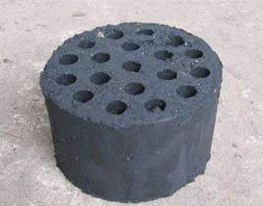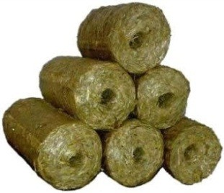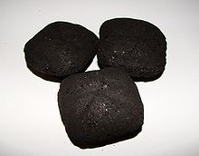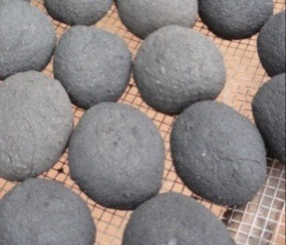

Figure 2: From left-right: honey-comb briquette (hydraulic press); non-carbonized straw briquette (piston- extruded); carbonized charcoal dust (roller press); hand-made charcoal dust briquettes

3.2 How briquettes are made
We produce briquettes from bio degradable municipal waste and agro waste. Below are the steps taken in production of briquettes;
- Waste Collection and sorting
Agricultural waste material such as maize cobs, crop stems/residues, cow dung etc are acquired from farmers at a given fee to enable them attain an extra income from material they deemed waste. Municipal organic waste such as peelings is collected from food markets, households and institutions. These are most times attained at no cost or very low cost.
- Drying
On receiving all the waste, we sort them according to the different types and dried separately so as to ease the carbonization process. Some wastes such as Maize cobs are received dry hence taken for carbonization directly. Others are received moist such as banana peelings they can be either dried under direct sunshine or using a constructed solar drier depending on weather conditions.
- Carbonization
This involves the conversion of waste into carbon or char. This is done by using either a constructed large scale carbonizer or a fabricated small scale carbonizer. However, during training, we advise participants that if they cannot afford the above carbonizers, they can adopt an open air method of carbonizing.
Comparison of carbonization methods

Carbonization Method | Yield % | Duration | Capital Intensity | Labor Intensity | Cost US$
Earth pit kilns | 10-15 | Days | Low | High | 0
Brick & steel kilns | 25-30 | hours | Medium/high | Medium | 50-200
Large-scale plants / retorts | 30-40 | Continuously | High | Low | 3,000-5,000
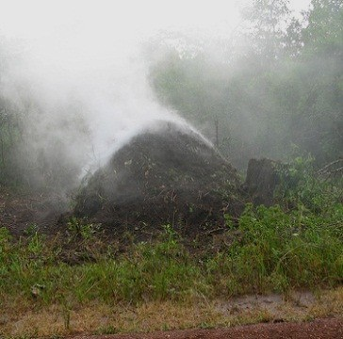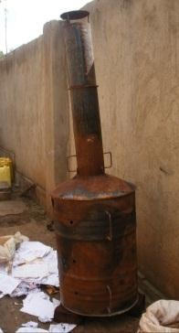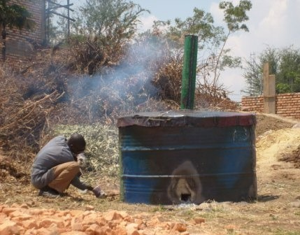

Figure 3: From left-right: traditional open air carbonization method; top-lit-down-draft (TLUD) steel kiln; ARTI steel drum retort
- Crushing
The carbon material is then crushed into ne and medium particles using either an automated crusher or a manually operated crusher. The automated can either be run by electric motor or diesel engine

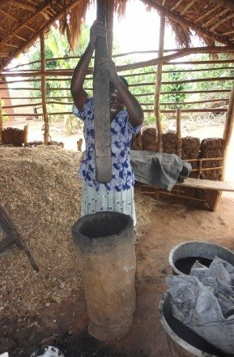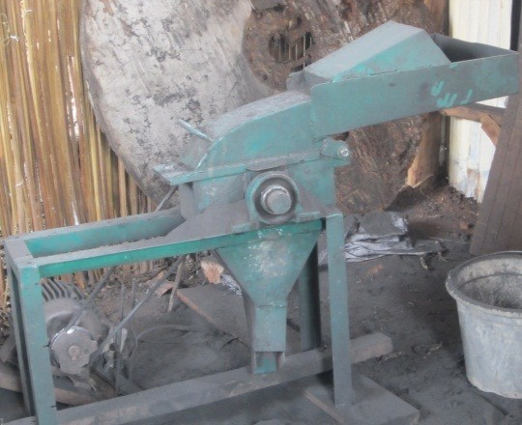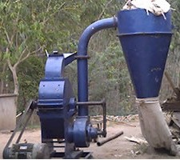
- Mixing with a binder
The crushed carbon material is then mixed with a binder to bind the fine particles together during compression stage. The various binders that can be used include; cassava our, molasses, crushed dry banana peelings and any other material with high starch content. Compression. The mixture of the fine particles and binder is compressed either with an automated extruder that uses a screw system or manual extruder that uses a piston system. These compress and mold the material into different forms of briquette which is taken for drying.
- Drying
This takes 2-3 days depending on the weather conditions. A solar drier or direct sunlight can be used to dry the briquettes.

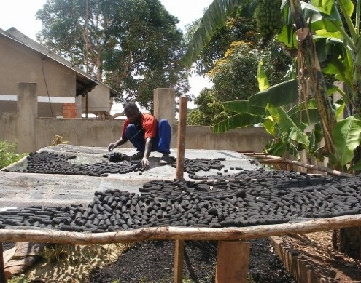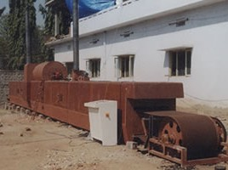

3.3 Packaging
Briquettes are then packed in paper bags for small consumers such as homesteads and in plastic crates for large consumers such as institutions.

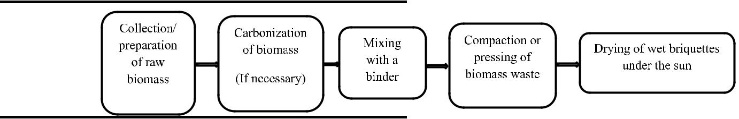

4.0 PROJECT OBJECTIVES
- Promotes environmental Conservation
- Creates jobs and improves women and youth income
- Reduced expenditure on fuel
- Improves Community Sanitation hence reducing disease outbreaks
- A complete solution to waste management challenges
- Reduces deforestation and forest degradable for fuel purposes
- Prevents Natural hazards like flood resulting from clogged channels

5.0 PROJECT ACTIVITIES

- Developing and promoting sustainable charcoal briquettes production and small scale business development in the field of renewable cooking fuels
- Raising awareness in the benefits of sustainable charcoal briquettes production and consumption
- Creating demand for sustainable, non-wood charcoal by developing well-functioning marketing mechanisms for charcoal briquette sales.
- Contributing to nearly 30 000 ton carbon emission reductions (incl. indirect)
- Creating new business opportunities and income sources for 620 rural families directly and income sources for approximately 2000 individuals indirectly.

5.1 Results

- The sustainability of the climate benefits, and in particular the up scaling potential, is interlinked with the viability of the project benefits.
- In a manufacturing environment, identifying opportunities to harness economies of scale are essential.
People buy into a brand, not necessarily into a business or business model.
- The creation and development of an attractive and sustainable brand are crucial for success in charcoal briquette manufacturing and sales.
- Building partnerships with solid, locally established businesses present multiple advantages.
- By providing credibility and grounded robustness to the project model, carefully chosen and prepared partnerships can increase the odds

5.2 Risks forecasted
- The social risk of the project is low as estimated by the management
- Stiff competition from the charcoal vendors
- Getting the right waste materials to be used in the production
- Product adaptability
- The inconsistency in production due to lack of advanced machines that produce more and better qualities
- Transportation of the product to the market places, thus producers will be taken advantage of by middlemen which will lead to low sale prices
5.3 Assumptions to achieve each objective
- Our target number is 1000 people after the training is down we estimate that these 1000 trainees will each need 5 people to help them effectively run their new innovation, from waste collection to marketing, transportation, production, and sales. This will increase the number of jobs as a replication from 1000 to 5000 jobs created. And this will be done in 3 districts in the North-East region of Uganda.

- YOFICC has developed a training program for the chain of demand for charcoal and firewood; we have created a database of most of the retailers, middlemen, and producers. A training will be tailored to the grass root first educating the producers about the environmental implications of cutting trees, but furthermore, give them briquettes as an alternative.

- Once the producers are convinced the middlemen will have no choice but to sell to the retailers what is available and the retailers will sell to the final customer. Why use this model you might ask, for Market penetration these 3 major parties need to be in the know. One, they will easily create a market for 1000 permanent jobs making it easy for them to concentrate on production while the middlemen who already have ready market push their products.

- YOFICC will engage CREEC (Centre for Research in Energy and Energy Conservation) to test our briquettes and give them a competitive advantage in the market.

6.0 JUSTIFICATION OF THE PROJECT

Carbonized briquettes can act as a replacement for charcoal for domestic and institutional cooking and heating, where they are favored for their near-smokeless use. In comparison to charcoal, they generally burn for longer and have a more consistent heat output, which is preferred by certain market segments such as restaurants, hospitals, schools, and poultry farmers.YOFICC plans to train 1,000 people Amuria, Soroti and Katawi.
A kilogram of briquettes is estimated to be between 700-1000shs; in a month YOFICC plans to produce 30 tons of briquettes with the cost at 800shs it brings it to 24million Ugandan shillings.YOFICC will train 50 trainees for the 1000 targeted women and youths in 3 districts. Each district will have 300 youth and women and 20 trainees assigned to implement the project.
We estimate at the end of the project, 1000 youth will need 5 people to work for them thus creating 5000 more jobs; the jobs will range from waste collection, marketing, transportation, budgeting and many more. The risks, in this case, will be people's adaptability towards this innovation, it hard to convince people who have been using firewood and charcoal for over 50 years to change to something they might not understand.

7.0 Pilot Study

YOFICC UGANDA has implemented a sustainable biomass out-growers project in central Uganda. One of the objectives is to create a value chain for the commercialization of renewable charcoal as a substitute for the conventional biomass fuels currently sold in the markets. Such are a leading cause of deforestation in Uganda. This Project proposal compiles the results from a pilot test aimed at studying user feedback from using sustainably produced briquettes instead of the conventional charcoal they typically use. The following are key results from the study:

- 8 households within four neighborhoods tested the briquettes for three weeks under a kitchen performance test. This follows one week baseline fuel monitoring as a means for comparison;
- 6 cooked food vendors tested the briquettes in an institutional setting for three weeks;
- At household level, it is calculated that 2.77 kg’s of charcoal is consumed on a daily basis. To match this need, it is required 2.48 kg’s of briquettes
- At the institutional level, vendors make use of 10.37 kg’s of charcoal every day to prepare food to sell. For the same purposes, they made use of 7.07 kg’s of briquettes.
- For the same energy contents, households make use of 10% less weight in fuel (briquettes compared to charcoal) while vendors reduced the weight in fuel up to 32%.
- User feedback highlights that the briquettes are easy to light; safe to use; high in heat intensity; and cook food faster compared to conventional charcoal;
- Users however also mentioned disadvantages such as a stronger smell emitted; more smoke; and a short burning time compared to conventional charcoal;
- Solutions to these problems have been identified. By increasing the temperature in the torrifaction process, it may be possible to combust more of the volatiles present in the briquettes which are responsible for the stronger smoke and smell;
- By increasing the size and density of the briquettes it will be possible to enhance burning time of the fuel and thus make it suitable for the traditional long simmering dishes.

Through this process, it is possible to produce the briquettes in a ratio of 1-2 (wood to briquette).
To assure that the project is economically viable, it was necessary to test the performance of the briquettes in a local setting. Factors such as user acceptance, cooking performance and market willingness to pay were analyzed in detail. This pilot project took place in the city of Lwera, within two different settings:

- Institutional pilot test – with cooked food vendors at municipal markets

- Household pilot test – Four peri-urban neighborhoods of Lwera

The following chapters outline the methodology used within this pilot, as well as the results obtained from the field work. This shall be followed by a short discussion and recommendations section.

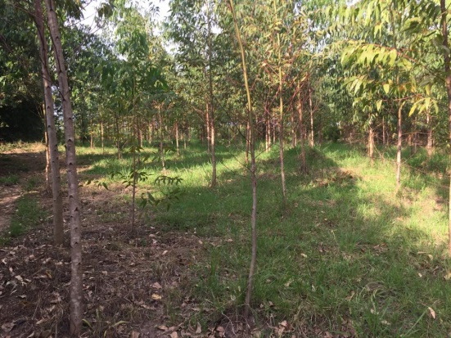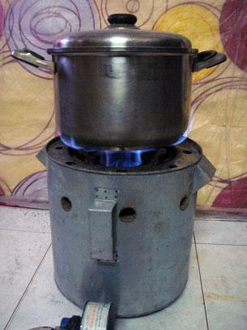

Figure 1: Kiboga Tree plantation (Left) and briquettes as end product (right

7.1 METHODOLOGY

The pilot project took place between the months of February and March 2019. The total duration of the field work was four weeks. The pilot was divided into two distinct studies:

  - Kitchen performance tests and controlled cooking tests at household level
  - Kitchen performance tests and controlled cooking tests at institutional level

Both test groups were subject to one week monitoring of their usual cooking habits with conventional charcoal. This was followed by the substitution of conventional charcoal with briquettes. Two different briquette types were introduced. A batch labelled “B” which resembles a typical briquette square form; and a batch labelled “C” which is in palletized form.

These are smaller pieces however of a more dense nature. Both batches were introduced simultaneously to all participants. Cooking practices were closely monitored during three weeks. This two-phase testing allows for fuel comparison during the data analysis stage.
Data collection was carried out by a group of four experienced surveyors, in the form of questionnaires, detailed observations and controlled experimentation (testing).
As a means to facilitate data collection, four types of questionnaires have been developed.

- Baseline fuel use survey: A means to collect information on energy practices prior to the introduction of the tested technology (Briquettes). Socio-economic information about the participants is also collected using this survey.
- Participant daily fuel use score cards: A means for participants to self-report fuel quantity used; type of meal cooked; as well as the cooking time.
- Controlled cook tests: A means to measure fuel quantity used as well as cooking time in a scientific and controlled manner. The surveyors follow through each step of the cooking process and measure all variables accordingly (weight of fuel, weight of food ingredients, time to boil, end-time, etc.)
- Briquette evaluation questionnaire: A means to collect information on user appraisal of the new technology. This questionnaire allows users to comment and recommend on desired changes.

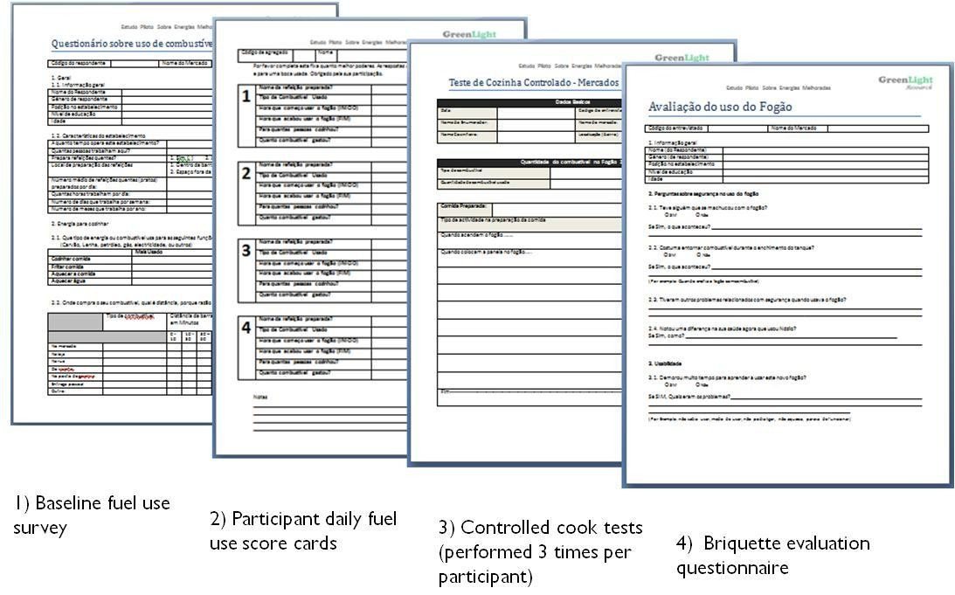

Figure 2: Different types of questionnaires administered during pilot testing phase

7.2. KITCHEN PERFORMANCE TEST METHODOLOGY

The kitchen performance test (KPT) is carried out to compare the performance of the briquettes to conventional charcoal at a natural household-level setting. The tests are normally carried out in the kitchens of users, under their normal cooking conditions.

Two sets of users have been assessed. The first were cooked food vendors at municipal markets across Kampala. Per capita these are the largest consumers of charcoal, as they cook all day to sell food. According to a recent market survey, around 90% of the vendors use charcoal to prepare warm meals. The government of Uganda under NEMA has started a new campaign to “green-up” this sector, as to improve on the environmental and health conditions of these vendors. Introducing sustainably produced briquettes is one solution which could be adopted by this sector. In total, 6 cooked food vendors participated in the pilot. Two were in Nakasero Market, another two in Zana Market and two in Nakawa Market.

The second users assessed were households. 8 families were selected to participate in the pilot and replace their conventional charcoal with briquettes for a period of 21 days. During the pilot, a team of enumerators assessed user satisfaction as well as consumption levels of this new fuel under the kitchen performance tests.
7.3 CONTROLLED COOKING TEST METHODOLOGY

The controlled cooking test (CCT) is designed to assess the performance of the improved fuel relative to the common or traditional fuel that the improved product is meant to replace. Stoves are compared as participants perform a standard cooking task that is closer to the actual cooking that local people do every day. However, the tests are designed in a way that minimizes the influence of other factors and allows for the test conditions to be reproduced.
The controlled cooking test collects the following information:

- The Specific Fuel Consumption (SFC) in grams of fuel used per KG of food cooked
- The time taken to cook the typical meal with the different fuel types

After cooking with each different fuel type, there was a brief appraisal survey administered to the cooks. This was done to record their experience with the fuels. Advantages, disadvantages and recommended modifications were highlighted by all participants.
7.4 TESTING PROCEDURES

- One week baseline fuel shadowing
  - Administration of a socio-economic and energy use questionnaire
  - Running one controlled cook test with each participant
  - Participant filled score cards - Daily self-reported fuel use
- Two week briquette usage testing
  - Running two controlled cook tests with each participant
  - Participant filled score-cards – Daily self-reported briquette usage
  - Regular visits to participants during cooking time – observation based research
  - Final fuel appraisal questionnaire – user feedback on briquettes
- Participants were encouraged to purchase the briquettes as continuation of usage
  - Market willingness to pay exercise
  - Monitoring of purchase behavior and quantities used.

8.0 RESULTS
8.1 HOUSEHOLD BASELINE FUEL RESULTS

BASELINE FUEL USAGE AND SOCIO-ECONOMIC CHARACTERISTICS OF PARTICIPANTS

As seen in table 1, eight households from four different neighborhoods participated within the pilot project. The neighborhoods chosen were:

      - Mutungo Kigo B
      - Mutungo Kigo C
      - Seguku
      - Akright estate bwebajja

Within each household, the participants were the members which are primarily engaged in the cooking process. All participants were female, of ages between 19 and 68 (average 36). Household sizes varied between 6 and 11. The average household size in the sample was 8 members. This directly corresponds to the number of people food is cooked for. Household monthly income varied between 150 USD up to 300 USD. Such was asked in intervals as seen in table 1.

With regards to cooking energy, table 2 shows that all households make use of charcoal stoves for daily cooking needs. Two of the participants have additional LPG stoves (gas). However when it was asked which stove is primarily used, all respondents mentioned charcoal. Most respondents bought their stoves at the markets; however two had them made by order. The price paid for the stoves varied between 12,000 and 125,000 shillings (3 USD – 33 USD). The average price is narrowed at 65,000/= (17 USD) for a charcoal stove. In all cases, it was a female household member whom made the decision to buy their respective stoves, as well as to make the purchase of them. When the participants were asked what advantages they associate with charcoal, the following answers were given:

- Ease of use;
- Fast cooking;
- Accessibility/availability of fuel;
- Economic.

Similarly, participants were asked of the disadvantages they associate with charcoal:

- Undesirable smoke and dirt;
- Dirties pots;
- Long time to light.

Table 3 shows baseline fuel use habits of participants. Six of the households purchase their charcoal at the nearby markets, while two buy from their neighbors. Nearly all participants purchase from a distance less than 10 minutes away. Only one participant needs to spend up to 30 minutes to buy charcoal. All participants stated that purchase location was chosen due to proximity. One also mentioned that she receives a price discount at her chosen retailer. Charcoal purchase frequency varied between daily, weekly and monthly.
Quantities bought were in their majority the 50-70 kg sacks. Three of the participants bought smaller quantities characterized by 500 g mounts or tin-can full amounts (1.5 kg). Average monthly expenditure on charcoal was at 165,000/= (43 USD), with the lowest at 95,000/= (25 USD) and the highest at 375,000/= (100 USD).When respondents were asked if at any time during the year it was most difficult to obtain charcoal. They all mentioned the rainy season, and the scarcity as well as price rise of charcoal associated during that time.

TABLE 1: HOUSEHOLD PILOT PARTICIPANT SOCIO-ECONOMIC INFORMATION

Criteria | Participant 1 (MC01) | Participant 2 (MC02) | Participant 3 (MB01) | Participant 4 (MB02) | Participant 5 (SUK01) | Participant 6 (SUK02) | Participant 7 (AEB01) | Participant 8 (AEB02)
Name | Angel Katumba | Namirembe  shalima | Namakula  Caroline  Sandra | Masiko Angella | maureen nantume | Akello jackie | faridah nakazibwe | Komugisha doreen
Neighbourhood | Mutungo Kigo C | Mutungo Kigo C | Mutungo Kigo B | Mutungo Kigo B | Seguku | Seguku | Akright estate bwebajja | Akright estate bwebajja
Gender | Female | Female | Female | Female | Female | Female | Female | Female
Age | 68 | 22 | 47 | 51 | 29 | 26 | 24 | 19
Position in household | Head of household | Daughter in Law | Wife | Wife | Daughter in Law | Wife | Daughter in Law | Daughter
Education level | 4th grade | Primary school | 6th grade | 3rd grade | 5th grade | 7th grade | Primary School | Primary School
Household size | 7 | 11 | 8 | 11 | 10 | 6 | 7 | 11
Total monthly income | 150-200 USD | 200-250 USD | 150-200 USD | 150-200 USD | 250-300 USD | 200-250 USD | 250-300 USD | 150-200 USD

TABLE 2: HOUSEHOLD PILOT BASELINE STOVE USAGE INFORMATION

Criteria | Participant 1 (MC01) | Participant 2 (MC02) | Participant 3 (MB01) | Participant 4 (MB02) | Participant 5 (SUK01) | Participant 6 (SUK02) | Participant 7 (AEB01) | Participant 8 (AEB02)
Stove type(s) owned | Charcoal stove and LPG stove | Charcoal stove | Charcoal stove | Charcoal stove | Charcoal stove | Charcoal stove | Charcoal stove and LPG stove | Charcoal stove
Which stove is mostly used | Charcoal stove | Charcoal stove | Charcoal stove | Charcoal stove | Charcoal stove | Charcoal stove | Charcoal stove | Charcoal stove
Place of purchase of  charcoal stove | Street Side | Market | Down-town | Market | Market | Market | Made by order | Made by order
Price of charcoal stove | 7$ | 2$ | 5$ | 16$ | 13$ | 8$ | 4$ | 14$
Purchase decision-  maker | Respondent | Female head | Female head | Female head | Female head | Respondent | Female head | Female head
Person who bought it | Respondent | Female head | Female head | Female head | Female head | Respondent | Female head | Female head
Advantages of charcoal stove | Ease of use and cooking time | Ease of use, cooking time and accessibility of fuel | N/A | None | Its economic | Ease of use | Easy to use, the time of cooking and lighting is fast and emits  less smoke | None
Disadvantages | Lack of alternative, smoke and  dirtiness of the fuel | Dirtiness and smoke | N/A | Smoke | N/A | Emits a lot of smoke and dirties pots | N/A | The ash, the time to light the charcoal,  the smoke and the dirtiness.

TABLE 3: HOUSEHOLD PILOT PARTICIPANT FUEL PURCHASE AND USAGE INFORMATION

Criteria | Participant 1 (MC01) | Participant 2 (MC02) | Participant 3 (MB01) | Participant 4 (MB02) | Participant 5 (SUK01) | Participant 6 (SUK02) | Participant 7 (AEB01) | Participant 8 (AEB02)
Where charcoal is  bought | At the market | At the market | At the market | From the neighbor | At the market | From the neighbor | At the market | At the market
Distance of purchase  location | Less than 10 minutes | Less than 10 minutes | Less than 10 minutes | Less than 10 minutes | Up to 30 minutes | Less than 10 minutes | Less than 10 minutes | Less than 10 minutes
Reason for chosen  location | Closest option | Closest option | Proximity | Receive a discount from  vendor | Proximity | Proximity | Proximity | Proximity
Frequency of purchase | N/A | Daily | Once a month | Once a month | Twice a month | Once a month | Once a week | Daily
Quantity bought each  time | N/A | 3 small mounts | 1 sack of 50 kg | 1 sack | 1 sack | 1 sack | 4 plastic bags full | 3-4 Small mounts
Monthly expenditure  on charcoal | N/A | 14$ | 12$ | 12$ | 18$ | 13$ | 50$ | 30$
Is there a Period of charcoal  scarcity | Yes, during the rainy season | Yes, in the beginning of the year | Yes, when it rains a lot | Yes, during the rainy season | Yes, when it floods | Yes, during rainy season | Yes, during rainy season | Yes, when it rains for long
Coping strategy | Paying more for the charcoal | Looking to buy from other  vendors which charge less | Buying only in small mounts (quantities) | Continue buying, but at higher price | N/A | Buying in small mounts (quantities) | Paying a higher price | Paying a higher price

9.0 PROJECT BUDGET

No. | Item (7 machine of each type per 333 people per district) | Description | Price of Machine(USD)
1 | Manual extruder  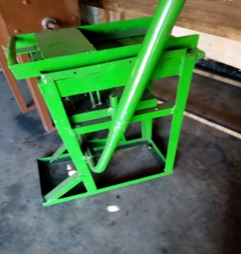 | Produces 9 cylindrical briquette pallets at a time | 215$ | 1,505$
2 | Manual crusher  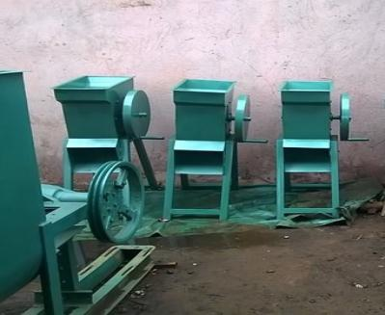 | This can crush about 50kgs of chur per hour | 170$ | 1,190$
3 | Single manual honey comb machine  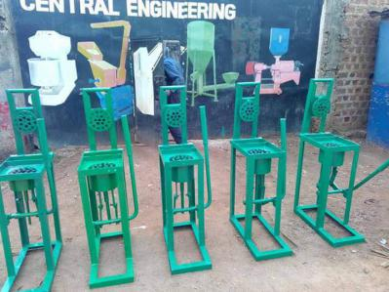 | This can be used to produce about 150 honey combs per day with an average weight of 2kg per honey comb | 188$ | 1,316$
4 | Double honey comb machine  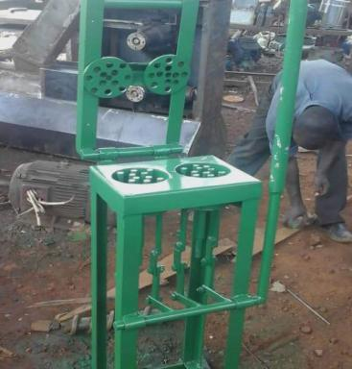 | This can be used to produce about 300 honey combs per day with an average weight of 1.5kg per honey comb | 245$ | 1715$
5 | Manual sieving machine  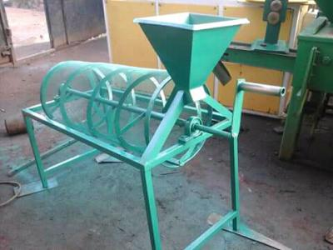 | This helps to sieve carbonized materials so as to obtain different particals required for the mixtures | 108$ | 756$
6 | Manual mixer  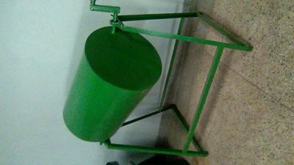 | This is used to mix the crushed particals with the binder | 180$ | 1,260$
7 | Small scale carboniser  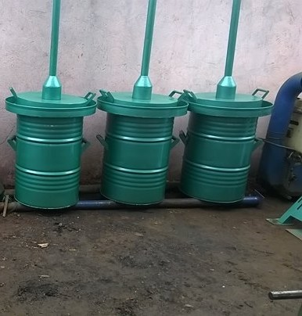 | This can carbonize about 70kg of chur per day | 300$ | 2,100$
8. | Small scale pit method carboniser  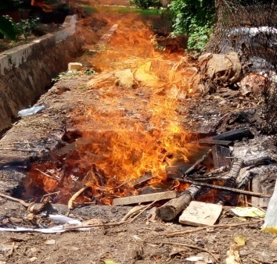 | This can carbonize about 400 to 500kg of chur in two days | 215$ | 1,505$
10 | National Consultants | 10 per district |  | 20000$
11. | Travels |  |  | 10000$
13. | Equipment and Furniture (laboratory  equipment, computers, rent of servers) |  |  | 10000$
15. | Audio Visual, Still Photos Printing and Documentary Production Cost |  |  | 10000$
16. | Miscellaneous Expenses |  |  | 20000$
 |  |  | TOTAL | 81,347$
Note; YOFICC will divide the 1000 by 3 which will bring it to 333 women and youth per district then further sub-divide them by 50 to bring it to 7 machines per 50 people in each district.
Account Name : YOFICC UGANDA
Account Number : 1036201173467
Branch/Service Centre: Equity Bank

