16 Preston Drive, Alexandra Park, Harare, Zimbabwe.
Cell +263772936861, Registration Number PV05/2018. obert@africanbushcamps.com

Main Camp Ablution block- July- October 2020

Background

Main Camp Primary School is located close to the main entrance in the southern part of the Hwange National Park in Zimbabwe. It is a school serving a community mainly made up of ZimParks employees who live in a more communal manner as evinced by the presence of shared critical infrastructural facilities. In 2006, Early Childhood Development classes were made mandatory across all government schools. However, research over the years has shown that ECD classes lack access to adequate basic resources to fully implement ECD related programshttps://www.unicef.org/early-childhood-development . This has been the case in the Matebeland North province and particularly in the Hwange District where most schools are incapacitated to fully implement the ECD classes. ABCF has partnered with Main Camp since 2006 to address development issues and to facilitate a more socially, culturally, economically, and ecologically sustainable community. The Foundation has supported the school to ensure that there is equitable access to education through resource mobilization, capacity building and infrastructural development.

With the growing trends in sanitary related diseases and vulnerability in schools, a need for an age appropriate, secure ECD ablution block and an overhaul refurbishment of the ECD classrooms at Main Camp Primary School was identified. The ECD students at Main Camp Primary School have been using a community shared ablution and learning in an unprotected and dilapidated housing turned into a classroom block. According to the World Health Environment and psychologists such as Piaget poor environmental experience and poor sanitation can be detrimental to the overall development of a child’s cognitive senses consequently affecting their growth into a functioning adult https://www.simplypsychology.org/piaget.html . The ECD students at Main Camp need an age appropriate sanitation facility, a vibrant, colourful, and fenced learning environment to provide continuum care that will maximize their development outcomes. An improved facility and environment of this nature will in future increase the enrolment for infant classes, promote hygienic tendencies, lessen probability of sanitary related diseases and improve the quality of life in Main Camp consequently benefitting the school (157 students & 10 staff members) and the community itself (169 households).

Progress Summary

The ECD ablution block construction took off in September 2020 after due processes were followed which included getting a structural plan drafted and approved by the Ministry of Environmental Health and the Hwange Rural District Council engineer. The ECD ablution block construction, the refurbishment and fencing of the ECD classroom block was initially fundraised for in 2019 with the aim for it to be completed in the first half of 2020. However, the school had engaged a different organization to construct an appropriate classroom block within school grounds. ABCF was asked to hold off on the initial targets at the current site and await development of the new classroom block site and construct the ablution block there and fence the area and paint the new classroom block once it is there. A new site for ECD classroom block and ablutions within the school grounds was identified early 2020 however due to the COVID-19 pandemic schools closed early and there was a national lockdown that grounded any progress from March 2020 till late June 2020. In July 2020 project related activities resumed and the ablution block situated within the school premises is now at the roofing level.

Detailed Activities.

- In the first quarter of 2020, ABCF engaged ZimParks with regards to an MOU for a clear indication on roles and responsibilities. This process was deemed to redundant due to the timeframes taken to approve an MOU by the Director General of ZimParks particularly if the only initiative to be conducted was to be the ablution construction and refurbishment of ECD classes. It was concluded that a donation certificate will be issued once the work is completed and ZimParks will acknowledge receipt and allow ABCF to put plaques acknowledging our partners.
- In July 2020, a local architectural engineer was engaged for the drafting of a structural plan for the ECD ablution block. A visit to Umtshibi pre-school was conducted for an overview of what the ablution block should resemble followed by a site visit at Main Camp primary school to assess the feasibility of the project.
- In August 2020, the engaged architect submitted the structural plan for the ECD ablution block, the plan was shared with HRDC engineer and the Ministry of Environmental Health who approved and gave the greenlight to commence construction.
- Quotations for building contractors were conducted and Abecious Investments won the bid to cover basics on construction, plumbing and electrification of the ablution block. The contractors gave a conclusive Bill of Quantities used to populate material for the ECD ablution block.

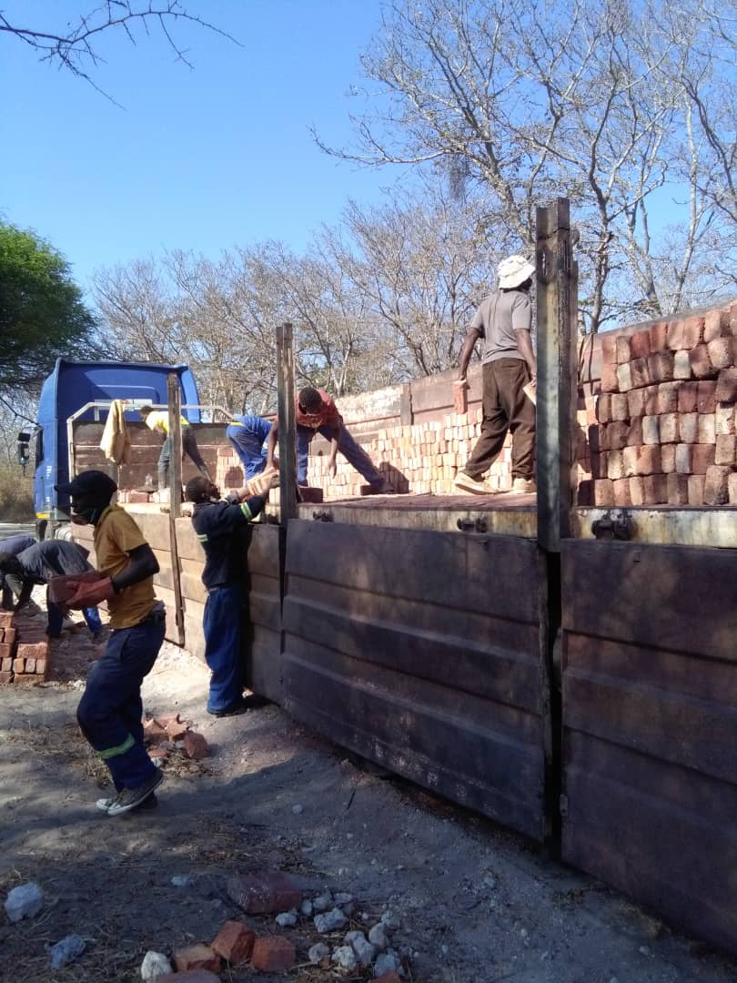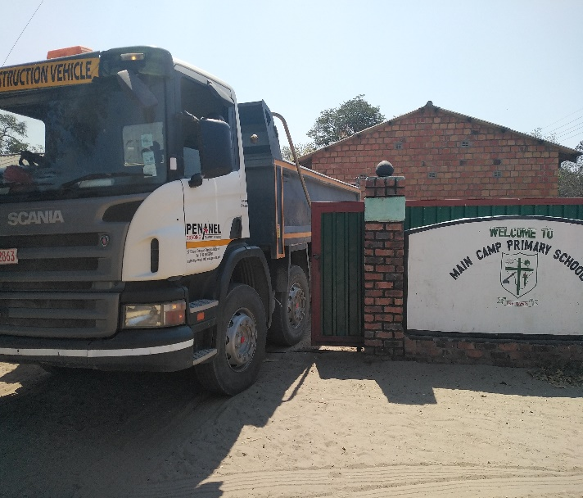
Above left: Main Camp community members helping offload a truck full of bricks for the ECD ablution. Right: A truck that delivered river sand for the ECD ablution construction.

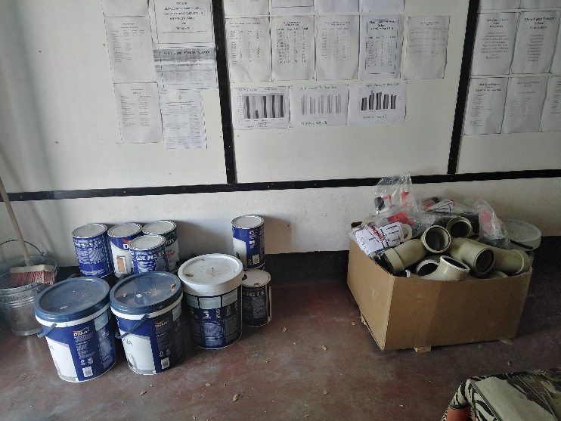
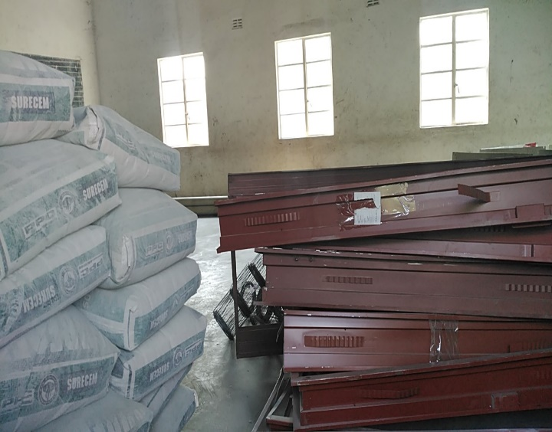
Above: Construction and plumbing material for the ECD ablution block.

- Construction commenced at the new site and is underway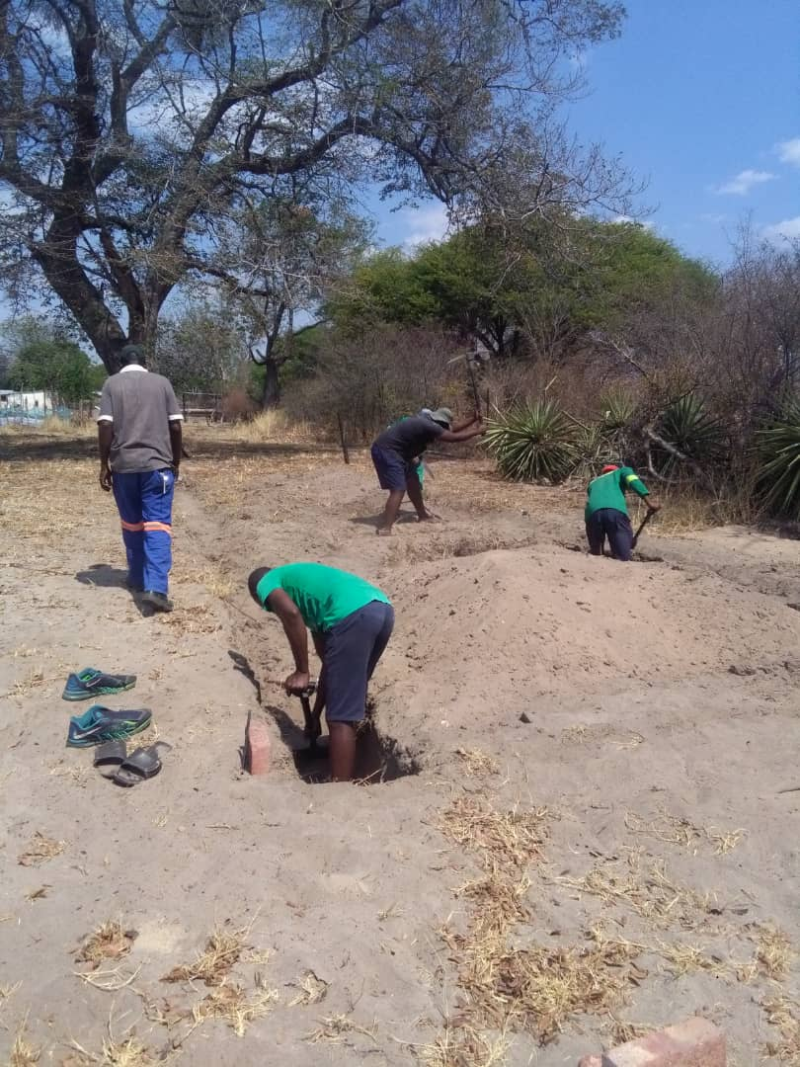 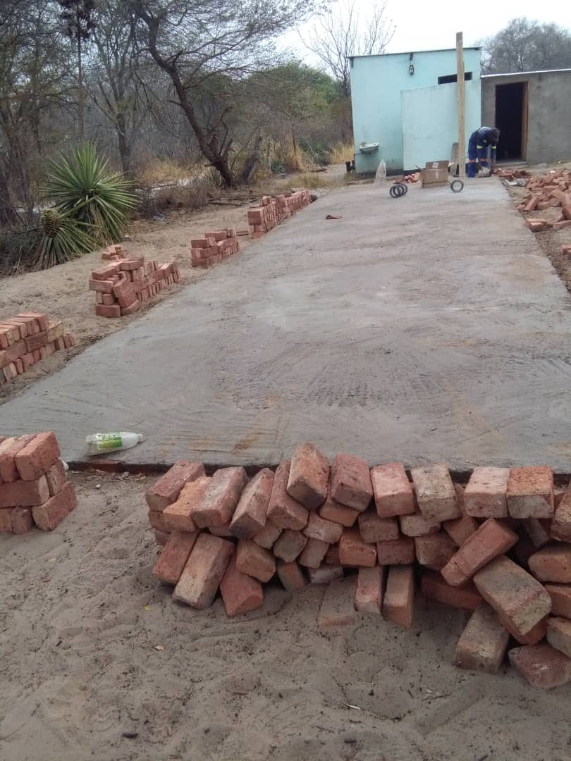
Above left: Foundation being dug at the site. Above right: Foundation level completed. Below left: Septic tank development.
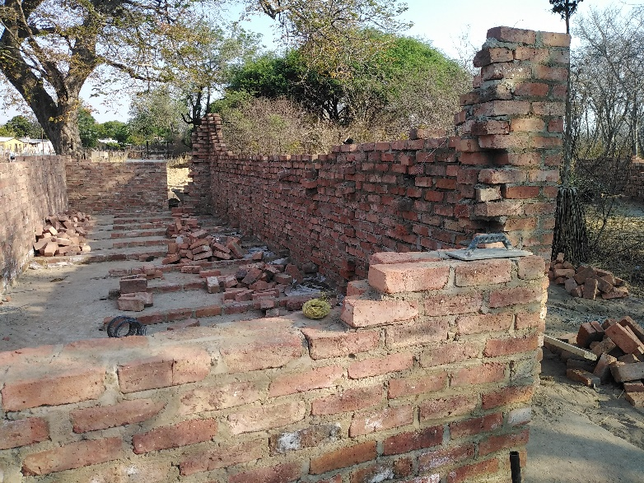
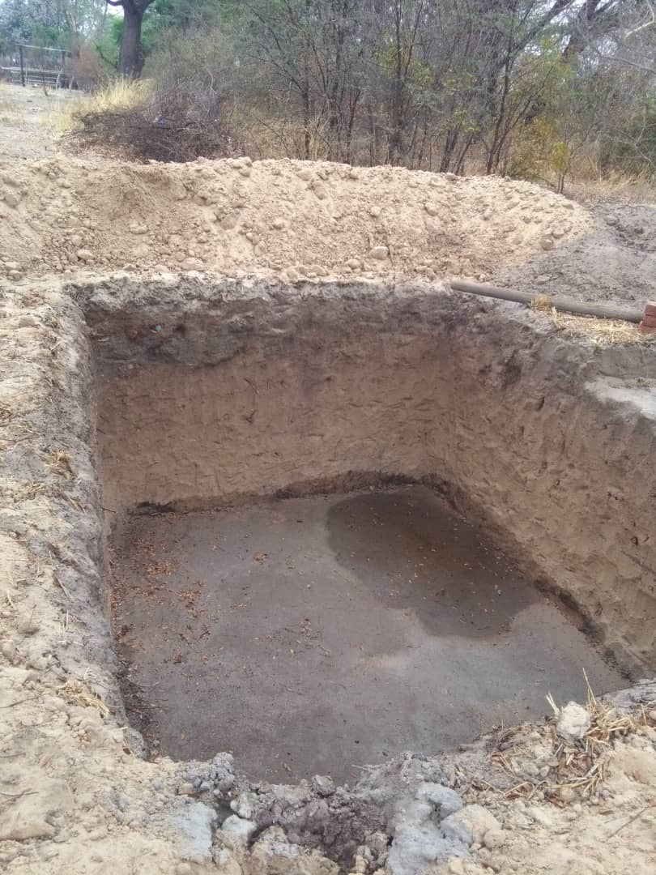

Partner & Stakeholder Engagement.

- The Ministry of Environmental Health and the Hwange Rural District Council commended the work being done and as a result did not charge any fees for their services which is the norm.
- ZimParks in Hwange offered contractors accommodation, offered security for materials delivered and a responsible individual from their office. Furthermore their office will see to the maintenance of the ablution block at the school.They rendered services of their vehicles to help with loading and transporting some of the material as shown in the below pic.
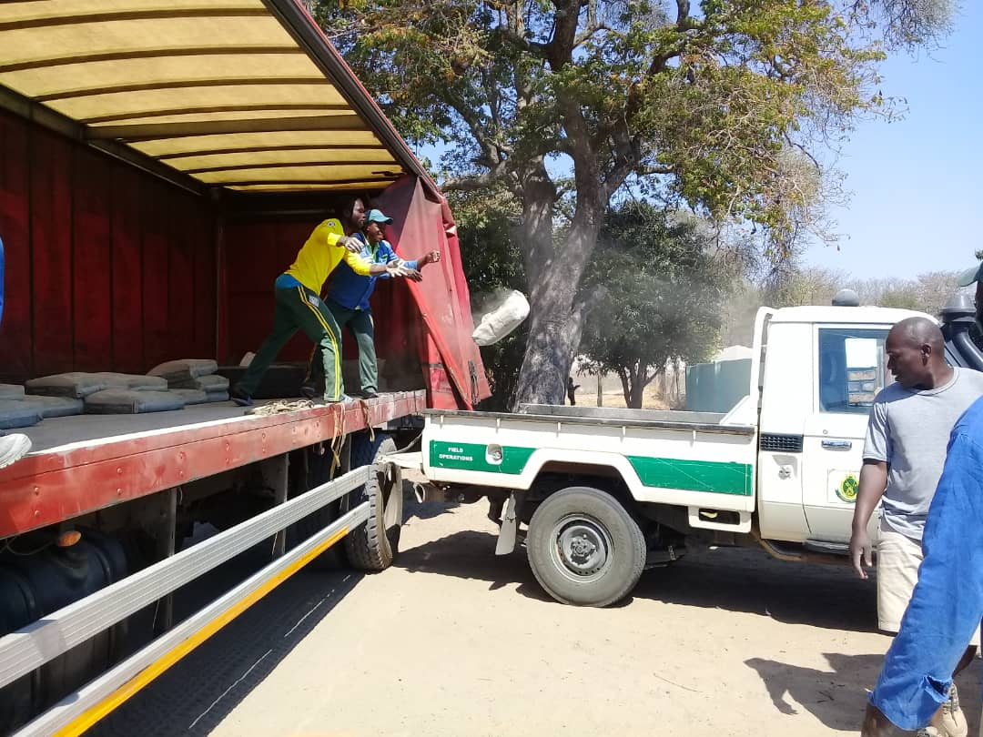

Challenges

- MOU drafting and consultative meetings for operations took time hence the revised approach to the process.
- Delays in starting off the project due to the premise of a new classroom block by a different organization resulting in the overdue commencement of plans and actions towards the ECD ablution block.
- The COVID-19 pandemic and national lockdown regulations limited movements and caused a long halt in project execution.
- Good roofing timber is hard to come by and that has delayed the roofing process.

Conclusion
The progress during construction has been quite steady and is promising to be efficiently completed. The school administration together with the ZimParks office have been instrumental in monitoring progress and ensuring the correct populated material is on the ground and is secure. The ablution block should be complete by the time ECD students resume classes. However there is need for the school to push for the classroom block construction so as to ensure the constructed age appropriate block is in full use by the intended users.

