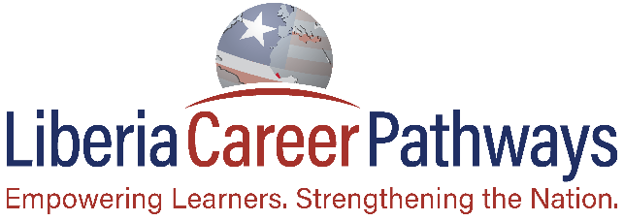
Liberia Career Pathways helps students make intelligent and informed career choices, fills in health and education gaps, and inspires learners to be globally competitive, in disciplines and trainings critical to Liberia’s economic growth.
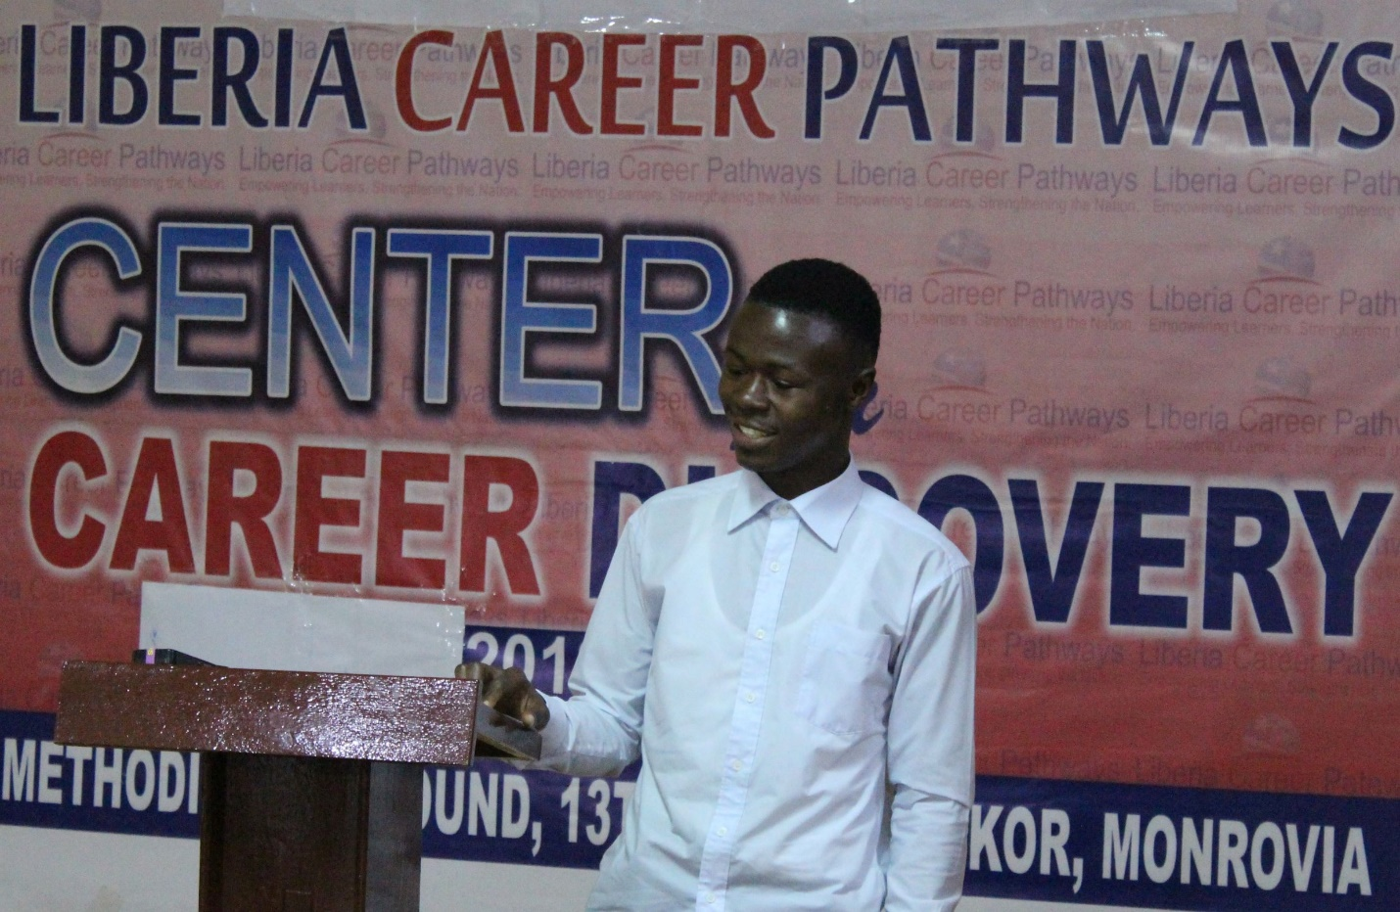
Please support Liberia Career Pathways to fill in health and education gaps in Liberia, help students make intelligent and informed career choices, and together let us inspire them to be globally competitive in disciplines and trainings critical to Liberia’s economic growth.
Last year (2018) almost every high school senior that took the West African standardize test – WASSCE, failed. LCP then piloted a program to fill the education gaps of incoming seniors preparing for the 2019 WASSCE. All 35 students enrolled in our program passed the 2019 WASSCE. Timothy B. (above) is one such student who said, “the content of the program plus the inspiration and concepts introduced were the push I needed to pass.” Your donation will help strengthen and expand our program to other schools in Liberia.
Please help us reach or exceed our goal of $5,000 by the end of September. A donation of $50 can sponsor one program of 50 students for a month.

