A REPORT ON MAKING OF THE VILLACHIC RE-USABLE SANITARY PAD TRAINING HELD IN BUNGOMA COUNTY (UFANISI WOMEN GROUP)

SPONSORED BY UFANISI WOMEN GROUP WITH FUNDING FROM THE ESTEEMED PANGEA GIVING FOR GLOBAL CHANGE.

FACILATATED BY- Dr.TABITHA G MURERWA(CHIEF DESIGNER-0722887320, tbbymurerwa@yahoo.com/ tbbymurerwa@gmail.com) and 2 other trainers (Lucy Nchekei and Peter Mugai)
UFANISI WOMEN GROUP’S WORKSHOP ON DESIGN, PRODUCTION AND MAINTENANCE OF VILLACHIC RE-USABLE SANITARY PADS.

The training took place at Ufanisi Women Group’s training centre in Bungoma County from 2rd May to 4th May 2018; and each day had its own program. It was attended by 58 women from Ufanisi Women Group’s membership, who also forms direct beneficiaries that were trained in design, production and maintenance of villachic re-usable sanitary pads. The training body was The Village Trust (www.villagefunds.org) from Meru County in Kenya. The Village Trust (TVT) provided 3 high profile trainers, led by Dr.Tabitha Murerwa that is the inventor and chief designer for villachic re-usable sanitary pads and also senior lecturer at one of the leading universities in Kenya. Other 2 trainers were Lucy Nchekei and Peter Mugai.

DAY 1

The training began with the welcome note by the women group chairlady .She introduced the participants to the facilitators. The Village Trust (TVT) outreach coordinator, who is also Chief designer and senior lecturer in one of renowned universities in Kenya (Dr. Tabitha Murerwa) gave a bit of the history of TVT and its accomplishment as far as reusable sanitary pads trainings is concerned. The facilitators gave a brief background of the re-usable sanitary pad on how it has helped determine the future of girls and women in some communities of the developing countries. The objective of Reusable Sanitary Pads initiative is to give hope for a brighter future to women and girls in such situations. As the name implies, reusable sanitary pads are not disposed off after use but instead they are washed and reused and with good care they can last up to one and a half years.
It is well known fact, that educating girls is one way of contributing to fight against poverty, building sustainable economies and contributing to healthy families in the developing countries. Unfortunately, even in countries where primary education is free and secondary education is subsidized by the governments like in Kenya, girls especially in the rural areas have continued to perform poorly compared to the boys. There are many factors that contribute to this alarming trend. They include absenteeism and drop out problems among the girls in the rural areas. Dreams of girls from poor families are sadly shelved due to challenges related to menstruation, early pregnancy, and HIV/AIDS. HIV infection rates in girls are 4 times that of boys the same age mainly because girls from poor families engage in sex at an early age as a way of earning a living. School dropout rate for girls has partly been linked to inability to afford sanitary pads. Therefore, by supporting local women groups to undertake self-supporting locally produced and environmentally-sound reusable sanitary pads, FAWEK is increasing the chances of improving school attendance rate and as a result academic performance for rural girls. FAWEK reusable sanitary pads initiative was motivated by research done in BONDO and THARAKA Meru and the results revealed the sad reality that girls in those areas were are using newspaper cuttings, leaves, grass, old rugs, sponges and virtually anything at their disposal during their menstruation periods. In some communities women are confined to secluded houses until their period days are over. Most of the girls in rural schools, like the ones pictured on this site, cannot afford to buy sanitary pads, napkins, cotton wool or any other form of protective supplies to use during their menstrual periods. This forces them to feign sickness and skip school when they are menstruating. This implies that girls in rural schools miss classes at least five days in a month which impacts negatively on both their academic performance and self esteem. Sometimes boys tease, humiliate and make fun of the girls who accidentally soil their clothes, which leads to the unlucky girl dropping out of school due to embarrassment. Their mothers, aunties, sisters and other female relatives are not in any better position to afford to buy pads for themselves and as such they go through the same suffering when they have their own monthly the reusable pads is addressing problems of rural villages in the most practical ways. Thus fawek is not only contributing to girls’ education through reduction in drop out rates and absenteeism but it has also introduced women to a healthy way of addressing their menstruation related problems. It has enabled women to rediscover their potential to earn income and provide for their families. By producing their own reusable sanitary pads, supported communities are creating businesses, expanding their income base, protecting environment and offering employment to local residents. In addition, risks of being infected by HIV are reduced as women have an option to provide to their families as opposed to engaging in commercial sex business. Furthermore, through the income earned from sale of the sanitary pads, families are able to take care of the relatives with HIV/AID
Expectations of the workshop
To know how the pad is made.
To know the properties of materials used.
To learn the skills of making the pads
To know the designs of the pads
To know how it is used
To acquire an entrepreneur business in pad making.

Objectives of the workshop

At the end of the workshop, the trainees were expected to:

- -to make a complete re-usable sanitary pad
- -to know how the pad is worn
- -to identify the materials used and their properties
- -to know how to take care of the pad.
- -to learn the accessories of the sanitary pad and how they are made.

Designs of the re-usable sanitary pad

The designs learnt were three, I-Top loading, 11-side loading and 111-envelope type. They are re-designed to fit the environment where most needy girls come from. They are easy to make and they have the following advantages:

- it is compact used like any other commercial pads
- it is re-usable, can be washed and used again
- They are changed and replaced with a new one
- It can be worn even if one has no underwear
- It’s never shared.
- They are cheap and easy to make a girl can use improvised materials and the cost can be nil

TOOL REQUIRED IN MAKING THE SANITARY PAD

A pair of scissors/razorblade
Hand needles (at least two
Tape measure/ruler
Sewing thread (if possible, color of fabric
Pencil
Tracing wheel and tracing paper
Dressmakers pin
Seam ripper
Sewing machine

STITCHES USED IN MAKING

- Backstitches
- Tacking
- Over sewing
- Loop stitching for neatening raw edge
- Hemming stitch
- Machine stitches (can be use if one has machine at home or take to tailor}

SEAMS USED

- Open seam
- Run and fell seam
- Bound seam

MATERIAL USED

- 100% cotton-loosely woven (dull colors)
- Toweling material.(any color, but not white
- Plastic material (can be strong sugar wrappers

PROPERTIES OF THE ABOVE MATERIALS

Cotton

it’s soft and porous and allows blood to pass through
- Cotton fabric allows air to flow through freely. The fabric absorbs sweat and releases it on its surface. This is often described as the fabric "breathing," and is considered an asset in clothing, particularly in warm climates.

- Toweling material

- it’s highly absorbent with the capacity for holding blood.

- Plastic material

- its non-porous it doesn’t allow blood to pass through

NB: materials used can be any that a pupil can afford, so long as its hygienic, and clean its meet the above properties e.g. pieces of clean old towels, plastic sugar papers.etc

Criteria for Identifying Fibers cotton (Natural Fibers) done practically to the participants)

Burns on flame, but does not melt. It has the odor of burning paper,
The residue is a fine, feathery, gray ash. The importance is to ensure women buy the right material as per requirements by the ministry of health,

SIZES OF THE PAD

Just like the commercial sanitary pad, the fawek pad comes in three sizes,
Large-for big women
Medium-for medium girls
Small-for very small girls, ages 9-15

MEASUREMENTS REQUIRED FOR DIFFERENT SIZES

LARGE

Cotton material- 28cm by 12 cm
- Toweling material-63cm by 25cm
- Plastic material- 28cm by 15.3cm
- Loop- 36cm by 3cm

MEDIUM SIZE

Cotton material- 26cm by 12cm
- Toweling material- 54cm by 25cm
- Plastic material- 26cm by 8cm
- Loop- 30cm by 3cm

SMALL SIZE

Toweling material- 54cm by 35cm
- Plastic “ - 10cm by 24cm
- Loop “ -24cm by 3cm
NB: seam allowances are inclusive

COMPONENTS OF THE PAD AND ITS ACCESSORIES.

The pad has the following components
- Shell or case- that holds the stuffing’s (made from toweling material)
- Removable/replaceable stuffing
- A loop
- a waistline strap
- Carrier bag and its strap

WAIST LINE STRAP- It should be individual’s waist measurements, plus half of it, e.g. if waist is 76cm, then half of it is 38cm, hence measurement of the strap will be 114c m by 3cm,the same as the loop width.

Important instruction

-Cut on straight grain of the material, by using the measurements on each size
-Add the seam allowance on each piece as per instruction.
-Mark the stitching line using a pencil and the dressmaker’s carbon paper of pencil alone directly on the fabric, if carbon paper is an available.
Practical- participants practiced on the stitches used.

PRACTICAL WORK IN GROUPS

Practice on seams and stitches to be used in the making of the re-usable sanitary pad.

ACTUAL MAKING OF THE RE-USABLE SANITARY PAD DESIGN 1

SHELLS:

- Cut the pad according to size
- Mark the right sides and the wrong sides of the fabric.(R.S and W.S)
- Cut the two pieces of cottons and one from the plastic.
- Place the one cotton pieces on the R.S. lay the plastic piece on top ready for making as shown below:
- -Tack and hand stitch using the back stitches or small running stitches on two sides shown below.
- In the picture below is Mrs. Ruth Naliaka, the chairlady of Ufanisi Women Group (UWG), standing and expressing a point to beneficiaries

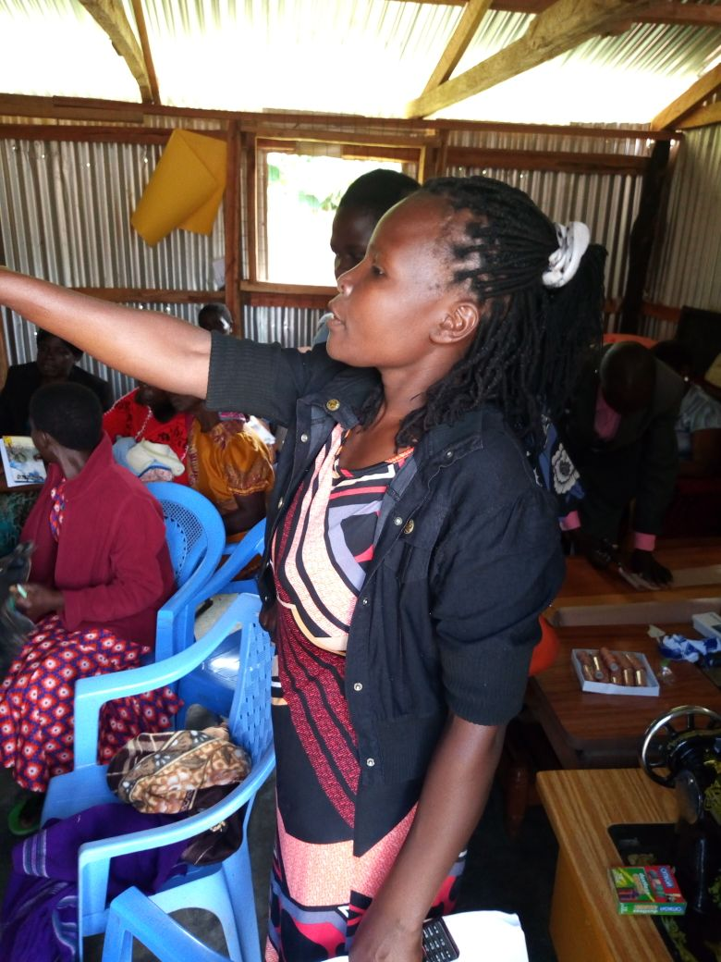
- on two sides shown below.

- turn the two layers to the R.S ensure to enclose the raw edges. Press with hands
- hem the top and button openings and press

MAKING OF THE LOOPS

- Using the given measurements 4cm by 36cm cut two pieces of cotton materials for the two loops.
- Take one piece of the fabric and fold into two lengthwise R.S. together.

Beneficiaries at work during training session at UWG’s training centre
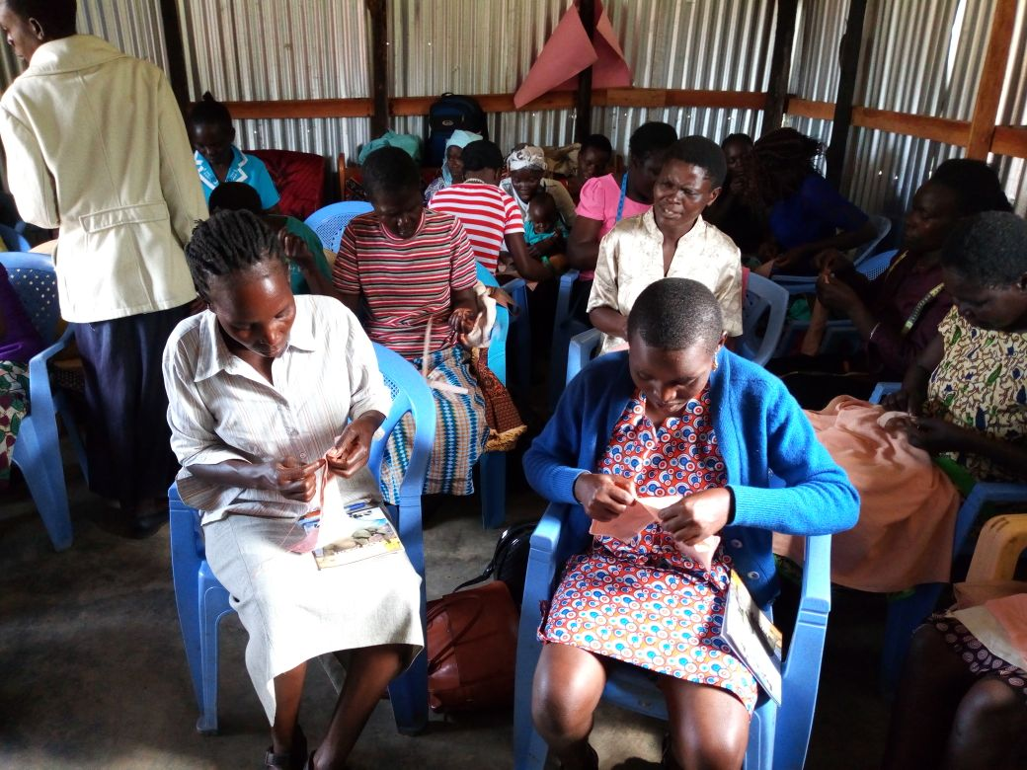
- Pin and tack
- Remove pins and over sew
- 5. Attach to the pad by over sewing out backstitching at the center of each opening.

DAY 2

CUTTING AND MAKING OF THE SANITARY PAD DESIGN 2

An instruction for cutting is same as for above pad, except that the two openings at the end of the shell are closed and one long side is left open.
Length of the shell and opening is made as follows:
For all the sizes, the side opening is 17cm
Place the three pieces of fabrics together, i.e. the two cottons and the plastic on the W.S
Backstitch all the sides leaving the opening at 17cm
Turn to the R.S and press; the plastic should be at the center.
Over sew the opening using over sewing stitch
Prepare the loops using the above method.
Attach the loops at the center of upper and lower sides of the pads.
The pad is ready for use

PREPARING STUFFING MATERIAL

Cut the toweling material as per the given measurements
Spread the fabric away from you. As shown below
3. Hold the two corners of the width ready to make folds.

In picture below is Dr. Tabitha Murerwa in glasses sitting on a chair during training session and Trainer, Peter Muigai cutting materials for making pads during training session.
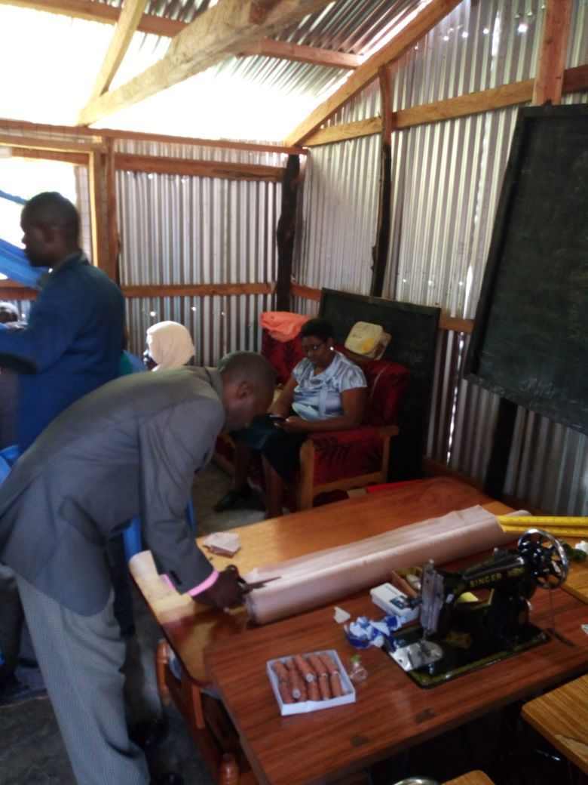

4. Make folds measuring the respective sizes of the shells
5. Make 4 layers for the small size and six for medium and large sizes.

STUFFING METHOD

Hold the shell with one hand
Put four fingers through the shell towards the other end of the shell and with the other hand holding the folded toweling material
Insert through the opening, until it passes through to the other end.
Straighten it up, to fit into the shell ready for use

CUTTING AND MAKING DESIGN 3

Cutting instructions

Plastic cut 1
Cotton cut1

Measurements

Length- 32cm by 12cm
Add 1cm as seam allowance.

METHOD
Lay the plastic and cotton pieces together R.S together.
On the W.S pin along the stitching line, tacks and back stitch.
Turn to the R.S and press, the plastic is seen on top
Fold on both sides to form the pocket, for holding the stuffing, hem in position
Make the loops as for the other designs above
Attach at the center of each end
The shell is ready for use.

MAKING A CARRIER BAG

Cut one piece from the cotton material measuring 25cm by 24cm
cut another similar piece from the plastic material
place the two pieces together and fold into half
On the W.S, tack and back stitch on the two sides. (No stitching done on fold.)

Turn to the R.S and press the seam neatens the raw edges using loop stitch.
Hem the opening of the bag, using hemming stitch. Press once again.(see sketch below of finished bag)

MAKING THE STRAP FOR THE BAG

Using the same method as of waist strap, use 61cm by 3cm, measurements.
Insert into the bag using the safety pin
Below in the picture is trainer, Lucy Nchekei, standing and in black expressing a point to beneficiaries during training session.
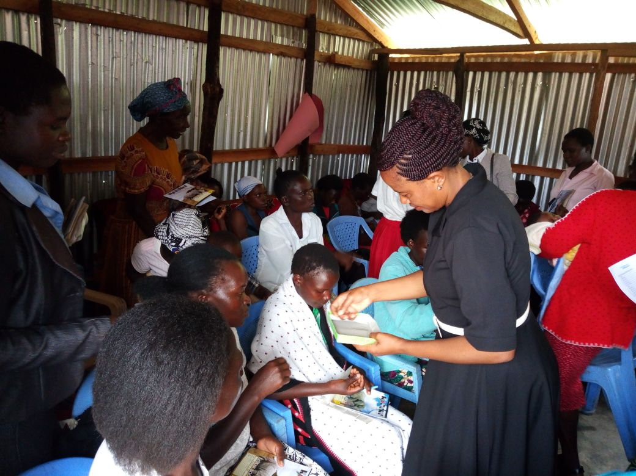
If elastic is to be used, instead of a strap, it should be 26cm long.

HOW THE PAD IS WORN

Hold the shell with both hands
Insert the stuffing i.e. toweling well folded
Put the strap at waist
Squat and put strap on the back loop
Pass through the front loop
Tighten and tie on the sides
When changing, do the same remove the stuffing and put in the carrier
Bag
In the picture below is a sample specimen of one of the beneficiaries during a training session in how to wear re-usable sanitary pads at UWG training centre.
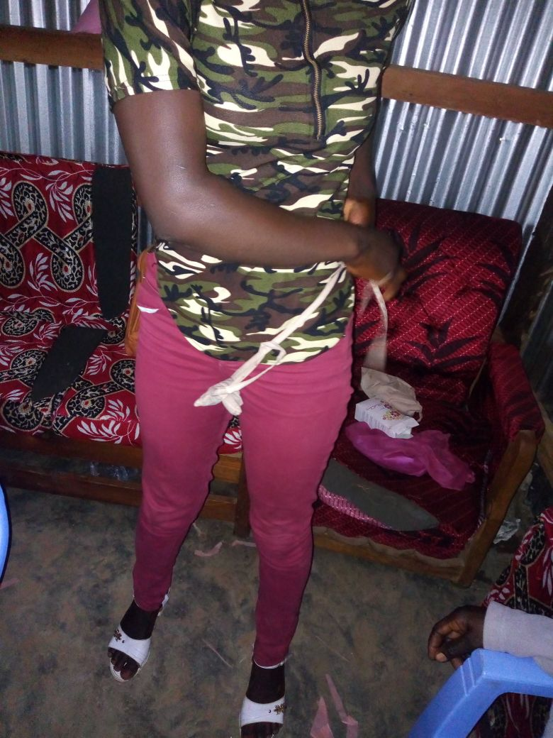
If it’s badly soiled remove even the shell and replace with a clean one.

CARE OF THE PAD (this was done practically by the participants)

- Wash by dipping in cold salty water
- Wash with soap and water using the kneading and sequencing method
- Rinse in warm water
- Give it a final rinse in cold water in order to freshen and enhance the fibres
- Dry under direct sunlight in order to kill germs and brighten the fibres
- Do not iron as it will matt the plastic fabric
- a set of six re-usable pads could be ideal

COSTING AND MARKETING OF THE RE-USABLE SANITARY PADS
All materials should be costed and the profit calculated so that its should be 30% of the total cost, the profit should be included in the selling price; this is to ensure the participants are able to make a living out of the activity at the same time be able to make their own pads for use.

EVALUATION

The participants had the following to comment about the training.
The course is helpful because it gives knowledge and skills on the making of the sanitary pad
They have seen the importance of the re-usable sanitary as it comes handy for the needy girls in the community
It has given them an insight to start a business on making re-usable sanitary pads and selling at affordable price
The participants felt that one can practice social responsibility by giving free skills of making sanitary pad to girls around their community
Benefits of Using Reusable Sanitary Pads
Compared to the disposable sanitary pads, Vila chic sanitary pads are environmental friendly and economical. They are soft and comfortable to wear. They allow for more airflow therefore reducing the scent of the menstruation blood and prevents fungal and bacteria growth that cause irritation and infection. Women who are using pads have reported that they experience less irritation compared to plastic disposable pads. Women with sensitive skins or those afflicted with certain types of vaginitis, also find the sanitary pads more comfortable for their skins and they are less likely to develop rashes or contract dermatitis. Vila chic reusable sanitary pads project empowers women and girls to have a voice to resist sex exploitation because they are able to gain access to affordable pads and generate income to provide for their families sanitary pads come in packets of 3 and cost about US$ 5 or € 3, including 1 storage bags. Each packet of the sanitary pads lasts between 8– 12 months if well taken care of. This implies that in addition to contributing to preservation of the environment through the use of bio-gradable materials, one would spend an average of US$ 5 per year, which is less than a monthly expenditure on most of the disposable sanitary pads available in the markets.
DS orphans and other victims and also keep them in school.
Below are beneficiary women displaying their certificates awarded to them following successful 3 day training in design, production and maintenance of villachic re-usable sanitary pads. They are standing in front of UWG’s training centre after graduation ceremony. In front is Joseph Jama, one of the project committee members and Lucy Nchekei, one of the trainers.
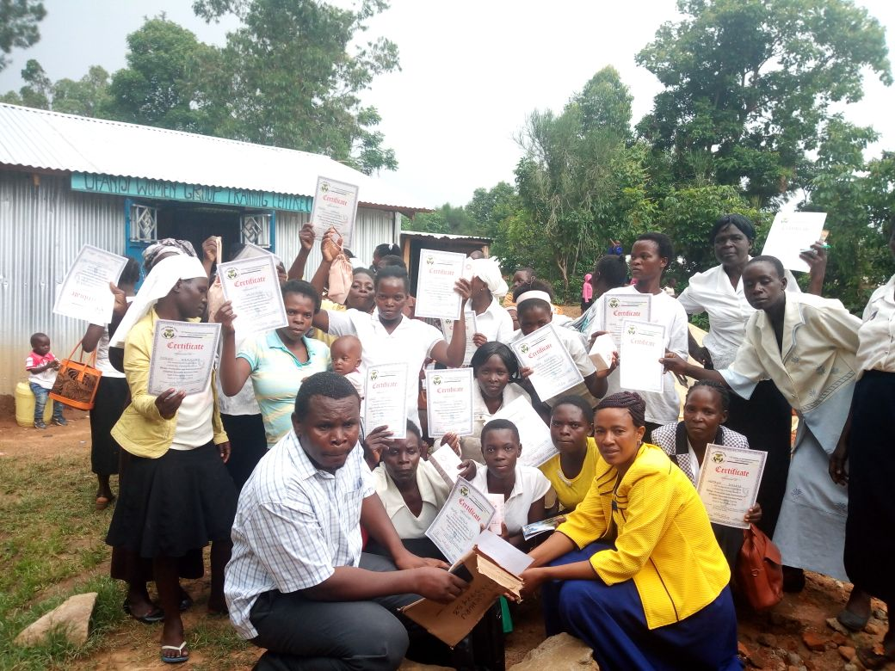

APPENDIX ONE

Date & Time |  | Event |  | Facilitation
Day 1  8.30.00-9.00 |  | - Registration |  | Ufanisi
9.00-10.30 |  | - Introductions  - Welcome Remarks  - Workshop Expectations  - Workshop Objectives  - Grouping |  | ufanisi/Tvt  facilitator  facilitator  facilitator  facilitator
10.30-11.00 |  | - Tea / Coffee Break
11.00-1pm |  | - History of the Re-usable sanitary pads  - Designs of the pads: components of the pad and its accessories  - Tools required & Display  - Stitches used  - Material used and their property |  | facilitator
1pm-2:00pm |  | - Lunch Break
2pm-4: 30pm |  | - Practical work (work in groups) practices the stitches, seams used.  - Sizes of pads, measurements required.  - Making of the first design of the sanitary pad |  | facilitator
DAY 2  8.30am-9: 00am | - 9Registration |  | Ufanisi
9:00-10:30am | - Recap  - Cutting of the 2nd design of the sanitary pad |  | facilitator
10:30-11:00am | - Tea Brea
11:00-1pm | - Making of the 1st and 2nd sanitary pad  - Making of sanitary pad |  | facilitator
1pm-2:00pm | - Lunch Break
2:00-3:00pm  3:00-4:30pm  4.30-.500 | Continuation of making of the pad  Evaluation of days made pads |  | facilitator

DAY 3  8.30am-9: 00am | - Registration | Ufanisi
9:00-10:30am | - Recap  - Cutting of the 3rd design of the sanitary pad and the carrier bag | facilitator
10:30-11:00am | - Tea Break
11:00-1pm | - Making of the sanitary pad  - Making of the carrier bag | facilitator
1pm-2:00pm | - Lunch Break
2:00-3:00pm  3:00-4:30pm  4.30-.500 | Care of the pad & washing ( Practical)  Demonstration on how the pad is worn.  evaluation  Closing Remarks | facilitator  ufanish/invited guests

END

BACKGROUND
Menstruation is generally perceived by most people especially in rural areas as unclean, filthy, dirty and shameful. Based on this general perception, information on menstruation and menstrual hygiene are often treated with a lot of secrecy and embarrassment. Some of these perceptions were confirmed as part of findings of studies that were conducted by Ufanisi Women Group on menstrual hygiene and Sexual Reproductive health in Kisiwa location in Kenya. Designing and development of this Menstrual Hygiene Management (MHM) manual was based on these findings. At home, in school, at work and play, the voices and demands from thousands of women and girls during these studies were loud and clear: let’s talk and do something about Menstrual Hygiene Management (MHM)–so that we can manage our menstruation with pride and dignity and dispose used menstrual material safely without further endangering the environment.
The support from Pangea, coupled with advocacy work of Ufanisi Women Group, is providing the ideal platform for taking message on Menstrual Hygiene Management and related services to every woman and girl in rural areas in Kisiwa location and Kenya at large. Ufanisi Women Group is engaging with County and National governments, Sexual Reproductive and Menstrual Hygiene Management (SR&MHM) experts, community health workers, community and opinion leaders, local women’s groups, teachers, trainers, schools and practitioners in WASH sectors; as part of the push for improved understanding, information sharing, counseling, training and support on menstrual hygiene.
PREFACE
A woman menstruates for a total of 40 years in her lifetime. But vast majorities of women and girls who live in the developing world do not have access to clean water, safe and private spaces for washing and cleaning, materials for absorbing menstrual blood, or facilities for proper and safe disposal of used menstrual hygiene materials.
In Kisiwa location, it is estimated that 98% of women and girls have a poor understanding of menstrual hygiene practices. Moreover, only 3 per cent of women and girls in the location use commercial sanitary products. Historically, myths, taboos and stigma around the female body and menstruation have overshadowed progressive initiatives aimed at improving menstrual hygiene in the location. Location’s residents associate menstruation with impurity and pollution of the sacred. This belief is coupled with restrictions and sometimes bizarre regulations on girls’ and women’s everyday lives and activities. For instance, some of the most common practices include restrictions on entering one’s own home or kitchen, touching food, water and plants, or participating in religious activities. Such beliefs and practices not only violate women’s dignity, they have serious implications for their health and wellbeing. To make matters worse, a lack of resources and knowledge means that many girls and women do not have access to basic hygiene materials and facilities.
In some cases, women and girls are forced to resort to unhygienic options, such as using ash, newspapers, hay, sand or old rags to absorb menstrual blood. Consequently, every period is loaded with mental, emotional and physical trauma, which affects the day to day lives of women across the location. At least 15% per cent of girls in the location drop out of school soon after reaching puberty. Schools are not equipped with the basic amenities for menstrual management, with non-availability of menstruation materials, places for changing menstruation materials, running water in toilets and the absence of disposal facilities all impacting on a girl’s education. As a result of stigma and taboos, communication between girls and teachers about healthy menstrual practices is non-existent.
Menstrual hygiene is fundamental to the dignity and wellbeing of women and girls, and an important part of basic hygiene, sanitation and reproductive health services. However, menstruation is too often taboo, with many negative cultural attitudes associated with it, including the idea that menstruating women and girls are ‘contaminated’, ‘dirty’ and ‘impure’. Facing this cultural challenge head on, UWG is conducting Menstrual Hygiene Management (MHM) awareness sessions in schools and local villages based on this MHM manual, specifically to address: a lack of knowledge of health issues of MHM at grassroots level.
To meet this demand, this Manual has been developed for UWG trainers and peer mentors, to enable them to speak confidently about an issue that is regularly shrouded in silence, and which impacts upon women and girls health, education and livelihoods. The Manual includes a series of Learning Units (LUs), which are aimed at improving menstrual hygiene for women and girls in Kisiwa location and Kenya at large. It covers key aspects of menstrual hygiene in different settings and is based on examples of good menstrual hygiene practice from around the world. Familiarity with this Manual will allow a trainer to complete two main objectives: to effectively plan, organize and conduct MHM Training Program; and to effectively monitor and evaluate MHM Training Program.
At the end of training, participants of MHM Training Program will be able to:
1. Explain the concept of MHM;
2. Conduct the MHM Training Program at grassroots;
3. Describe the process of safe disposal of sanitary napkins;
4. Demonstrate participatory approaches in the field;
5. Explain the necessity and importance of MHM;
6. Describe the roles and responsibilities of various stakeholders on MHM;
7. Describe the social marketing methodology for demand generation and IEC activities.
ACKNOWLEDGEMENT

Menstruation is a key indicator of health and vitality of women and girls. Managing this hygienically and with dignity is an integral path of good sanitation and hygiene. Menstrual Hygiene Management promotion campaigns are most effective among girls and women, who can be targeted both as beneficiaries and as agents of behavioral change within their families and their communities.
This MHM manual was written collaboratively between community health workers, Sexual Reproductive and Menstrual Hygiene Management (SR&MHM) experts and Ufanisi Women’s Group’s teams; with funding from Pangea. Thanks a lot Pangea for supporting Sexual Reproductive and Menstrual Hygiene Management (SR&MHM) in Kisiwa location in Kenya.

LEARNING UNITS (LUs)
There are 11 LUs in the Training Program, all of which must be completed by a participant before she/he can train others in MHM. The units are:

LU-1: Necessity, concept and components of MHM.
LU-2: The relationship between health and menstrual hygiene
LU- 3: Exclusion, disability and the role of men in MHM
LU- 4: MHM for different age groups (adolescents and menopausal women)
LU-5: Multi-level institutional arrangements and the roles and responsibilities of different stakeholders in MHM
LU-6: Facilities required for menstrual hygiene management in schools, public places and workplaces
LU-7: Safe disposal of sanitary napkins.
LU-8: Direct training skills and methods.
LU-9: Community participation approaches and their applications.
LU-10: Tools of behavior change and use of IEC material
LU-11: Training Evaluation

LEARNING UNIT-1: NECESSITY, CONCEPT AND COMPONENTS OF MHM
Session 1: breaking the silence

Some frequently asked questions
Q: At what age does a girl start menstruating?
A: Some girls begin to menstruate as early as age eight or nine, while others may not get their first period until a few years later. The onset of puberty or age of menarche is generally around age 12.
Q: How much flow is there normally?
A: Menstrual flow can vary from person to person. Usually, an entire period consists of a few to several spoonful of blood.
Q: How long should a girl’s period last?
A: The duration of a menstrual period can vary from girl to girl. Bleeding usually lasts for four to five days but anything between two and seven is normal. One girl might have three-day periods while another might have six-day periods. In some cases, the length of the period can vary from month to
month. For example, in the first month, a girl’s period might last four days, and then the next month it could be six days.
Q: What kinds of foods should be avoided during periods?
A: Eat everyday foods such as vegetables, roti, rice, pulses and lots of fiber, and drink plenty of water to avoid constipation, as it can lead to increased pain from menstrual cramps. Cutting down on salty foods will prevent water retention in the body.

Q: How does the body feel during menstruation?
A: Sometimes a girl may experience physical or emotional changes around the time of her period, while others may not feel any change in moods or body. Physical changes include: cramps, pain, bloating, weight gain, food cravings, painful breasts, headache, dizziness or irritability. Emotional changes include: short temper, aggression, anger, anxiety or panic, confusion, lack of concentration, nervousness, tension, fatigue or depression.
Q: Is it risky or dangerous to engage in sports and games during menstruation?
A: No, but if you feel tired or weak and feel the need to rest then rest is advised.
Q: Are girls unclean and impure during periods?
A: There is no impurity in the blood associated with menstruation. Cleanliness and hygiene are important to the menstrual flow, to keep away any odor or infection.
Q: Should girls use only sanitary napkins?
A: No. Clean and dry cotton cloth can be made into a pad for absorbing menstrual blood.
Q: What can be done to relieve menstrual cramps?
A: Place a hot water bottle on the abdomen or on the back, depending on the cramps’ location. Take a warm bath. Drink a hot beverage, such as tea. Take a walk. Rub or massage the abdomen. Get on your elbows and knees so that the uterus is hanging down, which helps it to relax. Lie on your back with knees up and move them in small circles.
Session 2: concept of MHM
Introduction

If your audience has both male and female participants it is advisable to divide them into gender specific groups. Some examples of leading questions are:
-What are the basic differences between male and female bodies?
- What changes occur in boys and girls as they grow?
- [Directed to male participants] have you seen the girl or woman in your house excluded from the rest of the house or refrained from usual activities on any particular day(s)?
- [Directed to female participants] Are you subject to exclusion from the rest [Directed to female participants] Are you subject to exclusion from the rest of the house or refrained from your usual activities on any particular day(s)?Of the house or refrained from your usual activities on any particular day(s)?
-What do you think are the reasons for these exclusions, restrictions? What do you think are the reasons for these exclusions, restrictions and customs?
Additional information
Write down all relevant responses on the flipchart or blackboard for use in further discussion. Once the participants are warmed-up and comfortable, further discussion. Once the participants are warmed-up and comfortable, be ready with case studies to sensitize them. Ask participants to share their stories, in brief.

Key messages:

-Menstruation is part of growing up.
-Menstruation is normal for every woman, including the differently abled.
-Menstruation is not a women’s issue but a universal issue – men need to know about it too!
-There are many myths and misconceptions around menstruation.
Session 3: the biology of menstruation.
Group activity

Having arranged a drop box for their responses, divide the participants into four groups, give each participant a paper chit4 and pen, and pose one of the following four sets of questions to each of group:
Group 1: Why do women menstruate?
Group 2: What do women use to manage menstruation; and what different kinds of materials have seen used for managing menstruation?
Group 3: At what age does a girl begin menstruation; how many times does a woman menstruate per month; how many times will she menstruate in a year; how many times will she menstruate in her lifetime?
Group 4: What is the relationship between menstruation and motherhood?
Response compilation
Once you have collected the responses from the drop box, sort them into their respective groups and display them on four separate charts for knowledge sharing.
Fact Sharing
Following the group activity, share the facts about menstruation and clarify any conflicting answers or ideas that may have been generated by the participants. Use sketch drawn diagrams to explain the difference in biological and physical changes that occur in the male and female body. The fold-out book will help to shift the discussion from external to internal changes in males and females..
Finally, use drawn diagram of menstruation wheel to support learning around the menstrual and reproductive process.
To make compiling the answers easier, try using different colored chits to identify each separate group.
Session 4: MHM components

Type of materials | Advantages | Disadvantages
Cotton Cloth pad (Muslin) | 1. Easily available | 1. Gets soaked fast
 | 2. Low / no cost | 2. Difficult to change
 | 3. Washable / Reusable | 3. Repeated use causes abrasions in the thigh
 | 4. Wearable without underpants | 4. Improper washing, drying and storage causes infections
Cloth pad filled with ash/ sand/ dried leaves | 1. Easily available | 1. Increased risk of infection
 | 2. Low / No cost | 2. Pad can fall or snap under its weight
 | 3. Washable / reusable | 3. Heavy and inconvenient when used with sand
 | 4. More soaking capacity
Sanitary napkins (polymers, wood pulp, cotton and gel) | 1. Safe and hygienic | 1. Costly
 | 2. High Soaking capacity | 2. Not biodegradable,  making disposal difficult
 | 3. Comfortable | 3. Prolonged use of a single  napkin causes infection and diseases
 | 4. Convenient to change | 4. Not reusable
 | 5. Convenient to carry | 5. Latrines / toilets / drains can get choked if napkins are disposed there.
 | 6. Easily available (except in some remote rural areas) | 6. Can cause environmental pollution
 | 7. Light weight
LEARNING UNIT-2: THE RELATIONSHIP BETWEEN HEALTH AND MENSTRUAL HYGIENE
Introduction
Every female will notice changes in her body as she grows up and develops. One of the fundamental changes that occur in most adolescent girls is menstruation, which is a natural part of the female reproductive cycle. But issues relating to menstruation and menstrual hygiene are all too often avoided or not discussed freely by community members and parents. Hence the need for an effective approach that takes socio-cultural factors into consideration and encourages dialogue. The following sessions will equip participants with concepts that will enhance their ability to identify and assess menstrual hygiene practices.
Session 1: dispelling myths about menstruation
Menstruation is:
-An indication that a girl is approaching maturity.
-The shedding of tissue and blood from the lining of the womb through a woman’s vagina.
-Also called ‘menses’, ‘menstrual period’, ‘monthly bleeding’ and ‘period’, menstruation is a normal and natural part of biological maturity.
-The blood and tissue that comes from the uterus when fertilization does not occur.
-The monthly self-cleaning action of a healthy uterus.
-An important developmental milestone for girls, the same way wet dreams are for boys.
Facts about menstruation:
-The first menstrual cycle is called ‘menarche’.
-Periods in the first few years of menstruation are not very regular.
-Some girls have their first period as early as eight or nine years of age.
-Some women menstruate every 28 days, while others have longer cycles (35 days) or shorter cycles (21 days).
-Periods usually last from 2-7 days, with five days being the average length of menstrual flow.
Menstruation is not:

-Sickness, illness, disease, infection, harmful, dirty, shameful, unclean or otherwise ‘negative’.
Menstrual cycle
Use sketch drawn diagram to support learning around the menstrual and reproductive process.
Common Symptoms that occur before or at the onset of menstruation:
-General weakness of the body; body feels heavy.
-Dizziness, nausea, cramps/lower abdominal pain.
-Headache, enlarged and painful breasts, fever.
-Backache, irritability, depression, tiredness, pimples, etc.
Menstrual Hygiene is important because it:
-Prevents infection.
-Prevents body odor.
-Enables women to remain healthy.
-Enables women to feel comfortable, confident and stay fresh all day.
Ways of minimizing poor menstrual hygiene:
- Hygiene education and promotion for women/girls.
- Education of young girls (primary and post-primary).
-Proper washing of vulva and hands with soap and water.
Session 2: aspects of reproductive health and menstrual hygiene
Hygiene-related practices of women and adolescent girls during menstruation are of considerable importance, as it may increase vulnerability to Reproductive Tract Infections (RTI’s). Poor menstrual hygiene is one of the major reasons for the high prevalence of RTIs in developing countries and contributes significantly to female morbidity.
To kick-start on some of the sexual reproductive ailments that can be linked to MHM, introduce the examples that are listed in the table below as potential areas for discussion.

Practice | Health risk
Unclean sanitary pads / materials | Bacteria may cause local infections or travel up the  vagina and enter the uterine cavity.
Changing pads | Wet pads can cause skin irritation which can then  become infected if the skin becomes broken.
Insertion of unclean material into the vagina | Bacteria potentially have easier access to the cervix into the vagina and the uterine cavity.
Using highly absorbent tampons during a time of light blood loss | Toxic Shock Syndrome.
Use of tampons when not menstruating (eg to absorb vaginal secretions) | Can lead to vaginal irritation and delay the seeking  advice for the cause of unusual vaginal discharge.
Wiping from back to front following urination or defecation. | Makes the introduction of bacteria from the bowel into the vagina (or urethra) more likely.
Unprotected sex | Possible increased risk of sexually transmitted  infections or the transmission of HIV or Hepatitis B  during menstruation.
Unsafe disposal of used sanitary materials or blood | Risk of infecting others, especially with Hepatitis B  (HIV and other Hepatitis viruses do not survive for  long outside the body and pose a minimal risk, except where there is direct contact with blood as it leaves the body).
Frequent douching (forcing liquid into the vagina) | Can facilitate the introduction of bacteria into the  uterine cavity.
Lack of hand-washing after changing a sanitary towel | Can facilitate the spread of infections such as Hepatitis B or thrush.

Toxic Shock Syndrome (TSS).
Toxic Shock Syndrome (TSS) can occur in a number of situations, including postpartum, from infected skin and surgical interventions, or as a result of menstrual hygiene practices – especially tampon use. Menstrual-related TSS results from insertion of a fomite (an object or substance capable of carrying infectious organisms). While rare, it is a serious and sometimes fatal disease. It is caused by a toxin produced by strains of a bacterium known as Staphylococcus aureus, which normally lives harmlessly on the skin and in the nose, armpit, groin or vagina of one in three people. In rare cases, these bacteria cause a toxin in people without antibodies (to the toxin), which results in TSS. The risk of TSS is greater in younger people than in older people, the acquisition of protective antibodies being a function of age. Infections have been especially linked to the use of high absorbency tampons. The signs and symptoms of TSS mimic flu symptoms. It normally begins with a sudden/acute high fever (38°C/100.4°F) before developing rapidly into other symptoms, often in the course of a few hours. These may include:
-Rash: a diffuse macular erythroderma (reddish eruption of bumps and flat discolored skin).
-Skin desquamation: rash-like sunburn with discoloration and skin peeling, especially on palms and soles, one to two weeks after the onset of illness.
-Hypotension: dizziness and fainting.
-Myalgia (muscle aches).
-Disorientation/alteration in consciousness, and confusion.
-Gastro-intestinal symptoms (vomiting and diarrhea).
Vaginal discharge
Vaginal discharge may be thin and clear, thick and mucous-like, or long and stringy. A discharge that appears cloudy white and/or yellowish when dry on clothing is normal. The discharge will usually change appearance at different times during the menstrual cycle, and for a variety of other reasons, including emotional or sexual arousal, pregnancy and use of oral contraceptive pills.
The following can be a sign of abnormal discharge and could indicate a health problem:
-Discharge accompanied by itching, rash or soreness.
-Persistent increased discharge.
-White, lumpy discharge (like curds).
-Grey/white or yellow/green discharge accompanying a bad smell.
Infections related to the reproductive tract
Girls and women may be more at risk of infections during menstruation. Some of the common infections associated with the reproductive tract are: Bacterial vaginitis, Vulvovaginal candidiasis (thrush), Chlamydia, Trichomonas vaginitis, Gonorrhea, Syphilis, Hepatitis B, HIV, Urinary tract infection (UTI), Pelvic inflammatory disease (PID) and Vaginitis.
While menstruation may make a girl or woman more susceptible to infection, sexually transmitted infections (STIs) only occur from having unprotected sex. The term reproductive tract infection (RTI) includes sexually and non-sexually transmitted infections. Some RTIs may also increase the risk of other reproductive health problems. The bacteria that cause bacterial vaginitis (BV) may have a possible, but not proven, link with increased vulnerability to HIV. BV is also thought to increase the chance of premature delivery, postpartum infections, and postsurgical complications following abortion or caesarean section. Poor menstrual hygiene may, in theory, contribute to infections such as BV, but it is not known if poor menstrual hygiene the risk of all reproductive tract infections or the risk of reproductive tract infections in different population groups. While there is no evidence of increased risk of chlamydia or gonorrhea in the lower genital tract during menstruation, if unprotected sex occurs at this time, there may be a higher risk of infection from increased penetration of the cervical mucus and movement of menstrual blood back into the uterus. This in turn could lead to a complication of PID and infection of the upper genital tract.
Sexual intercourse during menstruation can also be one possible risk factor for progression of lower genital tract infection to PID. UTIs are bacterial infections that can affect any part of the urinary tract and can be symptomatic of reproductive tract infections. However, there is limited research on the risk of UTI from poor menstrual hygiene practices.
Health risks from sanitary products and materials used for Menstruation
Sanitary materials manufactured by large multinationals are usually rigorously tested to ensure they do not cause hypersensitivity reactions. However, girls or women with particularly sensitive skin may experience reactions to menstrual hygiene products, particularly as a result of friction or prolonged contact with moisture on the skin.
Some women have allergic reactions to additives added to commercial products to mask odor and/or increase absorbency. Large-scale manufacturers are continually developing their products to increase absorbency and acceptability but the costs of such products may be out of reach of many women and girls.

Locally produced products can often be cheaper and just as acceptable for the majority of women. However, it is in the interest of every manufacturer to ensure that their products are acceptable, and are packaged and sold in hygienic conditions.
TSS has been associated with the use of tampons (particularly high absorbency tampons available in the 1980s). Not changing a tampon regularly is not believed to be a risk factor for TSS (although it is sometimes noted to be so); but changing a tampon regularly is still recommended as good practice. TSS risk can be reduced by using a tampon with the lowest absorbency needed to manage the menstrual flow, and interrupting tampon usage by using a sanitary towel from time to time during the period.
Session 3: community Health and Menstrual Hygiene Management.
Introduction

As is highlighted previously, menstruation is a natural process. However, if not properly managed, it can result in health problems. Reports have suggested links between poor menstrual hygiene and UTIs, RTIs and other illnesses. But further research and robust scientific evidence are needed in this area. The impact of poor menstrual hygiene on the psychosocial wellbeing of women and girls (e.g. stress levels, fear, embarrassment, and social exclusion during menstruation) should also be considered.
Brainstorming and demonstration
Materials required: salt, powder, and soap, pictures of hygiene practices, water, flipchart, ash, masking tapes, bowl, marker pens, and perfume.
What to do:
1. Divide participants into focus groups.
2. Ask them to brainstorm and come up with a list of how women take care of themselves during menstruation.
3. Let them present their group works in plenary.
4. Facilitate a discussion on the issues raised above.
NB: At this point the discussion should be gradually tailored towards distinguishing between safe and poor menstrual practices.
5. Still in plenary, ask participants to recall what happens when women do not take proper care of their bodies during menstruation.
NB: Note down answers on a flipchart and discuss the points one after the other.
6. Present participants with images of hygiene practices.
7. Ask them to describe what practices and messages they can deduce from the images.
8. Demonstrate proper hand washing during menstruation.
9. Conclude by summarizing key points.
10. Thank them for their patience and effort.
Note for facilitator - these points can be mentioned if they have not already come up:

A. Safe menstrual practices
-Change sanitary material at least three times a day or when soaked.
-Change underwear/panties daily.
-Wash hands before and after changing sanitary pad/cloth.
-Use hot water and salt to wash sanitary cloth and dry them under sun.
-Use sanitary pad or clean cotton materials/cloth that have been preserved specifically for menstruation every month.
B. Poor menstrual practices
-Use of toilet tissue.
-Drying sanitary cloths inside dark corners of the house.
-Washing of used sanitary cloth in streams or rivers.
-Use of dirty/unclean underwear/panties.
Effects of poor menstrual hygiene practices include: Infection, discomfort, offensive odor and low self-esteem.
LEARNING UNIT-3: EXCLUSION, DISABILITY AND THE ROLE OF MEN IN MHM.
Session 1: MHM and disabilities
Trainers must be aware of different types of disabilities, and their specific MHM needs. Regardless of their abilities, disabled people experience the same biological and physical changes as anyone else, so their menstrual management needs are identical. However, understanding differences in physical and mental abilities is essential when it comes to providing effective support to disabled people. For instance, a woman or adolescent girl who is differently-abled is subject to social, physical, cultural and economic barriers that stop her from getting information on health care, education, vocational training and employment. As a result, she is excluded from vital support programs, which worsens her situation.
Step 1: group discussion
To help tackle the problem of exclusion and lack of equity for disabled people, introduce the following examples as discussion points:
- If someone is blind or visually impaired
It may be difficult for a blind adolescent girl to identify her period initially as she will be unable to see the menstrual blood. However, over the course of a few months, she will understand her menstrual cycle, how it feels and sense its timing.

Useful advice would therefore be:

-Emphasize the hormone-triggered emotional changes that occur during the menstrual cycle, to create awareness on menstruation.

-Motivate her to take support from family members or someone she trusts to check if there is any blood on her clothing.

- If someone is deaf or has difficulty hearing

-Use visual aids to explain menstruation and hygiene management practices to those who are hearing impaired.

- If someone has a physical disability

Talk to the person to understand and assess the kind of facilities they require for managing menstruation. Guide them on how they can work with their family and support group to make provisions for these facilities, which include:
-A toilet and bathing space equipped with railings.
-Doors that open outward rather than inward.
-Water taps that are within their reach.
-Storage of cloth and sanitary napkins in a place within their reach.

- If someone is mentally challenged
Ask participants if they have family, friends or neighbors that are mentally challenged. Discuss how and what kind of support is needed to help them with menstrual hygiene management.
Step 2: instruction
Trainers should share key points to care givers of mentally challenged women and adolescent girls, so that they can help them manage their menstruation independently.
Key points include:
-Identify the kind of cloth or pads she has access to and use the same for demonstration.
-Show her where the supply of cloth or pad is kept.
-Show her where the pads or cloth are thrown out or how they are washed if they are to be reused.
-Put a pad or cloth inside her underwear so she can practice and get used to wearing it.
-Explain that she may want to wear dark clothing during her period, so there will be less chance of any blood stains showing.

Tips:
1. A woman who is blind or has difficulty in seeing:
-Unless it is an emergency, do not touch the woman before telling her who you are.
-Do not assume that she cannot see you at all.
-Speak in your normal voice.
-If she has a stick, do not take it away from her at any time.
-Say ‘goodbye’ before walking away or leaving.
2. A woman whose hearing is impaired:
-Make sure you have her attention before speaking to her. If she is not facing you, touch her gently on the shoulder.
-Do not shout or exaggerate your speech.
-Look directly at her and do not cover your mouth with anything.
-Ask her about her preferred way of communicating.
3. A woman with a physical disability:
-Do not assume she is mentally slow.
-If possible, sit so that you are at eye level with her.
-Do not move crutches, sticks, walkers or wheelchairs without her permission, or without arranging their return.
- If she is a wheelchair user, do not lean on or touch her wheelchair without her permission.
4. A woman who does not speak clearly:
-Even though her speech may be slow or difficult to understand this does not mean she has any difficulties in learning and understanding.
-Ask her to repeat anything you do not understand.
-Ask questions she can answer by yes / no.
-Let her take as much time as she needs to explain her problem.
-Be patient.
5. A woman who has a learning disability or difficulty understanding you:
-Use simple words and short sentences.
-Be polite and patient, and do not treat her like a child.
Session 2-The role of Men in MHM: Myth, Material, budget, and physical Support.
Step 1: group discussion
Men and boys have a specific role to play in the community supporting their wives, female relatives, friends, students, clients and colleagues in their menstrual hygiene. Trainers should ask the group to name some of these roles. Depending on the group discussion answers, the trainer can probe further using the following list, if these areas are not brought out by the group.
Roles include:
-Challenging negative attitudes and perceptions.
-Sharing information on good menstrual hygiene practices.
-Participating in local production of menstrual products.
-Ensuring women and girls can afford and access sanitary materials (some women will not buy sanitary napkins if men are selling them).
-Addressing barriers to water and sanitation for the hygienic management of menstruation with privacy and dignity.
Step 2: instruction and Q&A
Ufanisi Women Group (UWG) conducted interviews with men, boys, women and girls across villages and schools in Kisiwa location to find out more about attitudes on menstrual hygiene. Trainers can lead the following Q&A session, using the answers from the survey:
Where do you think men said they get their information from about menstrual hygiene?
-Most men gained their knowledge of MHM from their wives.
Where else do participants think men could get information? Is it important for men to have information? If so, why? How could we reduce teasing in schools for girls who are menstruating?
When do men usually get involved in menstrual hygiene discussions at home?
-Men generally get involved in MHM issues in their household only in circumstances of infections or other medical complexities reported by the menstruating women.
What other role could men play?
What role do men have in choosing appropriate materials for menstrual hygiene management?
-Choice of cloth or sanitary napkins for a woman is largely influenced by the economic condition of her husband.
-Sometimes women prefer a male relative to buy sanitary napkins from male retailers.
Do men agree with restrictions faced by some women during menstruation?
-Many interviewees felt that restrictions faced by women during menstruation are largely traditions passed from women to women.
-Most men found it reasonable to have unrestricted movements for women during menstruation.
-Bathing after menstruation is perceived as a sign of cleanliness, and in such situations, religious prayers at home and visiting temples by menstruating women were accepted by most men.
Expected outcomes from integrating school boys in MHM program
-They help break the silence.
-They will help to advocate for facilities required in schools to manage MHM like changing places; disposal systems; washing and drying facilities; bathing facilities (in case of emergencies); spare clothes/uniforms; stock of sanitary napkins/clothes; soap.
Running MHM program with boys aged 9-12

Purpose

-To create a friendly atmosphere in school for MHM
Process
Using a blackboard, draw a table and ask the boys what they feel are the advantages and disadvantages of ‘being a boy’.

Ask the boys what they understand about girls’ menstruation, and based on their responses, facilitate final session discussion.
Let boys suggest the kind of facilities needed to make girls’ menstruation days comfortable?
Let boys suggest how they can support their sisters, mothers and friends to make their menstruation days comfortable?
Conclusion
Message to be communicated:
“Let’s support our sisters, mothers, friends and other female family members to manage their menstrual days hygienically.”
LEARNING UNIT-4: MENSTRUAL HYGIENE MANAGEMENT (MHM)

Session 1: importance of engaging adolescents in MHM as a priority
Adolescents and pupils (both girls and boys) need to receive information about MHM and the biological facts and practical ways of managing blood flow in a hygienic and discrete way. Both types of education are significantly lacking in many schools. WASH practitioners can confront this problem by: establishing hygiene clubs, where older students teach younger students about MHM; Training teachers about how to convey biological facts in a sensitive manner; providing IEC materials about MHM; de-linking the teaching of sex education from training in menstrual hygiene practices, to avoid causing ethical or religious offence; strengthening the relationship between schools and health extension workers who should be encouraged to visit schools and offer counseling services; and focusing MHM education towards boys as well as girls, to foster more understanding attitudes and decrease social stigmas.
Session 2: growing up changes in the body
Experts’ flipbook is used explain the difference in biological and physical changes that occur in the male and female body. The Flipbook will help to shift the discussion from external to internal changes in males and females.
Session 3: managing menstruation during school –dos and don’ts
Group discussion
Trainers should ask the group to name some of the basic ‘Dos’ and ‘Don’ts’ concerning MHM at school and also during play time. Depending on the group discussion answers, the trainer can probe further using the following list, if the group has not already raised these issues.
Dos:
-Provide privacy for changing materials, and for washing the body with soap and water.
-Provide access to water and soap within a place that provides an adequate level of privacy for washing stains from clothes/reusable menstrual materials.
-include access to disposal facilities for used menstrual materials (from collection point to final disposal).
Don’ts:
Female teachers and adolescent schoolgirls face challenges in managing their menstruation at school. These include:
-Lack of sanitary menstrual materials.
-Less concentration and participation, including not being able to stand up to answer questions.
-Lack of private facilities and water supply for washing and drying of soiled clothing, cloths and hands.
-Absenteeism from school during menstruation because of lack of facilities.
-Fear of using the latrine in case others discover menstrual blood.
-Lack of information about the menstrual process, leaving them scare and embarrassed.
-Exclusion from sports.
LEARNING UNIT-5: MULTI-LEVEL INSTITUTIONAL ARRANGEMENTS AND THE ROLES AND RESPONSIBILITIES OF DIFFERENT STAKEHOLDERS IN MHM
Session 1: institutional arrangements
Trainers should ask the group to name some of the institutions that they see as being crucial to MHM. Depending on the group discussion answers, the trainer can probe further using the following list of questions and statements, if these areas are not brought out by the group.
Which government ministries, departments and utilities are involved in the WASH sector at national and local levels, and how are responsibilities divided between them?
Which is the lead ministry for sanitation? These questions will help you to understand which stakeholders are involved in the WASH sector, and what are their roles.
Both menstrual hygiene and sanitation generally involve many ministries (compared with other sectors, such as education, which have one core ministry). Examples for menstrual hygiene might include ministry of health, ministry of finance, the ministry of sanitation and even the ministry of water!
Trainers need to understand the roles and relationships between each of the ministries involved. Sources for this information across India include talking with government officials at different levels and government websites.
Session 2: roles of stakeholders
Trainers should ask the group to name some of the institutions that they see as crucial for better MHM. Depending on the group discussion answers, the trainer can probe further using the following list of questions and statements, if these areas are not brought out by the group.
In your context (national, state, County, district,) there are sector coordination mechanisms, either for WASH or for water and sanitation separately?
You can ask government officials or other NGOs for this information. If there is a coordination mechanism, is it functioning well? Does it include civil society? It would be useful to get the perspective of different ministries and external stakeholders (e.g. NGOs, UN agencies, donors) here. What role does the health sector play in sanitation and hygiene promotion? Does the ministry of health have any responsibility for sanitation and hygiene?

How are hygiene promotion and health integrated with water and sanitation?
The health sector has a role to play both in extending access to sanitation and hygiene services, and advocating for greater attention (politically and financially) to sanitation and hygiene across governments. However, while sound evidence exists about the negative impact of poor sanitation and hygiene on public health, and conversely the health benefits of improved sanitation and hygiene, the health sector (globally and nationally) has not always responded to this evidence. It would be good to assess the situation in your state. You could do this by talking to government officials, but you could also look at health policy documents.

Do they mention sanitation and menstrual hygiene? Is the health sector involved in any coordination mechanism that exists for either sanitation or WASH more broadly?
Ideally, sanitation and hygiene should be recognized as a critical determinant of health, environmental safety and some aspects of sanitation and hygiene should be integrated within health policy and programming. Is this the case? To what extent?

How about education? What are the links between sanitation, hygiene and education? Are there educational links and implications for WASH and more specifically MHM related issues?
Is there an effective framework for performance-monitoring in the WASH sector? Are CSOs, teachers and health extension workers involved? What are the gender related indicators in the WASH monitoring framework at different levels? Can we think of simple and effective indicators for good MHM?

In addition, how useful is the media in achieving government accountability?

What are the main newspapers, radio stations and television stations saying with regard to WASH issues? In terms of menstrual hygiene, you could look at how many articles on these issues have appeared in the national press over the last 12 months.

LEARNING UNIT -6: FACILITIES REQUIRED FOR MENSTRUAL HYGIENE MANAGEMENT IN SCHOOLS, PUBLIC PLACES AND WORKPLACES.
Women and adolescent girls face a number of problems and challenges accessing MHM facilities in the workplace, school and at home. Trainers should therefore include the following points in their lectures, group discussions and presentation
1. Workplace challenges

-Inadequate toilet facilities.
-Lack of facilities for washing and drying menstrual cloth.
-Lack of disposal for sanitary pads or menstrual cloths.
-Difficulty discussing menstrual issues with male managers.
-Managers often do not understand the need for women and girls to be able to take additional time in the toilet or the washroom to manage menstruation.
-Difficulty with concentrating on work due to menstrual cramps.
-Lack of sanitary materials or medicines.
-Lack of opportunities or facilities to change, wash or clean sanitary clothes while travelling for work.

2. School challenges

Female teachers and adolescent schoolgirls face a number of MHM challenges at school. These include:
-Lack of sanitary menstrual materials.
- Less concentration and participation, including not being able to stand up to answer questions.
-Lack of private facilities and water supply for washing and drying of soiled clothing, cloths and hands.
-Absenteeism from school during menstruation because of lack of facilities.
-Fear of using the latrine in case others discover menstrual blood.
-Lack of information about the menstrual process, leaving them scared and embarrassed.
-Exclusion from sports.

3. Household challenges
Women and adolescent girls face MHM challenges at home as well. These include:
- In some cultures girls and women are not allowed to bathe or wash themselves during menstruation. This causes discomfort and stress.
-Many women and girls have to manage their menstruation in the open air due to non-availability of toilets and running water.
-They can suffer from stress and anxiety due to the shame associated with menstruation.
-Moreover, they are unable to discuss these matters with family members due to taboos.
LEARNING UNIT -7: SAFE DISPOSAL OF SANITARY NAPKINS
Re-use
To clean blood-stained rags, clothes, bed sheets and cloth used as sanitary napkin, do the following:
-Soak the soiled material in soapy water for 20 minutes. To ensure there is enough soap in the water, make sure there are a lot of bubbles when you stir and shake the water with your hand.
-Wash the soiled material as you would normally with soap and water.
- Allow the cleaned materials to air dry in the sun. Throw the soaking water in the toilet.
-Wash your hands thoroughly with water and soap.
Disposal
Blood stained materials can contaminate the environment and spread diseases if not properly disposed of, so it is critical to emphasize the need for proper disposal of menstrual waste. Reiterate that women and girls should not throw soiled cloths or napkins in latrines, toilets, open drains or water bodies such as streams, rivers, ponds and wells.
The following are some of the best available methods of safe waste disposal.
Household level

1. Deep burial:
Used cloth and / or sanitary napkins could be buried in a simple pit.
-Dig a pit 0.5m wide x 0.5m in breadth x 1m deep.
-A pit this size can last for two years. Once filled, another pit can be dug and used.
-Such pits should be dug a minimum of seven meters from water sources, including hand pumps, tube wells, open wells, ponds, reservoirs and rivers.
2. Composting: This is an improvement over the deep burial method. Used cloth and / or sanitary napkins could be buried in a simple pit.
-In a pit 0.5m wide x 0.5m in breadth x 1m deep, deposit the waste cloth and sanitary napkins along with leaves, other wet biomass and dung slurry.
-The additional material needs to be added every time cloths or napkins are disposed.
-Cover the material with a layer of soil.
3. Incineration
Burning of used cloth and napkins is not recommended as the process emits toxic compounds, so it should only be practiced when there are no other feasible options. Depending on available resources there are two options for burning waste: burning the waste in a pit and burning the waste in a customized drum.
At schools and colleges.
It is not possible to accurately estimate the volumes of menstrual waste in schools due to several factors, including:
-Varying numbers of students.
-Absenteeism among girls who are menstruating.
-Very few students change their napkins during school hours due to the absence of proper facilities for changing and washing.
Privacy is a key factor in determining the location of menstrual waste disposal and collection facilities on school premises. Therefore, the location of these facilities should be decided after input from female students and teachers.
The following methods are suggested for the collection and disposal of used cloth and napkins in schools:
1. Collection of Used Cloths and Sanitary Napkins:

-Schools need a separate private collection and disposal system for used menstrual cloth and sanitary napkins, in addition to conventional systems for solid waste disposal.
-This collection system should ideally be administered by a group of girls or a staff appointed by the school.
-Collection bins should be placed in locations identified by girls and female teachers.
-Collection bins should have lids on top to keep the waste protected from flies and animals (See below for examples of collection bins).
-Once collected, menstrual waste can be buried, composted or incinerated depending on available resources in school.
2. Deep Burial
Used cloths or sanitary napkins, or a combination of both can be buried in a simple pit of 1m wide x 1m in breadth x 1m deep. The pit should be located in an open space in the school premises in a location selected by the girls. Once it is filled, another pit can be dug and used.
3. Composting: This is an improvement over the deep burial method
-In a pit of 1m wide x 1m in breadth x 1m deep, deposit used cloth and sanitary napkins with leaves and other wet biomass along with dung slurry to make the compost.
-The additional material needs to be added every time the cloths or napkins are disposed.
-Cover material with a layer of soil.
-A teacher or member of staff from the school should help with adding these materials and preparing the compost.
-Compost can be used by the community or for a kitchen garden around the school.

4. Burning / incineration
Used cloths / napkins could be burnt in an open pit similar to a deep burial pit. However, burning is not recommended and should be used only when there are no other viable options.
LEARNING UNIT -8: DIRECT TRAINING SKILLS AND METHODS
Session 1: direct training skills.

What makes you an effective MHM trainer?
Countless training experts suggest that what makes a training course special is the trainer. A good trainer is not necessarily one who knows more about the course topic than anyone else. The critical skill of a good trainer is the ability to teach and since this is a skill, it can be learned and mastered like all other skills. In other words, when it comes to teaching soft skills, it pays to become better at teaching than to become a world expert on, say, menstrual hygiene.
Activity 1:
To help participants become actively involved in how best to transfer MHM knowledge and skills, ask them to suggest methods of teaching (other than lectures), which they would like to adopt for engaging with adolescents. The following methods could be highlighted: storytelling, drama, poems and singing songs, puppet theatre, reading stories, nature walks, conversation and discussion, drawing, painting and coloring.
For some of the more advanced target groups, you could include: carrying out projects or surveys, quiz competitions, conversation-related discussion, dance , sculpture, modeling, writing compositions and creative writing, brainstorming , excursions, role play, development of maps, e.g. of the community and developing surveys and asking questions.
Activity 2:
Divide the participants into groups and give each of them one of the following case scenarios:
1. A teenage girl who is at school and needs psychological support.
2. A teenage girl has her period at school and needs some sanitary material.
3. A young girl who is worried about pubertal changes taking place in her body and needs counseling.
Each group should then perform a role play and share their points of view after identifying the specific requirement in each case scenario. Emphasis should be placed on the skills that are relevant for resolving the scenario at play.
LEARNING UNIT-9: COMMUNITY PARTICIPATION APPROACHES AND THEIR APPLICATIONS
Session 1: community participation approaches and processes
Master Trainers will outline various community participation approaches of MHM training, highlighting the MHM Lab and MHM Tent as key approaches. The MHM Lab is a space event that helps to bring menstrual hygiene out of the shadows. It uses simple yet effective approaches that address this taboo issue at scale – and across diverse geographies and contexts – and can be used throughout a wide range of cultural contexts. The MHM Lab’s aim is simple: to transform menstruation into a matter of pride and help women and girls stop suffering in silence. By enabling safe and hygienic MHM, as well as safe reuse and/or disposal of menstrual hygiene products, the Lab allows women and girls to regain control of a basic but fundamental part of their well-being.
Creating a welcoming yet efficient workshop venue where large numbers of participants can be engaged meaningfully, but within a short timeframe, is a practical necessity for any Lab event. But it is also important to use your imagination and create a stimulating training session within a holistic, highly visual and interactive space for sharing and learning.

The MHM Tent is a 3m x 3m portable structure that not only acts as a highly distinctive stand, but also as a place in which girls can be taught in the field about menstrual hygiene. The tent is designed to look like a typical African hut with a traditional ‘tiled’ roof and mud walls. The other panels have attractive imagery showing the training process, the three main campaign pledges and the ‘bracelet’ graphic denoting the menstrual cycle, along with a zipped front panel (with a door graphic) to add privacy when required. The frame is made from lightweight but strong aluminum; and the entire tent can be erected quickly and easily, and packs down into its own wheeled case.

LEARNING UNIT-10: TOOLS OF BE HAVIOUR CHANGE AND USAGE OF IEC MATERIAL
Session 1: tools for behavior change by using sense of dignity, pride, safety and health
The fold-out book, lab manual together with interactive discussions and real life stories are used to open-up the conversation on MHM. Many health and development programs use behavior change communication (BCC) to improve people’s health and wellbeing, including family planning and reproductive health, maternal and child health, and prevention of infectious diseases. BCC is a process that motivates people to adopt and sustain healthy behaviors and lifestyles. Sustaining healthy behavior usually requires a continuing investment in BCC as part of an overall health program.
Session objectives
At the end of the session participants will:

1. Have an understanding of the different BCC information tools available to assist with the design and the implementation of a BCC program.
2. Be able to describe when and how to use the following different BCC information tools available to enable the most effective BCC program with the widest reach:
-Working with the media
-Development of printed materials
-Health education for adults
3. Present information on BCC Information Tools as presented in the facilitator’s notes:
-Working with Mass Media
-Development of Print Materials
-Health Education for Adults
-Review with participants’ examples of effective and ineffective mass media and print materials
Session 2: demonstration and use of IEC material
1. Break participants into smaller groups and distribute copies of the practical BCC Group Activity to each group.
2. Ask the groups to review the information on the BCC Group Activity sheet and develop an appropriate BCC message for the target population using a media communication method they think will be best address the health issue presented.
3. Ask groups to record their ideas and developed media message, to share with the larger group.

Summary.
-Summarize the session highlighting major points under each tool from the information presented.
-There are many different types of communication channels available to health professionals to facilitate BCC. It is important each method is carefully considered when planning a BCC program and communication channels are chosen that are appropriate to your target population, and ensure messages are effective and have the widest possible reach.
-Adult learners learn differently to children. They are self-motivated and independent learners, so they need to be actively involved in the learning process; learning can thus be related to their life experiences and shared.
-Developing effective print and mass media materials requires a significant amount of skill and time.
-Messages should be simple, clear and constructed in a comprehensive way using a mix of written information and graphics that tell an interesting story and engage your target audience.
Facilitators’ notes: working with the media
The major roles of media in BCC are to:
- Inform (or educate) people about the ill-effects of unhealthy behaviors.
-Remind people of the ill-effects of unhealthy behaviors of which they are already aware, and maintain the relevance of this knowledge.
-Increase people’s motivation to adopt various healthy lifestyle practices, either directly or indirectly, by sensitizing or exposing individuals to other contributory influences.
-Provide self-help information on ‘how to get help’ or ‘how to help one-self.
-Provide social support by showing some evidence that society (at least to some extent) disapproves of the unhealthy behavior practices in question.
-Provide a context within which regulatory change can be introduced.
Summary of Media: Pamphlets, Videos, flipcharts , community Outreach, information sheets, program – Puppet Theatre, newsletters, television, posters, radio, T-Shirts, newspapers, stickers and magazines .
An important part of getting the message right is careful consideration of who your target audience is and what your communication objectives are before you start to design your message. Defining your target audience will consist of:
-Reviewing your data and research on target population health needs to determine the health priorities you want to focus on.
-Determining the risk factor(s) you will target.
-Deciding which groups are most affected by the health issue or risk factor(s).
- Gaining some understanding of attitudes, beliefs and behaviors within the selected target group.
-Once you know exactly who your target audience is, you can then determine ways to locate them and consult with them in developing your message.
Your Communication objectives should aim to:
-Command attention
- Clarify the message
-Communicate a benefit
-Make consistency count
- Cater to the head and heart
-Create trust
-Call to action
Getting the message right is important if you want to ensure the effectiveness of your campaign. You need to make sure that the materials produced are in a language, style and tone that match the target audience you are aiming to reach. Messages need to be not only appropriate and understandable but also able to motivate the target audience in some way. It is vitally important that messages are developed in consultation with the target audience and that they are pre-tested for clarity, credibility and appropriateness before you finally produce them ready for distribution. It can be a terrible waste of financial resources if materials are produced and the message is not suitable or understood by the target audience!

Useful ways of pre-testing materials are to use focus groups or individual one-on-one interviews. One method would be to ‘vox pop’ or randomly select people at a public venue, such as a street market, and ask them to review your materials and give you some initial feedback. This allows for any problems in interpretation of the messages to be addressed before final production of the materials.
What are we testing for when pre-testing materials?
-Comprehension
-Ease of understanding of graphics and words
- Appropriateness of reading level
-Technical accuracy
-Acceptability
-Cultural sensitivity
-Social acceptability
-Quality of illustrations
-Length of the presentation
LEANING UNIT-11: TRAINING EVALUATION

Session 1: training evaluation
Various learning activities could be easily organized after the training course.
Activities would be as follows:
1. Regular feedback by surface post, e-mail, phone and/or personal visit during concurrent evaluation.

2. There would be a provision for post-training evaluation at the time of course valediction.
3. Concurrent evaluation of practitioner trainings.
4. Improvement in the performance of practitioners’ implementation of MHM training.
Validation measures:
The Training of Trainers course includes the following measures:
1. Internal Validation
-Quiz
-Group exercise
-Group work
-Role play
-Immediate reaction questionnaire
2. External Validation
-Impact study of training
-Concurrent evaluation
Session 2:- training strategy
Master Trainers are specialists and outside experts. The conducting agency of Training of Trainers will develop and agree upon the course content, approach and methodology of the proposed training programs, modules, handouts and other material necessary for the training through an intense consultative and interactive process. The training designs developed would have the in-built flexibility to allow for suitable modifications in response to the emerging learning needs of the participants. The training agency can use state-of-the-art techniques for conducting ToTs. Most of it would come from in-house experience and expertise available within the institution of conducting a wide range of customized training and capacity development program in rural water supply and sanitation across most of the states in-country. At the same time, the experiences of international institutions will be utilized to enrich the ToT programs. This will include the framing of Training Objectives by participants at the beginning of training and strong links between presentations, lectures, demonstrations, handouts, interactive activities for hands-on learning by participants and the use of best practices from different parts of the country and outside. Additionally, an evaluation of the course by participants linked to the Training Objectives (defined at the outset) will also be included.
-End-

Thank you for reading and using this manual for MHM.

